

SYSTEMATIC REVIEW AND META-ANALYSIS
HIGHER VERSUS LOWER MEAN ARTERIAL PRESSURE TARGETS OUTCOME POST CARDIAC ARREST: SYSTEMATIC REVIEW AND META-ANALYSIS OF RANDOMIZED CONTROLLED TRIAL

D. S. Adhi¹, S. Paipinan¹, A. P. Kakerissa¹

¹Faculty of Medicine, Christian University of Indonesia

Background:
Comatose patients admitted to the ICU after out-of-hospital cardiac arrest (OHCA) face a high risk of death (30-50%) and commonly suffer major neurological impairments if they survive. Raising mean arterial pressure (MAP) in the post-resuscitation phase may offer potential benefits. Guidelines recommend targeting mean arterial pressure (MAP) > 65 mmHg in patients post cardiac arrest. The aim of this meta-analysis is to evaluate the differential impact on outcomes between patients exhibiting higher versus lower mean arterial pressure (MAP) following cardiac arrest.

Methods:
We searched the PubMed, Science Direct, Cochrane Library and Google Scholars for randomized control trials that assigned participants post cardiac arrest into two different MAP targets (≥71 mmHg or ≤70 mmHg). The outcomes were all-cause death, level of neuron-specific enolase (NSE) at 48 h, good neurological outcome by cerebral performance category score of 1-2, and length of ICU stay. Studies were appraised using Cochrane’s Risk of Bias tool and Meta analysis was performed using RevMan V.5.4.

Results:
Four trials that enrolled a total of 1,065 participants met the eligibility criteria for analysis. All the included trials were assessed as having a low risk bias. The odds ratio (OR) with 95% confidence interval for for all-cause mortality for higher versus lower MAP target was 1.12 (0.86, 1.45), there were no significant differences between the two groups in good neurological outcome, and the level of NSE at 48h. The length of ICU stay of patients treated with the higher MAP target was significantly shorter (MD -0.79 days, 95% CI: -1.55, -0.03, I² = 0%).

Conclusion:
There was no statistically significant disparity observed between higher and lower MAP target following cardiac arrest concerning all-cause mortality rates, level of NSE, and good neurogical outcome in patients. However, the higher MAP group demonstrated accelerated therapeutic interventions in the intensive care unit (ICU).

Keywords: Cardiac Arrest, Meta-analysis, Target, Mean Arterial Pressure
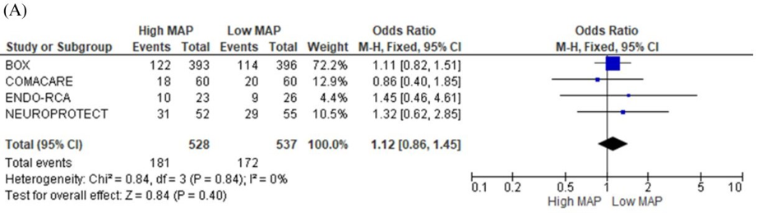

Figure 1. Forest plot analysis comparing (A) all-cause death,

EFFECT OF SACUBITRIL-VALSARTAN ON PLASMA NT-PROBNP LEVEL AND HOSPITALIZATION OF PATIENTS WITH HEART FAILURE: A SYSTEMATIC REVIEW

S. T. Lim¹, E. Huang¹, A. Kurniawan²

¹Faculty of Medicine, Pelita Harapan University
²Department of Internal Medicine, Faculty of Medicine, Pelita Harapan University

Background:
The prevalence of heart failure (HF) is increasing due to the aging population and remains associated with high mortality and morbidity. Sacubitril-valsartan is the first approved angiotensin receptor neprilysin inhibitor (ARNI) by the FDA for treating chronic heart failure with reduced ejection fraction (HFrEF). This systematic review aims to assess the effect of sacubitril-valsartan on the plasma N-terminal pro-brain natriuretic peptide (NT-proBNP) level which is a hallmark of heart failure as well as its correlation to hospitalization for patients with heart failure with preserved or reduced ejection fraction.

Methods:
2 individuals systematically searched the PubMed, ScienceDirect and Europe PMC database up to 24 June 2024 using the keywords "angiotensin–neprilysin inhibition" and "heart failure". Eligible studies were selected based on the inclusion criteria including randomized controlled trials, clinical trials and cohort studies. Our outcomes of interest were plasma NT-proBNP level and hospitalization due to heart failure. The risk of bias for randomized trials was measured using the Revised Cochrane Risk of Bias Tool (RoB 2) and the ROBINS-I tool was used to assess non-randomised trials. Systematic review, meta-analysis and trials on animals were excluded.

Results:
After screening the title and abstract, 9 of 141 studies met the inclusion criteria. Following the full-text assessment, 4 studies were included with 14,611 patients with heart failure with preserved or reduced ejection fraction. 3 of the included studies are of low risk of bias and 1 with some concerns of bias based on assessment with RoB 2. All studies found that sacubitril-valsartan was superior to valsartan (an angiotensin receptor blocker) or enalapril (an angiotensin-converting enzyme inhibitor) in reducing hospitalization for heart failure and plasma concentration of Nt-proBNP. Thus, sacubitril-valsartan can effectively prevent disease progression and increase the survival of patients.

Conclusion:
In conclusion, sacubitril-valsartan, an ARNI, effectively reduces plasma NT-proBNP levels and hospitalization rates in patients with heart failure with preserved or reduced ejection fraction. However, more studies are needed to validate these findings.

Keywords: reduced ejection fraction, heart failure, sacubitril-valsartan, plasma NT-proBNP, preserved ejection fraction

COMPARING MECHANICAL LEFT VENTRICULAR UNLOADING STRATEGIES TO IMPROVE SURVIVAL OF PATIENTS WITH CARDIOGENIC SHOCK OR CARDIAC ARREST RECEIVING VENO-ARTERIAL EXTRACORPOREAL MEMBRANE OXYGENATION: A NETWORK META-ANALYSIS

M. E. Ananta¹, C. F. Pragitara², N. R. Pratama³, A. D. Wijaya⁴, E. Ongkojoyo⁵, J. A. Wiryaputra⁶, D. A. Juzar⁵, B. Widyantoro⁵

¹Cempaka Putih Jakarta Islamic Hospital. ²Berkah Regional General Hospital. ³Faculty of Medicine, Universitas Airlangga. ⁴University College London. ⁵Department of Cardiology and Vascular Medicine, Faculty of Medicine, Universitas Indonesia, National Cardiovascular Center Harapan Kita. ⁶Hermina Kemayoran Hospital

Background:
Despite its increasing use in cardiogenic shock (CS) and cardiac arrest patients, Veno-arterial Extracorporeal Membrane Oxygenation (VA-ECMO) is associated with increased afterload and risk of ventricular dysfunction. No definitive evidence supports the addition of a left ventricular (LV) unloading device as previous studies have yielded inconsistent results. This study aims to assess the benefit, optimal device, and timing for LV unloading in VA-ECMO patients.

Methods:
We comprehensively searched Pubmed and Embase to identify full-text articles reporting the outcomes or complications of two or more LV unloading strategies in adult patients undergoing VA-ECMO. A Network meta-analysis using random-effects model within the frequentist framework was performed to pool Odds Ratio (OR) with 95% confidence interval (95%CI). Subgroup analyses were conducted based on study type (observational or RCT), patient population (VA-ECMO for CS or ECPR), and etiology (non-surgical vs postcardiotomy shock, acute myocardial infarction/AMI vs mixed). Risk of bias was assessed using Newcastle-Ottawa Scale for observational studies or Cochrane Risk of Bias-2 tool for RCT. Statistical analyses were conducted using the netmeta package in R 4.3.3.

Results:
Out of 4,272 records, 65 studies comprising 100,583 VA-ECMO patients were included in the meta-analysis (VA-ECMO alone: 56,964; VA-ECMO+IABP: 30,965; VA-ECMO+pLVAD: 12,155; VA-ECMO+left atrial decompression: 247; VA-ECMO+surgical venting: 252 patients). In the non-postcardiotomy population, compared to VA-ECMO alone, only concomitant use of IABP was associated with lower in-hospital mortality (OR=0.76; 95%CI 0.60–0.97) and lower composite of on-device mortality or unsuccessful weaning from ECMO (OR=0.63; 95%CI 0.44–0.89). Both IABP and pLVAD were associated with lower 30-day mortality (OR=0.56 [95%CI 0.45–0.70] and OR=0.67 [95%CI 0.49–0.92] respectively), but pLVAD was linked to bleeding requiring transfusion or reoperation, kidney replacement therapy, sepsis, and composite stroke. Left-atrial decompression was associated with higher cardiac tamponade and sepsis, while surgical venting was associated with lower myocardial recovery. Neither approach has demonstrated a survival benefit. We found that early or prophylactic LV unloading was associated with lower short-term mortality (OR=0.72; 95%CI 0.58–0.90) compared to delayed or bail-out strategies.

Conclusion:
Our network meta-analysis supports the early and prophylactic use of IABP in VA-ECMO patients when feasible and not contraindicated.

Keywords: Intra Aortic Balloon Pump (IABP), Percutaneous Left Ventricular Assist Device (pLVAD), VA-ECMO, complications, mortality
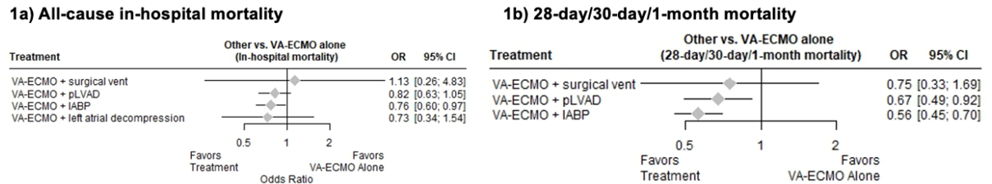

Figure 1. Forest plot and network graph of network meta-analysis comparing the mortality of VA-ECMO alone (referent group) with concomitant implantation of mechanical LV unloading devices in non-postcardiotomy patients

RETHINKING STEMI REPERFUSION PATHWAYS: A SYSTEMATIC REVIEW AND META-ANALYSIS OF DIRECT VS. INTER-HOSPITAL TRANSFER TO PRIMARY PCI

I. F. Arba¹, Andrianto², S. H. Aulia¹, W. Widiarti¹, C. E. C. Z. Multazam³, P. P. Siahaan¹, J. B. Swannjo¹

¹Faculty of Medicine, Universitas Airlangga
²Department of Cardiology and Vascular Medicine, Faculty of Medicine, Universitas Airlangga – Dr. Soetomo General Academic Hospital
³National Heart and Lung Institute, Imperial College London

Background:
Primary PCI is the preferred reperfusion therapy for STEMI patients. Timely revascularization is critical, as mortality risk is inversely related to the interval between symptom onset and revascularization. Clinical guidelines preferred direct transport of pre-hospital STEMI patients to PCI-capable centers. However, despite the growing availability of these facilities, regional non-PCI hospitals often remain involved in care, and studies on the impact of interhospital transfer have produced mixed findings. This study aims to compare the clinical outcomes of direct admission (DA) versus inter-hospital transfer (IHT) for STEMI patients undergoing primary PCI and assess its robustness through thorough sub-analyses.

Methods:
A systematic search across databases (PubMed, EMBASE, Cochrane, Scopus, ProQuest, and WebOfScience) leading to the inclusion of 55 papers comparing the short-term mortality of DA versus IHT for primary PCI.

Results:
Across all studies comprising a total of 325,221 patients, DA showed a non-significant trend towards lower mortality risk compared to IHT (RR0.91, 95%CI 0.81-1.03, p=0.14). Stratification by income classification revealed a higher mortality risk with DA in UMICs (RR1.16, 95%CI 0.52-2.55) and lower in HICs (RR0.92, 95%CI 0.82-1.02). Regional analysis showed the strongest trend favoring DA in America (RR0.79, 95%CI 0.62-1.00), followed by Europe (RR0.91, 95%CI 0.75-1.09), while Asian studies indicated a higher risk (RR1.09, 95%CI 0.88-1.36). Cohort period analysis revealed a diminishing advantage of DA over time, from RR0.91 (95%CI 0.80-1.03) before 2010, RR0.82 (95%CI 0.56-1.19) on 2010-2015, to RR1.05 (95%CI 0.81-1.36) after 2015. High heterogeneity (I² 27-80%) was observed across analyses.

Conclusion:
While our meta-analysis suggests an overall benefit for DA in STEMI patients undergoing primary PCI, this result is non-significant, showing no difference between the transport methods used. Moreover, the advantage of DA is not uniform across different contexts. The observed variations across income levels, geographical regions, and cohort periods highlight the need for tailored approaches to STEMI care pathways in underrepresented areas. The benefit of DA is more pronounced in resource-rich settings, and regional and period differences may reflect variations in healthcare system organization and resource allocation. Additionally, the temporal trend could reflect evolving transfer protocols and improved coordination between hospitals over time.

Keywords: Interhospital Transfer, Mortality, Direct Admission, STEMI, Primary PCI

CABERGOLINE FOR PERIPARTUM CARDIOMYOPATHY - A SYSTEMATIC REVIEW OF CASE REPORTS

A. F. K. Rahman¹, D. J. S. S. Dewi², N. Hajar³, A. Aulia⁴, C. Faizin³, I. A. Balqis³, A. N. Zulfa³, K. Nuriyah³

¹dr. Gondo Suwarno General Hospital
²dr. Ario Wirawan Pulmonary Hospital
³Faculty of Medicine of Universitas Muhammadiyah Semarang
⁴dr. H Soewondo General Hospital

Background:
Peripartum cardiomyopathy (PPCM) is an idiopathic cardiomyopathy that develops in late-term pregnancy or in the first few months following birth. It is characterized by heart failure due to left ventricular systolic dysfunction. According to certain research, bromocriptine reduces prolactin levels and enhance clinical results in women with PPCM. Like bromocriptine, cabergoline is a dopamine receptor agonist that may be useful in treating patients with PPCM. However, its effects have not been completely investigated. Our objective was to identify the effects of cabergoline in women with PPCM.

Methods:
This study was conducted in accordance with the PRESS Checklist. We searched MEDLINE, the Cochrane Library, and additional sources to identify cases of PPCM with cabergoline therapy. Established systematic review methods were used for screening and data extraction. A tool has recently been proposed to assess the methodological quality of case reports included in systematic reviews.

Results:
Six case reports were analyzed in this study. Cabergoline is a potent dopamine receptor agonist. The cardiac function and symptoms improved with the reduction in the level of prolactin. The present results demonstrated the usefulness of antiprolactin therapy with cabergoline in a patient with PPCM.

Conclusion:
Cabergoline is an anti-prolatic which is very useful for PPCM therapy. Further clinical studies need to address the best drug of choice and its optimal dose to treat the abnormalities.

Keywords: Cabergoline

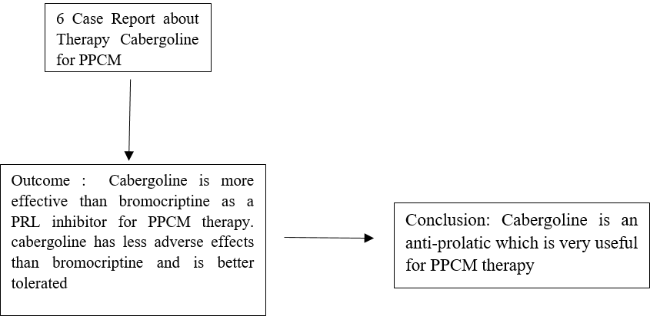
Figure 1. Systematic Review Cabergoline for Peripartum Cardiomyopathy - A Systematic Review of Case Reports

EFFECT OF CONTINUOUS POSITIVE AIRWAY PRESSURE THERAPY ON CARDIOVASCULAR EVENTS IN PATIENTS WITH OBSTRUCTIVE SLEEP APNEA: A SYSTEMATIC REVIEW

E. Tanially¹

¹Pelita Harapan University

Background:
Obstructive sleep apnea (OSA) is a condition characterized by episodes of complete airway collapse associated with the decrease in oxygen saturation during sleep and is known to lead to significant implications, such as mental illness, reduced quality of life, and decline cardiovascular health. To reduce the happenings of these implications, the use of continuous positive airway pressure (CPAP) therapy has been used. This review aims to showcase the effect in the use of CPAP therapy specifically on cardiovascular events in patients with OSA.

Methods:
Databases, such as PubMed, Elsevier, ATS Journals were systematically analyzed to extract studies on June 6, 2024. Keywords including “Continuous Positive Airway Pressure", "Cardiovascular Events", AND “Obstructive Sleep Apnea” were used to gain relevant studies and there are three independent researchers that have conducted this study. The outcome in this review is the prevalence of a composite of cardiovascular events. Studies in English from the last five years with accessible full text including randomized controlled trial studies, were included in this review. Studies that were systematic reviews, meta-analyses, animal studies, and case reports were excluded. The Newcastle Ottawa Scale (NOS) was then used to assess the studies' quality.

Results:
Three studies were extracted for this review, all are of high quality based on the NOS. As for effectiveness, three studies mentioned that CPAP did not significantly reduce the prevalence of cardiovascular events in OSA patients, where two of the studies mentioned that in patients with paroxysmal AF and OSA, treatment with CPAP did not further reduce the risk of AF recurrence after ablation and another showed that there is no reduction in the prevalence of ACS in the patients.

Conclusion:
In conclusion, CPAP does not significantly reduce the prevalence of cardiovascular events in OSA patients. However, further studies are needed to further confirm these findings as there are still limited resources in regards to this title.

Keywords: Cardiovascular events, CPAP, OSA

AMIODARONE VS DIGOXIN FOR ACUTE RATE CONTROL AGENTS IN ATRIAL FIBRILLATION: A SYSTEMATIC REVIEW AND META-ANALYSIS OF RANDOMIZED CONTROLLED TRIALS AND OBSERVATIONAL STUDIES

J. N. Arnindita¹, P. P. Siahaan², P. B. T. Saputra¹, R. B. Kurniawan², J. Lesmana¹, Y. H. Oktaviono¹, R. Julario¹, B. B. Dharmajati¹, R. N. Rosyadi¹, R. Amadis¹, M. J. Al-Farabi¹, C. E. C. Z. Multazam³, F. F. Alkaff⁴

¹Department of Cardiology and Vascular Medicine, Dr. Soetomo General Hospital, Faculty of Medicine, University of Airlangga. ²Faculty of Medicine University of Airlangga. National Heart and Lung Institute, mperial College London, London, UK
⁴Division of Nephrology, Department of Internal Medicine, University Medical Center Groningen, Groningen, Netherlands

Background:
The rate control strategy is the first-line therapy in alleviating atrial fibrillation (AF)-related symptoms and preventing complications. American College of Cardiology/American Heart Association and European Society of Cardiology recommended beta-blockers and non-dihydropyridine calcium channel blockers as the drug of choice in the rate control strategy of AF. Instead, Digoxin and Amiodarone are the most commonly used rate-control drugs in clinical practice in developed and developing countries. There has been no robust data supporting the superiority of either one of these drugs in the acute rate control of AF. Therefore, this meta-analysis aimed to compare the efficacy of Amiodarone and Digoxin in controlling the ventricular rate of AF patients.

Methods:
A systematic search was conducted across online databases on March 9, 2024. Analysis was performed using RevMan 5.4 (Cochrane Collaboration, Copenhagen) and R software version 4.2.2 (Posit PBC, USA). Binary data were pooled as risk ratio (RR), while continuous data were pooled as mead difference (MD). Either fixed-effect or random-effect meta-analysis was applied based on heterogeneity test results.

Results:
Seven cohorts and eight trials with 2,833 patients were included. Patients were followed up for the primary outcome in 1 – 4 hours after drug administration. Amiodarone was superior in controlling heart rate (MD-8.43 [95%CI -14.17, -2.70]; p=0.004; I²=64%). However, unlike Digoxin, Amiodarone exhibited minor adverse events (RR 2.06 [1.06,4.00], p=0.03, I²=48%) such as bradycardia, hypotension, and phlebitis. On the other hand, serious adverse events such as ischemic stroke were recorded in Digoxin patients. The duration of hospitalization and risk of recurrent AF and mortality in both groups were not different.

Conclusion:
Amiodarone is considered effective as the alternative rate control in patients with AF to Digoxin. Close monitoring during the administration is advised, as minor adverse events may be encountered.

Keywords: amiodarone, rate control, digoxin, atrial fibrillation

EFFECTS OF EXERCISE INTERVENTIONS AND THEIR VARIED INTENSITIES ON HEART FAILURE PATIENTS WITH CARDIAC RESYNCHRONIZATION THERAPY (CRT): A SYSTEMATIC REVIEW AND NETWORK META-ANALYSIS OF RANDOMIZED TRIALS

D. I. Hakim¹, A. Auzan², B. B. Bramantyo³, A. Z. Z. A. Hajiri¹, V. C. Gunawan³, C. A. N. Sihite³, Y. Waranugraha⁴

¹Muhammadiyah Hospital Babat
²Regional General Hospital Porsea
³M. Thomsen General Hospital Nias
⁴Department of Cardiology and Vascular Medicine, Brawijaya University Faculty of Medicine

Background:
Cardiac resynchronization therapy (CRT) is a well-established approach in patients with heart failure (HF) who do not respond to optimal pharmacological therapies. Exercise demonstrated positive effects in patients with cardiovascular disease and is also presumed to be advantageous in patients with CRT. Objective: to investigate the effects of exercise intervention in HF patients with CRT and determine the most optimal exercise intensity.

Methods:
We identified articles from PubMed, Scopus, ScienceDirect, EuropePMC, and Cochrane (CENTRAL) from inception to July 2024. For primary outcomes, we included randomized controlled trial (RCT) studies that assessed the impact of exercise on cardiac function, exercise capacity, and quality of life, as well as adverse events, hospital readmission, and mortality for secondary outcomes in HF patients with CRT. We further perform a subanalysis on the primary outcome, considering the training intensity levels of high-intensity interval and non-high-intensity interval. We conducted a network meta-analysis that encompassed pairwise comparisons and the available indirect evidence related to exercise intensity.

Results:
The search process yielded eight studies, totaling 670 participants. The result shows that exercise intervention ameliorates primary outcomes in patients when compared to usual care in terms of peak VO2 (mean difference [MD] = 1.90, 95% confidence interval [CI] 1.13 to 2.66, p<0.00001) and exercise duration (MD = 68.62, 95% CI 22.02 to 115.22, p=0.004). From subgroup analysis, it is known that non-high intensity exercise ameliorates most primary outcomes in patients when compared to usual care in terms of peak VO2 (MD = 2.21, 95% CI 1.10 to 3.32, p<0.0001), exercise duration (MD = 64.63, 95% CI 27.00 to 102.27, p=0.004), LVEF (MD = 6.03, 95% CI 3.00 to 9.07, p<0.0001), quality of life (standardized mean difference [SMD] = -1.30, 95% CI -2.47 to -0.14, p=0.03). Indirect analysis reveals that moderate-intensity interval training is the most effective exercise for enhancing primary outcomes, surpassing light intensity, high intensity, and usual care. There were no significant differences in secondary outcomes among groups.

Conclusion:
Non-high-intensity interval exercise enhances exercise capacity, cardiac function, and QoL in HF patients implanted with CRT, with moderate intensity being the most optimal training approach.

Keywords: CRT, Exercise, Intensity, HF

THE EFFECT OF EXERCISE THERAPY AS THE ADDITIONAL THERAPY IN PATIENTS WITH VARICOSE VEIN COMPLICATING WITH VENOUS LEG ULCER: A META-ANALYSIS OF RANDOMIZED CONTROL TRIALS

M. S. Sayfullah¹, K. A. A. P. Pramana², Y. Pintaningrum³

¹University of Padjadjaran
²Tabanan General Hospital
³Departmen Cardiology and Vascular Medicine, West Nusa Tenggara General Hospital

Background:
Venous leg ulcer (VLU) account for approximately 70% of all chronic leg ulcers and are the result of varicose vein. The mainstay of care is compression therapy and wound care. Little is known about the feasibility and efﬁcacy of exercise training used in combination with compression therapy patients with VLU.

Methods:
Electronic journals searching were performed in PubMed, ScienceDirect, and Cochrane from January 2017 to June 2024 to identify the studies assessing the effects of exercise intervention as the additional therapy in patients with varicose vein complicating with venous leg ulcer. Meta-analyses were performed on included studies, Mean Differences (MD), Odds Ratio (OR) and 95% Confidence Interval (CI) were estimated using Review Manager v5.4.

Results:
A total of four studies were included in our analysis. Exercise therapy group was found significantly improve the wound healing rates compared with usual care alone [OR 3.35 (95% CI, 1.64 to 6.87), p = 0.001] in patients with varicose vein complicating with venous leg ulcer. There is no significant difference on walking distance between exercise therapy group and usual care group

Conclusion:
Our findings suggest that exercise therapy can significantly improve the wound healing rates in patients with varicose vein complicating with venous leg ulcer.

Keywords: venous leg ulcer, exercise therapy, varicose vein

CORRELATION OF SERUM N-ACETYLNEURAMINIC ACID WITH THE RISK AND PROGNOSIS OF ACUTE CORONARY SYNDROME: A SYSTEMATIC REVIEW

C. A. CENDERA¹, L. K. Tori¹, E. Tanially¹

¹Faculty of Medicine, Pelita Harapan University

Background:
Acute coronary syndrome (ACS) poses significant clinical challenges due to its sudden onset and severe prognosis. Serum N-Acetylneuraminic Acid (Neu5Ac), involved in inflammation and endothelial function, has emerged as a potential biomarker for ACS. Elevated serum Neu5Ac levels correlate with increased inflammatory activity and plaque instability, key factors in ACS development. This study evaluates the correlation between serum Neu5Ac levels and ACS risk and prognosis, synthesizing current evidence to determine its utility as a predictive biomarker, potentially improving clinical management strategies.

Methods:
Databases, such as PubMed, Europe PMC, and SpringerLink were systematically analyzed to extract studies on June 6, 2024. Keywords including “N-Acetylneuraminic acid", "Acute coronary syndrome", “risk”, AND “prognosis” were used to gain relevant studies. The outcomes in this review are the level of Neu5Ac as a biomarker, MACE for adverse events that indicate risks, and GRACE scores for prognosis. Three independent researchers conducted this study. Studies in English from the last five years with accessible full text consisting of cohort studies, were included in this review. Studies that were systematic reviews, meta-analyses, animal studies, and case reports were excluded. The ROBINS-I tool is used to assess the quality of the studies.

Results:
Three studies were extracted for this review, including 1887 participants. The studies used were of moderate risk of bias based on the ROBINS-I tool. All studies show that patients in the ACS group have significantly higher Neu5Ac levels compared to control groups. Two studies show that there is a greater increase in plasma Neu5Ac in high-risk groups compared to medium and low risk. They also show that patients with MACE also have significantly higher plasma Neu5Ac level than without MACE. One study show that serum Neu5Ac is associated with myocardial injury and GRACE risk category. It is important to note that a history of previous stroke is another independent risk factor for the occurrence of MACE in the sample.

Conclusion:
In conclusion, serum Neu5AC levels can be used to diagnose, stratify risks, and predict prognosis based on the patient’s MACE score in ACS patients. However, randomized studies are needed to further strengthen the conclusion.

Keywords: prognosis, n-acetylneuraminic acid, acute coronary syndrome, risk

UNRAVELING THROMBOLYSIS FAILURE IN STEMI: A SYSTEMATIC REVIEW AND META ANALYSIS OF KEY PREDICTORS

J. Hartanto¹, A. G. Suwana¹, N. R. Putri², A. Ferly³

¹Faculty of Medicine, Universitas Indonesia, Jakarta
²Faculty of Medicine, Universitas Airlangga, Surabaya
³Doris Sylvanus Regional General Hospital, Palangka Raya, Central Kalimantan

Background:
Indonesia's healthcare infrastructure often places many facilities far from centers equipped to perform percutaneous coronary intervention (PCI), rendering pharmacological reperfusion the primary treatment for ST-elevation myocardial infarction (STEMI). Despite its widespread use, failed thrombolysis (FT) is frequent with reported failure rates ranging from 10% to 56.8%, which significantly increases mortality in STEMI patients. This emphasizes the urgent need for research to identify these predictors to guide clinical management.

Methods:
This review has been registered in PROSPERO (CRD42024563035). A comprehensive search was conducted on PubMed, Embase, and Scopus up to June 28, 2024. Each study was screened against the eligibility criteria. Included studies were extracted and assessed for risk of bias using the Quality In Prognostic Studies tool. Random-effect meta-analysis was used to pool effect estimates usingR V.4.3.2.

Results:
A total of 19 studies with 9,582 patients, identifies significant predictive factors for FT in STEMI. Older age (MD 1.13, 95% CI: 0.14–2.12) and comorbid conditions such as diabetes (OR 1.46, 95% CI: 1.13–1.88), hypertension (OR 1.51, 95% CI: 1.14-1.99), dyslipidemia (OR 2.00, 95% CI: 1.21–3.32), and heart failure (OR = 2.18, 95% CI: 1.43–3.33) are significantly associated with increased FT rates. Clinical characteristics upon admission, including higher diastolic BP (MD 5.17, 95% CI: 2.70–7.64), higher heart rate (MD 1.79, 95% CI: -0.33–3.92), Killip Class ≥2 (OR 1.95, 95% CI: 1.54–2.47), anterior myocardial infarction (OR 2.03, 95% CI: 1.21–3.42), and lower LVEF (MD -3.65, 95% CI: -5.69 – -1.61), were identified as predictors of FT. Interestingly, the duration of symptom onset to thrombolysis, current smoking state, higher systolic BP, and obesity were not significantly correlated with FT.

Conclusion:
In conclusion, this meta-analysis identifies the predictors of FT in STEMI, highlighting the urge for tailored management strategies and alternative reperfusion therapies. Incorporating these predictors into clinical practice can enhance patient stratification and treatment, ultimately improving outcomes in STEMI management.

Keywords: ST-elevation myocardial infarction, failed thrombolysis, comorbidities, anterior MI, predictor

UNVEILING GENDER DIFFERENCES IN THE EPIDEMIOLOGY OF ST ELEVATION MYOCARDIAL INFARCTION (STEMI) AMONG Women: A Meta-analysis

N. A. Putri¹, S. Amalia², R. M. Candrasatria³

¹General Practitioner, Bob Bazar General Hospital
²General Practitioner, Trijaya General Hospital
³Cardiologist, Abdul Moeloek General Hospital

Background:
Multiple studies have shown that ST Elevation Myocardial Infarction (STEMI) in women has different presenting symptoms and risk factors than in men. However, it remains unclear whether there are additional disparities in other aspects of STEMI between women and men. We aim to investigate the characteristics of women with STEMI, including presenting symptoms, clinical features, risk factors, electrocardiography, coronary angiography findings, and in-hospital outcome

Methods:
A systematic literature search was conducted in PubMed, ScienceDirect, and Springer up to Mei 2024 Data were pooled and meta-analyzed using fixed and random-effect models based on heterogeneity among studies and presented as Risk Ratio.

Results:
Twenty-two studies which involved 304768 patients were included in this Meta-Analysis. Women are more likely to have non-chest pain symptoms (nausea-vomiting [Risk Ratio/ RR: 1.42; 95%CI: 1.03-1.96] and palpitations [RR: 1.90; 95%CI: 0.94-3.84]) and presented as Killip Class 2 (RR: 1.37; 95%CI: 1.18-1.60) compared to men. Significant risk factors include prior Stroke [RR: 2.05; 95%CI: 1.69-2.49], Diabetes [RR: 1.48; 95%CI: 1.38-1.58], and prior heart failure [RR: 1.36; 95%CI: 1.06-1.75]. Women exhibited longer Symptoms-to-Door times (286.57 vs. 219.14 mins, p= <0.001) and receive fewer coronary angiography treatment than men (53.4% vs 54%, p =0.14), Although there is no significant difference, STEMI Anterior (47.7%), One-Vessel-Disease (31%), and Right Coronary Artery (13.5%) are among the higher proportion prevalence of ECG and coronary angiography findings among women. In-hospital outcome, such as mortality [RR:1.85; 95%CI: 1.43-2.40], Total AV Block [RR:1.54; 95%CI: 1.16-2.05], and Cardiogenic Shock [RR:1.42; 95%CI: 1.34-1.50] are more significantly to be observed in women than men.

Conclusion:
No significant difference is observed on infarct location and coronary angiography findings. However, women are more likely to have atypical symptoms, different risk factors, and more severe in-hospital outcome than men. This implies advanced research is needed to investigate the mechanisms that contribute to these observed differences.

Keywords: Women, Sex Differences, Myocardial Infarction, Epidemiology, ST-Elevation Myocardial Infarction
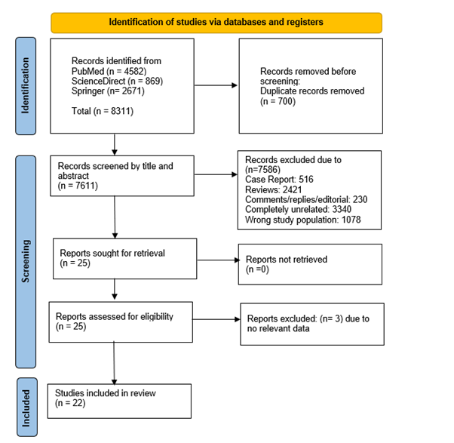
Figure 1. PRISMA Flow Chart
FACTORS ASSOCIATED TO SUBOPTIMAL DOSING IN GUIDELINE-DIRECTED MEDICAL THERAPY FOR HEART FAILURE WITH REDUCED EJECTION FRACTION: A SYSTEMATIC REVIEW AND META-ANALYSIS
A. T. Sridevi¹, J. Audrey¹
¹Fakultas Kedokteran Universitas Indonesia

Background:
Guideline-directed medical therapy (GDMT) has been proven to reduce morbidity and mortality in patients with heart failure with reduced ejection fraction (HFrEF). However, this reduction is only achievable when each heart failure medication is titrated to its guideline-recommended target doses (GRD). Unfortunately, many patients in clinical settings receive doses lower than those recommended. We believe that identifying patient characteristics associated with suboptimal dosing is essential for improving GDMT adherence. Hence, this study aims to identify the parameters associated with suboptimal GDMT dosing practices.

Methods:
A comprehensive search of four databases (PubMed, Cochrane, Embase, and ScienceDirect) was performed. The inclusion population was HFrEF patients with GDMT-intended management and having documented clinical and/or laboratory parameters. The observed outcome was whether patients achieved optimal GRD. The methodological quality of eligible studies was assessed using the Newcastle-Ottawa Scale (NOS). Odds ratios (OR) or mean differences (MD) of potential risk factors were pooled from the included studies using a random-effects model. Meta-analysis was conducted using Review Manager 5.3.

Results:
The literature search yielded 518 initial records, from which 22 studies underwent full-text evaluation. A total of 10 studies (n = 29,597 participants) with potential factors and extractable outcomes were included in the final analysis, reporting GDMT dosing for renin-angiotensin inhibitors (RASi), beta-blockers (BB), and mineralocorticoid receptor antagonists (MRA). Older age was associated with suboptimal GDMT doses across all three drug groups. Additionally, lower body mass index (BMI), left ventricular ejection fraction (LVEF), systolic blood pressure (SBP), diastolic blood pressure (DBP), estimated glomerular filtration rate (eGFR), and the presence of anemia and atrial fibrillation were significantly associated with suboptimal RASi dosing. Lower BMI, SBP, DBP, heart rate, and ischemic heart disease were associated with suboptimal doses of BB, while hypertension decreased the odds of suboptimal dosing. Lower eGFR was also associated with suboptimal MRA dosing.

Conclusion:
This meta-analysis demonstrated that certain demographic factors, clinical parameters, and comorbidities are associated with suboptimal GDMT dosing practices. Understanding these factors may provide opportunities to optimize GDMT adherence and improve patient outcomes.

Keywords: Parameters, Heart failure with reduced ejection fraction, Suboptimal dose, Guideline-recommended target doses, Guideline-directed medical therapy

Table 1. Summary of factors significantly associated with suboptimal GDMT dosing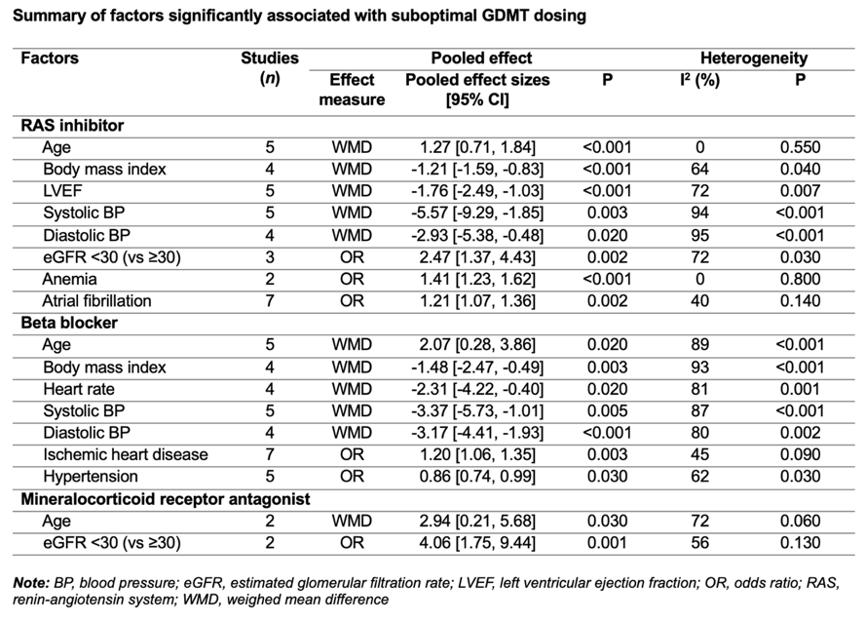

THE MOST POTENTIAL STEM CELL THERAPY FOR CONGENITAL HEART DISEASE: A SYSTEMATIC REVIEW

A. A. Bestari¹, M. P. Airlangga,¹, G. N. D. M. A¹

¹Universitas Muhammadiyah Surabaya

Background:
Congenital Heart Disease (CHD) affects 8 out of 1,000 live births in almost all countries in the world. Indonesia itself has 200 million population and the birth rate is 2%, so approximately the number of CHD sufferers in Indonesia increases by 32,000 babies every year. There are several treatment options, but invasive surgery is still the first line treatment. Even though invasive surgery has significantly progressed over the years, this procedure comes with high risk and complications such as bleeding, infection, or inadequate perfusion of organs or tissue. Currently, stem cells therapy is starting to be researched and developed for congenital heart disease treatment. Stem cells have many types of sources and specific functions. This review provides the types of stem cells with the most potential for treating congenital heart disease.

Methods:
Abstracts were screened and reviewed against the eligibility criteria and identified RCTs and clinical trials. Citation identification, data extraction, and synthesis were independently undertaken by 3 reviewers. Articles with language and publication date restriction were searched in PubMed, Library genesis, Google Scholar , and ScienceDirect. Search terms included congenital heart disease, congenital heart defect, stem cells, stem cells therapy.

Results:
The search identified 17.800 studies that examined terms using specified keywords; 28 studies met the inclusion criteria. All studies were assessed as having low risk of bias according to the PRISMA statement, although there was heterogeneity in the outcome measures and control interventions.

Conclusion:
This systematic review provides initial evidence that several types of stem cells had a high potential in repairing congenital heart disease such as mesenchymal stem cells, embryonic stem cells, and amniotic fluid-derived stem cells. Each type of stem cell has a different pathway to repairing. However, caution is advised in interpreting this literature review due to the limited number of research samples.

Keywords: congenital heart defects, stem cells, stem cells therapy, congenital heart disease

ASSOCIATION BETWEEN ADMISSION HYPERGLYCEMIA AND PROGNOSIS IN PATIENTS WITH ACUTE MYOCARDIAL INFARCTION COMPLICATED WITH CARDIOGENIC SHOCK (AMI-CS): A SYSTEMATIC REVIEW AND META-ANALYSIS

D. I. Hakim¹, F. R. Qhabibi², M. Yusuf³, A. B. Effendi⁴, I. Prasetya⁵

¹Muhammadiyah Hospital Babat
²Dharma Yadnya General Hospital
³Faculty of Medicine, Brawijaya University
⁴Sujudi General Hospital
⁵5Department of Cardiology and Vascular Medicine, Faculty of Medicine, Brawijaya University / Dr. Saiful Anwar Hospital

Background:
Cardiogenic shock (CS) is one of the main cardiovascular problems and has a very high mortality rate when accompanied by acute myocardial infarction (AMI-CS). High admission glucose (hyperglycemia) is presumed to be a valuable risk factor in determining the prognosis of patients with AMI-CS. Objective:to evaluate the association between admission hyperglycemia and prognosis in patients with AMI-CS

Methods:
Articles from PubMed, ScienceDirect, ProQuest, and EuropePMC were identified from inception to June 2024. Observational studies evaluating the impact of admission hyperglycemia (admission glucose =>~140 mg/dL) related to in-hospital, 30-day, and 1-year mortality for primary outcomes and evaluating the needs for mechanical support (mechanical ventilator (MV), intra-aortic balloon pump (IABP), extracorporeal membrane oxygenation (ECMO)) for secondary outcomes with a population of patients diagnosed with AMI-CS =>18 years old were included. Sub-analysis was also conducted for groups of higher admission hyperglycemia (admission glucose =>~200 mg/dL) and patients without diabetes mellitus (non-DM). The risk of bias was assessed using the quality in prognosis study (QUIPS) checklist. The random-effect model measured the pooled effect and was shown in risk ratio (RR) with the corresponding 95% confidence interval (CI).

Results:
From the search process, we obtained 9 studies with a total of 3227 participants which were analyzed quantitatively and qualitatively. Compared to AMI-CS patients with normoglycemia, patients with hyperglycemia have a significantly higher risk of in-hospital mortality (RR=1,59; P=0.03), 30-days mortality (RR=1.52; P<0.00001), 1-year mortality (RR=1.47; P=0.02), and needs for mechanical support such as MV (RR=1.46; P<0.00001) but not in IABP (RR=1.05; P=0.66). Subanalysis revealed that higher admission hyperglycemia significantly affects higher outcomes related to 30-day mortality (RR=1,76; P<0.0001) and needs for MV (RR=1,53; P<0.00001), but not in-hospital mortality (RR=2,29; P=0.12) and 1-year mortality (RR=1,96; P=0.21), and needs for IABP (RR=1,15; P=0.55). Due to limited data, sub-analysis on non-DM patients can only be done on 30-day mortality, resulting in significant differences (RR=1,58; P<0.00001). The overall risk of bias is low in all studies

Conclusion:
Admission hyperglycemia has a predictive value in determining outcomes in patients with AMI-CS especially related to mortality and the need for mechanical support.

Keywords: Cardiogenic Shock, Glucose, Hyperglycemia, Acute Myocardial Infarction

CASE COMPARATIVE ANALYSIS OF HYPERTENSION MANAGEMENT ACROSS SIX COUNTRIES (INDONESIA, CHINA, EGYPT, INDIA, MALAYSIA, THAILAND): EVALUATING PATIENT-CENTERED ACCESS TO HEALTH CARE

C. F. Albab¹, F. R. Muharram², G. M. Nurhadi¹, A. S. Hariftyani¹

¹Faculty of Medicine, Airlangga University, Surabaya, Indonesia
²Department of Global Health and Social Medicine, Harvard Medical School, Boston, USA

Background:
Hypertension has become a huge rising towards global health problem, with 2/3 of its population being from low-middle-income countries (LMICs). This number shows a stellar prevalence increase as the population ages. With the capacity of health systems and infrastructure that is not as good as High-Income Countries (HICs), this can be a time bomb that will add to the health burden. Evaluating patient-centered access to healthcare through sociocultural, GDP, geographic, and demographic similarities may provide deeper insights into better hypertension management among countries.

Methods:
We conducted a case comparative analysis search through Pubmed and Web of Science (WoS). The articles were screened based on eligibility criteria and were assessed for study qualities using the Newcastle-Ottawa Scale. The outcomes were presented as a comparison of approachability, acceptability, availability, accommodation, affordability, and appropriateness between 6 selected countries through their GDP PP; GDP USD; average year school; prevalence; awareness; treatment, control and treatment to control the rate of hypertension in the 6 selected LMICs countries.

Results:
The analysis on 58 studies revealed significant disparities in hypertension management among the countries. Indonesia exhibited the lowest treatment-to-control rate (17.9% and 20.9% for male and female, respectively) and the highest prevalence of hypertension (35.9 and 44.5 for male and female, respectively). China, Egypt, India, Iran, and Thailand, respectively, demonstrated better access to and management of hypertension, characterized by higher treatment-to-control rate ranged from 39.6% to 59.5%. Broader healthcare coverage were obtained in Thailand, Iran, and China (7,872; 8,034; and 10,650 GDP USD; respectively) Nevertheless, Indonesia’s healthcare coverage for hypertension was only 4,102 GDP USD. Patient access metrics varied significantly: Approachability was generally high in countries with extensive healthcare infrastructure; Acceptability was influenced by cultural and systemic factors; Availability and Accommodation were stronger in urban areas; Affordability varied, with government-supported systems showing better outcomes; and Appropriateness was influenced by local healthcare policies and practices.

Conclusion:
Indonesia faces significant challenges with hypertension control and healthcare access compared to other countries. Improving patient-centered care requires addressing gaps in approachability, acceptability, availability, affordability, and appropriateness to enhance treatment outcomes and reduce disparities.

Keywords: hypertension management, cascade of care, LMICs, access to health care, patient-centered

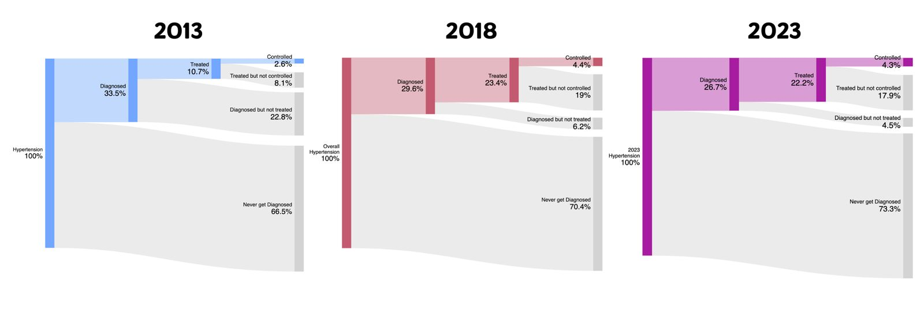
Figure 1. Indonesia Cascade of Care of Hypertension 2013-2018

WELL-BEING ENHANCEMENT WITH PHYSICAL ACTIVITY IN CONGENITAL HEART DISEASE: A RECENT UPDATE OF META-ANALYSIS STUDY

S. Az-Zahra¹, A. A. M. Rangkuti¹, M. F. Ikram¹, A. H. Abdillah¹

¹Universitas Sumatera Utara

Background:
Congenital heart disease (CHD) still remains as the most common form of birth anomaly, resulting in defects in cardiac structure and thus, incapacitate its functions. This also accounts greatly for the high number of mortalities from birth abnormalities in their first year of life. The effect of long-term CHD is detrimental to the patients, both physically and mentally. However, up to this time, there were no clear evidence which define the importance and efficacy of physical activity in CHD. Therefore, we conducted a study of meta-analysis to reveal the efficacy and safety of physical activity in CHD population.

Methods:
Literature searching was conducted from databases such as PubMed, Cochrane, Google Scholar, and ScienceDirect, using Boolean keywords “physical activity”, “congenital heart disease”, “treatment”, and “therapy”. Statistical analyses using ReviewManager 5.4.1 are presented in MD, except for adverse events which use OR.

Results:
Eleven studies which consist of 9 RCTs and 2 cohorts with a total subject number of 7683 participants were analyzed. The overall effect MD in each outcome was 1.40 (95% CI -0.15 – 2.94, p = 0.08) for VO2max, 2.45 (95% CI -2.90 – 7.80, p = 0.37) for %predictedVO2max, -0.52 (95% CI -1.34 – 0.29, p = 0.21) for maximum heart rate, 5.64 (95% CI 4.46 – 6.81, p < 0.00001) for maximum workload, -0.17 (95% CI -0.26 – -0.08, p = 0.0002) for maximum oxygen pulse, 0.02 (95% CI -0.01 – 0.05, p = 0.20) for RER, -1.29 (95% CI -1.56 – -1.02, p < 0.00001) for VE/VCO2 slope, 3.75 (95% CI 3.31 – 4.19, p < 0.00001) for quality of life, 1.35 (95% CI -2.31 – 5.00, p = 0.47) for time spent in MVPA, 0.62 (95% CI 0.55 – 0.70, p < 0.00001) for adverse events.

Conclusion:
This meta-analysis suggests that the use of physical activity in CHD does not improve cardiorespiratory fitness significantly. Thus, the efficacy and safety of physical activity in CHD shown that the intervention tended to be used as adjunctive therapy, mainly after the surgical correction procedure has been performed.

Keywords: cardiorespiratory fitness, meta-analysis, congenital heart disease, physical activity
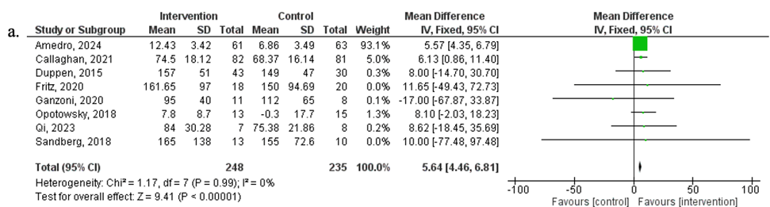

Figure 1. Meta-Analysis showing the Significant Results of: a) Maximum Workload, Comparing Mean Difference (MD) between Intervention Group and Control Group among the Congenital Heart Disease (CHD) Population

MESENCHYMAL STEM CELLS THERAPY IN CHRONIC LIMB-THREATENING ISCHEMIA: A META-ANALYSIS OF RANDOMIZED CONTROLLED TRIALS

Hariadi¹

¹RSI AT-TAQWA GUMAWANG

Background:
Chronic limb-threatening ischemia (CLTI) is an end stage condition of peripheral artery disease, which has high morbidity and mortality rate. Several therapeutic approaches have been conducted, but the outcome is still poor, therefore, new approach is urgently needed. Recently, mesenchymal stem cells (MSCs) have been performed in several randomized controlled trial. The aim of this study was to evaluate efficacy and safety of MSCs implantation in CLTI.

Methods:
Randomized controlled trials of MSCs implantation compared with control treatment for patients with CLTI were included. A systematic literature search was performed in the PubMed, Science Direct, Scopus, and ProQuest databases. Author screened studies and extracted data from them. The primary outcomes were amputation rate and ulcer healing rate. The secondary outcomes were pain-free walking distance (PFWD), rest pain score, ankle-brachial index (ABI), and collateral vesselimprovement.

Results:
Four RCTs were included with a total of 150 patients. Meta-analysis showed that MSCs was more effective than control group on the ulcer healing rate (OR = 5.3, 95% CI = 1.74–16.13). Although not statistically significant, amputation rate in MSCs therapy was also lower than in control group (OR = 0.38, 95% CI = 0.11–1.34). Pain-free walking distance (MD= 173.47, 95% CI = 121.05–225.89), rest pain score (MD= -1.37, 95% CI = [-1.67 – -1.06]), ankle-brachial index (ABI) (MD = 0.16, 95% CI = 0.13–0.20), and collateral vessel improvement (OR = 58.52, 95% CI = 3.07–1115.44) were significantly better in the MSCs therapy group than in the control group. Moreover, all of the included studies also indicated that MSCs was safe.

Conclusion:
This meta-analysis shows that MSCs therapy is effective and safe in patients with CLTI. However, larger RCTs with good quality are needed to verify these results.

Keywords: Chronic Limb-Threatening Ischemia, Mesenchymal Stem Cells

Table 1. Study Characteristics
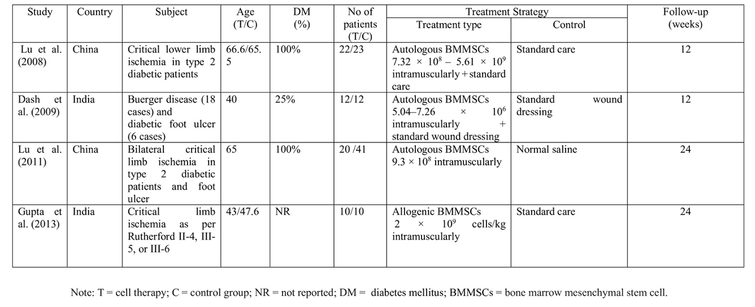

INNOVATIVE ADVANCES IN CARDIOPULMONARY RESUSCITATION: UNVEILING CUTTING-EDGE TECHNOLOGICAL INNOVATIONS AND QUALITY ENHANCEMENTS THROUGH ADVANCED TECHNOLOGY - A SYSTEMATIC REVIEW AND COMPREHENSIVE META-ANALYSIS OF RANDOMIZED CONTROLLED TRIALS

A. H. Ariouso¹, A. F. Yusriyah²

¹Mataram University
²Udayana University

Background:
Cardiopulmonary resuscitation (CPR) is a critical life-saving procedure, but its effectiveness heavily relies on the accuracy and quality of its administration. Recent technological advancements have introduced innovative tools and methods aimed at enhancing CPR performance. This systematic review and comprehensive meta-analysis aims to evaluate the impact of these cutting-edge technological innovations on key CPR performance metrics, including chest compression rate, chest compression depth, accuracy of the CPR procedure, and overall performance.

Methods:
This systematic review and meta-analysis followed PRISMA 2020 guidelines and the Cochrane Handbook for Systematic Reviews of Interventions. A comprehensive search across multiple databases (PubMed, Science Direct, Springer, Sqopus, Nature, Proquest) up to July 2024. Studies that investigated the impact of advanced technologies on CPR performance were included. Two reviewers independently performed data extraction and quality assessment. The risk of bias for each study was evaluated using Cochrane's RoB 2.0 Tool.

Results:
Thirty RCTs with 3.421 participants included in this study. Our study found that advanced technology significantly enhances CPR quality, improving compression depth (mean difference [MD]=2.50 [95% CI 1.20, 3.80; p<0.00001]), compression rate (MD=8.30 [95% CI 5.10, 11.50; p=0.01]), and compression quality (odds ratio [OR]=4.10 [95% CI 1.50, 11.20; p=0.05]). Subgroup analysis revealed that virtual reality and smartphones were most effective for improving compression rate, smartphones and feedback devices were best for compression depth, and virtual reality excelled in enhancing compression quality.

Conclusion:
The integration of advanced technology in CPR shows significant promise for enhancing its quality. However, variations in outcomes suggest that there is still much to learn about the optimal use of these technologies. To establish the best possible outcomes, larger and more diverse studies are necessary. These studies should consider a range of factors, including educational status, to allow for a more nuanced analysis. Additionally, further research is essential to understand the mechanisms through which these technologies can be integrated most effectively and to evaluate their overall impact on CPR efficacy.

Keywords: Quality Enhancement, Cardiopulmonary Resuscitation, Advanced Technology

B-TYPE NATRIURETIC PEPTIDE AS A PREDICTOR FOR CARDIOVASCULAR DISEASES IN PREGNANT WOMEN WITH CONGENITAL HEART DISEASE: A SYSTEMATIC REVIEW

C. A. Cendera, L. K. Tori¹, E. Tanially¹

¹Faculty of Medicine, Pelita Harapan University

Background:
Pregnant women with congenital heart disease (CHD) are at increased risk for cardiovascular complications due to the physiological demands of pregnancy. B-type Natriuretic Peptide (BNP), a biomarker, has shown promise in predicting cardiovascular diseases (CVD) in various contexts. However, its utility specifically in pregnant women with CHD is not well-defined. This systematic review aims to showcase BNP as a predictor for CVD in pregnant women with CHD.

Methods:
Databases, such as PubMed, European Heart Journal, and SpringerLink were systematically analyzed to extract studies on June 6, 2024. Keywords including “B-type Natriuretic Peptide", "cardiovascular diseases", AND “pregnant women with congenital heart disease” were used to gain relevant studies and there are three independent researchers that have conducted this study. The outcome of this review is the level of BNP in pregnant women with CHD. Studies in English from the last five years with accessible full text including cohort studies, were included in this review. Studies that were systematic reviews, meta-analyses, animal studies, and case reports were excluded. The Newcastle Ottawa Scale (NOS) was then used to assess the studies' quality.

Results:
Four studies were extracted for this review, all are of high quality based on the NOS. All studies showed that an increase in BNP levels in pregnant women with CHD is associated with adverse effects highly related to cardiovascular events such as arrhythmia and one study stated an example being the decline in subpulmonary ventricular function. In control patients, it is shown that there is a decrease in the levels of BNP as gestational age increases but this is not the case for patients with high risk of CVD. One study also stated that patients with a BNP level of less than 98pg/mL do not exhibit any of the previously mentioned adverse events.

Conclusion:
In conclusion, BNP levels can be a potential predictor for cardiovascular diseases in pregnant women with CHD as a means of observation and to ensure patient safety. However, more studies are needed on the exact predictive value of BNP for certain CHD conditions in pregnant women to strengthen further and specify this conclusion.

Keywords: b-type natriuretic peptide, pregnant women with congenital heart disease, cardiovascular diseases

EFFICACY OF DIFFERENT THERAPEUTIC OPTIONS IN TREATING BETA- THALASSEMIA PATIENTS WITH PULMONARY HYPERTENSION: A SYSTEMATIC REVIEW AND META- ANALYSIS

W. Huang¹, A. Frederich¹, C. Kezia¹, M. I. Fathoni¹, A. R. Khairunnisa¹, S. Samban¹

¹University of Padjadjaran

Background:
Development of pulmonary hypertension (PH) in beta- thalassemia patient indicates a poor prognosis and a significant predictor of mortality. Nonetheless, effective therapy remains to be elucidated. Hence, we aim to evaluate the efficacy of different therapeutic options in treating PH in beta- thalassemic patients.

Methods:
Four databases are searched until January 2024 to include clinical trial studies with either children or adult population. Interventions evaluated include PDE5 inhibitors (sildenafil, tadalafil), arginine, and inhaled nitrates. Outcomes measured are systolic pulmonary artery pressure (SPAP), tricuspid regurgitation jet velocity (TRJV), and 6 minutes walking distance (6MWD) between baseline and post intervention and between placebo and intervention group. Risk of bias is assessed with RoB-2 tool and random effects mean difference between groups are pooled with random effect inverse variance model with RevMan 5.4.

Results:
10 clinical trials with 338 patients and a follow up period of 4 - 12 weeks are included. Majority of them are adult population with thalassemia mayor who had received regular transfusion. In the pooled analysis, we found statistically significant reductions of post treatment SPAP and TRJV in PDE5 inhibitors (-10.05 mmHg and -0.45 m/s, p < 0.05) and arginine (-10.2 mmHg and -0.6 m/s, p < 0.05) groups but not in inhaled group when compared to their baseline level. Similarly, when compared to placebo, post treatment PDE5 inhibitors and arginine also resulted in a statistically significantly lower SPAP level (-17.68 mmHg; CI: -27.09, -8.27 &amp; -12.39 mmHg; CI: -21.29, -3.49, respectively). Despite these findings, treatment with PDE5 inhibitors has not been associated with an improvement of 6MWD (p = 0.54).

Conclusion:
PDE5 inhibitors and arginine/ carnitine but not inhaled nitrates significantly reduce SPAP and TRJV level post treatment and also when compared to placebo. However, no significant improvement in 6MWD is found in PDE5 inhibitor treatment group.

Keywords: pulmonary hypertension, thalassemia, systolic pulmonary artery pressure, tricuspid regurgitation jet velocity

EFFICACY AND SAFETY OF ESAXERENONE, A NEW MINERALOCORTICOID RECEPTOR ANTAGONIST, FOR LOWERING BLOOD PRESSURE IN HYPERTENSIVE PATIENTS

M. D. Eryanto¹, A. D. Tasetiningrum²

¹Universitas Diponegoro
²Universitas Islam Indonesia

Background:
Mineralocorticoid receptor antagonist (MRA) is a promising therapy for sodium- resistant hypertension. However, the use of currently available MRA is limited by adverse events. Esaxerenone is a new MRA that was recently developed. Several studies reveal that esaxerenone has high potency and selectivity compared to eplerenone

Methods:
We performed a meta-analysis to compare the antihypertensive effects and safety of esaxerenone compared to eplerenone. We searched several databases for Randomized Control Trials (RCTs) that used esaxerenone and eplerenone in patients with Hypertension. We conducted conventional meta-analyses separately using RevMan 5.4. We also performed an indirect comparison between esaxerenone and eplerenone for all RCTs.

Results:
Overall, there were ten studies and 2208 patients were included in the study. Only four studies and 1660 patients were included in the full analysis with a treatment duration of 12 weeks. This meta-analysis study showed a reduction in systolic blood pressure (SBP) of esaxerenone 5mg compared with eplerenone -1.92, 95%CI -2.09 to -1.75, P<0.001 and diastolic blood pressure (DBP) - 1.11, 95%CI -1.26 to -0.96, P<0.001. The increase in potassium levels from baseline was not significant for esaxerenone 5mg compared with eplerenone 3.32, 95%CI 0.91 to 12.14, P=0.07.

Conclusion:
Based on the results of the overall meta-analysis, esaxerenone is more effective in lowering blood pressure compared to eplerenone. More comprehensive therapeutic management may be required in patients with higher baseline potassium levels to avoid side effects.

Keywords: Esaxerenone, Eplerenone, Hypretension, Safety

OPTIMIZING ANTIPLATELET THERAPY IN CORONARY ARTERY DISEASE: A SYSTEMATIC REVIEW AND META-ANALYSIS OF RANDOMIZED CONTROLLED TRIALS COMPARING TICAGRELOR AND CLOPIDOGREL

A. C. Sarumpaet¹, S. Gohtama¹, P. Tedjokusumo²

¹Faculty of Medicine, Universitas Sumatera Utara
²Cardiovascular Unit, Bandung Adventist Hospital

Background:
Coronary artery disease (CAD) has been a leading cause of morbidity and mortality, affecting populations globally. An effective antiplatelet therapy regimen is crucial for managing CAD to prevent unwanted adverse cardiovascular events occuring. Ticagrelor and clopidogrel are the current most commonly used antiplatelet agents, but their comparative safety and efficacy, particularly concerning incidence of myocardial infarction and bleeding events post regular treatment, are questionable. This review aims to compare the safety and efficacy of Ticagrelor versus Clopidogrel in CAD patients.

Methods:
A systematic review and meta-analysis using PRISMA guidelines were conducted to screen for potential studies to be included in this review. Papers from 4 Scientific databases (ScienceDirect, PubMed, Proquest and Cochrane Library) were screened and filtered up to June 2024. The inclusion criteria for this review focused specifically on randomized controlled trials studies comparing Ticagrelor (LD 180 mg, MD 90 mg twice daily) and Clopidogrel (LD 600 mg, MD 75 mg daily) in CAD patients. Desired data from included eligible studies were extracted by using the Review Manager 5.4.1 software, with a fixed-effects model applied. Quality assessment of the studies included was done using the Cochrane risk-of-bias (RoB) 2.0 tool.

Results:
After screening, 4 studies with a total sample size of 8,645 patients, were retrieved and analyzed for myocardial infarct events and bleeding events post treatment. For myocardial infarction events, 3 studies with 7,845 patients (3,975 on ticagrelor and 3,870 on clopidogrel) were included. The RR was 0.79 (95% CI: 0.68-0.91), favoring Ticagrelor with less incidence myocardial infarction events (P = 0.002). While for bleeding events, 4 studies were included with 8645 patients (4,375 on ticagrelor and 4,270 on clopidogrel). The risk ratio (RR) for bleeding events was 1.12 (95% CI: 1.00-1.25), indicating a slight increase in bleeding events with ticagrelor (P = 0.05).

Conclusion:
To sum up the final analysis, Ticagrelor display a lower risk of myocardial infarction events when compared to Clopidogrel but may lead to a slightly higher incidence of bleeding events post regular treatment. These findings highlight the importance of considering the safety and efficacy when selecting either antiplatelet therapy for CAD patients.

Keywords: Ticagrelor, Clopidogrel, Coronary Artery Disease, Bleeding Events, Myocardial Infarction
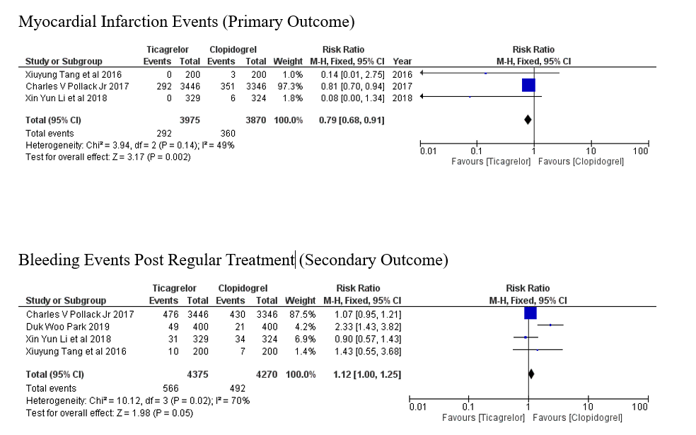
Figure 1. Forest plot of the association between comparison ticagrelor and clopidogrel to the events of myocardial infarcts and bleeding
THE PROGNOSTIC SIGNIFICANCE OF EXERCISE-INDUCED RIGHT BUNDLE BRANCH BLOCK: A SYSTEMATIC REVIEW

M. Q. A'yun¹, B. H. Kuncahyo¹

¹RSUD Ngudi Waluyo

Background:
Exercise-Induced Right Bundle Branch Block (EI-RBBB) during exercise stress test is an uncommon electrocardiographic finding with debatable clinical significance. Although information about EI-LBBB is available and written in the guidelines, fewer studies of EI-RBBB have been published. This paper aims to identify the prognostic relevance of EI-RBBB to determine the appropriate steps for better management.

Methods:
A systematic search in 3 databases, Pubmed, Scopus, and ScienceDirect using the keywords "Right Bundle Branch Block OR RBBB AND Exercise stress test AND prognostic OR clinical significance". A total of 457 articles meet the keywords. The inclusion criteria were: 1) study including normal sinus patients undergoing exercise stress test and there was data about EI-RBBB; 2) Publication between 2000-2024; 3) Fulltext in English.

Results:
Three studies were included. A total of 11.315 patients undergoing exercise stress test records were identified. Two studies were prospective with the observation period being 2-14.2 years. All of the studies have shown EI-RBBB correlated with all-cause mortality (OR 1.5 [CI, 1.1 to 1.9]; P < 0.017; HR 1.13 (95% confidence interval 0.51 to 2.5, p < 0.75); p < 0.021). One study has shown EI-RBBB was an independent risk for cardiovascular death HR 1.57 (95% confidence interval 0.51 to 4.8, p < 0.4). Patients with EI-RBBB also showed qualitatively and quantitatively lower EF (p < 0.001) and larger infarction and scar burden (p < 0.001) based on perfusion imaging.

Conclusion:
The number of studies that examined the clinical significance of EI-RBBB is still limited. The studies identified were diverse in design and the results were conflicting. This should be a focus for future research and determination in guidelines. Further evaluation may still be warranted depending on the clinical scenario to exclude coronary abnormality and assess ventricular function. Consider doing an echocardiogram, perfusion imaging, and/or angiography for better prognosis and management.

Keywords: exercise stress test, EI-RBBB, prognosis

Table 1. Baseline Characteristic Data

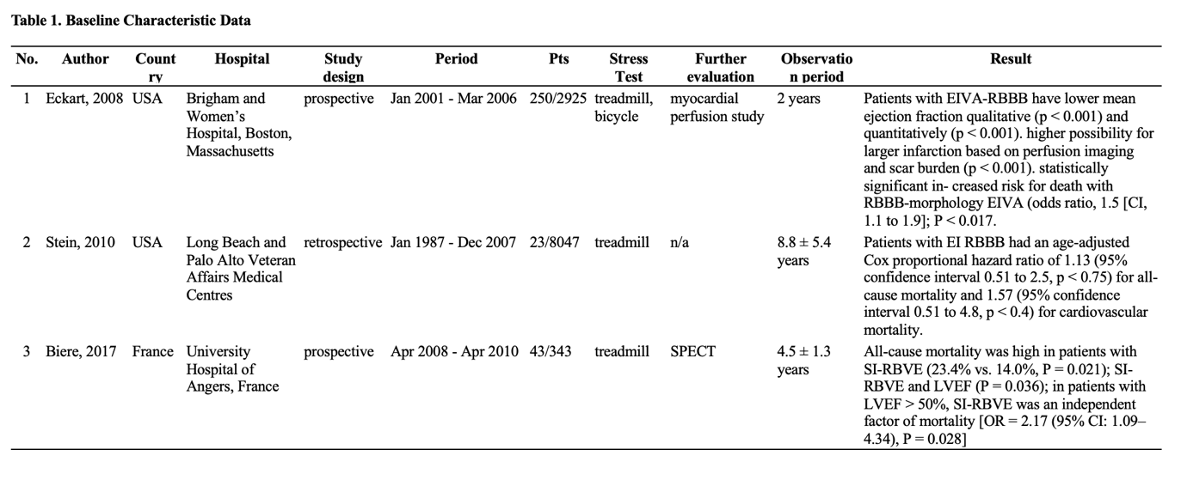
THE ASSOCIATION BETWEEN BIRTH WEIGHT AND INCIDENCE OF HEART FAILURE IN ADULTS: A SYSTEMATIC REVIEW AND META-ANALYSIS

A. R. Khairunnisa¹, W. Huang¹, M. I. Fathoni¹, S. A. R. Samban¹

¹Universitas Padjadjaran

Background:
A potential link between birth weight and thedevelopment of heart failure has been reported, however, the findings remain inconclusive. This study aims to evaluate the association between birthweight categories and the incidence of heart failure later in life.

Methods:
A systematic search was done on PubMed, Scopus, and Cochrane until June 2024 which included observational studies with adult population. We included studies reporting the association between birth weight categories and subsequent heart failure outcomes. Low, normal, and high birth weight categories were defined as weight at birth between 0.9 - 3.38 kg, 3.38 - 4.00 kg, and ≥ 4.00 kg, respectively. The primary outcome was the heart failure incidence calculated as pooled hazard ratio intervals using a generic inverse variance random effects model with a 95% CI. Statistical analysis was performed using RevMan version 5.4 software. Heterogeneity is assessed with I² and publication bias with funnel plot.

Results:
A total of four observational studies with 302,363 adult populations were followed for a mean of 20.7 years. There were 3,978 incidences of heart failure cases and 8.35% of the population also had hypertension as a risk factor for heart failure. In the pooled analysis of multivariate studies, individuals with low birth weight have a 26% higher risk of developing heart failure (HR 1.26, 95% CI [1.17, 1.36], I²= 2%, P < 0.00001) compared to those with normal birth weight. In contrast, no statistically significant association was observed between high birth weight and the incidence of heart failure (HR 1.13, 95% CI [0.99, 1.29], I² = 20%, P = 0.08) compared to normal birth weight. Sensitivity analysis after removing study with only male population also did not show statistically significant results (p > 0.05). No publication bias is found based on funnel plot assessment.

Conclusion:
Populations with low birth weight were associated with an increased risk of heart failure incidents later in life. Hence, it is important to determine a history of low birth weight in young adults and adults for the primary prevention of heart failure.

Keywords: risk factor, heart failure, birth weight

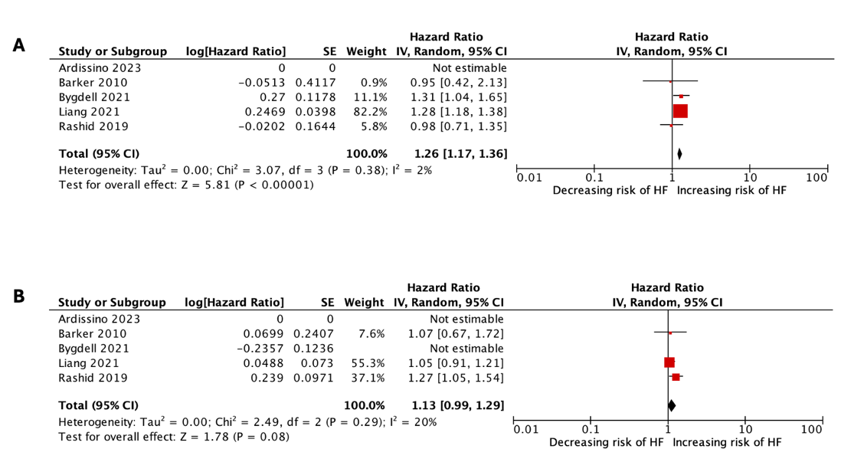
Figure 1. The forest plot for risk of heart failure in populations with (A) low birth weight and (B) high birth weight compared to normal birth weight. Individuals with low birth weight have a 26% higher risk of developing heart failure compared to those with normal birth weight.
DECONGESTION WITH ACETAZOLAMIDE AS AN ADDITION THERAPY FOR ACUTE DECOMPENSATED HEART FAILURE: SYSTEMATIC REVIEW AND META ANALYSIS OF RANDOMIZED CONTROLLED TRIALS

C. F. Jhoputri¹, R. Sutanto¹, R. Liauw¹, J. A. K. Subrata¹, E. Vinsky¹

¹University of Pelita Harapan

Background:
Patients with acute decompensated heart failure (ADHF) often face hospital discharge with residual congestion despite guideline-recommended high-dose loop diuretics (LD). Sequential diuretic therapy has proven more effective than LD alone. Acetazolamide, a carbonic anhydrase inhibitor, is infrequently used as monotherapy due to its limited diuretic effect but has potential to enhance LD efficacy and improve decongestion in combination. However, its efficacy and safety as adjunct therapy remain under-researched. This study aims to evaluate acetazolamide's efficacy and safety in ADHF patients.

Methods:
Studies were identified from PubMed, PMC, and ScienceDirect between July 10-12, 2024, using the MeSH keywords “acetazolamide” and “heart failure.” Five authors independently searched, extracted, and evaluated randomized controlled trials (RCTs) published in the past five years. Exclusion criteria included studies on patients under 18 years, animal studies, and articles with inaccessible full texts. The risk of bias was assessed using Cochrane RoB 2.0, and data analysis was performed with Cochrane Review Manager 5.4. Mean differences (MD) were calculated for numerical outcomes, and risk ratios (RR) for categorical outcomes.

Results:
Three RCTs involving 614 ADHF patients were included. The acetazolamide group exhibited higher rates of successful decongestion within three days post-randomization compared to the LD group (RR=1.36, 95% CI 1.09-1.71, p=0.007), defined by the absence of volume overload signs as assessed by a cardiologist. Additionally, there was a significant increase in natriuresis (MD=46.87, 95% CI=26.78-64.97, I²=75%, p<0.00001) favoring acetazolamide therapy. Combined therapy with acetazolamide-LD shows no significant difference in worsening renal function (WRF) incidence compared to LD alone (RR=1.72, 95% CI=0.89-3.35, p=0.11). Criteria of WRF varied between studies but generally included serum creatinine increase and estimated GFR decrease. All studies showed a low risk of bias.

Conclusion:
The addition of acetazolamide to loop diuretic therapy in ADHF patients significantly improved decongestion success rates and enhanced natriuretic effects without compromising renal function.

Keywords: heart failure, diuretic, decongestion, acetazolamide

NEUTROPHIL-TO-LYMPHOCYTE RATIO AS A NOVEL BIOMARKERS IN PREDICTING IN-STENT RESTENOSIS FOLLOWING CORONARY AND NON-CORONARY STENT IMPLANTATION: A SYSTEMATIC REVIEW AND META-ANALYSIS

P. P. Siahaan¹, W. Widiarti¹, P. B. T. Saputra², R. Y. Christianto¹, A. Gloria³, J. N. E. Putranto⁴

¹Faculty of Medicine, Universitas Airlangga, Surabaya, Indonesia
²Department of Cardiology and Vascular Medicine, Faculty of Medicine, Universitas Airlangga - Dr. Soetomo General Academic Hospital; Cardiovascular Research and Innovation Center, Universitas Airlangga
³Faculty of Medicine, Christian University of Indonesia, Jakarta, Indonesia
⁴Department of Cardiology and Vascular Medicine, Faculty of Medicine, Universitas Airlangga - Dr. Soetomo General Academic Hospital; Universitas Airlangga

Background:
The recurrence of stenosis due to atherosclerosis in stenting patients, known as in-stent restenosis (ISR), still harbors a massive disease burden. The inflammatory role of neutrophil and lymphocyte in atherosclerotic disease may show a great potential as a predictor. This meta-analysis were conducted to assess the capacity of NLR as predictor of ISR.

Methods:
Comprehensive literature searching was conducted in PubMed, Scopus, Science Direct, Proquest, Cochrane on 10th June 2024. Observational studies evaluating NLR in stented patients were included. Random effect meta-analysis and linear regression model were used to investigate odds ratios (OR) as predictor and linear dose-response relationship of ISR. Sensitivity and specificity of NLR to predict this outcome were pooled and a summary receiver operating characteristics (sROC) curve was generated.

Results:
There were 3889 patients from 15 studies pooled. This study found that high NLR was associated with increased risk of ISR in coronary stenting [aOR = 1.61 (95%CI 1.14-2.25)] and non-coronary stenting [aOR=1.69 (95%CI 1.52-1.87)]. One unit increase of NLR is equal to 30% and 44% increased risk of ISR in subsequently coronary and non-coronary patients. Ten pooled studies showing NLR as a robust predictor of ISR with sensitivity and specificity of 70.5% (95%CI 60.1%-79.2%) and 74.1% (95%CI 56.7%-86.2%) for coronary stenting and 77.7% (95%CI 69.8%-84.0%) and 66.4% (95%CI 49.6%-79.8%) non-coronary stenting, with AUC of 0.77 (0.70-0.82) in the coronary and 0.79 (0.70-0.85) in the non-coronary sub-groups. Given the time since stent placement, the NLR is generally more effective at predicting early ISR [AUC of 0.78 (0.53-0.94) for coronary and 0.83 (0.71-0.87) for non-coronary stenting] than late ISR [AUC of 0.73 (0.64-0.80) for coronary and 0.68 (0.49-0.85) for non-coronary stenting]

Conclusion:
NLR has a great potential to predict ISR in coronary and non-coronary stent, and during the early ISR rather then late ISR in both different stenting placement.

Keywords: In-Stent Restenosis, Prognostic, Neutrophil-Lymphocyte Ratio, Predictive

THE ROLE OF SUBCUTANEOUS FUROSEMIDE IN HEART FAILURE MANAGEMENT: A SYSTEMATIC REVIEW

W. Widiarti¹, P. B. T. Saputra², M. V. Ariyanto¹, C. G. Savitri², C. E. C. Z. Multazam³, J. N. E. Putranto², F. F. Alkaff⁴

¹Faculty of Medicine, Universitas Airlangga, Surabaya, Indonesia
²Department of Cardiology and Vascular Medicine, Faculty of Medicine, Universitas Airlangga - Dr. Soetomo General Academic Hospital; Cardiovascular Research and Innovation Center, Universitas Airlangga
³National Heart and Lung Institute, Imperial College London, London, United Kingdom
⁴Division of Nephrology, Department of Internal Medicine, University of Groningen, University Medical Center Groningen, Groningen, The Netherlands

Background:
Acute decompensated heart failure (ADHF) patients with symptomatic congestion often require in-hospital admission for intravenous (IV) diuretic, impacting both patient well-being and healthcare expenses. Subcutaneous (SC) furosemide has a potential to facilitate outpatient management of ADHF patients. Thus, this study aims to assess the efficacy and safety of SC furosemide utilization, offering a potential alternative to traditional IV administration.

Methods:
A systematic search was conducted until April 14 2024 across scientific databases. This review included studies comparing SC furosemide with oral and IV formulations in adult HF patients.

Results:
This study analyzed 687 patients from 20 studies. The results demonstrate that SC furosemide can effectively manage symptomatic congestion in HF patients and results in significant cost reductions, symptom relief, and improved quality of life. Although further investigation into mortality rates is needed, SC furosemide demonstrates efficacy comparable to IV furosemide in diuresis and weight loss, with similar bioavailability and natriuretic effects. Adverse events are generally minor, predominantly related to skin irritation. Innovative strategies, such as developing isotonic alkaline solutions and improved infusion devices, are being explored to address these challenges.

Conclusion:
SC furosemide offers a promising alternative for managing ADHF, particularly in symptomatic HF patients with volume overload. The integration of SC furosemide into routine clinical practice and future guidelines, could optimize the management of HF, reducing hospital admission and improving patient outcomes.

Keywords: diuretic, heart failure, subcutaneous furosemide, acute heart failure

PROGNOSTIC VALUE OF LATE GADOLINIUM ENHANCEMENT ON CARDIAC MAGNETIC RESONANCE IN PATIENTS WITH PERIPARTUM CARDIOMYOPATHY: A SYSTEMATIC REVIEW AND META-ANALYSIS

A. Nurhafizah¹, W. Huang¹, C. Kezia¹, M. I. Fathoni¹

¹Faculty of Medicine, University of Padjadjaran

Background:
Peripartum cardiomyopathy (PPCM) is a potentially life-threatening condition that occurs during the peripartum period. Late Gadolinium enhancement (LGE) by Cardiac Magnetic Resonance (CMR) can detect myocardial tissue damage specifically attributable to PPCM patients with worse prognosis associated with non-recovery. This review aims to explore the prognostic value of LGE by CMR in patients with PPCM.

Methods:
A systematic review was conducted from PubMed, Science Direct, and Cochrane Library databases to include studies that evaluate the association of LGE parameters with clinical outcomes in PPCM patients. Composite endpoints of poor outcomes (persistently reduced LVEF, left ventricular assisted device implantation, heart transplantation, and all-cause mortality) were calculated as pooled hazard ratios using a generic inverse variance random effect model. Heterogeneity and publication bias were assessed with I² and funnel plot respectively.

Results:
A total of 8 cohort studies, with a low to medium risk of bias, comprising 227 patients, were included. The mean age of patients was 32.4 years with the majority of patients were in NYHA class III. Diagnosis of PPCM was made during the postpartum period in 74.83% of patients. The prevalence of preeclampsia, gestational hypertension, and hypertension in the study population were 11.23%, 6.41%, and 18.71% respectively. The mean LVEF was 30.5% and the mean SBP was 108 mmHg. Compared to PPCM patients without LGE, PPCM patients with LGE were significantly associated with a 34% increased risk of poor outcomes (HR 1.34, CI 1.04–1.73, I² = 52%, p = 0.02). The risk of persistently reduced LVEF in patients with LGE was not significantly different (HR 1.11, CI 0.85–1.45, I² = 14%, p = 0.45) but LGE presence was significantly associated with composite outcome other than persistently reduced LVEF (HR 2.05, CI 1.04–4.02, I2 = 56%, p = 0.04). Exclusion of study with preeclamptic population >50% resulted in a non-significant association with poor outcomes (p = 0.05). No publication bias was found based on funnel plot assessment.

Conclusion:
In patients with peripartum cardiomyopathy, LGE presence in CMR imaging is significantly associated with poor outcome. Hence, long-term monitoring would be necessary to evaluate these patients.

Keywords: peripartum cardiomyopathy, late gadolinium enhancement, cardiac magnetic resonance

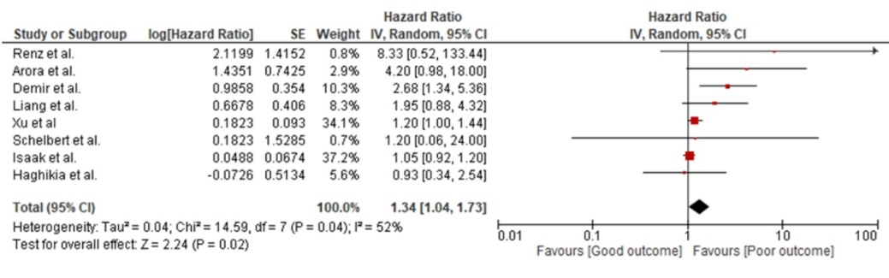
Figure 1. Forest plot of pooled hazard ratios of LGE presence and poor outcomes. The Presence of LGE was significantly associated with a 34% increased risk of poor outcomes
COMPARISON OF N-13 AMMONIA POSITRON EMISSION TOMOGRAPHY MEASURES FOR CHARACTERIZATION OF CORONARY ARTERY DISEASE: SYSTEMATIC REVIEW

E. N. Hailianto¹, T. C. E. Adeodatia¹, K. P. Sugiono¹, S. Valentina¹, A. Kurniawan²

¹Faculty of Medicine, Universitas Pelita Harapan, Tangerang, Indonesia
²Department of Internal Medicine, Faculty of Medicine, Universitas Pelita Harapan, Tangerang, Indonesia

Background:
Even though both epicardial atherosclerosis and microvascular disease are involved in coronary artery disease (CAD), the significance of assessing microvascular dysfunction hasn’t been adequately acknowledged in clinical practice. Therefore, there is a need for a simple and non-invasive method to evaluate microvascular dysfunction, which is the N-13 ammonia PET (Positron Emission Tomography) measurements. We aim to determine which PET measurements—coronary flow reserve (CFR), relative flow reserve (RFR), or myocardial blood flow (MBF)—acquired through myocardial perfusion PET best reflects the degree of microvascular dysfunction.

Methods:
Studies were extracted from ScienceDirect, PMC, and Pubmed using MesH terminology with “Myocardial flow reserve”, "Ammonia", and “Positron-Emission Tomography” keywords on 7 June 2024.This study involves more than 2 independent research investigators to reduce bias. Inclusion criteria were randomized controlled trials, clinical trials, cohorts, or observational studies with accessible full-text for the last 10 years. Patients included were clinically indicated for N-13 Ammonia PET without any history of myocardial infarction, previous revascularization, overt heart failures, and other structural heart diseases. Exclusion criteria were systematic reviews, meta-analyses, case reports, animal studies, and non-english texts. Correlation between PET measurements (CFR, RFR, MBF) and quantitative coronary angiography analysis—fractional flow reserve (FFR)—were used as the outcome of this study. The Newcastle-Ottawa Scale (NOS) was used to assess the quality of the studies.

Results:
A total of 3 retrospective cohort studies and 4 observational studies with 839 patients were included. All studies showed good quality based on NOS. Studies indicate that all PET measurements can assess microvascular dysfunction. However, an abnormal CFR does not necessarily indicate significant microvascular dysfunction, as CFR is an inclusive parameter that reflects epicardial stenosis, diffuse atherosclerosis, and microvascular function. Also, RFR is more specific to epicardial stenosis compared to MBF and CFR.

Conclusion:
CFR and RFR measured with N-13 ammonia PET can offer a thorough evaluation of CAD, considering both diffuse atherosclerosis and epicardial stenosis. Utilizing both parameters together through PET will aid in characterizing CAD and guiding suitable treatment options.

Keywords: Ammonia, Positron-Emission Tomography, Myocardial flow reserve

DIAGNOSTIC ACCURACY OF ARTIFICIAL INTELLIGENCE-POWERED ECHOCARDIOGRAPHY IN PRENATAL DETECTION OF CONGENITAL HEART DISEASE: A META-ANALYSIS

N. G. Dyson¹, E. Ferdinand¹, G. Krisandi¹

¹Faculty of Medicine, Universitas Indonesia

Background:
Congenital heart disease (CHD) is the most prevalent birth defect globally. Early prenatal screening with fetal echocardiography has the potential to lower the morbidity and mortality caused by CHD. However, the requirement for expertise in fetal cardiology and the high volume of screening cases limits the achievable detection rates. Consequently, there is a demand for automated prenatal screening to assist clinicians. Our objective is to determine the diagnostic accuracy of artificial intelligence (AI) for echocardiography analysis in the prenatal detection of CHD.

Methods:
Literature searching was conducted in 6 databases, including PubMed, Scopus, ScienceDirect, EBSCOHost, ProQuest, and Cochrane. Studies using AI or deep learning algorithms to facilitate echocardiography analysis for prenatal detection of CHD were included. The Newcastle Ottawa Scale for cross-sectional studies and retrospective cohort risk of bias assessment tool were used to assess the quality of each study. Quantitative analysis using Meta-DiSc with a random effects model was performed.

Results:
We included 10 studies involving 117,089 participants. Eight studies used deep learning algorithm, with an overall sensitivity of 0.92 (95% CI 0.91 to 0.92), specificity of 0.95 (95% CI 0.94 to 0.95), positive likelihood ratio of 15.39 (95% CI 8.72 to 27.17), negative likelihood ratio of 0.08 (95% CI 0.04 to 0.15), diagnostic odds ratio of 189.34 (95% CI 85.3 to 420.27), and area under the curve (AUC) of 0.977. Furthermore, the remaining two studies that utilized machine learning and fetal intelligent navigation echocardiography also exhibited high accuracy. Meanwhile, there are still some challenges to address, such as the variability in diagnostic tools used to train these AI systems and the diversity of CHD conditions included in research studies which requires further investigation.

Conclusion:
The use of artificial intelligence in echocardiography shows promise for accurately detecting congenital heart disease (CHD), which could significantly enhance healthcare accessibility, particularly in rural areas.

Keywords: deep learning, congenital heart disease, artificial intelligence, prenatal screening, echocardiography

THE EFFECTS OF CARDIAC REHABILITATION IN PATIENTS WITH ACUTE HEART FAILURE WITH PRESERVED VERSUS REDUCED EJECTION FRACTION: A SYSTEMATIC REVIEW AND META-ANALYSIS

A. A. Budiarto¹, L. Pramushinta¹

¹Muhammadiyah Lamongan Hospital

Background:
Acute heart failure is a rapid onset or worsening symptom of heart failure that is associated with high morbidity and mortality. This condition also causes physical limitations, so efforts are needed to improve good physical function one of them is physical exercise. Several studies state that physical exercise in HFpEF patients is safe and effective, however, this exercise can also be done in patients with HFrEF. This study aimed to assess the effect of physical exercise on the physical function of heart failure patients with preserved versus reduced ejection fraction.

Methods:
We performed a PubMed and the Cochrane Library search of randomized controlled trials of cardiac rehabilitation in patients with acute heart failure with preserved versus reduced ejection fraction. Studies were selected according to inclusion and exclusion criteria. The outcome was the Short Physical Performance Battery (SPPB) score. Data synthesis was performed with Review Manager 5.4.

Results:
2 studies that included 382 patients were available for the meta-analysis. The fixed-effects model was selected for the low heterogeneity (I²= 0%, P= 0.47). The meta-analysis showed a statistically significant improvement in short physical performance battery scores [mean difference = 0.87, 95% CI (0.34, 1.40), P = 0.001] for patients in the heart failure with reduced ejection fraction group compared with the heart failure with preserved ejection fraction group.

Conclusion:
This study shows that early cardiac rehabilitation in patients with ADHF provides an increase in physical function in both HFrEF and HFpEF patients, but the increase is more significant in HFrEF patients.

Keywords: HFrEF, HFpEF, Heart failure, cardiac rehabilitation

FROM THE ENVIRONMENT TO THE HEART: EMERGING CARDIOVASCULAR THREATS OF MICROPLASTICS AND NANOPLASTICS - A SYSTEMATIC REVIEW
S. S. Immanuel¹, G. Tandecxi², C. Cusan², V. Bandana¹, R. Tenggara¹

¹Department of Internal Medicine, Faculty of Medicine and Health Sciences, Atma Jaya Catholic University of Indonesia
²Faculty of Medicine and Health Sciences, Atma Jaya Catholic University of Indonesia

Background:
Microplastics (MPs) and nanoplastics (NPs) are pervasive environmental pollutants increasingly detected in human biological samples. Their potential impact on cardiovascular health is a growing concern. This systematic review is the first to evaluate the association between MPs/NPs exposure and cardiovascular diseases, highlighting the urgency of addressing this emerging threat.

Methods:
We conducted a comprehensive search in PubMed, ProQuest, SAGE, EBSCOHost, Wiley Online Library, and Google Scholar on June 15, 2024. Inclusion criteria encompassed cohort, case-control, and cross-sectional studies published in the past five years involving adults aged 18 and above, measuring MPs or NPs in biological samples, with reported associations to cardiovascular diseases. Exclusion criteria included studies involving only animal or in vitro data, non-original research articles, or unclear exposure assessment methods. Following the Preferred Reporting Items for Systematic Reviews and Meta-Analyses (PRISMA) guidelines, three reviewers independently extracted data and conducted quality assessments using the Newcastle-Ottawa Scale.

Results:
Four good-quality studies met the inclusion criteria, encompassing 360 patients. Study designs consecutively included one cohort study, two cross-sectional studies, and one case-control study. Marfella et al. (2024) found that patients with carotid plaques containing MPs and NPs had a significantly higher risk of myocardial infarction, stroke, and death (hazard ratio 4.53, 95% confidence interval 2.00-10.27), with polyethylene and polyvinyl chloride correlating with elevated inflammatory markers. Wang et al. (2024) detected MPs in 80% of thrombi in 30 patients undergoing thrombectomy, with higher MPs concentrations associated with elevated D-dimer levels and national institute of health stroke scores. Wu et al. (2022) observed MPs in 61.5% of thrombi in 26 patients with arterial dissection or acute arterial embolism, finding a positive association between MPs levels and blood platelet counts. Yan et al. (2023) reported that patients with vascular calcification had significantly higher levels of MPs in feces.

Conclusion:
MPs and NPs in human biological samples are associated with a higher risk of cardiovascular diseases. This review underscores the urgent need for further research to elucidate the mechanisms driving these associations and develop strategies for mitigating the impact of these pollutants on cardiovascular health.

Keywords: Environmental Pollutants, Risk Factors, Cardiovascular Diseases, Nanoplastics, Microplastics

EFFECTIVENESS OF AI-ENHANCED ELECTROCARDIOGRAPHY IN DETECTING LOW EJECTION FRACTION: A SYSTEMATIC REVIEW

A. Zahra¹

¹Faculty of Medicine UIN Syarif Hidayatullah Jakarta

Background:
Early and accurate detection of low ejection fraction (EF) is crucial in the management of patients with heart failure (HF). Traditional diagnostic methods, such as echocardiography, are effective but can be resource-intensive and time-consuming. Recent advances in artificial intelligence (AI) have introduced AI-enhanced electrocardiography (AI-ECG) as a promising tool for detecting low EF. This systematic review aims to evaluate the effectiveness of AI-ECG in detecting low ejection fraction compared to traditional diagnostic methods.

Methods:
We conducted a comprehensive search of PubMed, Cochrane Library, and ProQuest for studies published in a 5-year period up to July 2024. Studies were included if they evaluated the diagnostic performance of AI-ECG in detecting low EF in patients with suspected HF. Data were extracted on study design, population characteristics, AI model details, and diagnostic performance metrics (sensitivity, specificity, positive predictive value, negative predictive value). The quality of included studies was assessed using the QUADAS-2 tool.

Results:
Preliminary results indicate that AI-ECG demonstrates high sensitivity and specificity in detecting low EF, comparable to traditional echocardiography. Several studies reported that AI-ECG could serve as a rapid and cost-effective screening tool, potentially improving early diagnosis and management of HF.

Conclusion:
AI-ECG shows promise as an effective tool for detecting low ejection fraction, offering a feasible alternative to traditional methods. Further research is needed to validate these findings across diverse populations and clinical settings. The integration of AI-ECG into clinical practice could enhance early detection and improve outcomes for patients with HF.

Keywords: Diagnostic Accuracy, Heart Failure, Sensitivity, low EF, Artificial Intelligence

RED BLOOD CELL DISTRIBUTION WIDTH-TO-ALBUMIN RATIO AS NOVEL BIOMARKER PREDICTING MORTALITY IN CARDIOVASCULAR DISEASE: A SYSTEMATIC REVIEW AND DOSE-RESPONSE META-ANALYSIS

I. F. Arba¹, Y. H. Oktaviono², C. E. C. Z. Multazam³, W. Widiarti¹, P. P. Siahaan¹, P. B. T. Saputra², A. D. Lamara², J. N. Arnindita², D. Setyobudi¹

¹Faculty of Medicine, Universitas Airlangga
²Department of Cardiology and Vascular Medicine, Faculty of Medicine, Universitas Airlangga – Dr. Soetomo General Academic Hospital; Cardiovascular Research and Innovation Center
³National Heart and Lung Institute, Imperial College London

Background:
The red blood cell distribution width-to-albumin ratio (RAR) has emerged as a novel, cost-effective inflammatory biomarker. While numerous studies have explored the association between RAR and mortality in cardiovascular diseases (CVD), the overall strength and consistency of these findings remain unclear, necessitating a comprehensive meta-analysis. This study aims to synthesize existing evidence on the relationship between RAR and all-cause mortality across various CVDs.

Methods:
A systematic literature search was conducted in Scopus, Web of Science, PubMed, and ProQuest databases up to February 1, 2024. The Generic Inverse Variance method was used to pool mortality hazard ratios (HRs) comparing the highest and lowest RAR categories. Dose-response relationships were assessed using generalized least-squares regression. Publication bias was evaluated through funnel plot inspection and Egger's test. Subgroup analyses were performed based on specific CVDs. All statistical analyses were conducted using RStudio, with significance set at p < 0.05.

Results:
This meta-analysis included 15 high-quality studies published between 2021 and 2024, encompassing 21,676 participants with various CVDs including Acute Myocardial Infarction (AMI), Heart Failure (HF), Atrial Fibrillation (AF), aortic valvular disease, stroke, and pulmonary embolism. RAR values ranged from 0.80–1.20 ml/g in the lowest quartile to 6.09–15.45 ml/g in the highest quartile. Random-effects model analysis revealed that higher RAR was significantly associated with increased all-cause mortality risk (RR 2.78, 95%CI 2.12–3.65, p < 0.0001, I² = 91%). A non-linear dose-response relationship was observed, with every 1 ml/g increase above normal RAR levels corresponding to a 60% rise in mortality risk (RR 1.61, 95%CI 1.29–2.00). Subgroup analyses showed consistent associations across different CVDs (HF: RR 2.05, 95%CI 1.14–3.70, I² = 98.2%; Other CVDs: RR 3.08, 95%CI 1.33–7.16, I² = 83.0%; AMI: RR 4.08, 95%CI 3.04–5.47, I² = 32.0%; Stroke: RR 2.06, 95%CI 0.49–8.70, I² = 46.6%).

Conclusion:
This is the first meta-analysis demonstrating a robust positive dose-response relationship between RAR and all-cause mortality in CVD patients. These findings suggest that RAR could serve as a valuable and accessible prognostic biomarker in cardiovascular medicine.

Keywords: dose-response meta-analysis, biomarker, red blood cell distribution width-to-albumin ratio, mortality, cardiovascular disease
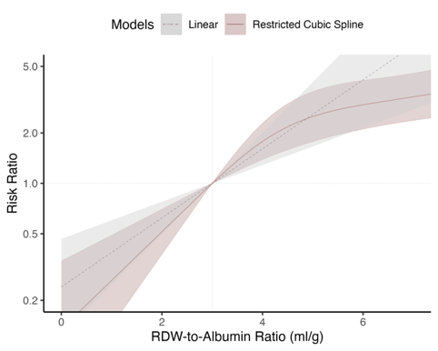
Figure 1. Dose-response curves showing the association between RAR values and pooled HR for overall ACM. The linear model is shown by the grey dashed line, and the RCS model (with knots at the 10th, 50th, and 90th percentiles) by the red solid line. Shaded areas represent the 95% CIs.
THE RISK OF VENOUS THROMBOEMBOLISM IN WOMEN WITH SUPERFICIAL VENOUS THROMBOSIS WHO USE COMBINED HORMONAL CONTRACEPTIVES: A SYSTEMATIC REVIEW AND META-ANALYSIS

S. S. Syahruddin¹, W. Huang¹, L. M. Anabela¹, S. A. R. Samban¹

¹Faculty of Medicine, University of Padjadjaran

Background:
Combined hormonal contraceptives (CHCs) are associated with an increasing risk of thrombosis. Hence, it is crucial to understand the risk of CHCs use on the incidence of venous thromboembolism (VTE) in women with superficial venous thrombosis (SVT) to improve patient safety. There is currently a limited quality of evidence regarding their association, thus we conducted a study to investigate the associated risk.

Methods:
Three databases (PubMed, Scopus, Cochrane Library) are searched and screened based on prespecified inclusion and exclusion criteria. A meta-analysis was conducted to evaluate the effect of CHCs towards the incidence of VTE in women with SVT. CHCs include oral, patch, vaginal ring, and injectable contraceptives. Data are analyzed using random effects model of pooled ORs with Mantel Haenszel method and publication bias assessed with funnel plot.

Results:
Ninestudies (7 longitudinal studies, 1 RCT, and 1 cross-sectional) with 3984 cases from five countries are identified. The combined OR was 0.85 (CI [0.58, 1.23] P = 0.38, I² = 0%), suggesting a non-significant odd of VTE incidence with CHCs compared to control. Leave one out sensitivity analysis did not find any changes in statistical significance and heterogeneity level. Meta-analysis of only longitudinal and RCT also did not show a statistically significant odd (OR 0.84, CI [0.57, 1.23] P = 0.37, I² = 0%). Additionally, after addressing potential confounders of prior history of VTE, cancer, and history of immobilization, there is a non-statistically significant increase odds of VTE incidence in SVT patients with CHCs use (OR 1.43, CI [0.43, 4.68] P = 0.56, I² = 0%). No publication bias is detected with funnel plot analysis.

Conclusion:
The meta-analysis did not find a statistically significant association between the use of CHCs and the development of VTE in women with SVT. Further research with higher-quality evidence is needed to conclusively determine the risk of VTE in this population.

Keywords: combined hormonal contraceptives, superficial venous thrombosis, venous thromboembolism

EFFICACY AND SAFETY OF TRANSCATHETER EDGE-TO-EDGE REPAIR FOR MITRAL REGURGITATION: A SYSTEMATIC REVIEW

K. J. A. Santoso¹, J. M. Prawira¹, M. Z. Sabran¹, V. A. Damay², A. Kurniawan³

¹Faculty of Medicine, Pelita Harapan University
²Department of Cardiovascular, Siloam Hospital Lippo Village, Pelita Harapan University
³Department of Internal Medicine, Siloam Hospital Lippo Village, Pelita Harapan University

Background:
Mitral regurgitation (MR) is a prevalent valvular heart disease associated with significant increase of morbidity and mortality. Transcatheter edge-to-edge repair (TEER) has emerged as a minimally invasive alternative to surgical repair for high-risk patients. This systematic review aims to evaluate the clinical efficacy and safety of TEER in patients with MR.

Methods:
A comprehensive literature search of PubMed, ScienceDirect, and NEJM was conducted up to June 7, 2024, by two independent investigators. Studies reporting clinical outcomes of TEER for MR, including randomized controlled trials (RCTs) and cohort studies, were included. Data were extracted and analyzed, and the Risk of Bias 2.0 (ROB 2.0) tool was used to assess the risk of bias.

Results:
This review included four RCTs and one cohort study, encompassing a total of 1,937 patients. Of the 19 studies assessed, 14 were excluded due to data overlap. The included studies demonstrated significant improvements in MR patients undergoing TEER, including reduced rates of heart failure hospitalizations and decreased mortality. One study reported non-significant improvements, attributed to differing baseline characteristics. All studies confirmed that TEER is a safe procedure, with a low risk of bias assessed via the ROB 2.0 tool.

Conclusion:
TEER appears to be an effective and safe procedure for treating MR. However, further research is warranted to corroborate these findings and optimize patient outcomes.

Keywords: Mitral Valve Insufficiency, Transcatheter Edge-to-Edge Repair, Minimally Invasive Surgical Procedures, Mitral Valve Annuloplasty

CORONARY ARTERY CALCIUM SCORE AND STATIN TREATMENT EFFECT ON MYOCARDIAL INFARCTION AND MAJOR ADVERSE CARDIOVASCULAR EVENT OF ATHEROSCLEROTIC CARDIOVASCULAR DISEASE: A SYSTEMATIC REVIEW AND META-ANALYSIS

I. F. Basyir¹, Y. Pintaningrum¹

¹Mataram University

Background:
Coronary artery calcium (CAC) scores plays an important role to improve prognostic accuracy and can be selectively use to guide allocation of statin therapy for atherosclerotic cardiovascular disease outcomes and potentially associated with the occurrence of MACE (Major Adverse Cardiovascular Event) and MI (Myocardial Infarction). This systematic review and meta-analysis aim to analyzed findings of study about CAC Score and statin treatment effect on MI and MACE risk.

Methods:
Search for published scientific articles using the PRISMA (Preferred Reporting, Items for Systematic Reviews and Meta-Analysis) method conducted on PubMed, Cochrane Library, and Medline databases published in the last 20 years on “coronary artery calcium” AND “statin” AND “cardiovascular disease” Further systematic review and meta-analysis using RevMan version 5.4 were performed based on the included published scientific articles

Results:
Based on 11 studies included with total of 1055 participants, we performed meta-analysis and found out that individual with CAC score > 0 increase risk ratio of MI 8.48 (RR = 9.48: 95% CI: 6.22 – 14.45) times and MACE 2.48 (RR = 3.48: 95% CI: 2.98 – 4.05) times higher than CAC score 0 individual. Statin compared against non-statin treatment shown statistically insignificant overall effect on risk of MI (P = 0.81) and MACE (P = 0.89) in individual with elevated CAC score 1 – 100 (P = 0.65) and > 100 (P = 0.11)

Conclusion:
This study found that elevated CAC score individual has higher risk of MI and MACE than non-elevated CAC score individual. There is no significant effect of statin compared against non-statin treatment to reduce MI and MACE in elevated CAC score individual of 1 – 100 or > 100.

Keywords: statin, cardiovascular disease, coronary artery calcium

AN UPDATED META-ANALYSIS OF SELF-ADMINISTERED INTRANASAL ETRIPAMIL FOR SUPRAVENTRICULAR TACHYCARDIA (SVT): A POTENTIAL GAME-CHANGER FOR SVT TREATMENT

S. Zahrani¹, R. R. Eri²

¹Universitas Indonesia
²Abdi Waluyo Hospital

Background:
No self-administered nonparenteral drug is currently available for rapid termination of supraventricular tachycardia (SVT). Etripamil, a novel fast acting intranasally administered non-dihydropyridine L-type calcium channel blocker, may fill this gap. Recently, the results of the phase-3 clinical trial for Etripamil (NODE-303) had been released.

Methods:
We searched 4 databases including PMC, PubMed, SCOPUS, and Cochrane library through to 14 June 2024 using keywords “etripamil” and “supraventricular tachycardia”. The inclusion criteria were studies studying the rate of conversion of SVT to sinus rhythm in patients with a history of paroxysmal SVT (PSVT) intervened with self-administered Etripamil compared to placebo. Selected studies were then to be assessed for risk of bias using the GRADE approach. Both the study selection process and quality assessment were conducted by two different reviewers and any disagreement was to be resolved through discussion. The meta analysis for this study was performed through Cochrane Review Manager version 5.4.

Results:
4 studies were included for the final review and 2 studies were further meta-analyzed. The mean median time to conversion was 18.7 min (+- 4.3 min) with mean conversion rate of 59.8% at 30 minutes. Self-administered Etripamil was superior to placebo for PSVT conversion to sinus rhythm at 30 min with a risk ratio of 1.78 (CI 1.37-2.30) (Figure 1) The time to conversion rate of Etripamil is higher than the current self-administered pill-in-the pocket strategy including oral beta-blockers and calcium channel blockers (18.7 min vs 30 min). Intranasal administration may improve bioavailability and avoid first-pass metabolism, degradation via gastrointestinal route, hence promoting faster onset of action. This drug also has a longer half life compared to adenosine (20 minutes vs 10-30 seconds), promoting prevention of recurrent PSVT.

Conclusion:
Self administered intranasal calcium channel blocker is effective for rapid termination of PSVT persistent after vagal maneuver and may serve as a promising alternative to self-administered oral pill approach, reducing the need for hospital admission.

Keywords: Etripamil, Intranasal calcium channel blocker, self-administered, supraventricular tachycardia

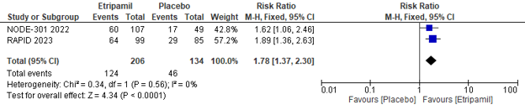
Figure 1. Forest plot of self-administered etripamil conversion to sinus rhythm at 30 minutes
PLATELET-TO-LYMPHOCYTE RATIO AS A PREDICTOR OF CARDIOVASCULAR EVENTS: A SYSTEMATIC REVIEW

A. Rachman¹, M. M. Robot¹, B. Widyantoro¹

¹Department of Cardiology and Vascular Medicine, Faculty of Medicine, Universitas Indonesia / National Cardiovascular Center Harapan Kita, Jakarta, Indonesia

Background:
The platelet-to-lymphocyte ratio (PLR) has emerged as a potential biomarker for predicting cardiovascular events due to its reflection of both thrombosis and inflammation. This systematic review aims to evaluate the evidence regarding the predictive value of PLR in various cardiovascular conditions.

Methods:
We conducted a comprehensive search of electronic database from PubMed, Embase, and Cochrane Library from June to July 2024. Studies were included if they evaluated the association between PLR and cardiovascular events such as myocardial infarction, stroke, and heart failure. The primary outcome was the incidence of cardiovascular events.

Results:
A total of 8 studies met the inclusion criteria, encompassing 3372 patients with diverse cardiovascular conditions from a population of cardiovascular events or at risk of cardiovascular disease without any other infectious or autoimmune disease. All publications reported that a higher PLR is a significant predictor of cardiovascular events, as evidenced by the results of statistical tests in each study, which revealed that the p-value was less than 0.05, or the OR value, and the lower and higher bounds. The 95 percent confidence interval (CI) value was greater than 1. The systematic review revealed that higher PLR was significantly associated with an increased risk of myocardial infarction, stroke, and heart failure. It also indicated that the predictive value of PLR was consistent across different populations and clinical settings.

Conclusion:
This systematic review provides strong evidence that a higher PLR is a significant predictor of cardiovascular events. PLR is a readily available and cost-effective biomarker that could be integrated into clinical practice for risk stratification in patients at risk for cardiovascular events. Further prospective studies are warranted to validate these findings and explore the mechanisms underlying the association between PLR and cardiovascular risk.

Keywords: Platelet Lymphocyte Ratio, Cardiovascular Event

IMPACT OF ANTICOAGULANT THERAPY ON CEREBROVASCULAR EVENTS AND IN-HOSPITAL MORTALITY IN LEFT-SIDED INFECTIVE ENDOCARDITIS WITH NATIVE AND PROSTHETIC VALVES: A SYSTEMATIC REVIEW AND META-ANALYSIS

K. A. C. Dewi¹, S. P. Sanjaya¹

¹Udayana University

Background:
Anticoagulant therapy (ACT) in infective endocarditis (IE) has been a controversial issue, as it poses a significant risk of bleeding while also being crucial for preventing thromboembolic events due to mobile vegetations on heart valves. Existing guidelines suggest considering ACT case by case basis with pre-existing indications. This study aims to investigate cerebrovascular events (CVE) and in-hospital mortality in patients with left-sided IE, comparing those with ACT during their treatment course to those without.

Methods:
A systematic literature search according to PRISMA guideline was conducted using four databases (PubMed, ScienceDirect, ProQuest, and Wiley’s Library) for relevant studies. Primary outcome is reported CVE including cerebral hemorrhagic stroke, cerebral ischemic stroke, cerebral infection, and brain infarct. Secondary outcome is in-hospital mortality. All eligible studies were quality assessed using New-Castle Ottawa Scale (NOS). Meta-analysis was done using the Review Manager version 5.4.

Results:
We included five cohort studies involving a total of 1,204 patients with a mean age of 58.5 years in our analysis. All studies met high-quality assessment, with the majority utilizing in-hospital data. Native valve endocarditis (NVE) accounted for 86.5% of cases, predominantly affecting the mitral valves (56%). In our primary outcome, patients with left-sided IE who were treated with anticoagulants showed significantly lower rates of CVE compared to those without anticoagulants (OR: 0.51; 95% CI: 0.35-0.75; p = 0.0006, I² = 49%, p-heterogeneity = 0.10). There was no significant difference in in-hospital mortality between patients with anticoagulants and those without (OR: 0.95; 95% CI: 0.58-1.56; p = 0.84, I² = 15%, p-heterogeneity = 0.32).

Conclusion:
ACT was associated with lower frequency of CVE in left sided-IE patients involving native or prosthetic valves. Additionally, ACT was not associated with increased in-hospital mortality. These findings indicate that ACT could potentially benefit in lowering CVE in left-sided IE patients without impacting short-term mortality rates. Thus provide a reasonable approach for physicians in weighing benefits and risks of ACT in left-sided IE carefully. Further research is needed to confirm these findings and investigate long-term outcomes.

Keywords: Cerebrovascular Event, Anticoagulant, Infective Endocarditis, In-Hospital Mortality

CANGRELOR IN PRIMARY PCI: IMPACT ON PLATELET INHIBITION, INFLAMMATORY RESPONSE, AND MYOCARDIAL PROTECTION IN STEMI PATIENTS

A. W. P. Perdana¹, E. Vinsky¹, A. M. Nayotama¹, E. Phielibert¹, E. W. Otto¹, W. S. Atmaja¹, V. A. Damay¹

¹Faculty of Medicine, University of Pelita Harapan

Background:
ST elevation myocardial infarction (STEMI) is a critical medical emergency requiring prompt intervention to prevent severe complications or death. Achieving a door-to-balloon time (D2BT) within ninety minutes is essential. Rapid administration of antiplatelet agents ensures effective platelet inhibition, preventing clot formation during and after percutaneous coronary intervention (PCI). Dual antiplatelet therapy (DAPT), typically using aspirin and a P2Y12 inhibitor, is the standard adjunct therapy for PCI. This systematic review evaluates the efficacy of cangrelor, a reversible P2Y12 inhibitor, in platelet inhibition and its effects when compared with or combined with other antiplatelet agents.

Methods:
Studies were sourced from PubMed, PMC, ScienceDirect, and SpringerLink using the MeSH keywords “Cangrelor” and “Ticagrelor” on June 8, 2024. Inclusion criteria comprised randomized controlled trials (RCTs) within the past five years involving cangrelor interventions. Exclusion criteria included incomplete outcome reporting, non-English studies, and irretrievable full-text articles. The quality of the included studies was assessed using the Newcastle-Ottawa Scale (NOS).

Results:
Four RCTs involving 264 patients were included. Two studies found that combining cangrelor with ticagrelor showed no drug-drug interaction (DDI) and enhanced platelet inhibition within ten minutes. This combination significantly reduced peripheral blood inflammatory markers, suggesting reduced cardiac damage. One study demonstrated that cangrelor provided early and potent P2Y12 inhibition at the time of the first balloon inflation compared to ticagrelor alone, although no significant differences were observed in myocardial microvascular function and infarct size. Another study found tirofiban more effective than cangrelor in inhibiting platelet aggregation, although both were superior to prasugrel. This may be due to tirofiban's different mechanism of action as a glycoprotein IIb/IIIa inhibitor, providing more consistent inhibition.All studies were of high quality.

Conclusion:
Cangrelor has proven to be a safe and effective option for rapidly enhancing platelet inhibition and reducing inflammatory markers, suggesting potential cardiac protection. Cangrelor can still mitigate the risks of acute ischemic complications during primary PCI. Further studies with larger sample sizes are needed to confirm these findings.

Keywords: Cangrelor, Ticagrelor, Antiplatelet Agents

EFFECT OF SGLT-2 INHIBITORS ON WEIGHT LOSS IN HFREF AND HFPEF PATIENTS: META-ANALYSIS OF 14 THOUSAND PARTICIPANTS

A. F. Sunjaya¹, A. P. Sunjaya²

¹University College London
²University of New South Wales

Background:
Obesity, an important predictor of cardiovascular morbidity and mortality, is often present in patients suffering from heart failure. Sodium glucose co-transporter (SGLT-2) inhibitors, a new mainstay drug for heart failure, have been shown in previous studies to be effective in lowering body weight, regardless of diabetic status and comorbidities. This study aims to evaluate the impact of SGLT-2 inhibitors on weight loss based on heart failure subgroups.

Methods:
A literature search of four databases was conducted: Pubmed, Embase, the Cochrane Library, and Scopus. Eligible RCTs concerning SGLT-2 inhibitors in HFpEF and HFrEF patients was included from January 2020 up to December 2022. Difference in weight from baseline (in kilograms) was the main outcome measure.

Results:
Eight RCTs were included in the meta-analysis totalling 14646 participants - 6312 with HFpEF and 8658 patients with HFrEF. Study duration ranged from 6 weeks to 26 months. Mean age of patients included were 71 years old and 66 years old for HFpEF and HFrEF participants respectively with baseline BMI of 30 (Obese category) and 27.92 (Overweight category) among HFpEF and HFrEF participants. In HFpEF patients, adminstration of SGLT-2 inhibitors was associated with non significant weight changes (Mean Difference -1.10 95%CI -1.61 to - 0.60, p=0.14). Similar results were obtained in HFrEF patients (Mean Difference -1.00 95%CI -1.47 to - 0.52, p=0.30).

Conclusion:
SGLT-2 confers minimal weight loss benefits in patients with HFrEF and HFpEF. Further studies are required which should include more female participants and other SGLT-2 drugs such as canagliflozin. Physicians should consider adjunctive pharmaco and non-pharmacotherapy options to support achievement of weight loss in patients with HFpEF and HFrEF which can improve their clinical outcomes.

Keywords: Weight loss, Heart failure, Obesity, SGLT2 inhibitors

URIC ACID/ALBUMIN RATIO AS A NOVEL BIOMARKER FOR PREDICTING POOR CORONARY COLLATERAL CIRCULATION IN CORONARY ARTERY DISEASE: META-ANALYSIS STUDY

F. Farabi¹, M. N. Afifa²

¹Faculty of Medicine, Universitas Padjadjaran
²Faculty of Medicine, Universitas Indonesia

Background:
Coronary collateral circulation (CCC) forms when there is severe ischemia in coronary blood vessels. Poor CCC is associated with increased incidence of myocardial infarct and long-term major cardiac adverse events. Uric acid to albumin ratio (UAR) has recently been discovered as a novel biomarker associated with cardiovascular disease. This study aims to determine the relationship between UAR and CCC formation in coronary artery disease patients.

Methods:
Literature search was conducted on all articles published up to July 2024 in Google Scholar, PubMed, ProQuest, ScienceDirect, and Springer Link. Literature that was selected was those that discussed the relationship between UAR and coronary collateral circulation. A meta-analysis was conducted to assess the overall standardized mean difference (SMD) in UAR to assess its effect on CCC formation in coronary artery disease.

Results:
A total of 4 articles were included in this study after a systematic search that discuss the relationship between UAR and coronary collateral circulation (CCC) with a total of 543 patients. The meta-analysis results showed higher UAR was associated with poor CCC (SMD = 0.71, 95% CI = 0.12 - 1.31, p = 0.02).

Conclusion:
UAR is a novel biomarker that can simply be used in predicting the poor CCC formation. Therefore, UAR score may also be considered as one of the biomarkers for assessing severity, predicting major cardiac adverse events, and predicting mortality in patients with coronary artery disease.

Keywords: coronary collateral circulation, coronary artery disease, albumin, uric acid, ischemic

PERCUTANEOUS REPAIR IN SINUS VENOSUS ATRIAL SEPTAL DEFECT: A SYSTEMATIC REVIEW

N. Sukmadi¹, C. J. Cool¹, A. F. Khalid¹

¹Universitas Padjadjaran

Background:
Sinus venosus atrial septal defect (SVASD), is one of the rare types of atrial septal defect (ASD). This condition commonly associated with partial anomalous pulmonary venous connection (APVC) of the right upper pulmonary vein (RUPV). Traditionally, surgical repair with numerous techniques were performed to close the ASD and redirect the APVC, unfortunately these procedures were known to have some complications, such as sinus node dysfunction (SND), residual shunt, and SVC or pulmonary venous stenosis. Recent techniques have been developed to repair SVASD percutaneously using covered stent. However, the data regarding the technique, safety, and efficacy were scarce.

Methods:
This systematic review was according to Preferred Reporting Items for Systematic Review and Meta-Analysis (PRISMA). In this review, an English written Randomized Controlled Trial (RCT), prospective and retrospective cohort studies, case-control, or nested-case control studies, and cross-sectional studies, are included. We searched online from PubMed, EBSCOHost, ProQuest, and manual searching with search terms of “Percutaneous Repair”, and “Sinus Venosus Atrial Septal Defect”. This Systematic review registered in PROSPERO CRD 42023470929

Results:
A total of 295 studies were identified and after screening process only 7 studies with total of 403 patients were eligible to be included. Cardiac Computed Tomography (CT) or magnetic resonance imaging (MRI), and with printed/virtual 3-dimensional models was used for cross-sectional imaging. Stent implantation techniques varied, generally involving venous access points and balloon occlusion testing to evaluate potential pulmonary vein obstructions. All studies used 10-zig covered Cheatham Platinum (CP) stents, with variations in length and additional stents for anchoring in some cases. Major complications such as stent embolization and pericardial effusion were reported in few cases but resolved without long-term issues. Hospital stays were shorter for percutaneous group in one study. Follow-up periods ranged from 1 months to 5.1 years, showing significant reductions in right ventricular dimensions and flow ratios, few patients with minimal residual shunts, and no late complications like sinus node dysfunction.

Conclusion:
Percutaneous repair in SVASD patients is rapidly growing. Percutaneous repair is feasible with good outcome and safety. Larger study with having control surgical group is needed to establish the better choice of the two.

Keywords: Sinus Venosus Atrial Septal Defect, Percutaneous Closure

ELECTROCARDIOGRAPHIC CHARACTERISTICS OF LEFT VENTRICULAR REVERSE REMODELING: SYSTEMATIC REVIEW AND META-ANALYSIS

A. R. Kusumowardani¹, N. L. Yudhisthira¹

¹Universitas Airlangga

Background:
Left ventricular reverse remodelling (LVRR) is associated with the improvement of systolic and diastolic function, leading to better outcomes in patients with heart failure. LVRR had been targeted as the goal of heart failure treatments. However not all patients achieve this result, therefore prediction of successful LVRR is important. The electrocardiogram (ECG) is an accessible and inexpensive tool that can provide valuable insights into myocardial structural and functional changes. This review aims to identify the ability of baseline ECG to predict LVRR in heart failure patients.

Methods:
The search for relevant studies was conducted through Medline, Scopus, and Google Scholar databases. Studies reporting baseline ECG parameters before cardiac resynchronization therapy were included. The outcome of interest was LVRR. The comparison of baseline ECG parameters between groups with and without LVRR was performed. The review was conducted in accordance to the PRISMA guidelines. Meta-analysis was conducted with Review Manager.

Results:
Eighteen studies were included in the final review. ECG parameters to be examined were the presence of left bundle branch block (LBBB) morphology, QRS duration, PR interval, and QTc duration. The analysis showed the relationship between LBBB morphology and LVRR (MD 3.25, 95% CI 2.55 to 4.15, p<0.0001), indicating higher probability of LVRR in patients with LBBB. In contrast, baseline QRS duration did not demonstrate any predictive tendency and was not associated with the likelihood of LVRR (MD 0.02, 95% CI -2.01 to 2.05, p=0.98). Receiver operating curve of QRS duration yields low sensitivity to predict LVRR (AUC 0.653, 95% CI 0.461 to 0.844, cut-off value 163.95, sensitivity 0.556, specificity 0.899). The result of PR interval (MD -2.43, 95% CI -12.52 to 7.67, p=0.64) and QTc duration (MD 4.95, 95% CI -11.14 to 21.04, p=0.55) between two groups did not show significant difference, suggesting that these parameters are not reliable indicators of LVRR.

Conclusion:
The presence of LBBB morphology is associated with LVRR, while other ECG parameters did not show reliable correlation with LVRR. These findings suggests that LBBB morphology may serve as a predictor of LVRR compared to other parameters.

Keywords: cardiac resynchronization therapy, left ventricular reverse remodelling, predictor, electrocardiogram

FOCUSING ON HYPOTENSION IN ARNI VS ACE-I; A SYSTEMATIC REVIEW

F. G. Anggreini¹

¹RSUD Cibabat

Background:
ARNi and ACE Inhibitor are two classes of medications used primarily in the treatment of heart failure. For now, ARNi is the first drug of Class 1B recommendation in the management of HFrEF. Hypotension is the most frequent reason for treatment discontinuation or up-titration failure. Patients with heart failure often present with low blood pressure and because this is associated with poor outcomes and physicians are concerned about hypotension.

Methods:
A systematic review was conducted using the Pubmed and Science Direct databases published between 2015-2024. Our inclusion criteria were; compared treatment between ARNi and ACE Inhibitor; clinical trials, case report and observational studies. The methode of selection and analysis of article followed the PRISMA.

Results:
We found 183 databases from search engine and after screened all the databeses we got four titles that meet our criteria. Some study said in PARADIGM-HF, symptomatic hypotension occured more frequently with ARNi group than with ACE-I, although this did not lead to a difference in discontinuation between the treatment. Report by Yunlin et al shows even low dose of ARNi was effective and safe in hemodialysis patient with decompensated heart failure and hypotension.

Conclusion:
Both ARNi and ACE Inhibitor are effective in managing heart failure but have different profiles regarding the risk of hypotension. ARNi tends to cause more significant hypotension, which needs careful monitoring and management. The choice between these medications should consider individual patient tolerance, blood pressure levels and spesific clinical indications.

Keywords: ACE Inhibitor, ARNi, hypotension

EFFICACY AND SAFETY OF DAPAGLIFLOZIN IN HEART FAILURE WITH MILDLY REDUCED EJECTION FRACTION: A SYSTEMATIC REVIEW OF RANDOMIZED CONTROLLED TRIAL

H. D. Ardiyani¹, F. M. Supriana¹

¹Faculty of Medicine, Pasundan University

Background:
The prevalence of heart failure with mildly reduced ejection fraction (HFmrEF) increases with age but it remains underrepresented. The treatment of HFmrEF is generally similar to heart failure with preserved ejection fraction (HFpEF). Dapagliflozin, an SGLT-2 inhibitor, comes across as the new treatment option for HFmrEF. This systematic review aims to evaluate the efficacy and safety of dapagliflozin for the treatment of HFmrEF.

Methods:
A systematic search was conducted through databases such as PubMed, GoogleScholar, and ScienceDirect based on the PRISMA guidelines. Specific keywords such as “heart failure” AND “dapagliflozin”, “mildly reduced ejection fraction” AND “dapagliflozin” were used. Inclusion and exclusion criteria were applied to the screening process.

Results:
Two studies met the inclusion and exclusion criteria and data were extracted. Both RCTs showed a significant reduction in cardiovascular events and hospitalizations with dapagliflozin compared to placebo. Differences in age-specific responses, including adverse events (AEs) and serious adverse events (SAEs) were observed, with younger patients showing greater therapeutic advantages. The Cochrane Risk of Bias (ROB-2) tool was used to assess the risk of bias in each study.

Conclusion:
Dapagliflozin reduced the risk of both primary and secondary outcomes, including worsening heart failure events or cardiovascular death across all age patients. Although AEs and SAEs increased with age, all predetermined safety outcomes were consistent for patients in all age categories.

Keywords: HFmrEF, SGLT-2 inhibitor, dapagliflozin, heart failure, heart failure with mildly reduced ejection fraction

COMPARING THE EFFICACY AND SAFETY OF LEFT BUNDLE BRANCH PACING VS HIS-BUNDLE PACING VS BIVENTRICULAR PACING SYSTEM IN HEART FAILURE PATIENTS THROUGH A SYSTEMATIC REVIEW AND NETWORK META-ANALYSIS OF 3,544 PATIENTS’ CLINICAL OUTCOMES

N. J. Tjipta¹, D. D. C. H. Rampengan², M. V. Ariyanto³, K. G. P. Anugraha³, S. C. Surya⁴

¹Medical Programme, Faculty of Medicine, Universitas Airlangga, Surabaya, Indonesia
²Medical Doctor Programme, Faculty of Medicine, Universitas Sam Ratulangi
³Medical Doctor Programme, Faculty of Medicine, Universitas Airlangga
⁴Medical Doctor Programme, Faculty of Medicine, Universitas Udayana

Background:
Newer methods of pacing in the alarming world of heart failure patients have emerged, including left bundle branch pacing (LBPP) and His-bundle pacing (HBP). These novel physiological pacing approaches are said to outshine the formerly conventional pacing, biventricular pacing (BVP), in terms of procedure efficacy and follow-up. Moreover, LBBP and HBP are also associated with lower long-term risk of device-related complications. Although several studies have revealed this superiority, minimal comparisons have been made between all three methods. Thus, this study aims to unveil the safety and efficacy of all three methods compared.

Methods:
We conducted a systematic literature search using the PRISMA NMA Checklist of Items through six databases. The further network meta-analysis was done by using RStudio. Surface under cumulative ranking curve (SUCRA) was done as well as subgroup and meta-regression analysis.

Results:
From the meta-analysis, we found that HBP and LBBP both have unique superiority in terms of safety and efficacy profile compared to BVP. HBP has the lowest complication rate such as infection (OR = 0.35, 95% CI = 0.02 - 6.56), lead dislodgement (OR = 0.40, 95% CI = 0.08 - 2.10), pericardial effusion (OR = 0.55, 95% CI = 0.07 - 4.06), pneumothorax (OR = 0.74, 95% CI = 0.06 - 8.60) despite having higher mortality rate compared to LBBP (OR = 1.61, 95% CI = 0.13 - 19.15). While HBP has a better safety profile, LBBP showed lower fluoroscopy time (OR = 2.06, 95% CI = 0.83 - 3.30), least hospitalization time (OR = 1.05, 95% CI = 0.10 - 10.98), lower LVEDV (OR = 59.37, 95% CI = 32.53 - 86.21) and lower pacing threshold (OR = 1.01, 95% CI = 0.81 - 1.21) revealing better efficacy profile. It is also worth mentioning that BVP has the highest LVEF (OR = -6.88, 95% CI = -8.26 - -5.50) compared to others.

Conclusion:
Our analysis demonstrated that HBP has a lower complication rate compared to LBBP and BVP. In terms of efficacy, LBBP was associated with reduced fluoroscopy time, hospitalization time, LVEDV, and pacing threshold.

Keywords: His-Bundle Pacing, Biventricular Pacing, Network Meta-Analysis, Left Bundle Branch Pacing, Heart Failure

REVISITING THE FORGOTTEN CHAMBER – A SYSTEMATIC REVIEW OF COMPARISON BETWEEN CARDIAC MAGNETIC RESONANCE AND TRANS THORACIC ECHOCARDIOGRAPHY IN EVALUATING RIGHT VENTRICLE FUNCTION

A. Z. Barano¹, P. P. R. Gharini², D. A. Kusumastuti²

¹Cardiology and Vascular Medicine, Faculty of Medicine, Public Health, and Nursing, Sardjito Hospital/Universitas Gadjah Mada
²Nuclear Cardiology and Cardiovascular Imaging Division, Department of Cardiology and Vascular Medicine, Faculty of Medicine, Public Health, and Nursing, Sardjito Hospital/Universitas Gadjah Mada

Background:
Evaluation of cardiac anatomy and function are crucial to aid the diagnosis of particular cardiovascular condition. While the full study of left cardiac ventricle is quite common, the study of right ventricle anatomy and function are still very limited and less described. We aim to compare between 2 imaging modalities, the advance cardiac magnetic resonance and conventional trans thoracic echocardiography, in evaluating right ventricle function.

Methods:
PubMed, Medline, and EMBASE are searched for articles comparing Cardiac Magnetic Resonance and Trans Thoracic Echocardiography describing their role in evaluating right ventricle function. A total of 8 articles are included into the study. We generate a comparison table from articles included to determine the role of two imaging modalities in the evaluation of right ventricle, mentioning their author, year, title, type of study, subjects, right ventricle evaluation, results, and conclusion.

Results:
The studies derived from 2005 to 2022, includingretrospective and prospective studies. Subjects are varying from normal, to IHD, HHD, VHD, cardiomyopathies (DCM, HCM, Perinatal, Uremic), RHD, Myocarditis, and arrhythmia (ARVD). Most evaluated patients are PH, uncorrected and corrected congenital heart disease (ToF, TGA, CoA, etc). Both CMR and TTE (2D and/or 3D acquisition) mostly evaluate RV Volume (ESV and EDV) and also RV EF. Another parameter including RV dimension, RV FAC, and TAPSE. Other parameter such as RV GLS, GCS, and longitudinal strain are uncommonly assessed. Diastolic function is uncommonly evaluated (TV E, TV S', TV A', TV E/E', TV E'/A', TV S' and A' wave, Time from isovolumic contraction to end of isovolumic relaxation, RV ejection time, and Myocardial Performance Index).

Conclusion:
:CMR and TTE can be used to evaluate RV function with RV Volume, EF, FAC, and TAPSE as parameters. Both modalities mostly evaluate RV function in PH, uncorrected, and corrected CHD patients.CMR is still mentioned to be the gold standard for imaging evaluation of RV function compared to TTE from the perspective of image acquisition and quality, while the superiority still unmatched with accessibility, cost, simplicity, and expertise compared to TTE.

Keywords: Right Ventricle Function, CMR, Echocardiography

COMPARATIVE OUTCOMES OF MILRINONE VERSUS DOBUTAMINE IN CARDIOGENIC SHOCK: A SYSTEMATIC REVIEW, META-ANALYSIS, AND META-REGRESSION OF RANDOMIZED CONTROLLED TRIALS AND OBSERVATIONAL STUDIES

I. Ivan¹, C. A. Tanumihardja², V. Winata², F. Budiman¹, D. A. Juzar³

¹Internship Doctor, RSD Kalabahi, Alor, East Nusa Tenggara, Indonesia
²General Practitioner, RSD Kalabahi, Alor, East Nusa Tenggara, Indonesia
³Department of Cardiology and Vascular Medicine, Faculty of Medicine, Universitas Indonesia, National Cardiovascular Centre Harapan Kita, Jakarta, Indonesia

Background:
Cardiogenic shock (CS) and low cardiac output syndrome (LCOS) are severe complications from acute myocardial infarction (AMI), acute decompensated heart failure (ADHF), or cardiac surgery. Previous reviews have shown lower mortality with Milrinone compared to Dobutamine, but they did not consider clinical variations in their analyses. We aim to compare outcomes between Milrinone and Dobutamine in CS and LCOS.

Methods:
We followed PRISMA 2020 guidelines and searched across 8 databases. We included observational and randomized trials published from inception to July 9, 2024, comparing Milrinone and Dobutamine in CS or LCOS. Outcomes include all-cause mortality and ICU length of stay (LOS). Meta-analyses and meta-regression were performed to evaluate the effects of age, sex, baseline mean arterial pressure (MAP), maximum doses of Milrinone and Dobutamine used, ejection fraction (EF), comorbidities (ischemic HF, coronary artery disease-CAD, renal failure, hypertension, diabetes, atrial fibrillation, stroke), precipitating factors (MI, ADHF, cardiac surgery), and follow-up duration. Study quality was assessed using the Newcastle-Ottawa Scale.

Results:
Our study included thirteen cohorts and two randomized trials, comprising 25,628 patients (28.18% received Milrinone). Average age ranged from 58 to 73 years. Follow-up duration varied based on hospital stay, and up to 1 year. There was a significant reduction in all-cause mortality among the Milrinone group (RR=0.78, 95%CI:0.66–0.92, p=0.004; I²=81%). There was no significant difference related to ICU LOS between groups (MD=0.33, 95%CI:-0.47–1.14, p=0.42; I²=79%). Older age, comorbidity such as CAD, and precipitating factor such as AMI were associated with smaller reduction in all-cause mortality in the Milrinone group (p=0.0484,p=0.0323,p=0.0271, respectively). Sex, baseline MAP, maximum doses of Milrinone and Dobutamine used, EF, comorbidities (ischemic HF, renal failure, hypertension, diabetes, atrial fibrillation, stroke), precipitating factors (ADHF, cardiac surgery), and follow-up duration did not influence mortality risk among patients receiving Milrinone (All p>0.05).

Conclusion:
Our study found a lower risk of all-cause mortality among CS and LCOS patients treated with Milrinone compared to Dobutamine. However, we observed a diminished treatment benefit specifically in patients with coexisting CAD or those who developed CS due to AMI. Therefore, we recommend that future studies focus on addressing this treatment disparity within this particular patient group.

Keywords: dobutamine, systematic review, cardiogenic shock, low cardiac output state, milrinone

EFFECT OF SGLT2 INHIBITORS ON CARDIOVASCULAR DEATH OR HOSPITALIZATION AND EGFR IN HEART FAILURE PATIENT WITH CHRONIC KIDNEY DISEASE: A SYSTEMATIC REVIEW AND META-ANALYSIS

A. A. Budiarto¹, L. Pramushinta¹

¹Muhammadiyah Lamongan Hospital

Background:
Modern medical therapy for heart failure patients accompanied by chronic kidney disease significantly reduces the burden of morbidity and mortality, one of which is by adding standard sodium-glucose cotransporter 2 (SGLT-2) inhibitors therapy. This study aimed to perform a systematic review and meta-analysis of RCTs assessing the effects of SGLT-2 inhibitors on reducing cardiovascular death or hospitalization and estimated glomerular filtration rate (eGFR).

Methods:
We performed a PubMed, EMBASE and the Cochrane Library search of randomized, placebo-controlled, event-driven outcome trials of SGLT-2 inhibitors versus placebo control in patients with heart failure with chronic kidney disease from inception to July 2024. The primary outcome is a decrease in eGFR while the secondary outcome is cardiovascular death or hospitalization.

Results:
Five studies were included, and 21.475 patients were enrolled.The results showed that there was a difference in the decline in GFR between patients who were given SGLT2 inhibitor therapy compared to placebo, where patients who received SGLT2 inhibitor therapy had a lower decline in eGFR over one year (mean different [MD]: -1.29; 95% confidence interval [CI]: -1.90, -0.68; p<0.0001). SGLT2 inhibitors significantly reduced composite cardiovascular death or hospitalization for heart failure; pooled hazard ratio [HR]: 0.88, 95% confidence interval [95%CI]: 0.77–1.00; p=0.05).

Conclusion:
This study demonstrates the benefits of SGLT2 inhibitors for improving cardiovascular and renal outcomes in HF patients with declining renal function.

Keywords: SGLT2 inhibitors, heart failure, eGFR, chronic kidney injury

A META-ANALYSIS OF ON-HOURS VS. OFF-HOURS HOSPITALIZATION OF ACUTE HEART FAILURE: DOES TIMING MATTER?

I. F. Arba¹, S. H. Aulia¹, Andrianto², P. P. Siahaan¹, C. E. C. Z. Multazam³, W. Widiarti¹

¹Faculty of Medicine, Universitas Airlangga
²Department of Cardiology and Vascular Medicine, Faculty of Medicine, Universitas Airlangga – Dr. Soetomo General Academic Hospital
³National Heart and Lung Institute, Imperial College London

Background:
Acute heart failure is a life-threatening condition requiring prompt medical attention. The timing of hospital admission may impact patient outcomes, with concerns that off-hours admissions might be associated with higher mortality rates due to reduced staffing and resource availability. However, studies comparing in-hospital mortality between on-hours and off-hours admissions have yielded inconsistent results. This meta-analysis aims to compare in-hospital mortality rates between on-hours (ON) and off-hours (OFF) admissions for patients with acute heart failure, and to assess the robustness of findings through comprehensive subgroup analyses.

Methods:
systematic search across databases (PubMed-EMBASE) resulted in 2231 studies screened, and 18 studies included for comparing in-hospital mortality outcomes between ON and OFF for AHF patients. With a total of 2.992.927 sample, We used the REML method for tau2 estimation and the HK-SJ approach for confidence intervals due to large sample size differences among included studies.

Results:
Our main analysis revealed a non-significant trend towards higher mortality risk for ON compared to OFF (RR1.01, 95%CI 0.91-1.11, p=0.81). Subgroup analysis by year showed varying, yet non-significant trends, with a result favoring ON before 2010 (RR0.94, 95%CI 0.78-1.14), while the opposite showed in 2010-2015 (RR1.10, 95%CI 0.89-1.35), and after 2015 (RR1.02, 95%CI 0.76-1.37). Categorization by admission type revealed a significant subgroup difference, with weekday vs weekend admissions showing a trend favoring weekdays (RR 0.95, 95% CI 0.85-1.06), while on-hours vs off-hours admissions trended towards higher risk for on-hours (RR1.16, 95%CI 0.95-1.42). Regional analysis showed varying trends across America (RR 1.03, 95% CI 0.90-1.19), Europe (RR0.92, 95%CI 0.74-1.14), and Asia (RR1.11, 95%CI 0.82-1.51). High heterogeneity was observed across analyses (I² ranging from 50.9% to 94.6%).

Conclusion:
Our meta-analysis indicates that timing of admission (on-hours vs. off-hours) does not significantly impact in-hospital mortality for acute heart failure patients. Subgroup analyses by year, admission type, and region revealed only variability without no consistent advantage for either ON or OFF admissions. These findings imply that while there may be contextual differences, the overall quality of care remains consistent regardless of timing. Thus, timing of admission does not substantially influence mortality outcomes in acute heart failure patients.

Keywords: Acute heart failure, in-hospital mortality, on-hours, off-hours, meta-analysis

Table 1. Comparison of Mortality risk associated with hospitalization during On Vs Off-hour
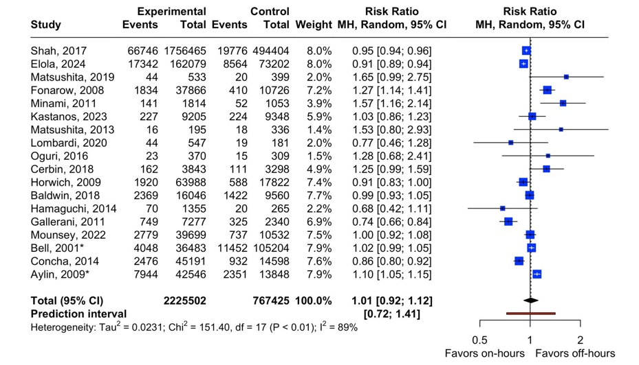

CRY ME A RIVER – WILL VASODILATORY PROPERTY OF BETA BLOCKER BENEFIT ACUTE MYOCARDIAL INFARCTION PATIENTS? A META-ANALYSIS

J. N. Arnindita¹, Y. H. Oktaviono¹, A. D. Lamara¹, M. I. A. Pratama², W. Widiarti³, S. D. Rasti¹, D. Pasahari¹, P. B. T. Saputra¹

¹Department of Cardiology and Vascular Medicine, Dr. Soetomo General Hospital, Faculty of Medicine, University of Airlangga
²Faculty of Medicine, Universitas Indonesia
³Faculty of Medicine University of Airlangga

Background:
Acute myocardial infarction (AMI) remains a significant global health challenge, causing considerable morbidity and mortality despite medical advancements. Newer generation of beta-blocker with vasodilating properties such as carvedilol, nebivolol, and labetalol, shows potential superiority over b1-selective beta-blockers in improving coronary flow reserve, maintaining cardiac index, reducing resistance in peripheral vascular resistance, and reducing HbA1c in diabetic patients. This meta-analysis and systematic review aim to analyze the potential benefits of beta-blockers with vasodilatory properties in AMI.

Methods:
We performed a systematic search for studies comparing the outcomes between vasodilating beta-blockers and non-vasodilating beta blockers in patients with acute MI. Database search was conducted on PubMed, Science Direct, and Scopus. Risk measure was demonstrated in odds ratio and performed using Review Manager 5.4.

Results:
The eight studies included in the analysis with a total of 54,014 participants. Among them, 38,080 received beta-blockers (16,610 vasodilating beta-blockers (VBB) and 21,470 non-vasodilating beta-blockers (NVBB)). A random-effects analysis conducted for rehospitalization outcomes produced a significant result favoring VBB participants, indicating a lower likelihood of readmission to the hospital for all causes (OR: 0.69; 95% CI: 0.49-0.96; I²: 0%). VBB reduced all-cause mortality (555 vs 646 events) and cardiac mortality (272 vs 396 events), even though the difference was not significant. No difference was observed in non-fatal MI and repeat revascularization between VBB and NVBB.

Conclusion:
Vasodilating beta-blockers may offer considerable benefits in the outcomes of AMI patients, especially in reducing future rehospitalization, all-cause and cardiac mortality.

Keywords: acute myocardial infarction, vasodilating beta-blockers, beta blockers

EFFICACY AND SAFETY OF DIFLUNISAL THERAPY IN PATIENTS WITH TRANSTHYRETIN CARDIAC AMYLOIDOSIS: A SYSTEMATIC REVIEW AND META-ANALYSIS

W. Huang¹, A. Frederich¹, A. Nurhafizah¹, A. R. Khairunnisa¹, M. I. Fathoni¹, C. Kezia¹, S. Samban¹, S. Flindy¹, S. S. Syahruddin¹, C. A. Suwono¹, L. M. Anabela¹

¹University of Padjadjaran

Background:
Transthyretin cardiac amyloidosis (ATTR-CA) is a progressive cause of diastolic heart failure associated with poor prognosis. Currently available treatment, tafamidis, a TTR stabilizer, is highly effective and tolerable but isn’t cost-effective. Hence, we aim to evaluate the efficacy and safety of a mechanistically similar but more affordable TTR stabilizer, diflunisal, in patients with ATTR-CA

Methods:
Systematic searching until June 2024 was done on 4 databases to include patients with any ATTR-CA types. Efficacy and safety of diflunisal are assessed by mean difference of specific parameters and mortality outcome evaluated by relative risk. The proportion of discontinuation rate and adverse effects are evaluated with a single-arm inverse variance model. Statistical analyses are done with a random effect model conducted on RevMan and R software.

Results:
Twelve studies comprising 539 ATTR-CA patients with a mean of 70 years old are included. The majority of them are male with NYHA I – II severity and are being followed up for approximately 12 months. For efficacy outcomes, we found no statistically significant changes in BNP, troponin I, LVEF, GLS, IVSD, PWD, and E wave from baseline to diflunisal posttreatment, however, we found a statistically significant posttreatment increase of transthyretin level (MD 9.34 mg/dL; CI 1.54 – 17.14; I² 0%; p 0.02). Diflunisal group also shows a statistically significant posttreatment decrease of troponin level compared to control group (p < 0.001). Additionally, we found a statistically significant 77% (CI 58 – 87%; I 34%; p < 0.001) risk reduction of mortality in the diflunisal group compared to the control group. For safety outcomes, we found a statistically significant reduction of eGFR, hemoglobin, and platelet count (MD -5.55, -0.32, -11.61, respectively) but no statistically significant change in creatinine level. Pooled proportion of discontinuation rate of diflunisal therapy is 24% (CI 15 – 36%; I² 72%; p < 0.01) and adverse events causing therapy discontinuation are renal impairment (21%), GI impairment (13%), bleeding (6%), and fluid retention (6%).

Conclusion:
Diflunisal therapy is beneficial in treating ATTR-CA patients but is associated with adverse effects that require therapy discontinuation. Hence, careful monitoring during diflunisal therapy is necessary.

Keywords: amyloidosis, diflunisal, transthyretin, cardiomyopathy
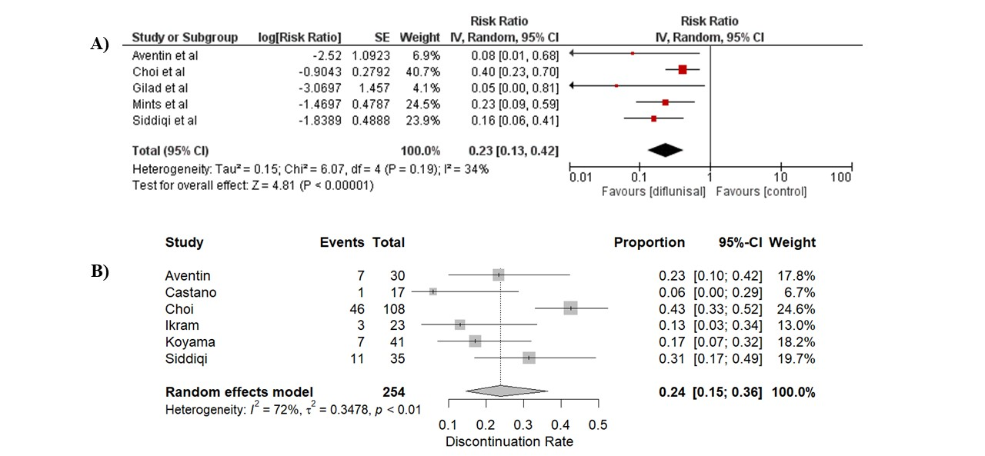Figure 1. A) Efficacy of diflusinal therapy on transthyretin cardiac amyloidosis (ATTR-CA) patients in reducing mortality. Diflusinal reduces mortality by 77% compared to control group. B) Discontinuation rate of diflunisal therapy. Pooled result shows that 24% patients on diflunisal discontinue therapy.

DIASTOLIC FUNCTION IN PATIENTS WITH TRASTUZUMAB-BASED CHEMOTHERAPY REGIMEN: A SYSTEMATIC REVIEW AND META-ANALYSIS

M. E. Saputra¹, A. Lefi¹, Y. H. Oktaviono¹, B. B. Dharmadjati¹, D. P. Kartikasari¹, I. Maghfirah¹, M. J. Al-Farabi¹, Y. Azmi¹, P. M. H. Putri¹, H. O. Hermawan¹, P. B. T. Saputra¹, P. A. Simanjuntak¹, W. Widiarti¹, C. E. C. Z. Multazam¹

¹Universitas Airlangga

Background:
Human epidermal growth factor receptor (HER2) inhibitors enhance survival and quality of life for cancer patients. While the impact of trastuzumab on systolic function has been extensively studied, its effects on diastolic function parameters remain unclear. This study aims to evaluate diastolic echocardiography parameters following HER2 inhibitor treatment in cancer patients.

Methods:
A systematic search was performed on 28 February 2024 in PubMed, Science Direct, Cochrane, Scopus, and Web of Science using the following MeSH terms “human epidermal growth factor receptor” and “diastolic dysfunction”. A total of 371 articles were obtained and selected based on inclusion criteria. Newcastle Ottawa Scale (NOS) was used to assess the risk of bias in included cohort studies.

Results:
A total of 17 studies with 1746 breast cancer patients were included in this meta-analysis. All included studies used Trastuzumab as a HER2 inhibitor drug, with or without other regimen. There was a significant difference in diastolic dysfunction (RR 6.89 (1.93, 24.58); p=0.003, I² 93%) and E velocity (MD 4.20 (0.26, 8.14); p=0.04, I² 19%) before and after trastuzumab-based regimen treatment. No significant differences were found in A velocity (MD 1.57 (-2.11, 5.25); p=0.40, I² 0%). and e’ velocity (MD -0.36 (-1.02, 0.31); p=0.29, I² 80%) after the follow-up. In addition, other parameters such as E/A ratio (MD 0.06 (0.07, 0.19); p=0.36, I² 91%), E/e’ ratio (MD 0.20 (-0.33, 0.73); p=0.47, I² 86%), deceleration time (MD1.27 (-22.45, 25.00); p=0.92, I² 87%), and IVRT (MD 1.81 (-8.95, 12.57); p=0.74, I² 85%) were also not affected at the follow-up.

Conclusion:
There is a significant alteration in diastolic function among breast cancer patients undergoing trastuzumab-based chemotherapy. However, the analysis reveals inconsistencies in the observed alterations across various diastolic parameters, suggesting further investigation to confirm these findings.

Keywords: Diastolic function, Chemotherapy, Trastuzumab

THE RISING STAR VERSUS THE OLD SCHOOL: A META-ANALYSIS OF RENAL DENERVATION VERSUS SPIRONOLACTONE FOR RESISTANT HYPERTENSION

K. Luke¹, C. Milla¹, J. K. Tandi², M. Jonatan³

¹Faculty of Medicine, Universitas Airlangga
²Faculty of Medicine, Universitas Tarumanagara
³Department of Cardiology and Vascular Medicine, Faculty of Medicine, Universitas Airlangga

Background:
Resistant hypertension (RH) is common problem in clinical practice. Recently, sympathetic renal denervation (RDN) had been studied for its efficacy for blood pressure (BP) control among RH. This meta-analysis aims to compare the efficacy of RDN to spironolactone among RH.

Methods:
A systematic search was conducted on PubMed, ScienceDirect, and Web of Science in July 2023 according to PRISMA Guideline. All observational and trials comparing RDN and spironolactone for BP control among RH were included in this study. Expected outcomes are office BP, 24-hour ambulatory BP, and day-night BP.

Results:
Three RCTs with total of 199 RH patients were included for analysis. Majority of the patients were male (62.5%-79.7%) and aged around 57.5 to 63.5 years old. The dose of spironolactone was 25-50 mg daily. The overall BP outcome was not statistically difference among RDN and spironolactone for RH. The office SBP and DBP (SMD=0.28, 95%CI: -0.00─0.57; and SMD=0.12, 95%CI: -0.17─0.41, respectively); The 24-SBP and DBP (SMD=0.09, 95%CI: -0.57─0.75; and SMD=-0.07, 95%CI: -0.55─0.41, respectively); The day SPB and DBP (SMD=0.54, 95%CI: -0.74─1.83; and SMD=0.37, 95%CI: -0.70─1.43, respectively); The night SBP and DBP (SMD=0.32, 95%CI: -0.52─1.17; and SMD=0.14, 95%CI: -0.61─0.89, respectively).

Conclusion:
RDN was not superior in controlling BP compared to spironolactone

Keywords: Mineralocorticoid Receptor Antagonist,, Sympathetic Renal Denervation, Ambulatory Blood Pressure, Resistant Hypertension

UNVEILING THE POTENTIAL: A SYSTEMATIC REVIEW AND META-ANALYSIS OF ARTIFICIAL INTELLIGENCE-ENHANCED ECG FOR HYPERTROPHIC CARDIOMYOPATHY DIAGNOSIS

F. A. Theja¹, L. F. J. Jusni¹, R. Soetedjo¹, D. A. Theja¹

¹School of Medicine and Health Sciences, Atma Jaya Catholic University of Indonesia, Jakarta, Indonesia

Background:
Hypertrophic cardiomyopathy (HCM) is a common genetic cardiac disorder marked by cardiac muscle thickening, potentially leading to severe complications if not diagnosed accurately. Traditional modalities like echocardiography and genetic testing often have several limitations for widespread utilization in asymptomatic individuals. Artificial intelligence (AI) has recently shown promise in enhancing electrocardiogram (ECG) interpretations, improving early detection and diagnosis of HCM. This systematic review and meta-analysis aims to evaluate the accuracy of AI-enhanced ECG algorithms in diagnosing HCM.

Methods:
This study was conducted using the Preferred Reporting Items for Systematic Reviews and Meta-Analysis (PRISMA) guideline. Articles were retrieved from PubMed, ProQuest, and EBSCO. Inclusion criteria included all published and unpublished studies evaluating AI algorithms for the detection of HCM from the 12-lead ECG. Meta-analysis was performed using R v4.4.1. Based on sensitivity and specificity pairs, bivariate random-effects models were used to calculate the pooled estimates of sensitivity, specificity, and the area under the curves (AUCs) of summary receiver operating characteristic (SROC).

Results:
A total of 3 retrospective cohort studies with 90.380 participants were included. Majorities of studies show a relatively low risk of bias. The pooled sensitivity of AI-enhanced ECG for detecting HCM is 85% (95% CI: 83%-87%), and the specificity was 92% (95% CI: 91%-92%). The AI-enhanced ECG showed excellent diagnostic accuracy (SROC-AUC 0.95) in detecting HCM.

Conclusion:
AI-enhanced ECG is promising and could be a novel screening tool for detecting Hypertrophic cardiomyopathy. The considerable heterogeneity and the limited number of studies require careful interpretation and highlight the need for additional research in the future.

Keywords: Hypertrophic cardiomyopathy, AI-enhanced ECG, Diagnostic

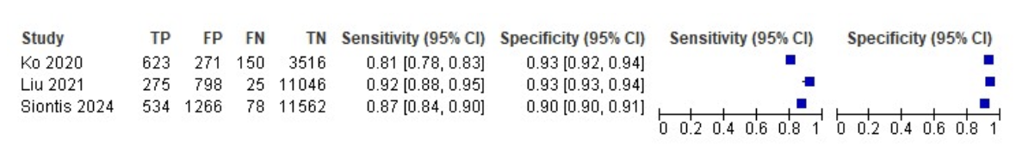
Figure 1. Forest Plot of Sensitivity and Specificity for AI-enhanced ECG in Detecting Hypertrophic Cardiomyopathy
CORONARY SINUS REDUCER (CSR) AS INTERVENTIONAL MODALITY FOR REFRACTORY ANGINA: A SYSTEMATIC REVIEW AND META-ANALYSIS OF RANDOMIZED CONTROLLED TRIAL

Jery¹, Y. R. Tambunan², D. Suwanto³

¹Hermina Sukabumi General Hospital
²Primaya Hospital Sukabumi
³Mahawira Hospital Medan

Background:
Refractory angina is defined as a debilitating symptom, commonly associated with significant and diffuse coronary artery disease, usually not amenable to revascularization. A novel non-pharmacological approach by narrowing the coronary sinus, known as coronary sinus reducer (CSR) has been proposed to tackle this entity. It has been hypothesized that the focal narrowing of CS could increase backward venous pressure and restore subendocardial perfusion, thus potentially relieving anginal symptoms. Although numerous single-arm studies have shown a trend towards the benefit, the lack of strong trials limits its usage. Therefore, we sought to provide further comprehension regarding CSR intervention for refractory angina.

Methods:
A comprehensive literature search was conducted using several databases (i.e. PubMed, Google Scholar, Cochrane Library and ScienceDirect). We searched for studies that prospectively compared CSR procedure and sham procedure, specifically RCT studies, with the outcome of interest being the improvement of Canadian Cardiovascular Society (CCS) class and Seattle Angina Questionnaire (SAQ). The Cochrane risk of bias was utilized to assess the included RCT. Statistical analysis was conducted using RevMan 5.4. The pooled effect was shown in Odds Ratio (OR) and Mean Difference corresponding to 95% confidence interval (CI).

Results:
The final three RCTs were included for quantitative analysis, enrolling a total of 179 populations divided between CSR intervention and sham intervention. The follow-up duration was 6 months in all three studies. Overall pooled analysis showed that CCS class was significantly improved in CSR procedure group compared to sham procedure (OR 3.66 [1.52 - 8.83] p=0.004). Likewise, the mean changes were also significantly different between both groups (MD -0.43 [(-0.73) – (-0.14)] p=0.004). However, in terms of the SAQ, there were no significant differences in all five dimensions.

Conclusion:
In our analysis of the available evidence, the coronary sinus reducer procedure improves anginal symptoms in refractory angina patients.

Keywords: Coronary sinus reducer, Canadian Cardiovascular Society Class, Seattle Angina Questionnaire, Refractory angina

P WAVE PEAK TIME AS A NOVEL ELECTROCARDIOGRAPHIC PARAMETER FOR PREDICTING LEFT VENTRICULAR DIASTOLIC DYSFUNCTION IN CARDIOVASCULAR DISEASE: A SYSTEMATIC REVIEW

D. A. Y. Mahendra¹, P. S. Hadi², A. P. Suyono³

¹Internship Medical Program, Dr. Loekmono Hadi General Hospital, Kudus, Indonesia
²General Practitioner, Dr. Loekmono Hadi General Hospital, Kudus, Indonesia
³Cardiologist-Interventionist, Dr. Loekmono Hadi General Hospital, Kudus, Indonesia

Background:
Left ventricular diastolic dysfunction (LVDD) is a condition of increased left ventricular (LV) filling pressure due to cardiomyocyte remodeling and increased LV stiffness that can lead to heart failure (HF), arrhythmias, coronary artery disease (CAD), and cardiovascular death. Electrocardiography (ECG) can assess LVDD with the novel P wave peak time (PWPT) parameter which reflects intra- or inter-atrial conduction prolongation as a cause of increased intra-atrial pressure due to LVDD. This study aims to determine the correlation of PWPT prolongation with LVDD in cardiovascular diseases to predict prognosis and disease severity.

Methods:
We conducted a data search on online databases: PubMed, ScienceDirect, and Google Scholar. We selected articles using a PRISMA flowchart and assessed their quality using the Cochrane’s GRADE (Grade of Recommendations, Assessment, Development, and Evaluations) method. PWPT will be compared with the standard LVDD examination, the left ventricular end diastolic pressure (LVEDP) measurement via cardiac catheterization or echocardiography.

Results:
78 articles were obtained and 7 of them were relevant. The cardiovascular diseases associated with LVDD in this study were hypertension, coronary artery disease (CAD), and mitral regurgitation (MR). There was a significant correlation between the prolongation of PWPT and the severity of these diseases [hypertension (p = 0.001), CAD (p < 0.001), and MR (p < 0.001)]. PWPT of ≥1.5 mm (60 ms) in lead II was significant with increased left atrial volume index or elevated LVEDP in hypertension, CAD, and MR patients. In addition, PWPT prolongation had a positive association with LVDD and increased LVEDP.

Conclusion:
PWPT can be used as a parameter to assess LVDD in hypertension, CAD, and MR as well as to determine their severity.

Keywords: coronary artery disease, P wave peak time, hypertension, mitral regurgitation, left ventricular diastolic dysfunction

OPENING A NEW HORIZON: PROGNOSTIC POTENTIAL OF E-WAVE PROPAGATION INDEX (EPI) IN PREDICTING LEFT VENTRICULAR THROMBUS - A COMPREHENSIVE SYSTEMATIC REVIEW

F. J. Umam¹, A. R. Ismail¹, G. W. Pradipta¹, P. V. Mustafiza¹, N. Purwaningtyas¹

¹Universitas Sebelas Maret

Background:
Left ventricular thrombus (LVT) is an important clinical sequela of acute myocardial infarction (AMI) and severe chronic cardiomyopathy. Accurate prediction and early detection of LVT are critical for managing and preventing potential complications such as systemic embolization. Recently, the E-wave Propagation Index (EPI) has been proposed as a novel echocardiographic metric to predict LVT formation by evaluating apical LV flow. This systematic review encapsulates the significance of the EPI in predicting LVT, providing a foundation for its potential clinical application.

Methods:
We performed a systematic search according to PRISMA guidelines, using MEDLINE, Pubmed, Cochrane Central Database, Scopus, and Google Scholar for trial, cohort, and case-control studies. The EPI was defined as the product of E-wave velocity time-integral divided by the left ventricle length (LVL). An EPI >1 indicates good penetration of the mitral jet into the apex, while an EPI <1 suggests incomplete apical washout. Relevant articles were appraised using guidelines from the Oxford Centre for Evidence-Based Medicine and Cochrane Risk of Bias Tool.

Results:
A total of 439 patients were included in the 2 eligible studies we found, 1 prospective cohort and 1 retrospective cohort study. Based on these articles, EPI was specifically designed to predict apical blood flow and could be a marker to predict the risk of LVT. Both studies also showed that low EPI was associated with the development of LVT formation significantly. An EPI < 1 signifies poor apical blood flow and a high likelihood of LVT development, with the OR of 53.7 (95% CI: 6.9 - 416) from the first study, and OR of 23.41 (95% CI 10.06 - 54.49) from the second study. These consistent findings across various patient groups validate EPI's reliability as an echocardiographic metric.

Conclusion:
EPI is a promising echocardiographic parameter for predicting LVT formation. Our systematic review suggests that an EPI < 1 is associated with a significantly increased risk for LVT, independent of LVEF and LV volume. Prospective studies are needed to further validate EPI and explore its clinical utility in guiding therapeutic decisions, including anticoagulation strategies.

Keywords: e-wave propagation index, ST-elevation myocardial infarct, cardiomyopathy, left ventricular thrombus

Table 1. Summary of Included Studies
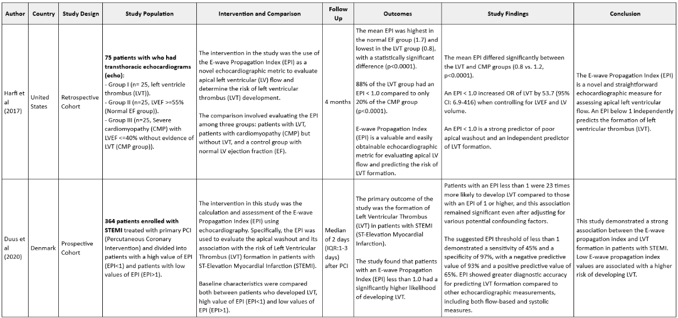

ENHANCING CARDIOVASCULAR DISEASES DETECTION WITH AI: FROM CORONARY ARTERY DISEASE TO LEFT VENTRICULAR DIASTOLIC DYSFUNCTION

A. W. P. Perdana¹, E. Vinsky¹, A. M. Nayotama¹, E. Phielibert¹, E. W. Otto¹, W. S. Atmaja¹, I. M. Pardede¹

¹Faculty of Medicine, University of Pelita Harapan

Background:
Cardiovascular diseases (CVDs) remain a leading cause of death globally, often due to inadequate health screenings, unhealthy lifestyles, and asymptomatic presentations. Early detection is critical in preventing severe complications, and artificial intelligence (AI) is increasingly aiding this effort. Echocardiography and electrocardiography, as non-invasive diagnostic tests, provide invaluable insights into both cardiac structure and function, as well as electrical activity. The integration of AI into these tests shows great potential in enhancing diagnostic accuracy and supporting clinician decision-making. This systematic review evaluates the efficacy of machine learning in assisting clinicians to detect CVDs, either through echocardiography or electrocardiography.

Methods:
All studies were collected from PubMed, PMC, and ScienceDirect using the MeSH keywords “Echocardiography” and “Machine learning” on June 6, 2024. Inclusion criteria were randomized controlled trials (RCTs) from the past five years. Exclusion criteria were incomplete outcome reporting, studies not available in English, and irretrievable full-text articles. The quality of the included studies was assessed using the Newcastle-Ottawa Scale (NOS).

Results:
Three RCTs involving 2867 patients were reviewed and included in this analysis. One study utilizing echocardiography demonstrated an improvement in detecting coronary artery disease (CAD) based on myocardial work (MW) and left atrial strain features, achieving a sensitivity of approximately 95% and a specificity of around 69%. Additional studies employing unique geometric and kinematic features from echocardiography advanced the identification of severe CAD, with sensitivity and specificity rates of approximately 84% and 92%, respectively. Another study utilizing electrocardiography effectively estimated myocardial relaxation velocities, with the area under the receiver operating characteristic curve (AUC) for abnormal myocardial relaxation and left ventricular (LV) diastolic dysfunction ranging from 0.83 to 0.84 and 0.88 to 0.94, respectively. Two studies showed high quality, one was of moderate quality.

Conclusion:
Integrating machine learning with diagnostic tests has shown significant potential in assisting clinicians detect CAD and LV diastolic dysfunction early. Nonetheless, further studies are needed to confirm these results.

Keywords: Machine Learning, Echocardiography, Electrocardiography

DRUG COATED BALLOON AS TREATMENT OF CHOICE FOR DE NOVO CORONARY ARTERY DISEASE: A SYSTEMATIC REVIEW AND META-ANALYSIS

P. A. Baravia¹, A. D. Subali², F. R. Qhabibi³, V. Mayangsari⁴, C. T. Tjahjono⁴

¹Idaman General Hospital
²Dr. Saiful Anwar General Hospital
³Dharma Yadnya General Hospital
⁴Department of Cardiovascular Prevention and Rehabilitation, Dr Saiful Anwar General Hospital

Background:
Percutaneous coronary intervention (PCI) with drug-eluting stents (DES) is a common approach for coronary artery disease management. Nevertheless, the presence of permanent metal stents increases restenosis risk. Drug-coated balloons (DCBs) offer an alternative, delivering antiproliferative drugs directly to the vessel wall without leaving metal behind, aligning with the "leave nothing behind" strategy. At present, DCB is only taken into account when the risk of developing restenosis is high. DCBs have shown efficacy in treating in-stent restenosis and are endorsed by current myocardial revascularization guidelines. Whether the long-term safety and efficacy of DCBs will surpass that of the latest generation of drug-eluting stents in patients with de novo coronary lesions remains uncertain. This study aims to answer the uncertainity by comparing DCB performance on de novo lesions versus in-stent restenosis.

Methods:
We performed a meta-analysis of randomized controlled trials by performing systematic search of studies comparing DCB clinical outcome in de novo and in-stent restenosis lesion using PubMed, Europe PMC, and ScienceDirect, reported until June 14, 2024.

Results:
Five studies met the inclusion criteria with a total of 7,302 patients. Pooled dichotomous data were analyzed using Odds Ratio (OR) and 95% confidence intervals (CI) via the Inverse Variance method. Over a 6-12 months period, DCB application on de novo lesions demonstrated significantly better clinical outcomes based on cardiac death (OR = 0.45; P = 0.67; 95% CI: 0.32 – 0.62), myocardial infarction (OR = 0.25; P = 0.45; 95% CI: 0.17 – 0.37), target lesion revascularization (TLR) (OR = 0.22; P = 0.09; 95% CI: 0.17 – 0.28) that conclude lower Major Adverse Cardiac Events (MACE) (OR = 0.27, 95% CI = 0.23 - 0.33).

Conclusion:
DCBs should not solely be considered an alternative for managing stent restenosis; they are also a viable treatment option for de novo coronary lesions.

Keywords: De Novo Lesion, Drug-Coated Balloon, Coronary Artery Disease, In-Stent Restenosis, Cardiovascular Disease

RISK OF BLEEDING IN ATRIAL FIBRILLATION PATIENTS USING NON-DHP CCBS AND DOACS VERSUS DOACS ONLY: A SYSTEMATIC REVIEW AND META-ANALYSIS

S. Flindy¹, W. Huang², C. A. Suwono², L. M. Anabela²

¹Department of Cardiology and Vascular Medicine, Faculty of Medicine, University of Padjadjaran, Bandung, Indonesia
²Faculty of Medicine, University of Padjadjaran, Bandung, Indonesia

Background:
Direct Oral Anticoagulants (DOACs) and Non-dihydropyridine Calcium Channel Blockers (Non-DHP CCBs) as anticoagulants and symptoms control drugs are the first line treatment for Atrial Fibrillation (AF) patients. However, concomitant use of these drugs may increase the bleeding risk of DOACs due to pharmacokinetic interactions. Thus, the objective of the study was to evaluate the bleeding risk of Non-DHP CCBs use in addition to DOACs versus DOACs only in AF patients.

Methods:
A comprehensive search was conducted on PubMed and ScienceDirect databases to identify RCTs and observational studies investigating the concomitant use of DOACs and Non-DHP CCBs versus DOACs only in patients with AF. The outcomes of composite bleeding, major bleeding, intracranial bleeding, and gastrointestinal bleeding were calculated as pooled risk ratios using a generic inverse variance random effects model. The analysis was conducted with RevMan 5.4 software, and heterogeneity is assessed using the I² statistic.

Results:
Seven studies (1 RCT and 6 observational studies) were included, comprising 62,802 patients. The HAS-BLED score were not significantly different in both groups. In AF patients using DOACs, concomitant use of Non-DHP CCBs was associated with increased risk of composite bleeding (RR 1.12, 95% CI [0.96, 1.32]), I²= 67%, p=0.16) compared to DOACs only, even though the result was not statistically significant. Similarly, risk of major bleeding (RR 1.22, 95% CI [0.90, 1.65], I²=77%, p=0.20) was also increased, yet not statistically significant. Intracranial bleeding risk (RR 1.26, 95% CI [0.50, 3.20], I²=82, p=0.62) was higher, and gastrointestinal bleeding risk (RR 0.95, 95% CI [0.86, 1.05], I²=0%, p=0.28) was lower in patients with Non-DHP CCBs and DOACs compared to DOACs only, both were also not statistically significant.

Conclusion:
The concomitant use of Non-DHP CCBs on AF patients using DOACs is not associated with an increased risk of bleeding. More RCTs are needed to support the result of this study.

Keywords: anticoagulants, calcium channel blockers, drug interactions, atrial fibrillation, direct oral anticoagulants

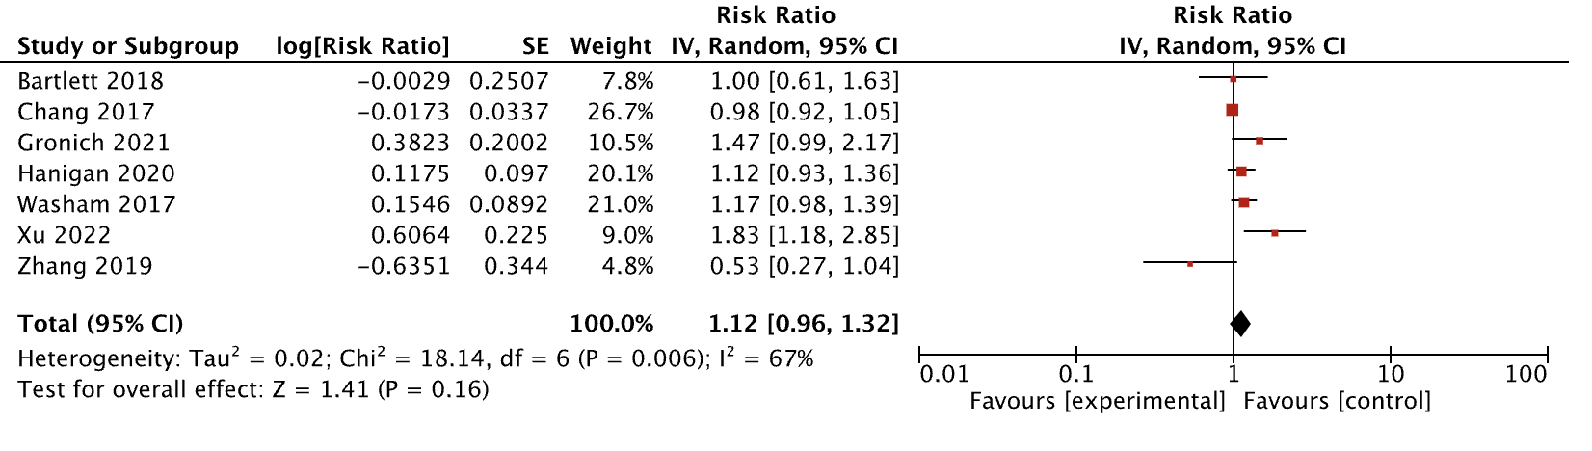
Figure 1. Forest Plot of Composite Bleeding Outcome

ASSESSING THE EFFICACY AND SAFETY OF ANGIOTENSIN RECEPTOR-NEPRILYSIN INHIBITORS IN PATIENTS WITH VARIOUS STAGES OF EJECTION FRACTION HEART FAILURE - HFREF/HFMEF/HFPEF: A CLINICAL OUTCOME META-ANALYSIS OF 97,979 PATIENTS

W. Kwandou¹, D. D. Rampengan², M. V. Ariyanto³, S. C. Surya⁴, K. C. Tjandra⁵

¹Department of Cardiology and Vascular Medicine Sam Ratulangi University Prof. Dr. R. D. Kandou General Hospital
²Medical Doctor Programme, Faculty of Medicine, Universitas Sam Ratulangi, Manado, Indonesia
³Medical Doctor Programme, Faculty of Medicine, Universitas Airlangga, Surabaya, Indonesia
⁴Medical Doctor Programme, Faculty of Medicine, Universitas Udayana, Bali, Indonesia
⁵Medical Doctor Programme, Faculty of Medicine, Universitas Diponegoro, Semarang, Indonesia

Background:
Heart failure (HF), affecting over 64 million people globally, leads to high morbidity, mortality, and healthcare costs. HF is classified into three types: heart failure with reduced ejection fraction (HFrEF), mildly reduced ejection fraction (HFmEF), and preserved ejection fraction (HFpEF), each type requires distinct approaches due to different pathophysiological mechanisms. A new class of medications, angiotensin receptor-neprilysin inhibitors (ARNIs), shows promise in treating HFrEF by enhancing natriuretic peptides and blocking the renin-angiotensin-aldosterone system. Clinical trials have proven ARNIs' effectiveness over ACE-I/ARB in reducing cardiovascular mortality and hospitalizations in HFrEF patients, but their efficacy in HFmEF and HFpEF remains unclear. This meta-analysis aims to investigate ARNIs' effectiveness and safety across the HF spectrum compared to ACE-I/ARB

Methods:
A systematic literature search was conducted based on PRISMA 2020 guidelines in six databases for eligible studies. The risk of bias assessment utilized using the RoB 2 tool for randomized studies and ROBINS-I for cohort studies. Meta-analysis was done using RevMan 5.4. We additionally performed subgroup and meta-regression analysis.

Results:
A total of 26 studies with 97,979 patients were included in the analysis. The overall quality assessment showed low risk of bias. We found that treatment with ARNI was associated with a significantly lower risk of cardiovascular death (RR = 0.76; 95% CI = 0.60 – 0.96; p = 0.02) and renal impairment (RR = 0.76; 95% CI = 0.64 – 0.91; p = 0.003). However, the risk of hypotension was significantly higher in patients receiving ARNI (RR = 1.49; 95% CI = 1.35 – 1.65; p < 0.00001). Subgroup analysis showed significant differences in the covariate HF type for outcomes such as all-cause mortality (p <0.00001), cardiovascular death (p <0.00001), major adverse cardiac events (MACE) (p <0.00001), heart failure hospitalization (p <0.00001), and renal impairment (p = 0.007).

Conclusion:
This study concludes that ARNI is most efficacious in the HFrEF group specifically for the outcome of all-caused mortality and MACE, but overall remains effective in lowering the risk of cardiovascular death and renal impairment risk in patients with various stages of ejection fraction (HFrEF/HFmEF/HFpEF).

Keywords: Angiotensin Receptor-Neprilysin Inhibitors, Meta-Analysis, Heart Failure, Sacubitril/Valsartan

CURRENT EVIDENCE ON SODIUM-GLUCOSE COTRANSPORTER-2 INHIBITORS FOR PREVENTING CANCER THERAPY-RELATED CARDIAC DYSFUNCTION AND REDUCING MORTALITY RISK: A SYSTEMATIC REVIEW, META-ANALYSIS, AND META-REGRESSION

I. Ivan¹, F. Budiman¹, V. A. Damay²

¹Internship Doctor, RSD Kalabahi, Alor, East Nusa Tenggara, Indonesia
²Department of Cardiovascular Medicine, Universitas Pelita Harapan, Banten, Indonesia

Background:
Sodium-glucose cotransporter-2 inhibitors (SGLT2i) have shown effectiveness in preventing the development of symptomatic heart failure (HF) in both diabetic and non-diabetic patients. A compelling area of research now explores the potential role of SGLT2i in cardio-oncology, focusing on mitigating cancer therapy-related cardiac dysfunction (CTRCD) and lowering mortality risk. Our objective is to elucidate the current evidence regarding SGLT2i for preventing CTRCD and reducing mortality risk.

Methods:
We followed PRISMA 2020 guidelines and searched across 8 databases. We included all observational studies published from inception to June 30, 2024, focusing on SGLT2i used in all types of cancer patients undergoing various cancer treatments. We examined outcomes such as all-cause mortality, HF hospitalization, HF incidence and clinically significant arrhythmias. Meta-analyses and meta-regression were performed to evaluate the effects of age, sex, and cancer therapy, cancer type and follow-up durations. Study quality was assessed using the Newcastle-Ottawa Scale.

Results:
Ten retrospective cohort studies were included in the meta-analysis, encompassing 84,066 patients, of whom 24.43% received SGLT2i. The SGLT2i utilized included canagliflozin, dapagliflozin, empagliflozin, and ertugliflozin. Types of cancers included lung, gastrointestinal, hepatocellular, breast, hematologic, lymphatic and genitourinary. Average age ranged from 60 to 75 years. Follow-up duration ranged from 1.5 to 4.8 years. There was a significant reduction in all-cause mortality among the SGLT2i group (RR=0.48, 95%CI:0.33-0.70, p<0.0001; I²=98%). HF hospitalization was significantly lower in the SGLT2i group (RR=0.51, 95%CI:0.41-0.64, p<0.0001; I²=21%). HF incidence was significantly reduced in the SGLT2i group (RR=0.57, 95%CI:0.35-0.94, p=0.03; I²=17%). The risk of clinically significant arrhythmias was significantly lower in SGLT2i group (RR=0.39, 95%CI:0.22-0.68, p=0.0009; I²=0%). Advanced age, anthracycline treatment, certain cancers (breast, lung, gastrointestinal, hepatocellular), and shorter follow-up periods were associated with smaller reduction in all-cause mortality in SGLT2i group (p<0.05). Sex, certain therapies (tyrosine kinase inhibitors, antimetabolites, alkylating agents), certain cancers (hematologic, lymphatic, genitourinary) did not influence mortality risk among patients receiving SGLT2i (p>0.05).

Conclusion:
Our study revealed a reduced risk of all-cause mortality, HF hospitalization, HF incidence, and clinically significant arrhythmias among cancer patients receiving SGLT2i. These findings suggest that SGLT2i have a cardioprotective effect in preventing CTRCD and in reducing mortality risk.

Keywords: cardio-oncology, meta-analysis, heart failure, sodium-glucose cotransporter-2 inhibitors, cancer therapy-related cardiac dysfunction

COMPARING THE EFFICACY AND SAFETY OF ADVANCED ENDOVASCULAR REPAIR VERSUS OPEN SURGERY IN ABDOMINAL AORTIC ANEURYSM: A POOLED STUDY-LEVEL NETWORK META-ANALYSIS OF 25,032 PATIENTS

D. D. Rampengan¹, M. V. Ariyanto², S. C. Surya³, J. Limantoro³, D. Nugraha², R. N. Ramadhan², G. N. P. Jagannatha³

¹Medical Doctor Programme, Faculty of Medicine, Universitas Sam Ratulangi, Manado, Indonesia
²Medical Doctor Programme, Faculty of Medicine, Universitas Airlangga, Surabaya, Indonesia
³Faculty of Medicine, Udayana University/Prof. Dr. I.G.N.G Ngoerah General Hospital, Bali, Indonesia

Background:
The treatment of abdominal aortic aneurysms (AAA) has evolved significantly over the past few decades, with two primary approaches: endovascular aneurysm repair (EVAR) and open surgical repair (OSR). EVAR, preferred for its lower perioperative morbidity, mortality, and faster recovery, faces concerns over long-term durability and re-interventions compared to OSR. Furthermore, recent advancements in EVAR, such as chimney and fenestrated techniques, have shown promise in managing complex AAA, offering comparable outcomes to OSR. However, studies assessing the efficacy and safety of both EVAR methods, as well as their comparison with OSR, are still lacking. Thus, this network meta-analysis aims to provide a detailed comparison of these treatment modalities.

Methods:
We conducted a comprehensive literature search from Pubmed, Scopus, Proquest, Cochrane, Web of Science, and EBSCO. Study quality was assessed using ROBINS-I. Network meta-analysis was done using R-Studio with net meta package.

Results:
A total of 41 eligible studies involving 25,302 patients with complex AAA were included. For perioperative outcomes, fEVAR was associated with shorter procedural time (OR = -3.56; 95% CI = -3.70 – 3.43), lower mortality rate (OR = 0.65; 95% CI = 0.54 – 0.78), highest survival rate (OR = 1.60; 95% CI = 1.19 – 2.14), and highest success rate (OR = 0.27; 95% CI = 0.07 – 1.00). Furthermore, fEVAR seems to have better postoperative outcomes in terms of lower incidence of myocardial infarction (OR = 0.6; 95% CI = 0.43 – 0.84), pneumonia (OR = 0.12; 95% CI = 0.08 – 0.18), cardiorespiratory failure (OR = 0.15; 95% CI = 0.09 – 0.23), wound infection (OR = 0.57; 95% CI = 0.41 – 0.78), and renal insufficiency (OR = 0.16; 95% CI = 0.11 – 0.22) than ORS.

Conclusion:
This network meta-analysis concludes that EVAR is more efficacious in aortic-related intervention outcomes compared to ORS with fEVAR being possibly superior to cEVAR in lowering mortality rate and procedural complication. However, a defining statement of the finest modality is considered a specific manner, as fEVAR and cEVAR each hold a different advantage in various efficacy and safety aspects of the therapy.

Keywords: EVAR, Open Surgery, Network Meta-Analysis, Abdominal Aortic Aneurysm, Endovascular Repair

FIVE-YEAR OUTCOME OF BIORESORBABLE VASCULAR SCAFFOLDS VERSUS SECOND-GENERATION DRUG-ELUTING STENTS FOR THE TREATMENT OF CORONARY ARTERY DISEASE: SYSTEMATIC REVIEW AND META-ANALYSIS OF RANDOMIZED TRIALS

D. S. Adhi¹, S. Paipinan¹, A. P. Kakerissa¹

¹Faculty of Medicine, Christian University of Indonesia

Background:
Bioresorbable vascular scaffolds were developed with the intent to provide mechanical support and drug delivery functions and preventing the adverse events associated with the use of metallic DES, followed by progressive resorption may help recover vascular structure and function. Complete scaffold resorption after several years offers the promise of improved very late clinical outcomes. We performed a meta-analysis to compare the safety and efficacy of BVS and second-generation drug-eluting stents (DES) at 5 years after implantation.

Methods:
Published randomized trials comparing BVS to second-generation DES for the treatment of coronary artery disease were identified within PubMed, Science Direct, Cochrane Library and Google Scholars. The primary efficacy endpoint was target lesion failure (TLF). The primary safety endpoint was definite/probable stent/scaffold thrombosis. Secondary outcomes were cardiac death, target vessel myocardial infarction (TVMI), and ischemia-driven target lesion revascularization(ID-TLR). Studies were appraised using Cochrane’s Risk of Bias tool and Meta analysis was performed using RevMan V.5.4.

Results:
Six randomized controlled trials, with a total of 7,596 patients (BVS n=4,221; DES n=3,375), were included. At 5 years, BVS was associated with higher rates of target lesion failure (OR=1.37, 95% CI: 1.20–1.56, P<0.00001) and definite/probable stent/scaffold thrombosis (OR=2.60, 95% CI: 1.77–3.82, P<0.00001) compared with DES. The incidence of TVMI (OR= 1.46, 95% CI: 1.22–1.74, P<0.0001), ID-TLR (OR=1.42, 95% CI: 1.19–1.69, P0<0.0001), were higher for those treated with BVS compared with DES. However, there was no significant difference in risk of cardiac death (OR=0.89, 95% CI: 0.68–1.16, P=0.37) between treatment groups.

Conclusion:
At the 5-year follow-up, BVS was inferior to second-generation DES in both safety and efficacy.

Keywords: Meta-analysis, Bioresorbable scaffold, coronary artery disease, drug-eluting stents

FACTORS ASSOCIATED WITH FFR/IFR DISCORDANCE IN CORONARY ARTERY DISEASE PATIENTS: A META-ANALYSIS

V. J. Dirjayanto¹, S. Amirah¹, D. A. Yumnanisha¹, A. M. Sarayar², S. Adiarto³

¹Faculty of Medicine, Universitas Indonesia, Indonesia
²Kramat Jati Regional Hospital
³Harapan Kita National Cardiovascular Referral Center, Jakarta, Indonesia

Background:
Identification of functionally significant stenosis by invasive physiological assessments such as FFR and iFR have been proven to benefit coronary revascularization. However, FFR/iFR discordance occurs in 20% of cases, making decisions for revascularization dubious. Identifying factors associated with FFR/iFR discordance and understanding the mechanism is important in guiding treatment decision.Objective: To identify factors associated with FFR/iFR discordance.

Methods:
Following the PRISMA statement, we searched 7 databases for studies reporting predictors of FFR/iFR discordance. We pooled proportions using random-effects meta-analysis in R software (version 4.1.3) and mean differences using inverse variance, random-effects model in Review Manager (version 5.4). Quality assessment was performed using the Newcastle-Ottawa Scale.

Results:
Our search yielded 16 studies with 5,742 patients. There were large pooled proportions of discordant patients who had dyslipidemia (FFR-/iFR+:0.74[95%CI:0.66-0.82];I2=68%, FFR+/iFR-:0.75[95%CI:0.65- 0.85];I2=84%) and lesion in left anterior descending (LAD) artery (FFR-/iFR+:0.81[95%CI:0.74-0.89];I2=45%, FFR+/iFR-:0.71[95%CI:0.59-0.83];I2=75%); small proportions were found for females (FFR-/iFR+:0.30[95%CI:0.20-0.40];I2=88%, FFR+/iFR-:0.17[95%CI:0.12-0.21];I2=40%), smokers (FFR-/iFR+:0.28[95%CI:0.10-0.47];I2=97%, FFR+/iFR-:0.25 [95%CI: 0.14-0.36];I2=83%), chronic kidney disease (CKD) (FFR-/iFR+:0.13[95% CI:0.02-0.25];I2=75%, FFR+/iFR-:0.09[95%CI:0.00-0.20];I2=80%), previous infarction (FFR+/iFR-:0.12[95%CI:0.06-0.18];I2=38%, FFR-/iFR+:0.15[95%CI:0.07-0.24];I2=63%), and family history of coronary artery disease (CAD) (FFR-/iFR+:0.19[95%CI:0.12-0.27];I2=0%, FFR+/iFR-:0.20[95%CI:0.12-0.28];I2=24%). Older age was associated with FFR-/iFR+ discordance (MD:2.05[95%CI:0.28-3.81];P=0.02;I2=52%). Meanwhile, for FFR+/iFR- discordance, lesion length was significantly longer (MD:2.02[95%CI:0.45-3.59];P=0.010;I2=44%).

Conclusion:
Large proportions of discordant patients had dyslipidemia and lesions in LAD. Meanwhile, the percentages of females, smokers, those who had CKD, previous infarction, and family history of CAD were small. FFR-/iFR+ discordance was associated with older age; FFR+/iFR- discordance was associated with younger age and increased lesion length.

Keywords: Instantaneous Wave-Free Ratio, factors, coronary artery disease, fractional flow reserve, discordance

POOR OUTCOMES AFTER DISCONTINUATION OR DOWN-TITRATION OF RAAS-I AND MRA IN HYPERKALEMIA-ASSOCIATED HEART FAILURE, A NEED TO REVISIT THE GUIDELINES: SYSTEMATIC REVIEW AND META-ANALYSIS

S. Nurhayati¹, R. B. D. Hadiningrat², R. Philo³, Benedictus⁴

¹RSD A. Dadi Tjokrodipo
²RSUD Sleman
³RSUD Tarempa
⁴RS Islam Sukapura

Background:
We believe that both hyperkalemia (HK) and hypokalemia are dangerous and produced poor outcomes. However, how confident are we that poor outcomes which occur in HK-associated HF are caused by HK itself and not due to the reduction in RAAS-i or MRA dose?

Methods:
This meta-analysis was conducted in accordance with the PRISMA 2020. PubMed, Scopus, and Science Direct were explored for studies from 2000 to 2024. The search strategy was a combination of keywords including (discontinuation OR stopping OR cessation) AND heart failure AND hyperkalemia AND (renin-angiotensin-aldosterone system inhibitor OR mineralocorticoid receptor antagonist). We used Newcastle-Ottawa Scale to measure the quality of the studies. Inverse variance - random-effect models was used to compute the pooled hazard ratios (HRs).

Results:
Based on the results of this meta-analysis, there was an increased risk of death in patients who stopped or reduced the dose of MRA (HR = 1.12, 95% CI: 1.07 – 1.18, p < 0.00001, I² = 26%) and RAAS-i (HR = 1.18, 95% CI: 1.05 – 1.31, p = 0.003, I²= 66%). If further assessment was carried out on the cause of death, discontinuation/down titration of MRA increased the risk for either all-cause or CV mortality (HR = 1.17, 95% CI: 1.08 –1.26, p = 0.0002, I²= 24% and HR = 1.08, 95% CI: 1.04 –1.13, p = 0.0003, I²= 0%, respectively). Meanwhile, discontinuation/down titration of RAAS-i was only associated with an increased risk for all-cause death (HR = 1.25, 95% CI: 1.06 –1.47, p = 0.009, I²= 77%) and doesn’t associate with an increased risk for CV mortality (HR = 1.10, 95% CI: 0.99 –1.23, p = 0.81, I² = 0%).

Conclusion:
HF patients with HK who were discontinued or down titrated RAAS-i or MRA featured an enhanced mortality in comparison to patients who remained adherent to optimal RAAS-i therapy despite HK. Our results emphasize the need to revisit heart failure treatment guidelines for HK management during the use of RAAS-i and MRA.

Keywords: RAAS-i, heart failure, discontinuation, hyperkalemia, MRA

EFFECT OF EARLY DISCONTINUATION OF TRASTUZUMAB ON CARDIAC FUNCTION IN HER2-POSITIVE BREAST CANCER PATIENTS: A SYSTEMATIC REVIEW

E. Tanially¹

¹Pelita Harapan University

Background:
Breast cancer is known as the most common cancer diagnosed in women. The HER2-positive subtype of breast cancer that is known to be more aggressive than other types of breast cancer due to its high recurrence rate thus has posed a challenge to treat. Trastuzumab has emerged as a treatment option for patients with HER2-Positive breast cancer, however, its impact on the patients’ cardiac function remains unknown. This review aims to highlight the possible impact of trastuzumab on cardiac function in HER2-positive breast cancer patients.

Methods:
Databases, such as Pubmed, Crossmark, and JNCI were systematically analyzed to extract studies on June 6, 2024. Keywords such as "Trastuzumab", "Cardiac Function", “HER2-Positive Breast Cancer Patients” were used to gain relevant studies and there are three independent researchers that have conducted this study. The outcome in this review is cardiotoxicity measured by the level of LVEF and number of HF patients among BC patients undergoing trastuzumab treatment. Studies in English from the last ten years with accessible full text including retrospective cohort, were included in this review. Studies that were systematic reviews, meta-analyses, animal studies, and case reports were excluded. The Newcastle Ottawa Scale (NOS) was then used to assess the studies' quality.

Results:
4 studies were extracted for this review, all are of high quality based on the NOS. 3 studies mentioned that Trastuzumab is associated with a negative effect of cardiotoxicity, particularly manifested as decreased left ventricular ejection fraction below 50%. One other study revealed that the early discontinuation of trastuzumab was associated with more HF or death by HF. Despite these risks, the studies underscored the importance of individualized patient monitoring and highlighted that early intervention and cardiac care strategies could optimize both cardiac health and cancer treatment efficacy.

Conclusion:
The early discontinuation of Trastuzumab has a toxic effect on cardiac function in HER2-positive breast cancer patients. Despite this concern, careful monitoring and early intervention strategies can mitigate the potential cardiac side effects. Nevertheless, further studies are needed to further confirm these findings as there are still limited resources in regards to this title.

Keywords: Cardiac Function, HER2-Positive Breast Cancer Patients, Trastuzumab

THE EFFICACY OF TICAGRELOR MONOTHERAPY AFTER 1 MONTH OF DUAL ANTIPLATELET THERAPY VERSUS TICAGRELOR PLUS ASPIRIN DUAL THERAPY (STANDARD DAPT) ON PATIENTS WITH ACS WHO UNDERWENT PCI: A SYSTEMATIC REVIEW AND META‐ANALYSIS OF RANDOMIZED CLINICAL TRIALS

N. N. Junior¹, M. J. P. Sihotang²

¹Faculty of Medicine, Diponegoro University
²Pertamina Cirebon Hospital

Background:
Dual-antiplatelet therapy (DAPT), including aspirin and P2Y₁₂ inhibitor, is standard care for acute coronary syndrome (ACS) patients undergoing percutaneous coronary intervention (PCI). It prevents ischemic events, but increases major bleeding risk, impacting mortality, morbidity, and costs. Recent trials show shorter-duration DAPT followed by P2Y₁₂ inhibitor monotherapy reduces bleeding while maintaining anti-ischemic effects. This analysis evaluates efficacy of ticagrelor monotherapy after one month DAPT versus 12 months DAPT among ACS patients undergoing PCI.

Methods:
A systematic search from May to June 2024 identified randomized controlled trials comparing ticagrelor monotherapy versus standard DAPT. This study is registered in PROSPERO (CRD42024556727). Endpoints included all-cause mortality, major adverse cardiovascular event (MACE: myocardial infarction, stroke, repeat revascularisation, and stent thrombosis), bleeding events, and net adverse clinical events (NACE: MACE and bleeding). The meta-analysis was performed using RevMan 5.4, with risk ratio (RR) and 95% confidence intervals (CI).

Results:
The analysis included 8,342 ACS patients who underwent PCI derived from 3 eligible randomized trials. No significant differences were found in the relative risk of all-cause mortality (RR 0.97, 95% CI, 0.66–1.42, P = 0.86, I² = 0%), myocardial infarction (RR 1.28, 95% CI, 0.85–1.92, P =0.24, I² =0%), stroke (RR 0.85, 95% CI, 0.54–1.33, P =0.47, I² =0%), repeat revascularisation (RR 0.97, 95% CI, 0.77–1.24, P =0.84, I² =0%), or stent thrombosis (RR 0.98, 95% CI, 0.58–1.64, P =0.93, I² =0%) between ticagrelor monotherapy and standard DAPT. However, ticagrelor monotherapy significantly reduced the risk of major (BARC type 3 or 5) (RR: 0.41; 95% CI: 0.29–0.59; p<0.00001, I² =0%) and all bleeding events (RR 0.59, 95% CI, 0.46–0.77, P <0.0001, I² =72%) compared to standard DAPT. The rate of NACE were similar in both groups (RR 0.96, 95% CI, 0.82–1.13, P =0.65, I² =89%).

Conclusion:
Ticagrelor monotherapy after 1 month of DAPT in ACS patients post-PCI significantly lowers the risk of all and major bleeding events without compromising protection against all-cause mortality, adverse cardiovascular events, and net adverse clinical events. This study supports ticagrelor monotherapy as an evolution in antiplatelet therapy post-PCI.

Keywords: Ticagrelor monotherapy, percutaneous coronary intervention, dual antiplatelet therapy, acute coronary syndrome

EFFICACY AND SAFETY OF CLOPIDOGREL VERSUS ASPIRIN MONOTHERAPY FOLLOWING DUAL ANTIPLATELET THERAPY IN PATIENTS WHO HAVE UNDERGONE PERCUTANEOUS CORONARY INTERVENTION: A SYSTEMATIC REVIEW AND META-ANALYSIS

Z. A. Alkatiri¹, H. P. Megantara¹, A. A. Faisal¹, R. I. Faiq¹, M. H. Hakim¹, R. I. Mulyana¹, B. Widyantoro²

¹Faculty of Medicine, Universitas Indonesia
²Department of Cardiology and Vascular Medicine, Faculty of Medicine Universitas Indonesia

Background:
Antiplatelet treatment is highly recommended in patients undergoing percutaneous coronary intervention (PCI) post initial Dual Antiplatelet Therapy (DAPT). Aspirin and clopidogrel are amongst the frequently used antithrombotic agents. Current guideline, however, has not succinctly unraveled a head-to-head comparison between aspirin and clopidogrel and whether one regiment provides a potent antithrombotic effect whilst deterring the bleeding and other adverse events. Objective: Current research aims to confirm the efficacy and safety, including antithrombotic effects, bleeding risks, and other adverse events, of aspirin versus clopidogrel monotherapy, following DAPT in patients undergoing PCI.

Methods:
We conducted literature screening from five databases. We included all DAPT strategies (one to up to 18 months of clopidogrel based-DAPT). We compared primary end-points, ischemic outcomes (major cardiac events, all-cause death, cardiac death, ischemic and hemorrhagic stroke, the need for revascularization, stent thrombosis, myocardial infarction (MI)) and bleeding outcomes defined as major bleeding.

Results:
Our search found seven eligible studies using clopidogrel or aspirin monotherapy following clopidogrel based-DAPT with DAPT duration of one month to up to 18 months, follow-up time of 12 months to up to 5 years. For bleeding risk, clopidogrel is associated with lower major bleeding events [RR 0.53 (0.30-0.94)]. Clopidogrel is also associated with lower Major Adverse Cardiac Events (MACE) [RR 0.78 (0.71 - 0.86), any stroke [RR 0.73 (0.57 - 0.93)], hemorrhagic stroke [RR 0.44 (0.27 - 0.72), ischemic stroke [RR 0.62 (0.46-0.84)], and target vessel revascularization [RR 0.74 (0.59 - 0.94)] with aspirin as comparison. No outcomes in favor of aspirin as monotherapy following DAPT.

Conclusion:
Current research reported the efficacy and safety of using aspirin and clopidogrel in patients undergoing PCI, in which, clopidogrel exhibits lesser adverse events, confirming it as a more preferred antithrombotic agent monotherapy following DAPT.

Keywords: aspirin, PCI, clopidogrel, DAPT, Monotherapy

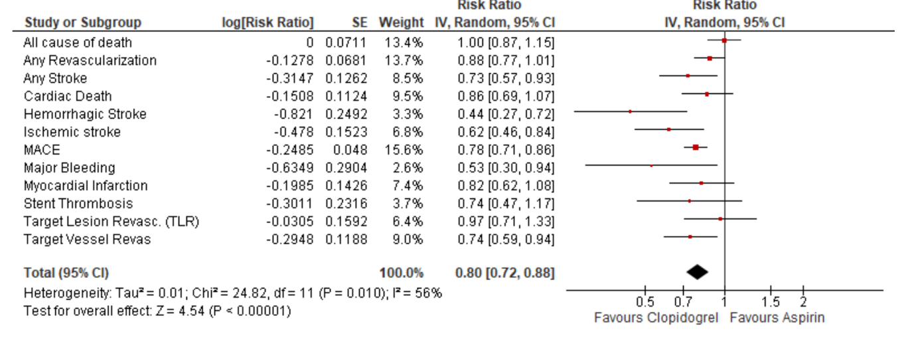
Figure 1. Clopidogrel versus Aspirin comparison post initial Dual Antiplatelet Therapy
THE USE OF RIGHT VENTRICLE-TO-PULMONARY ARTERY MEASUREMENT BY ECHOCARDIOGRAPHY IN THE PROGNOSTICATION OF PULMONARY HYPERTENSION : A SYSTEMATIC REVIEW AND META-ANALYSIS

M. Sugiyanto¹, P. P. P. Hutahaean¹, F. M. Chandra¹, B. Dwiputra²

¹Faculty of Medicine, Universitas Indonesia
²Department of Cardiology and Vascular Medicine, Universitas Indonesia-National Cardiovascular Center Harapan Kita

Background:
The mortality rate of pulmonary hypertension (PH) continues to increase, mainly attributed to the WHO group II to V. The impairment of right ventricle-to-pulmonary artery (RV-PA) coupling has been associated with poor prognosis in heart failure, however its prognostic value in PH is unknown. The review aims to assess the prognostic value of RV-PA coupling, represented by TAPSE/PASP ratio measured by echocardiography, in predicting clinical outcomes in PH patients.

Methods:
A systematic review was conducted by literature searching through four databases: PubMed, EBSCOhost, Scopus, and EMBASE, searching for cohort studies assessing the association of TAPSE/PASP ratio with various clinical outcomes in PH patients using the previously determined inclusion and exclusion criteria. Quantitative analysis was done using generic inverse variance method with hazard ratio (HR) and the respective 95% CI as the effect estimates. The quality of the included studies was assessed using the Newcastle Ottawa Scale (NOS).

Results:
Six cohort studies with a total of 775 patients with various PH groups were included. The outcomes assessed in this review are mortality, rehospitalization, increase in WHO functional class, and escalation of therapy. Two studies assessed the association between TAPSE/PASP ratio and mortality, and the remaining four assessed the association with the composite of clinical worsening. The pooled analysis showed decreased risk of mortality [HR 0.30, 95% CI 0.05-1.81, p=0.19] and the composite of clinical worsening [HR 0.33, 95% CI 0.10-1.02, p=0.06] following the higher TAPSE/PASP ratio. The trend is consistent for all PH types included in this review. However, the association is not statistically significant. Begg’s funnel plot identified publication biases in both mortality and composite of clinical worsening.

Conclusion:
Despite statistical insignificance, there is a consistent trend of decreasing mortality and clinical worsening in PH patients with higher TAPSE/PASP ratio regardless of the PH type. Further prospective studies are needed to determine the true prognostic value of TAPSE/PASP ratio in PH.

Keywords: RV-PA coupling, prognosis, clinical outcome, TAPSE/PASP ratio, pulmonary hypertension
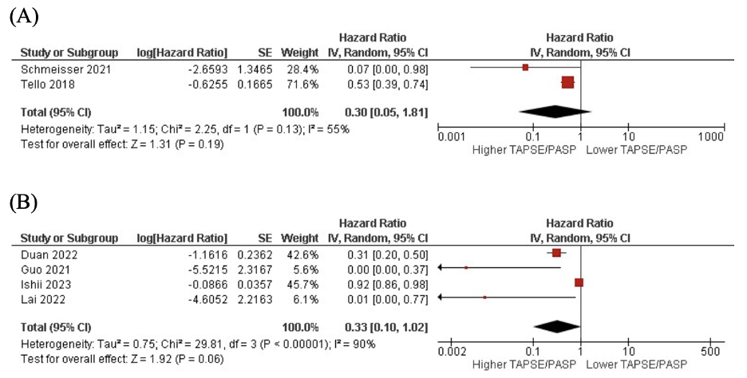
Figure 1. The pooled analyses of (A) The association between TAPSE/PASP ratio and mortality and (B) with the composite of clinical outcomes.
EFFICACY OF ASPIRIN MONOTHERAPY COMPARED TO DUAL THERAPY WITH CLOPIDOGREL FOLLOWING TRANSCATHETER AORTIC VALVE IMPLANTATION: A SYSTEMATIC REVIEW

S. T. Lim¹, E. Huang¹, A. Kurniawan²

¹Faculty of Medicine, Pelita Harapan University
²Department of Internal Medicine, Faculty of Medicine, Pelita Harapan University

Background:
Transcatheter aortic valve implantation (TAVI) is a minimally invasive approach to treat aortic stenosis and is especially done for those with a high risk for open surgery. Optimal antiplatelet therapy post-TAVI to prevent thromboembolic events remains a subject of debate. This systematic review aims to evaluate the efficacy of aspirin monotherapy compared to aspirin plus clopidogrel in patients after TAVI focusing on clinical outcomes such as major adverse cardiovascular and cerebrovascular events (MACCE) and bleeding events.

Methods:
2 individuals systematically search the PubMed, ScienceDirect, NEJM and Europe PMC database up to 24 June 2024 using the keywords "aspirin", "clopidogrel" and "transcatheter aortic-valve implantation". Eligible studies were selected based on the inclusion criteria including randomized controlled trials, clinical trials and cohort studies comparing aspirin monotherapy with aspirin plus clopidogrel. The outcome assessed will be the occurrence of major adverse events and bleeding events after the therapy. The risk of bias for randomized trials would be measured using the Revised Cochrane Risk of Bias Tool (ROB 2) and the ROBINS-I tool would be used to assess non-randomised trials. Systematic review, meta-analysis and trials on animals were excluded.

Results:
5 studies met the inclusion criteria after screening of title and abstract. After assessment of full-text, 4 randomized studies were included with 1086 patients, of which 2 were of low risk of bias and 2 had some concerns of bias based on RoB 2. All included studies found that the incidence of MACCE following TAVI including myocardial infarction, major stroke and life-threatening bleeding was reduced with aspirin only, thus dual antiplatelet therapy was not necessary.

Conclusion:
In conclusion, aspirin monotherapy is sufficient to reduce bleeding events and the occurrence of major adverse events after receiving TAVI. However, further studies with a larger sample size are required to substantiate these findings.

Keywords: clopidogrel, aspirin, transcatheter aortic valve implantation

PRESERVED FRACTIONAL FLOW RESERVE GUIDED PRIMARY PERCUTANEOUS CORONARY INTERVENTION FOR CORONARY ARTERY DISEASE: A SYSTEMATIC REVIEW AND META-ANALYSIS OF RANDOMIZED-CONTROL TRIALS

I. Rasyid¹, F. Qorina², D. Rostiati¹, F. Fathini¹

¹Hermina Arcamanik Hospitals
²Faculty of medicine, Universitas Indonesia

Background:
Despite the growing evidence, controversies persist among different studies regarding the efficacy and cost-effective impact of preserved fractional flow reserve (FFR) compared to conventional coronary angiography for guiding percutaneous coronary intervention in coronary artery disease patients.

Methods:
This study was reported based on the Preferred Reporting Items for Systematic Reviews and Meta-Analyses (PRISMA) statement. Systematic literature searches were performed through PubMed, Scopus, Science Direct, and EBSCOHost from inception to July 6, 2024. Studies fulfilling pre-determined inclusion and exclusion criteria were qualitatively appraised using Joanna-Briggs Institute (JBI) Critical Appraisal Tools for Randomized-controlled Trials and quantitatively analysed using Review Manager version 5.4. Pooled estimates of outcomes are presented as Risk Ratio (RR) with 95% confidence interval.

Results:
The qualitative analysis includes seven published studies with a total of 308.755 patients. The FAME trial and other studies suggest that FFR-guided PCI can reduce patient costs by $675 and $5,931 respectively. Quantitative analysis was performed on six published RCTs. Patients who underwent FFR-guided PCI had significantly associated with a lower risk of cardiovascular death events (RR, 0.66; 95% CI, 0.52 - 0.83; p = 0.0004), major adverse cardiovascular events (RR, 0.75; 95% CI, 0.66 - 086; p = <0.0001), and repeat revascularisation events (RR, 0.76; 95% CI, 0.63 - 0.91; p = 0.003) compared to patients who underwent angiography coronary revascularisation. The length of hospital stay in days between the FFR-guided PCI and angiography group was not statistically significant (Mean Difference: -0.04; 95% CI: -0.19 - -0.11; p: 0.59). Further randomised controlled trials with larger sample sizes and cost-benefit analysis are recommended.

Conclusion:
Among patients with CAD, FFR-guided PCI reduces medical costs compared to non-FFR-guided procedures. Furthermore, FFR-guided PCI is associated with significantly lower risks of cardiovascular death, major adverse cardiovascular events, and repeat revascularization.

Keywords: cardiovascular outcomes, fractional flow reserve, percutaneous coronary intervention, coronary artery disease

STENT ANGIOPLASTY VERSUS BALLOON ANGIOPLASTY ALONE FOR DYSFUNCTIONAL ARTERIOVENOUS FISTULA INTERVENTION: A SYSTEMATIC REVIEW & META-ANALYSIS

Y. R. Tambunan¹, Jery², D. Suwanto³

¹Primaya Hospital Sukabumi
²Hermina Hospital Sukabumi
³Mahawira Hospital

Background:
The number of patients being treated for end-stage chronic kidney disease with hemodialysis is growing. This indicates a rising demand for hemodialysis access and a significant need to maintain the patency of existing accesses, as many of them fail several months after implantation. Angioplasty and/or stent placement have been used as an option to treat compromised dialysis access. However, the optimal management strategy for failing dialysis access remains poorly defined. The aim of our study is to compare stent and balloon angioplasty in terms of patency rates and procedural success for the treatment of dysfunctional arteriovenous fistula (AVF).

Methods:
A comprehensive literature search was performed using PubMed, ScienceDirect, Cochrane Library, and Google Scholar databases to identify studies comparing stent angioplasty and balloon angioplasty in dysfunctional arteriovenous fistula. There were no restrictions on publication date. The meta-analysis was designed following the PRISMA (Preferred Reporting Items for Systematic reviews and Meta-Analyses) guidelines. The study protocol has been registered in PROSPERO (CRD42024524136). Meta-analysis was conducted using Review Manager software version 5.4. The pooled effect was shown in Odds Ratio (OR) corresponding to 95% confidence interval (OR).

Results:
A total of 16 studies enrolling 1870 patients were included in final analysis, of which 917 (49.04%) underwent stent angioplasty, whereas 953 (50.09%) were receiving balloon angioplasty. Overall pooled analysis showed that stent angioplasty was associated with significantly higher patency rate at 3 months (OR 0.67 [0.48 – 0.92] p=0.01), 6 months (OR 1.25 [1.03 – 1.53) p=0.03) and 12 months (OR 0.46 [0.35 – 0.60] p<0.00001). On the other hand, although secondary patency rate was higher in stent angioplasty group, it was not statistically significant (OR 0.75 [0.54 – 1.04] p=0.09). Likewise, the procedural success in stent angioplasty was also notably higher than in balloon angioplasty (OR 0.66 [0.44 – 0.98] p=0.04).

Conclusion:
In our analysis, stent angioplasty intervention is superior to balloon angioplasty in terms of providing primary and secondary patency of dysfunctional AV fistula.

Keywords: Balloon Angioplasty, Arteriovenous Fistula, Stent Angioplasty, Haemodialysis

ELUCIDATING THE ROLE OF VITAMIN D IN DETERMINING THE LEFT VENTRICULAR GEOMETRY AMONG PATIENTS WITH HEART DISEASES: A SYSTEMATIC REVIEW AND META-ANALYSIS

N. Gusti¹, M. Iqhramullah¹, D. D. Rampengan², A. M. Yapanto³, M. V. Ariyanto⁴

¹Postgraduate Program of Public Health, Universitas Muhammadiyah Aceh
²Faculty of Medicine, Sam Ratulangi University
³Faculty of Medicine, Universitas YARSI
⁴Faculty of Medicine, Universitas Airlangga

Background:
Understanding the mechanisms of actions of vitamin D in improving heart failure or other heart diseases is important for clinical decision-making. This study aims to investigate the effect of vitamin D on left ventricular geometry among heart disease (HD) patients.

Methods:
We performed a literature search on Europe PMC, PubMed, Scilit, Scopus, and Web of Science as of 7 June 2024, where the selection of eligible articles were carried out by two independent reviewers. Observational and interventional studies reporting the effect of vitamin D on left ventricular geometry among HD patients were included and appraised with standardized tools. Estimation of the pooled effect size was carried out using a restricted maximum-likelihood model on RStudio version 2024.04.2.

Results:
Of 3022 identified records, 21 studies had sufficient data for quantitative analysis, consisting of 15 observational studies and 6 interventional studies with a total sample of 4614 patients. Being deficient in circulating vitamin D is significantly associated with the elevated LVEDD p =0.017), LVESD p <0.001), and LVMI p =0.03). No association was found between hypovitaminosis D with IVST p =0.181), PWT p =0.061) and LVWT p =0.158). Supplementation of either active or inactive form of vitamin D to HD patients could improve LVEDD p =0.029) and LVESD p =0.029). The vitamin D was also associated with the LV cardiac function, as indicated by the LVESV p =0.004), LVESD p =0.011), and LVEF p =0.044); where the supplementation was found to improve the LV ejection fraction p =0.008).

Conclusion:
Hypovitaminosis D contributes to the impaired LV geometry, which is reversible by its repairment. Our findings warrant a robust RCT recruiting large cohorts for confirming these beneficial effects of vitamin D.

Keywords: Heart Disease, Left Ventricle, Vitamin D, cardiac structure, Ergocalciferol

STUDYING THE EFFECTS OF COFFEE INTAKE AND THE CORRELATION WITH HEART FAILURE: A SYSTEMATIC REVIEW

M. Khansa¹, J. R. Utami¹, C. Y. Addina¹

¹Fakultas Kedokteran Universitas Indonesia

Background:
Heart failure, as one of the most common chronic heart diseases, is associated with several known risk factors. However, the risk of coffee as a common daily beverage in heart failure is still controversial. There is not any recent study that analyzes the association of coffee consumption with the incidence of heart failure.

Methods:
We conducted a systematic review of studies from 2013 to June 2024. We searched 3 electronic databases including Scopus, Cochrane, and Pubmed using related terms as MeSH terms. No language restrictions were applied. Studies were limited to adults with caffeinated coffee consumption in cups/day without the history of heart failure. Pregnant women were excluded in this review.

Results:
After the selective analysis, there are 4 studies included. From the study by Han Q, et al. (2023) with 497.503 samples, they reported that moderate coffee consumption (3-4 cups/day) may reduce risk of HF (HR Z 0.920; 95% CI: 0.869-0.974) despite the different types of coffee. Stevens LM, et al. (2021) with 21.361 samples also reported based on 3 large epidemiological studies, there is a relation between higher caffeine-contained coffee consumption (≥2 cups/day) in decreasing risk of HF. However, Senftinger J, et al. (2023) with 9.009 samples and Bodar V, et al. (2020) with 20.433 samples reported a different result where coffee or dietary caffeine intake have no significant correlation in major cardiovascular disease including heart failure (95% CI) before and after adjustment for potential confounders.

Conclusion:
The correlation between coffee intake with heart failure, especially on increasing or reducing the incidence, still have inconsistent results on many studies. Thus, it requires further studies to prove the correlation between them.

Keywords: coffee, heart decompensation, cardiac failure, caffeine, heart failure

PREDICTORS AND PROGNOSIS OF HFIMPEF DEVELOPED FROM HFREF: A SYSTEMATIC REVIEW

Z. Z. Cardiva¹
¹RSUD Sultan Suriansyah

Background:
Heart failure (HF) is one of the major contributors to the global burden of disease in the world. Not only does it have high morbidity and mortality, but also causes poor functional capacity and quality of life. There are several classifications of HF, and heart failure with improved ejection fraction (HFimpEF) has recently gained recognition as a distinct and important sub-classification of HF.

Methods:
A literature search was conducted via Pubmed. Keywords used included “HFimpEF”, “HFrecEF”, and their variations. Inclusion criteria were as follows: (1) population ≥18 years old, (2) baseline EF ≤40%, (3) improvement of EF ≥10%, (4) follow-up EF >40%, (5) cohort study. Exclusion criteria were the lack of data on baseline characteristics and prognosis. All eligible studies were then assessed using the Newcastle Ottawa Scale (NOS).

Results:
We found 6 eligible studies out of an initial record of 336 articles. All studies showed a low risk of bias according to the Newcastle Ottawa Scale. The pooled population of the studies was 4281 patients with HFrEF, with 1699 patients developed HFimpEF after a minimum of 3 months follow-up (39.6%). All studies showed consistent results in showing that patients with ischemic profile are less likely to have improved EF compared to patients with non-ischemic profile. Three studies showed that patients with HFimpEF tend to be younger. Four studies looked into echocardiographic profile of patients. Patients with HFimpEF showed a significant relation with lower LAVi, lower LV diameter, higher IVSd and higher TAPSE in their baseline echocardiography in most of the studies. Patients with HFimpEF showed better prognosis compared to non-HFimpEF group. They showed lower all-cause mortality and hospitalization in all studies. However, one study showed that transiently improved EF had comparable outcomes with persistent HFrEF.

Conclusion:
Predictors for HFimpEF included younger age, with non-ischemic profile, lower LAVi and LV diameter, and higher IVSd and TAPSE. HFimpEF patients showed better prognosis, whilst HF with transiently improved EF showed similar outcomes compared to their non-improved counterparts. Further research is needed to confirm and expand on these findings.

Keywords: prognosis, HFrecEF, HFimpEF, predictor

THE IMPACT OF PRE-SURGERY NUTRITIONAL STATUS ON CONGENITAL CARDIAC SURGERY OUTCOMES: A SYSTEMATIC REVIEW AND META-ANALYSIS OF CLINICAL STUDIES

F. N. Satria¹, C. A. Harmen¹

¹Fakultas Kedokteran Universitas Indonesia

Background:
Corrective surgery is shown to have a positive impact on weight gain of patients with congenital heart disease. However, suboptimal preoperative nutritional state may affect the outcomes of the corrective surgery. Therefore, a study to review the effect of nutritional status on congenital heart surgery outcomes is needed.

Methods:
Following PRISMA, three databases including PubMed, Cochrane, and Scopus were searched for clinical studies assessing clinical outcomes of paediatric patients who have undergone congenital cardiac procedures from inception up to June 2024. Critical appraisal was performed using Newcastle-Ottawa Scale for cohort studies. For statistical analyses, heterogeneity was assessed using the I2 statistic. Inverse variance and random effects model was utilised for quantitative synthesis in RevMan (Version 5.4.1). Subsequent subgroup and sensitivity analyses were performed where appropriate.

Results:
The analysis included six studies with a combined total of 2,119 patients. Mortality odds were higher in the malnourished group (pooledOR:1.57[95%CI:0.59-4.22],p=0.37;I2=70%], though not statistically significant. Malnourished patients tended to have longer ICU stays (pooledOR:1.69[95%CI:0.74-2.64],p<0.05;I2=88%). A significantly extended hospital stay was observed in malnourished patients (pooledOR:2.41[95%CI:1.02-3.79],p=0.02;I2=65%). Additionally, the duration of mechanical ventilation was longer for malnourished paediatric patients compared to those with normal nutritional status (pooledOR:0.93[95%CI:0.46-1.40],p<0.05;I2=79%).

Conclusion:
Malnutrition in patients is associated with a trend towards higher mortality, longer ICU and hospital stays, and extended mechanical ventilation duration, underscoring the significant impact of nutritional status on patient outcome.

Keywords: + congenital cardiac surgery

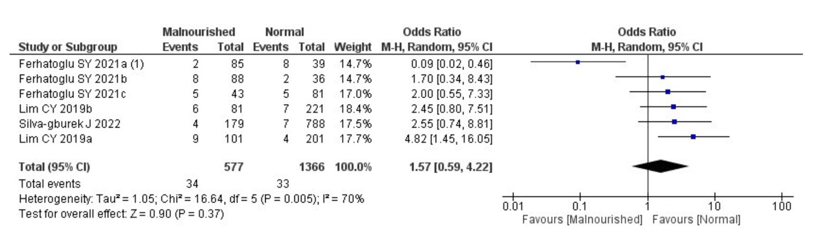
Figure 1. Forest Plot Analysis of Mortality in Children Undergoing Congenital Heart Surgery, Stratified by Nutritional Status

CILOSTAZOL: A VIABLE ALTERNATIVE FOR ASPIRIN-INTOLERANT PATIENTS IN CORONARY STENT IMPLANTATION - A SYSTEMATIC REVIEW AND META-ANALYSIS

C. A. N. Tanumihardja¹, I. Ivan², V. Winata³

¹General Practitioner, RSD Kalabahi, Alor, East Nusa Tenggara, Indonesia
²Internship Doctor, RSD Kalabahi, Alor, East Nusa Tenggara, Indonesia
³Gener

Background:
Aspirin intolerance presents a significant challenge in managing antiplatelet therapy for patients undergoing coronary stent implantation. Cilostazol, a phosphodiesterase III inhibitor with antiplatelet properties, has been proposed as an alternative. We evaluate the efficacy and safety of cilostazol as an alternative for aspirin in aspirin-intolerant patients undergoing coronary stent implantation.

Methods:
This systematic review aligns with the Preferred Reporting Items for Systematic Reviews and Meta-Analyses (PRISMA) 2020 guidelines. Comprehensive searches were conducted in databases including PubMed, ScienceDirect, Wiley Online, CENTRAL, and Google Scholar, covering literature up to 11 July 2024. Cohort studies comparing cilostazol with aspirin in aspirin-intolerant patients undergoing coronary stent implantation were eligible for inclusion. The primary outcomes measured were Major Adverse Cardiovascular Events (MACE), all-cause death, stroke events, bleeding events, and restenosis events.

Results:
Our analysis included three studies with a total of 2,757 participants. We found that cilostazol, administered at a dose of 100 mg per day (50 mg twice daily), demonstrated a favorable effect on the incidence of Major Adverse Cardiovascular Events (MACE) compared to aspirin, which was given at a dose of 100 mg once daily (Risk Ratio [RR] = 0.72, 95% Confidence Interval [CI] = 0.55-0.95). Cilostazol was also favorable in preventing restenosis compared to aspirin (RR = 0.27, 95% CI = 0.09-0.82). Additionally, cilostazol was non-inferior to aspirin for all-cause death (RR = 1.78, 95% CI = 0.71-4.47), stroke (RR = 2.54, 95% CI = 0.86-7.52), and bleeding complications (RR = 0.73, 95% CI = 0.29-1.87). Both cilostazol and aspirin were taken in combination with a P2Y12 inhibitor at the same dose in both the study (cilostazol) and control (aspirin) groups.

Conclusion:
Our study demonstrates that cilostazol is an effective and safe alternative to aspirin for aspirin-intolerant patients undergoing coronary stent implantation. Cilostazol shows favorable outcomes against major adverse cardiac events and in preventing restenosis, with non-inferior results for all-cause death, stroke, and bleeding complications compared to aspirin. These findings underscore the viability of using cilostazol in clinical practice for this specific patient population. However, further large-scale randomized controlled trials are warranted to confirm these results and establish definitive clinical guidelines.

Keywords: Cilostazol, MACE, Coronary stent implantation, Aspirin intolerance

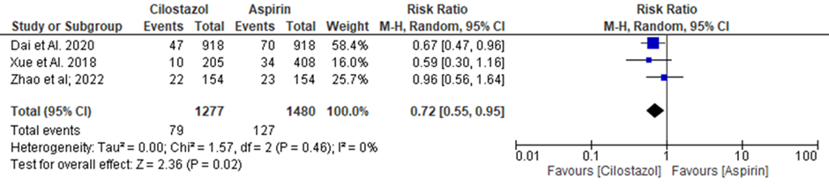
Figure 1. Major Adverse Cardiovascular Events on Cilostazol Compared to Aspirin in Aspirin-Intolerant Patients Undergoing Coronary Stent Implantation

OPTIMAL PULMONARY VASODILATORS IN PEDIATRIC PULMONARY HYPERTENSION: A SYSTEMATIC REVIEW AND MEDICATION RANKING WITH NETWORK META-ANALYSIS

J. Budiono¹, F. S. Hasibuan¹
¹Department of Cardiovascular Medicine, RSUD dr. R. Koesma Kabupaten Tuban, Jawa Timur, Indonesia

Background:
Selecting pulmonary vasodilators for pediatric patients with pulmonary hypertension (PH) is debatable. Meanwhile, the treatment approaches for pediatric PH patients mostly rely on clinical trials conducted on adults and clinical expertise. Therefore, we performed the first network meta-analysis to determine the most effective pulmonary vasodilators (whether phosphodiesterase-5 inhibitors, endothelin receptor antagonists, or prostacyclin) in terms of efficacy and safety for pediatrics diagnosed with PH.

Methods:
An extensive search was performed on PubMed, Embase, and Cochrane Library until May 2024 to identify randomized controlled trials (RCTs) that evaluated the pulmonary vasodilators and placebo in pediatric PH patients. The quality assessment of the trials included in the study was performed using the Cochrane risk of bias. A Bayesian network meta-analysis was conducted to investigate the most optimal pulmonary vasodilators for pediatric PH patients.

Results:
18 RCT studies comprising 848 patients were included in the final analysis. Twelve studies used sildenafil, three used bosentan, two used iloprost, and one used beraprost. The pulmonary vasodilators significantly improve mean pulmonary artery pressure (mPAP) [MD: -4.46 (95%CI: -7.86, -1.05; p-value: 0.01)], pulmonary arterial/aortic pressure (PA/AO) [MD: -0.09 (95%CI: -0.12, -0.07; p-value < 0.01)], and oxygenation index (OI) [MD: -13.34 (95%CI: -23.89, -2.80; p-value: 0.01)]. In addition, the pulmonary vasodilators significantly reduced mechanical ventilation duration [MD: -3.84 (95%CI: -7.28, -0.41; p-value: 0.03)], intensive care unit (ICU) stay [MD: -2.65 (95%CI: -4.65, -0.64; p-value: 0.01)], and mortality [RR: 0.21 (95%CI: 0.07, 0.62; p-value: 0.005)]. The Bayesian network meta-analysis suggests that sildenafil have the highest effectiveness in improving mPAP, improving PA/AO, improving OI, reducing ICU stay, and reducing mortality rate. Meanwhile, bonsentan indicated the highest effectiveness in decreasing the mechanical ventilation duration. Litmus rank-o-gram (figure 1) was also used to demonstrate the ranking of the medications.

Conclusion:
The meta-analysis showed that pulmonary vasodilators significantly improve hemodynamic and respiratory parameters, reduce mechanical ventilation duration, ICU stay, and mortality. In addition, the network meta-analysis suggested that sildenafil showed the highest effectiveness in majority of the efficacy and safety outcomes.

Keywords: endothelin receptor antagonists, pulmonary vasodilators, phosphodiesterase-5 inhibitors, pulmonary hypertension, network meta-analysis
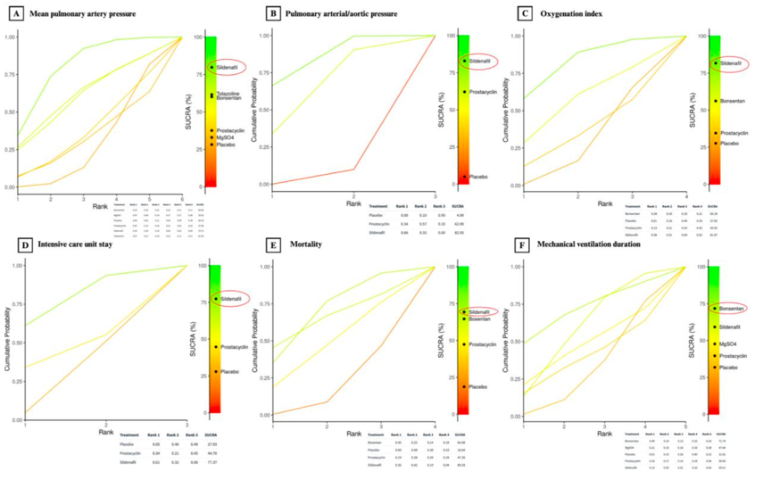
Figure 1. Litmus rank-o-gram from Bayesian network meta-analysis showed sildenafil showed the highest effectiveness in improving mPAP (A), improving PA/AO (B), improving OI (C), reducing ICU stay (D), and reducing mortality rate (E). Meanwhile, bonsentan indicated the highest effectiveness in decreasing the mechanical ventilation duration (F).
CLINICAL CHARACTERISTICS AND SURGICAL OUTCOMES OF COR TRIATRIATUM: A COMPREHENSIVE SYSTEMATIC REVIEW

W. Widiarti¹, Juliana¹, P. B. T. Saputra², Y. H. Oktaviono²

¹Faculty of Medicine, Universitas Airlangga, Surabaya, Indonesia
²Department of Cardiology and Vascular Medicine, Faculty of Medicine, Universitas Airlangga - Dr. Soetomo General Academic Hospital; Cardiovascular Research and Innovation Center, Universitas Airlangga

Background:
Cor triatriatum is a rare congenital heart defect with an abnormal membrane within the atrium, potentially resulting in obstructive blood flow. This study aims to investigate the clinical characteristics and surgical outcomes related to cor triatriatum.

Methods:
A systematic search on scientific databases were performed until March 31 2024 with following keywords: “(((((surgery) OR (surgical repair)) AND (outcome)) OR (results)) AND (cor triatriatum)) OR (Subdivided Left Atrium)”.

Results:
This study included 15 studies conducted in various countries, including the United States, Egypt, Australia, and South Korea, comprising 428 patients. The age of patients at the time of surgery ranged from neonates to adults. Clinical manifestations commonly included dyspnea, recurrent respiratory infections, failure to thrive, and heart murmurs. Cor triatriatum was frequently associated with other cardiac defects, particularly atrial septal defect (ASD).Surgical correction through median sternotomy and cardiopulmonary bypass proved effective, with low mortality rates. The presence of associated congenital heart defects often necessitated concurrent corrective procedures. Complications were infrequent but included arrhythmias, infections, and residual lesions. Echocardiography was instrumental in facilitating effective diagnosis and post-operative management.Long-term follow-up indicated that most patients remained asymptomatic, with the majority achieving New York Heart Association (NYHA) class I status, indicating no significant limitation in physical activity. Recurrence of the membrane was rare, and reintervention was seldom needed. The studies emphasized the efficacy and safety of surgical intervention, particularly in improving long-term outcomes for both classic and atypical forms of cor triatriatum.

Conclusion:
Surgical intervention for cor triatriatum typically yields excellent short-term and long-term outcomes. Long-term outcomes are generally favorable, although periodic monitoring for residual defects or complications is recommended.

Keywords: Cor triatriatum, Surgical outcomes, Congenital heart defect

INTRACORONARY INFUSION OF SUPERSATURATED OXYGEN IN PATIENTS WITH MYOCARDIAL INFARCTION UNDERGOING PERCUTANEOUS CORONARY INTERVENTION: A SYSTEMATIC REVIEW AND META-ANALYSIS

Z. Z. Aghna¹, A. Rachmantiawan¹, R. M. Candrasatria²

¹Faculty of Medicine, Lampung University
²Interventional Cardiology Division, Cardiology and Vascular Department, Abdul Moeloek General Hospital

Background:
Incidence of myocardial infarction (MI)-related mortality has decreased because of percutaneous coronary intervention (PCI). Despite this benefit of early reperfusion, MI management remains challenging because of reperfusion injury. Recent adjuvant therapy that has the potential to overcome this burden is supersaturated oxygen therapy (SSO₂). SSO₂ utilizes hyperoxemic levels of oxygen infusate to improve coronary microvascular flow after PCI. However, dedicated data on this topic remains scarce. We conduct the first systematic review and meta-analysis to evaluate the subsequent outcome of SSO₂ for patients with MI undergoing PCI.

Methods:
We systematically searched PubMed, ScienceDirect, and Cochrane for studies assessing the clinical outcome of SSO₂ in patients with MI undergoing PCI. The efficacy endpoint was infarct size and the safety endpoint were composite major adverse cardiovascular events (MACE), all-cause of mortality, reinfarction, and target vessel revascularization. Meta-analyses were performed on included studies. Odds ratio (OR), Mean Differences (MD) and 95% Confidence Interval (CI) were estimated using Review Manager v5.4.1

Results:
Four studies with a total of 1.610 patients were included. In patients with MI undergoing PCI, the use of SSO2 significantly reduced the infarct size (pooled MD: -4.09; 95% CI; -6.48–-1.70; p < 0.01; I2 = 0%). There are no significant difference between the use of supersaturated oxygen therapy compared to PCI-only treatment for composite MACE (pooled OR: 0.83; 95% CI; 0.31–2.24; p = 0.72; I2 = 54%), all-cause of mortality (pooled OR: 0.89; 95% CI; 0.10–8.18; p = 0.91; I2 = 59%), reinfarction (pooled OR: 0.89; 95% CI; 0.32–2.45; p = 0.82; I2 = 0%), target vessel revascularization incidence (pooled OR: 0.81; 95% CI; 0.33–1.97; p = 0.64; I2 = 0%).

Conclusion:
This is the first systematic review and meta-analysis assessing SSO₂ in patients with MI undergoing PCI. This study demonstrates that SSO₂ reduced infarct size and may provide promising results for MI patients undergoing PCI. This therapy had no safety concern based on studies we included.

Keywords: percutaneous coronary intervention, myocardial infarction, supersaturated oxygen therapy

EFFECT OF SGLT-2 INHIBITOR CANAGLIFLOZIN FOR HEART FAILURE PATIENTS WITH TYPE 2 DIABETES: A SYSTEMATIC REVIEW

C. A. Cendera¹, E. Tanially¹, L. K. Tori¹

¹Faculty of Medicine, Pelita Harapan University

Background:
Heart failure is a significant comorbidity associated with type 2 diabetes mellitus (T2DM), contributing to increased mortality and morbidity. Recently. sodium-glucose cotransporter-2 (SGLT-2) inhibitors have emerged as a promising therapy for glycemic control and cardiovascular benefits, including heart failure outcomes. One of these inhibitors is canagliflozin. This study evaluates the effect from both an efficacy and safety angle of the SGLT-2 inhibitor canagliflozin for HF patients with type 2 diabetes.

Methods:
Databases, such as Google Scholar, MDPI, and Wiley Online Library were systematically analyzed to extract studies on June 26, 2024. Keywords including “Canagliflozin", "Heart Failure", AND “Type 2 Diabetes” were used to gain relevant studies. The outcomes in this review are NT-proBNP concentrations and adverse events. Three independent researchers conducted this study. Studies in English from the last five years with accessible full text consisting of cohort studies, were included in this review. Studies that were systematic reviews, meta-analyses, animal studies, and case reports were excluded. The ROBINS-I tool is used to assess the quality of the studies.

Results:
Three studies were extracted for this review, including 429 participants. One study used was of low risk of bias and two other studies of moderate risk of bias based on the ROBINS-I tool. All studies showed that there is a reduction in the NT-proBNP concentrations in the canagliflozin group, however only in the early weeks of administration. After 24 weeks, the NT-proBNP concentration did not meet the predefined endpoint for the study to be effective. One study stated that canagliflozin administration also caused significant weight loss in patients. All studies showed that there were no adverse events following the administration. Another study stated that canagliflozin therapy at discharge was also correlated with a lower risk of readmission for HF.

Conclusion:
In conclusion, canagliflozin is only efficacious in the early stage of 4 weeks within its administration and showed no significant improvement after 24 weeks. Canagliflozin is also safe as there are no indicated adverse effects in the patients. However, further large-scale randomized studies are needed to conclude further the beneficial effects of canagliflozin in heart failure patients.

Keywords: heart failure, type 2 diabetes, canagliflozin

THERAPEUTIC MICRORNA IN ANGIOGENESIS PROCESS OF HINDLIMB ISCHEMIA: A SYSTEMATIC REVIEW

Hariadi¹

¹RSI AT-TAQWA GUMAWANG

Background:
Chronic limb-threatening ischemia (CLTI) represents the most advanced stage of peripheral artery disease. Recent approaches have proposed stimulating the angiogenesis process to enhance clinical results. Several studies have indicated that microRNAs (miRNAs) exert beneficial effects on limb ischemia. This study aims to review the therapeutic role of microRNAs in the angiogenesis of limb ischemia.

Methods:
A comprehensive search was performed up to July 2021 using the PubMed, Scopus, and Science Direct databases. The author assessed the role of miRNA in angiogenesis related to limb ischemia both in vivo and clinical research.

Results:
All the selected studies were conducted in vivo, comprising a total of 20 articles and examining 17 distinct microRNAs. These microRNAs potentially regulate angiogenesis by targeting different targets. The upregulation of the following microRNAs is essential for enhancing angiogenesis: miRNA-126-3p, -93, -130a, -210, -146b, -21, -let-7g, -132/212, and -150. Conversely, the downregulation of the following microRNAs is necessary: miRNA-15a/16, the 14q32 microRNA gene cluster, -100, -133a, -139-5p, -615-5p, -15b/5p, and -124-3p. Among these, miRNA-126 was the most extensively studied. However, the included studies exhibited significant heterogeneity concerning the induction of hindlimb ischemia and the timing of microRNA administration.

Conclusion:
MicroRNA’s application in preclinical model of hindlimb ischemia has demonstrated a beneficial impact on angiogenesis.

Keywords: gene target, limb ischemia, microRNA, angiogenesis

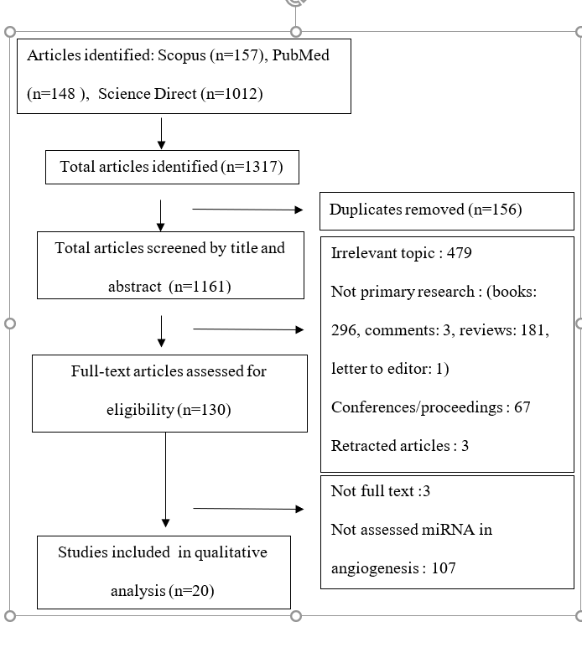
Figure 1. Flow Diagram of This Study

EVALUATING THE ROLE OF CATHETER ABLATION PRIOR TO TRANSCATHETER ATRIAL SEPTAL DEFECT CLOSURE IN ATRIAL FIBRILLATION: A SYSTEMATIC REVIEW AND META-ANALYSIS

P. P. P. Hutahaean¹, M. Sugiyanto¹, F. M. Chandra¹, Y. Kurniawati²

¹Faculty of Medicine, Universitas Indonesia, Jakarta, Indonesia
²Pediatric Cardiology and Congenital Heart Disease Division, Cardiology and Vascular Medicine Department, Faculty of Medicine, Universitas Indonesia, Jakarta, Indonesia

Background:
Atrial fibrillation (AF) is a common condition in adult patients with atrial septal defect (ASD) due to atrial dilation and pressure changes. While transcatheter ASD closure is known to promote electrical reverse remodeling, it is not associated with the reduction of atrial arrhythmias. Catheter ablation is the main option for patients with paroxysmal or persistent AF resistant to medications. However, its effect combined with ASD closure is still unclear. This review aims to synthesize the evidence on the association between catheter ablation before transcatheter ASD closure and AF recurrence.

Methods:
Literature searching was conducted through PubMed, ScienceDirect, EBSCOhost, and Scopus for cohort studies evaluating the recurrence of atrial fibrillation between patients with and without catheter ablation prior to transcatheter ASD closure. Atrial fibrillation recurrence in the hazard ratio (HR) was collected. Hazard ratios not stated in studies were obtained indirectly by two independent writers using formulas and the Kaplan-Meier curve data extraction method. Meta-analysis was performed using the generic inverse variance method (RevMan 5.4). The risk of bias in the studies was assessed using the Newcastle Ottawa Scale (NOS).

Results:
Three cohort studies (n=102) were included. In all studies, circumferential pulmonary vein isolation was done. Transcatheter closure was conducted after a minimum of three months blanking period. ASD closure devices chosen were Amplatzer septal occluder or Occlutech Figulla Flex II. Pooled analysis showed a significant reduction of AF recurrence in patients with catheter ablation (HR 0.20 [95% CI 0.10-0.42]). All studies had a low risk of bias.

Conclusion:
The findings suggest that catheter ablation prior to transcatheter ASD closure helps to lower AF recurrence in patients with paroxysmal AF. Further studies are needed to discover the true efficacy of catheter ablation.

Keywords: atrial septal defect, atrial fibrillation, device closure, catheter ablation

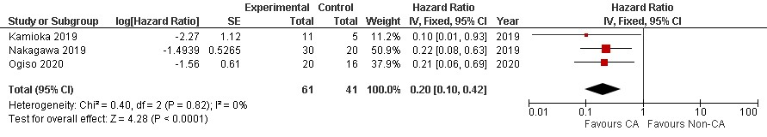
Figure 1. The pooled analyses of the association between catheter ablation and atrial fibrillation recurrence.

THE IMPORTANCE OF HEART RATE VARIABILITY MEASUREMENT IN TYPE 2 DIABETES MELLITUS PATIENTS

P. P. Nugiaswari¹

¹Udayana University

Background:
Type 2 diabetes mellitus (T2DM) individuals present reduced autonomic function in the cardiovascular system, evidenced by decreased heart rate variability (HRV), which results in cardiac autonomic neuropathy and increased risk for sudden cardiac death. HRV is a non-invasive measurement that indirectly reflects cardiac autonomic regulation. Its analysis is based on fluctuations in the sequential RR intervals from sinus rhythm. The aims of this study were to review the significance of measuring HRV in type 2 diabetic subjects.

Methods:
Literature review was conducted by formulating the research questions as the first step. Then, searching for extant literature and screening for inclusion were performed. Assessing the quality of primary studies was the next step. Extracting and analyzing data were the last steps.

Results:
Cardiac autonomic neuropathy is an independent risk factor for cardiovascular mortality and also is associated with a high risk of lethal arrhythmias and sudden death in people with type 2 diabetes. HRV is an index of cardiac autonomic function. HRV is significantly changed in diabetic patients and both sympathetic and parasympathetic autonomic nervous system activity were impaired. Study showed that most time- and frequency-domain HRV parameters were decreased in diabetic patients. It was reported that HRV parameters had a strong long-term predictive value of all-cause mortality in diabetic patients. On the other hand, decreased HRV could predict development of diabetes in an initially healthy population. Overall HRV (as determined by total power), sympathetic activity (low frequency power) and parasympathetic activity (time domain measures and high frequency power) were significantly reduced in all the diabetic subgroups, implying that both sympathetic and parasympathetic limbs are symmetrically affected in T2DM patients even in the earliest stages (<5 years) implying subclinical cardiac autonomic dysfunction in the earliest stages.

Conclusion:
Early diagnosis provides interventions in pre-diabetes patients, which is important in the primary prevention of T2DM and its chronic complications, such as cardiac abnormalities.

Keywords: heart rate variability, cardiac autonomy neuropathy, diabetes mellitus

