

ORIGINAL RESEARCH

VESSEL SUPPLIED MYOCARDIAL STRAIN ANALYSIS AS A PRESUMPTIVE NON-INVASIVE TOOL TO PREDICT THE CORONARY ARTERY STENOSIS IN PATIENT WITH CORONARY ARTERIAL DISEASE UNDERGOING PCI PROCEDURES

B. Afriansyah¹, M. Yanni², Nani²

¹RSU dr. Mdjamil Padang
²RSUP dr. Mdjamil Padang

Background:
Early diagnosis of coronary artery disease (CAD) remains a clinical problem in patients undergoing percutaneous coronary intervention procedures, especially in the absence of regional wall motion abnormalities and good ejection fraction on echocardiography. However, most CAD patients have significant stenosis in coronary arteries on coronary angiography despite normal echocardiography findings. Identification of these patients may have a major impact on treatment and prognosis.

Methods:
This study was carried on 30 Non-STEMI patients who underwent coronary angiography procedures in cardiac center DR. M. Djamil Padang Hospitals. All patients underwent thorough history taking, full clinical examination, 12 leads surface ECG, full 2D, M-mode and Doppler echocardiographic study, and two-dimensional speckle tracking echocardiography study.

Results:
The patients involved in this study had mean age 59 ± 11.7 year old with 76.7% were male. Fifty seven percents was non STEMI patients with smoking as the most prevalence risk factors for CAD. There was decrease GLS value despite normal LVEF in all subjects (-13.8 ± 2.77%) and we found a significant difference in GLS value and regional LV strain between significant stenosis group and non-significant stenosis group statistically (-13.87 ± 2.4 vs -16.26 ± 3.0, p = 0.037). ROC curve analysis demonstrated the ability of VMS to identify the presence of coronary stenosis of LAD, LCX or RCA (AUC for VMS-LAD 0.82 [0.67– 0.97] p=0.008; LCX 0.82 [0.66–0.97] p=0.009; RCA 0.84 [0.70–0.98] p=0.005).

Conclusion:
Global and regional peak longitudinal systolic strain can offer accurate and feasible, and non-invasive predictor in patients undergoing percutaneous coronary intervention procedures. Territorial strain assessed with STE might be a non-invasive tool to localize coronary artery stenosis in patients with NSTE-ACS, even without wall motion abnormalities.

Keywords: 2D speckle tracking echocardiography; Acute coronary occlusion; Non ST segment elevation acute coronary syndrome.

UTILIZING APACHE IV AND GRACE SCORES AS PREDICTORS OF MORTALITY COMPARED WITH SAPS-3 SCORES FOR ACUTE CORONARY SYNDROME PATIENTS IN THE CARDIAC VASCULAR CARE UNIT

T. Yudha¹, I. Prasetya¹, S. Anjarwani¹

¹saiful anwar hospital

Background:
Acute coronary syndromes (ACS) frequent cause of hospitalization in the cardiovascular care unit. Positive predictive data are being developed and shown to be effective for patients with ACS; the Global Registry of Acute Coronary Events, or GRACE, has shown the most accurate outcomes. In contrast, intensive care clinicians predominantly employ prognostic scores derived from diverse cohorts of critically ill patients. Prominent examples of such scores include APACHE IV and SAPS 3. This research endeavor aimed to assess and contrast the efficacy of these three scores across an unselected sample of ACS cases.

Methods:
The study included all ACS patients admitted from August 2021 to November 2023. Hospital mortality prediction was assessed using score calibration and discrimination.

Results:
There were 843 patients in total included. SAPS 3 could not be calibrated appropriately, whereas APACHE IV and GRACE could. Across all scores, discrimination was exceptional (area under the curve values of 0.811 for APACHE IV, 0.740 for GRACE, and 0.732 for SAPS 3).

Conclusion:
GRACE and APACHE IV were calibrated thoroughly in this cohort of intensive care unit-admitted ACS patients; however, SAPS 3 lacked such calibration. All three scores exhibited exceptional discrimination. GRACE and APACHE IV may be utilized to predict the risk of mortality in patients with ACS.

Keywords: Simplified Acute Physiology Score 3 Acute Physiology and Chronic Health Evaluation Score, Global Registry of Acute Coronary Events, intensive cardiovascular care unit

CORRELATION BETWEEN ELECTROCARDIOGRAPHIC PHENOTYPE AND GENOTYPE IN CHILDREN WITH RASOPATHY SYNDROMES

A. F. Sunjaya¹, O. Boleti², J. P. Kaski¹

¹Institute of Cardiovascular Science, University College London
²Zayed Centre for Research into Rare Diseases in Children, Great Ormond Street Hospital for Children

Background:
RASopathy syndromes constitute a phenotypically similar group of malformation syndromes caused by dysregulation of the RAS/MAPK pathway. Collectively, they are one of the largest groups of multiple congenital anomalies known, affecting approximately 1 in 1000 individuals. Hypertrophic cardiomyopathy (HCM) is the second most common cardiac abnormality found in the syndrome. Characteristic ECG features are thought to be present in RASopathy-associated HCM (R-HCM), but this has never been systematically studied and its link with RASopathy type and genotype is still poorly understood. This study aims to determine the correlation between ECG findings on RASopathy-associated HCM patients and RASopathy syndrome type as well as genotype.

Methods:
Data from Great Ormond Street Hospital electronic health records of children (<18 years old), from the period of 1985-2023, presenting with R-HCM was collected. Data from Sarcomeric HCM (S-HCM) patients were also included as a comparison group. Patients included have baseline ECG available within a year of first date of assessment. Repeated and blinded systematic ECG assessment was carried out to reduce bias. Association between ECG phenotype and RASopathy type and genotype was analysed. Link between ECG and mortality was carried out using logistic regression.

Results:
Eighty four R-HCM patients were included in the study with 113 S-HCM patients as a comparison group. Median age of R-HCM patients was 6 years (IQR 11-19.5). The majority of patients have Noonan syndrome (n=59, 70.2%), with the most common genetic variants being PTPN11 (29.8%), RAF1 (13.1%), and HRAS (8.3%). In comparison with S-HCM, ECG in R-HCM patients show significantly more evidence of superior axis deviation (29.8% vs 2.5%, p-value <0.001) and RVH criteria (52.4% vs 28.3%, p-value=0.001). No significant association between ECG phenotype and RASopathy syndrome type or genotype was found. No significant link between specific ECG phenotype and mortality was found.

Conclusion:
Several ECG features common in R-HCM were identified, with some being unique to the syndrome such as extreme axis deviation and RVH criteria. No significant association between ECG phenotype and RASopathy type as well as genotype was found. Possible reason for results is due to the small study sample size. Larger multi-centred studies are required to confirm these findings.

Keywords: RASopathies, Electrocardiogram, Hypertrophic Cardiomyopathy, Sarcomeric HCM, Genotype

UNVEILING THE HIDDEN CULPRITS: A RETROSPECTIVE INSIGHT OF HEART FAILURE RISK FACTORS AT RSUD DR. R. KOESMA, TUBAN

I. Fitriani¹, F. S. Hasibuan¹

¹Rumah Sakit Umum Daerah dr. R. Koesma Tuban

Background:
Heart failure is a major public health issue with various underlying risk factors contributing to its prevalence. In our hospital, heart failure is the highest cause of admission to cardiac polyclinic. Understanding these risk factors is crucial for improving patient outcomes and developing targeted interventions. This study aims to evaluate the primary causes of heart failure among patients at RSUD dr. R. Koesma, Tuban.

Methods:
A cross-sectional retrospective study was conducted using medical records from May 1-7, 2024. The study population included patients admitted to cardiac polyclinic with heart failure within this period. Patient not included are those who have incomplete data or have not undergone any examination. Data on potential risk factors such as hypertension, diabetes mellitus, coronary heart disease, dyslipidemia, age, and gender were extracted and analyzed.

Results:
Ninety five patients met the inclusion criteria. Hypertension was present in 53.7% of patients. Diabetes mellitus, dyslipidemia, and coronary heart disease were observed in 33.7%, 50.5%, and 48.4% of patients, respectively. The age of patients are well distributed which were 35% (54 and younger), 27% (55-64), 27% (65-74), and 7% (75+) , with a mean age of 58,9 years. Gender distribution showed a slight female predominance (57.9%).

Conclusion:
This research is a preliminary study to show the characteristics of heart failure patients in our hospital. The findings shown that the younger age group have the highest number of patients, this might highlight the importancy of early screening in Tuban. Collaboration with primary healthcare facilities, the government, and other social aspects is essential to reduce the incidence of heart failure in young people. Additionally, better management and prevention of risk factors such as diabetes, hypertension, dyslipidemia, and coronary heart disease are necessary. Further study should be continued to find the significancy and relation of each risk factor for heart failure among patients at RSUD dr. R. Koesma, Tuban.

Keywords: diabetes mellitus, heart failure, age, hypertension, coronary heart disease

ARTIFICIAL INTELLIGENCE IMPROVED ACCURACY TO PREDICT CLINICAL OUTCOMES IN ACUTE DECOMPENSATED HEART FAILURE WITH REDUCED EJECTION FRACTION AND DIABETES

A. Halimi¹, H. S. Muliawan¹, V. G. Rejeki¹, D. Y. Hasanah¹, A. Y. Husodo², S. Adiarto¹, W. Jatmiko³, B. Widyantoro¹

¹Department of Cardiology and Vascular Medicine, Faculty of Medicine, Universitas Indonesia, National Cardiovascular Center Harapan Kita
²Department of Informatics Engineering, Universitas Mataram
³Faculty of Computer Science, Universitas Indonesia

Background:
Heart failure (HF) patients often experience readmissions with a high mortality rate, therefore early detection and appropriate management are required to improve the prognosis. The risk of hospitalization due to heart failure is increased 1.5x in type 2 diabetes mellitus (DM) patients. Using artificial intelligence (AI), clinical data can be integrated with supporting examinations such as ECG and chest X-ray. Artificial intelligence can also help diagnoses in the cardiovascular field without inter-observer variability, as well as increasing time and cost efficiency. This study aims to compare the ability of conventional statistics compared with AI in predicting clinical outcomes, namely length of stay, 30 day readmission, 180 day mortality, and composite outcome in acute decompensated heart failure (ADHF) patients with reduced ejection fraction (EF) and type 2 DM.

Methods:
A retrospective cohort study was conducted at National Cardiovascular Center Harapan Kita on 292 ADHF patients with reduced EF and type 2 DM in the period January 2018 – March 2023. Data analysis was carried out using conventional statistics with bivariate and multivariate analysis, where the results were then compared with analysis using Balanced Random Forest, an AI algorithm.

Results:
The percentages of outcomes observed for length of stay >5 days, 30-day readmission, 180-day mortality, and composite outcome were 39.7%, 14.0%, 10.6%, and 21.2% respectively. The discrimination ability of AI was better than conventional statistics for all four outcomes, with the AUC of length of stay >5 days were 0.800 vs 0.775, readmission 0.790 vs 0.732, mortality 0.794 vs 0.785, and composite outcome 0.628 vs 0.596.

Conclusion:
AI performed better than conventional statistics in predicting clinical outcomes in the form of length of stay, 30-day readmission, 180-day mortality, and composite outcome in ADHF patients with reduced EF and type 2 DM.

Keywords: artificial intelligence, clinical outcome, HFrEF, type 2 DM, ADHF

PREDICTIVE VALUE OF THE COMBINATION OF AGE, CREATININE, EJECTION FRACTION, AND DIABETES (ACEF-DM) SCORE IN STEMI PATIENTS UNDERGOING PRIMARY PCI

F. M. W. Sondakh¹, C. Setiawan¹, C. A. A. Rosmaningtyas¹, F. M. Yofrido¹, Kalyanavati¹, F. H. Maradjabessy¹, C. Kurniawan¹, S. H. Rampengan¹, V. F. F. Joseph¹, E. L. Jim¹

¹Department of Cardiology and Vascular Medicine, Faculty of Medicine, Sam Ratulangi University, Manado

Background:
The age, creatinine, and ejection fraction (ACEF) score was originally developed for risk stratification of patients undergoing elective cardiac surgery. The combination of ACEF and diabetes (ACEF-DM score) has demonstrated superior discriminatory ability compared to the original ACEF score in STEMI patients. Accurate risk assessment and stratification at an early stage after STEMI are crucial in clinical practice. This study aims to adapt the ACEF-DM score for risk assessment in STEMI patients undergoing primary PCI.

Methods:
This observational study employed a hospital-based cohort design. Data were retrospectively collected from STEMI patients who underwent PPCI at Prof. Dr. R. D. Kandou General Hospital Manado between January 1, 2019, and December 31, 2022. The relationship between the ACEF-DM score and major adverse cardiovascular events (MACE), including all-cause mortality, rehospitalization, repeat revascularization, stroke, and heart failure during hospitalization was analyzed using bivariate analysis and ROC curves.

Results:
A total of 207 STEMI patients underwent PPCI with DES stent implantation, with a median age of 59 (IQR 52-66). Of these, 174 (84.1%) were male, and 66 (31.9%) had T2DM. The total all-cause mortality was 19 (9.2%), rehospitalization 45 (21.7%), repeat revascularization 9 (4.3%), stroke 2 (1%), and heart failure during hospitalization 56 (27.1%). ROC curve analysis revealed that the ACEF-DM score's prognostic value for predicting MACE had an AUC of 0.673. A higher ACEF-DM score (>1.34) was significantly associated with an increased risk of MACE (RR=2.08, 95% CI 1.39–3.11, P < 0.001).

Conclusion:
STEMI patients undergoing PPCI with a high ACEF-DM score had a 2.1 times higher risk of experiencing MACE. The ACEF-DM score provides better predictive value, aiding in the stratification of high-risk patients and potentially facilitating clinical decision-making.

Keywords: ACEF, PPCI, STEMI, DM

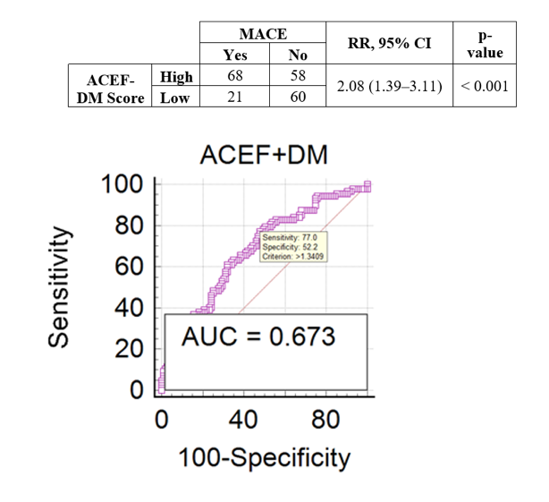
Figure 1. ROC curve & predictive value from ACEF+DM score
CARDIOVASCULAR DISEASE RISK ASSESSMENT OF PATIENTS AT THE KARANG BARU COMMUNITY HEALTH CENTRE, ACEH TAMIANG: A CROSS-SECTIONAL STUDY

N. K. Fitri¹, Y. B. Saragih¹

¹Aceh Tamiang General Hospital

Background:
The rise of cardiovascular disease (CVD) in Indonesia is driven by demographic changes, urbanization, lifestyle shifts, and socioeconomic conditions. In Aceh, 26.5% of the population is hypertensive, with most cases in Aceh Tamiang. Modifiable factors like obesity and smoking and non-modifiable factors like gender and genetics contribute to this risk. Public health initiatives focusing on prevention, early detection, and CVD management are crucial, especially in rural areas.

Methods:
A cross-sectional study was conducted over 3 months (March-May 2024) at a community health center, involving 10,912 people. A sample of 1,035 participants aged 40 and older consented to join. Data on age, BMI, SBP, gender, smoking status, and risk classifications were collected. Salt consumption and activity levels were categorized. Risk classification used WHO CVD risk charts for South-East Asia. Statistical analyses included ANOVA, Chi-square tests, and logistic regression. Analyses were performed using SPSS software.

Results:
Participants had an average age of 55.41 ± 9.51 years; 40% were men and 60% women. The average BMI was 26.48 ± 4.38, and the average SBP was 138.51 ± 20.36 mmHg. Smoking prevalence was 34.5%. Salt intake was low for 43.5%, moderate for 29.2%, and high for 27.3% of participants. Activity levels were mostly light (98.4%). Chi-Square tests showed a significant association between smoking and high CVD risk (χ2(1) = 10.85, p = 0.001). Logistic regression identified significant predictors of CVD risk: gender (OR = 2.34, p = 0.03), smoking (OR = 3.21, p = 0.002), age (OR = 1.78 per decade, p = 0.01), BMI (OR = 1.15 per unit increase, p = 0.04), SBP (OR = 1.22 per 10 mmHg increase, p = 0.02), salt consumption (OR = 1.349, p = 0.01), and distance from healthcare (OR = -0.005, p = 0.03).

Conclusion:
CVD risk is influenced by behavioral, demographic, and clinical factors. Reducing smoking, managing BMI, controlling blood pressure, and modifying dietary habits are crucial. Gender-specific and age- targeted interventions are necessary. Future research should explore the socio-environmental dynamics affecting healthcare access and CVD risk to develop comprehensive prevention strategies.

Keywords: Rural Health, Cardiovascular Disease, Risk Factors, Hypertension, Indonesia

EVALUATING THE CAPABILITY OF INDONESIAN PRIMARY HEALTH CARE (PUSKESMAS) IN MANAGING CARDIOVASCULAR DISEASES: A MULTICENTRE STUDY

W. Widiarti¹, W. S. P. Harmadha², C. E. C. Z. Multazam², F. R. Muharram³, J. B. Swannjo¹, I. F. Arba¹, P. P. Siahaan¹, O. N. Salsabila¹, M. H. Mahyuddin¹, A. Salsabila¹, Andrianto⁴, M. Ardiana⁴

¹Faculty of Medicine, Universitas Airlangga, Surabaya, Indonesia
²National Heart and Lung Institute, Imperial College London, London, United Kingdom
³Department of Global Health and Social Medicine, Harvard Medical School, Boston, Massachusetts, United States of America
⁴Department of Cardiology and Vascular Medicine, Faculty of Medicine, Universitas Airlangga - Dr. Soetomo General Academic Hospital; Cardiovascular Research and Innovation Center, Universitas Airlangga

Background:
The escalating prevalence of cardiovascular disease (CVD) globally, driven by aging populations, urbanization, lifestyle changes, and healthcare access, is a significant concern. In Indonesia, ischemic heart disease is the leading cause of premature death. The extensive network of over 10,000 primary health care facilities (PUSKESMAS) is vital in addressing this issue, especially in low-resource settings. This study aims to evaluate the capability of PUSKESMAS in delivering cardiovascular services aligned with the latest guidelines, in order to identify gaps between practice and standards.

Methods:
Utilizing the WHO Service Availability and Readiness Assessment (SARA) and the latest European Society of Cardiology (ESC) guidelines, adapted to Indonesian regulations, data were collected from 38 PUSKESMAS across Indonesia from October to December 2023, including Aceh, DKI Jakarta, Special Region of Yogyakarta, Central Java, East Java, Bali, East Nusa Tenggara, East Kalimantan, North Kalimantan and South East Sulawesi. The study used structured interviews and questionnaires to examine general services, human resources, diagnostic tools, supporting equipment, and essential medicine availability. Capability scores were calculated based on these domains.

Results:
PUSKESMAS provide comprehensive cardiovascular services, including health promotion, disease prevention, and diagnosis. Most offer basic treatments and inpatient care. Readiness scores for managing CVD, based on ESC guidelines, ranged from 37.01 to 71.29, and according to WHO SARA criteria, from 42.33 to 82.51. Notably, nearly half of the PUSKESMAS scored below average (ESC: 47.37%, WHO SARA: 44.74%). The noticeable shortcomings identified from the limited availability of diagnostic tools and essential medicine shortages.

Conclusion:
Despite their critical role, PUSKESMAS in Indonesia need enhanced capabilities to provide optimal cardiovascular services, particularly in diagnostic tools and essential medicine availability. Targeted improvements and collaborations with governmental and stakeholder entities are crucial to effectively mitigate the cardiovascular disease burden effectively

Keywords: Primary health care, Cardiovascular disease, Service readiness

DIFFERENCES IN THE EFFECTS OF NEBIVOLOL AND BISOPROLOL ON INTERLEUKIN-6 LEVELS IN ACUTE MYOCARDIAL INFARCTION PATIENTS

I. P. R. S. Wiratama¹, A. Yasa¹

¹Sebelas Maret University

Background:
Inflammation plays an important role in the pathogenesis of acute myocardial infarction (AMI) and post-AMI events. Cytokine-induced inflammatory mediators such as Interlekuin-6 (IL-6) and activation of oxidative stress are the most important molecular mechanisms contributing to LV dysfunction after AMI. Nebivolol is able to reduce oxidative stress and inflammation, and bisoprolol is also can suppress inflammatory cytokines. The ability of nebivolol and bisoprolol to suppress inflammatory cytokines is a beneficial effect for AMI patients. In this study, we compare the differential effect of nebivolol and bisoprolol on IL-6 levels in patients with acute myocardial infarction.

Methods:
It is asingle center experimental study with a randomized control trial conducted in November 2023. A total of 35 AMI patients undergoing treatment at dr. Moewardi General Hospital Surakarta was sequentially involved in the research and then randomly divided into nebivolol group and bisoprolol group where total of 5 patients were excluded. Blood plasma was taken on the first day before treatment and on the 7th day after therapy. IL-6 levels were examined using the ELISA method.

Results:
There was a significant decrease (186.81) in IL-6 in the nebivolol group compared to the bisoprolol group (70.29) and the results were statistically significant (p=0.032). The nebivolol group had a 94.0% decrease in IL-6 compared to the bisoprolol group's 82.0% decline. Multivariate analysis results also showed that nebivolol (r=0.259; p=0.043) was significantly associated with a decrease in IL-6, with a p value <0.05.

Conclusion:
There is a difference in the reduction of IL-6 in the nebivolol group compared to the bisoprolol group. The decrease in IL-6 was greater in the nebivolol group than in the bisoprolol group, although nebivolol and bisoprolol could reduce IL-6 levels significantly during the 7 day observation period.

Keywords: interleukin-6, bisoprolol, nebivolol

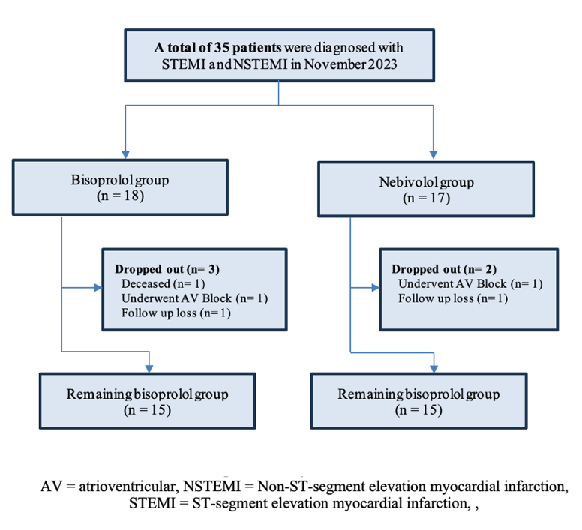
Figure 1. Study flow selection

CARDIAC POWER OUTPUT BY ECHOCARDIOGRAPHY: A POTENT PREDICTOR OF MORTALITY IN STEMI PATIENTS – INSIGHTS FROM THE SCIENCE REGISTRY

D. Setiaji¹, F. Saputra¹, H. P. Bagaswoto¹, B. Y. Setianto¹

¹Universitas Gadjah Mada

Background:
The prognostic value of cardiac power output (CPO), derived from echocardiography, in predicting in-ICCU (Intensive Cardiac Care Unit) mortality among patients with ST-elevation myocardial infarction (STEMI) remains under-explored. This study aims to evaluate the predictive power of CPO in determining the risk of mortality in STEMI patients during their hospitalization in the ICCU.

Methods:
A retrospective cohort study was conducted using data from the Science Registry. The study population consisted of 700 STEMI patients admitted to the ICCU from January-December 2023 and 15 patients excluded due to incomplete data. The CPO measured via echocardiography performed within one day after admission. Patients were categorized based on their CPO values, with a threshold of ≤ 0.6 W and > 0.6 W. A multivariable logistic regression analysis was used to examine the association between CPO and adjusted in-ICCU mortality.

Results:
A total of 700 patients (79,3% male) were evaluated with admission diagnosis as STEMI (Anterior MI 50,7%, non-anterior MI 49,3%). A total of 104 patients (15%) died in the ICCU. Among patients with a CPO ≤ 0.6 W, the incidence of cardiac arrest, cardiogenic shock, and mortality was significantly higher compared to those with a CPO > 0.6 W (P= < 0.001). From multivariable analysis revealed that patients with a CPO ≤ 0.6 W had a mortality risk that was twice as high compared to those with a CPO > 0.6 W (OR 1.957, P = .042).

Conclusion:
Cardiac power output measured by echocardiography is a valuable predictor of in-ICCU mortality in STEMI patients. A CPO ≤ 0.6 W measured by echocardiography can effectively predict mortality in ICCU patients with STEMI. This offers a promising non-invasive alternative to traditional invasive CPO measurement using a Pulmonary Arterial Catheter.

Keywords: CPO, Echocardiography, STEMI, ICCU, Mortality

INTEGRATION OF MOBILE ECG APPLICATION AND ECG INTERPRETATION OFFLINE WORKSHOP FOR HEALTHCARE PROFESSIONALS IN YOGYAKARTA

B. Hafizhah¹, H. M. Solikhah¹, P. P. R. Gharini², R. A. Gumilang², A. B. Hartopo², R. K. Marsam², V. A. N. Fatimah¹, S. Hasana¹, O. Kokasih¹

¹Faculty of Medicine, Public Health, and Nursing, Gadjah Mada University
²Department of Cardiology and Vascular Medicine, Faculty of Medicine, Public Health, and Nursing, Gadjah Mada University

Background:
Electrocardiogram (ECG) plays a major role in diagnosing cardiovascular disease (CVD). Despite the escalating CVD rates, medical professionals exhibit suboptimal ECG interpretation skills due to inadequate training and declining competencies over time. Conventional teaching methods have proven ineffective. The Mobile ECG application was developed in 2022, employing online learning to enhance ECG interpretation skills. While previous studies demonstrated the efficacy of Mobile ECG in online learning, this study aims to evaluate its impact in a one-day timeframe ECG offline workshop setting.

Methods:
An observational study was done using a Mobile ECG application in combination with an offline workshop. Participants were recruited using consecutive sampling. The inclusion criteria were participants of ECG Interpretation Offline Workshop and agreed to participate in this study. Participants were assigned to a 2-hour offline workshop. Pre- and post-test analysis and System Usability Scale (SUS) questionnaire were used to evaluate the study.

Results:
A total of 28 participants were analyzed in the study, with the majority of participants (89.7%) being general practitioners. The study showed a significant result based on the mean pre- and post-test scores of 29,29 ± 15,62 and 48,21 ± 16,79 (p-value < 0.05), respectively. According to the SUS score, this study demonstrated good usability (73.19, SD 15.45). The evaluation of users’ experiences also showed participants’ satisfaction, while some issues were further needed, such as offline access to the features, teaching video materials, and discussion forum.

Conclusion:
Mobile ECG application is favorable to be a complementary learning media in an ECG interpretation offline workshop to improve interpretation skills for healthcare professionals.

Keywords: ECG interpretation, System Usability Scale, Mobile ECG application, healthcare professionals, ECG offline workshop

Table 1. SUS study score

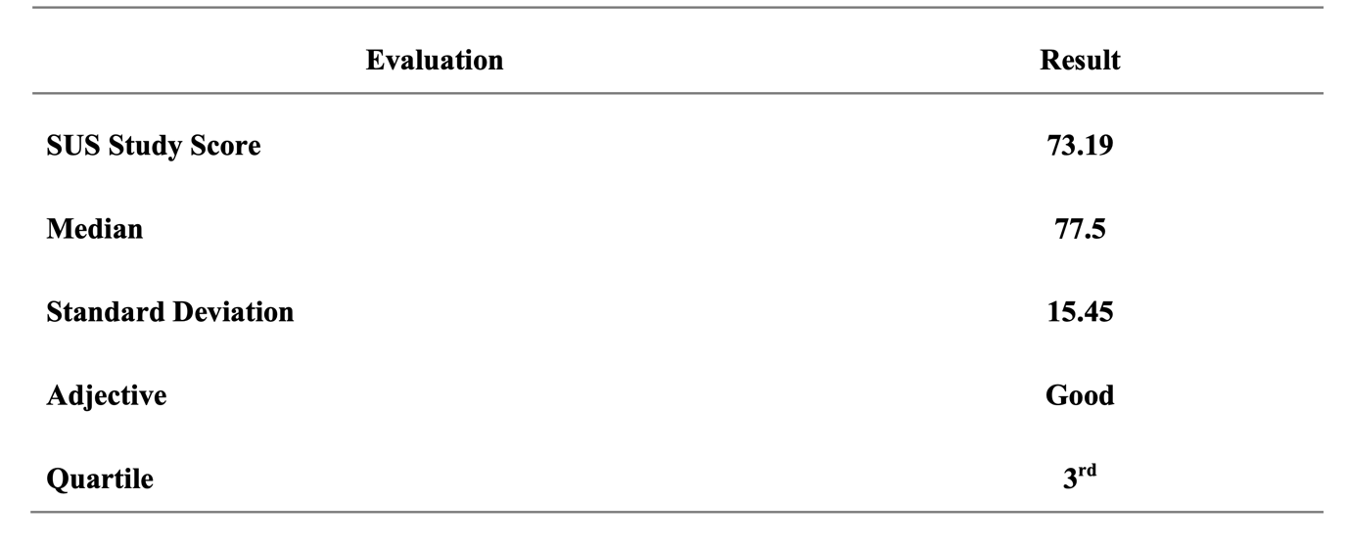
1-YEAR MORTALITY IN PATIENT WITH LEFT MAIN BIFUCARTION ONE-STENT STRATEGY VERSUS TWO-STENT STRATEGY

Y. J. Rasyid¹, A. Saboe¹, A. F. Yahya¹

¹Department of Cardiology and Vascular Medicine, Faculty of Medicine, Universitas Padjadjaran/Dr. Hasan Sadikin General Hospital, Bandung, Indonesia

Background:
Percutaneous Coronary Intervention (PCI) is an invasive procedure performed on Coronary Artery Disease (CAD) patients. PCI of the Left Main (LM) artery is a complex procedure and has many post-operative complications. The procedure for treating patients with LM bifurcation lesion usually using Coronary Artery Bypass Graft (CABG) or PCI, where PCI usually uses one-stent or two-stent methods. This study aimed to compare 1-year mortality between the one-stent strategy and the two-stent strategy in the treatment of LM bifucartion lesion.

Methods:
An analytical cross-sectional observational study was conducted involving 57 patients with CAD and LM bifurcation lesions underwent PCI in Hasan Sadikin General Hospital Bandung from January 2020 to May 2023. Participants were divided into two groups: the one-stent strategy group and the two-stent strategy group. Mortality was assessed during a one year follow-up period post-PCI

Results:
There were 57 patients included in this study, 31 were in the one-stent strategy group and 26 were in the two-stent strategy group. The average age of patients was 61.08 ± 8.86 with the majority were men (80.7%) and most often diagnosed with Chronic Coronary Syndrome (CCS) (68.4%). The most common risk factor was hypertension (70.1%). Of the 1 year follow-up, 1 person died (33.3%) in the one-stent strategy and 2 people died (66.7%) in the two-stent strategy (P= 0.587).

Conclusion:
There was no significant difference in the occurrence of 1-year mortality between patients treated with the one-stent strategy and those treated with the two-stent strategy

Keywords: left main disease, two-stent strategy, one-stent strategy, stent, PCI

EVALUATION OF INDEX OF CARDIAC-ELECTROPHYSIOLOGICAL BALANCE CHANGE USING PEAK-TO-END T WAVE DURATION BEFORE AND AFTER HEMODIALYSIS IN PATIENTS WITH END-STAGE RENAL DISEASE
J. C. Kurniawan¹, V. Bandana¹, G. Soemara¹, H. W. Rawung¹, Kalyanavati¹, F. W. Sondakh¹, C. Setiawan¹, F. H. Maradjabessy¹, A. T. Ali¹, B. M. Setiadi¹, J. A. Pangemanan¹
¹Department of Cardiology and Vascular Medicine, Faculty of Medicine, Sam Ratulangi University, Manado, Indonesia

Background:
Patients with end stage renal disease (ESRD) undergoing hemodialysis have a high cardiovascular mortality rate and a higher risk of developing ventricular arrhythmias and sudden cardiac death. Index of cardiac-electrophysiological balance (iCEB) is a non-invasive parameter showing the risk of ventricular arrhythmia. Peak-to-end T wave (Tp-e) is expected to serve as a simple iCEB screening tool in assessing the risk of impaired ventricular repolarization and the occurrence of ventricular arrhythmias in this population. In this study, we aim to assess ventricular repolarization using Tp-e change before and after hemodialysis.Index of cardiac-electrophysiological balance (duration of Tp-e)

Methods:
This was a cross-sectional study, conducted in November-February 2022. It included 43 ESRD patients who underwent electrocardiogram, echocardiogram, and laboratory examination before and after hemodialysis. Exclusion criteria was patients with LVEF ≤ 50%, patients with structural heart disease/ significant valvular lesion, patients with significant electrolytes abnormalities, patient currently on QT prolonging drugs, patients with atrial fibrillation or implanted cardiac devices. The changes in Tp-e parameters before and after hemodialysis were compared using paired t-test.

Results:
From all 43 subjects, 55.8% were male patients with a median age of 54 years. Hypertension (79%) and diabetes mellitus (44.1%) were the most common comorbidities in this population. There was no significant difference of mean LVEF before and after hemodialysis (57.20 ± 5.17 vs 57.54 ± 5.04, p = 0.564). There was a significant decrement of mean potassium level after hemodialysis (4.92 ± 0.81 vs 4.58 ± 0.6, p = 0.000), while there was significant increment of mean calcium level after hemodialysis (9.30 ± 1.42 vs 9.93 ± 1.34, p = 0.000). The mean of Tp-e duration before hemodialysis was 83.98 ± 18.70ms, while the mean of Tp-e duration after hemodialysis was 88.59 ± 20.67. There was a significant 4.61 ± 13.64 increment Tp-e after hemodialysis (p=0.032).

Conclusion:
Tp-e was found to increase after hemodialysis suggesting that potential vulnerability malignant ventricular arrhythmia risk increases after hemodialysis episode. Larger studies on this subject are needed to confirm our results.

Keywords: Index of cardiac-electrophysiological balance, Peak-to-end T wave duration, End stage renal disease, hemodialysis, ventricular arrhythmia

Table 1. Comparison of electrocardiogram, echocardiogram, and laboratory parameters before and after hemodialysis
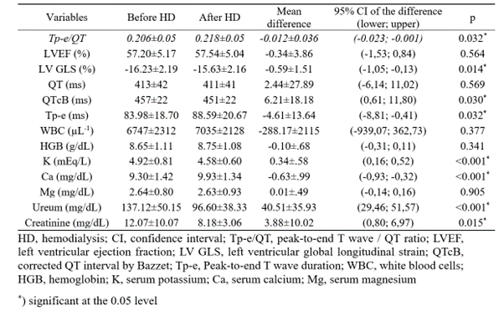
NEUTROPHIL/LYMPHOCYTE RATIO (NLR) VERSUS PLATELET/LYMPHOCYTE RATIO (PLR) AS PREDICTOR IN HOSPITAL DEATH IN STEMI PATIENT: IS THERE STILL AN ASSOCIATION?

M. A. Rahmadhani¹, H. P. Bagaswoto¹, F. Saputra¹

¹RSUP DR. SARDJITO

Background:
It has been known that inflammatory process plays a role in the process coronary heart disease, especially ST Elevation Myocardial Infarction. The aim of this study was to investigate Neutrophil/Lymphocyte Ratio versus Platelet/Lymphocite Ratio as predictor of mortality in ST segment elevation myocardial infarction patients

Methods:
This study was a single-center, retrospective and observational study were enrolled from July 2022 – June 2024 in Sardjito Hospital. One thousand three hundred and eighty four STEMI patients was found. The white blood cell subtypes and platelets counts were determined in the blood samples obtained at the emergency room.

Results:
Bivariate tests showed that both variables, NLR and PLR has an association with incidence of mortality in hospital (NLR P < 0.01 and PLR < 0.01, Cut off value for NLR is 6,5). However, NLR shows a linear relationship, that a one point increase in NLR will increase mortality by 0.034. Meanwhile, PLR shows an inverse relationship, where an increase of one point in PLR reduces mortality by 0.198. Meanwhile, in multivariate tests, NLR (P 0.947) and PLR (P 0.721) failed to show a relationship as predictors of in hospital mortality.

Conclusion:
Neutrophil/lymphocyte ratio can predict in hospital mortality than Platelet/lymphocyte ratio. Further studies need to be carried out in the same population with other inflammatory markers so that predictors of mortality can be assessed.

Keywords: Neutrophil/Lymphocyte Ratio, Platelet/Lymphocyte Ratio, predictor, mortality

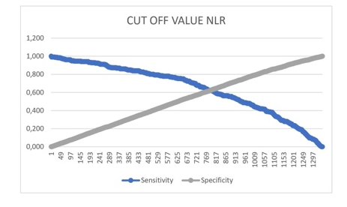
Figure 1. Cut off value NLR for Predictor In Hospital Mortality STEMI Patient
THE SIGNIFICANCE OF THE LEFT ATRIUM VOLUME INDEX IN PREDICTION OF VENTRICULAR ARRHYTHMIAS IN PATIENTS WITH HEART FAILURE PRESERVED EJECTION FRACTION AND END-STAGE RENAL DISEASE ON HEMODIALYSIS

C. Setiawan¹, F. B. Santoso¹, A. T. A. Ali¹, K. Vati¹, F. M. W. Sondakh¹, F. H. Maradjabessy¹, F. M. Yofrido¹, C. Kurniawan¹, B. M. Setiadi¹, E. L. Jim¹

¹Department of Cardiology and Vascular Medicine, Faculty of Medicine, Sam Ratulangi University, Manado

Background:
Annual cardiovascular mortality in patients with end-stage renal disease undergoing hemodialysis is much higher than in general population. Left atrial size was knowingly related to increased cardiovascular events in subjects on hemodialysis.

Methods:
This was a cross-sectional study conducted from January to March 2023 in Manado. This study involved patients with heart failure preserved ejection fraction and end-stage renal disease on hemodialysis. Patients were separated into two groups: those who were with high grade ventricular arrhythmia and not. Receiver operating characteristics (ROC) analysis were produced to investigate LAVI as a predictor of ventricular arrhythmia and to determine a cut-off point for LAVI in predicting ventricular arrhythmia, according to sensitivity and specificity.

Results:
This study include 45 patients with the mean age 53±12 years old, 55% of male patients, mean LVEF was 57.7±7.2%. The median duration of hemodialysis was 26 months (14-42 months). The mean LAVI in patients with high grade ventricular arrhythmia significantly higher (56.6±18.7 vs 41.9±14.4 ml/m² ). The cut-off points of LAVI value in predicting the risk of ventricular arrhythmia was 61.87 ml/m². Patients with LAVI > 61.87 ml/m² was 2.9 times higher to have high grade ventricular arrhythmia which could have subsequent lethal ventricular arrhythmia (p <0.001, 95%CI: 1.8-4.6).

Conclusion:
LAVI is an important forecaster of progression of ventricular arrhythmia and might be useful to optimalize sudden cardiac death prevention in patients with end-stage renal disease on hemodialysis.

Keywords: ESRD, hemodialysis, high grade ventricular arrhythmia, LAVI

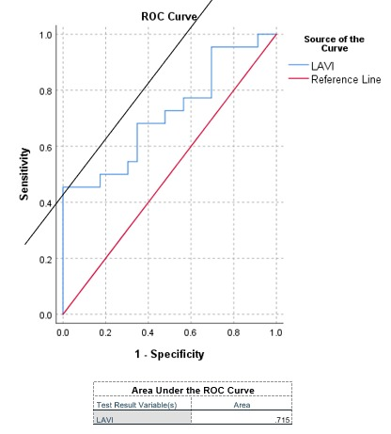
Figure 1. ROC Curve LAVI as a Predictor of Ventricular Arrhythmia
CORRELATION BETWEEN NON-INVASIVE SUDDEN CARDIAC DEATH RISK STRATIFICATION PARAMETERS WITH MADIT-ICD BENEFIT SCORE IN ISCHEMIC CARDIOMYOPATHY

W. Kwandou¹, S. Adiwinata¹, F. M. Halim¹, J. Julianus¹, F. M. Yofrido¹, B. M. Setiadi¹, A. L. Panda¹

¹Department of Cardiology and Vascular Medicine Sam Ratulangi University Prof. Dr. R. D. Kandou General Hospital

Background:
Non-invasive sudden cardiac death (SCD) risk stratification such as signal averaged electrocardiogram (SAECG), heart rate variability (HRV), deceleration capacity (DC), frontal QRS-T angle and spatial QRS-T angle have been reported can predict both SCD and non-arrhythmic mortality in ischemic cardiomyopathy, however the usage of these parameters for predicting SCD is still contradictive. The MADIT-ICD benefit score was developed based on landmark MADIT trials topredicts implantable cardiac defibrillator (ICD) benefit by assessing the competing risk of life threatening ventricular tachyarrhythmia vs. non-arrhythmic mortality. The aim of this study is to assess correlation between non-invasive SCD parameters with ICD benefit probability measured with MADIT-ICD benefit score in ischemic cardiomyopathy

Methods:
This is a cross-sectional study including 84 ischemic cardiomyopathy patients in Prof. Dr. R. D. Kandou general hospital with left ventricular ejection fraction (LVEF) ≤ 40%. Non-invasive SCD risk stratification parameters including SAECG, HRV, DC, frontal QRS-T angle and spatial QRS-T Angle, are measured with 15-min holter recording using Vasomedical BIOX holter with Frank lead system. MADIT-ICD Benefit score was calculated based on ventricular tachycardia/ventricular fibrillation (VT/VF) score and non-arrhythmic mortality score of the patients. All parameters are analyzed using SPSS version 25.

Results:
Among 84 subjects, 60 patients (71%) are male and 24 patients (29%) are female with a mean age of 61 ± 9.7 years. Among all of non-invasive SCD risk stratification parameters, there is a weak but significant correlation between root mean square of successive differences (RMSSD) with VT/VF score (r = -0.23, p = 0.035) and there is a moderate significant correlation between DC value and spatial QRS-T angle with non-arrhythmic mortality score (r = -0.3, -0.42, all p = < 0.01). And only spatial QRS-T angle parameters have a significant correlation with ICD benefit score (r = -0.25, p = 0.02).

Conclusion:
Among all of non-invasive SCD risk stratification parameters, only spatial QRS-T angle have a significant correlation with ICD benefit probability measured with MADIT-ICD benefit score in patients with ischemic cardiomyopathy. Further research is needed to verify use of non-invasive SCD risk stratification especially spatial QRS-T angle with ICD benefit probability

Keywords: Non-Invasive Sudden Cardiac Death Risk Stratification, ICD Benefit, Ischemic Cardiomyopathy

RELATIONSHIP BETWEEN GENDER, PREDICTOR OF PROCEDURAL DIFFICULTY AS ASSESSED BY J-CTO SCORE, AND SUCCESFUL REVASCULARIZATION IN CORONARY CTO PATIENTS

J. J. Samsudin¹, Subiyanto¹, V. B. F. P. Untu¹, J. C. Kurniawan¹, R. E. Lumentut¹, A. N. Aristo¹, F. M. Halim², S. H. Rampengan², E. L. Jim²

¹RSUP Prof Dr R D Kandou
²RSUP Prof Dr R D Kandou

Background:
Gender differences exist in presentation and outcome of coronary chronic total occlusion (CTO). Previous research shows that women with CTO were significantly older, and exhibit more comorbidities. Relationship between J-CTO score and gender was controversial, in which some research shows no significant difference between both genders, while others show significantly higher J-CTO score in men. Technical and procedural success rates were previously found to be higher in women. Previous research in Indonesia was done in Harapan Kita National Cardiovascular Centre, in which gender was found to not have significant relationship with procedural success.

Methods:
A retrospective cross-sectional study was performed in Prof Dr Kandou General Hospital, Manado, from January 2021 to December 2022. Study subjects were enlisted from patients undergoing angiography and found to have CTO. Primary outcome was the comparison of J-CTO scores between gender, as well as comparison of successful revascularization, defined as TIMI flow 3, between gender. Statistical analysis was performed with IBM SPSS Version 24.

Results:
A total of 70 study subjects (58 male and 12 female), were included in this study. Demographic analysis shows no significant difference between age (p = 0.091), prevalence of diabetes (p = 0.335), and hypertension (p = 0.271) between gender. There was a significantly higher prevalence of dyslipidaemia in male (p = < 0.047). There was no significant difference in J-CTO Score between male and female subjects (median 2 (0-3) vs 2 (1-3), p = 0.466). Overall rate of successful revascularization was significantly less in male compared to female (36% vs 75%, OR = 0.2, p = 0.013). In patients with J-CTO >= 2, succesful revascularization was also lesser in male compared to female, but there was no statistical significance (34% vs 67%, OR = 0.12, p = 0.06).

Conclusion:
This study shows no significant difference in J-CTO Score between male and female subgroups. Overall rate of successful revascularization was higher in female compared to male, but there was no statistical significance between gender in patients with J-CTO Score >= 2. Further study with bigger sample size is recommended.

Keywords: CTO, Gender, PCI, J-CTO

MAJOR ADVERSE CARDIOVASCULAR EVENTS ON CORONARY ARTERY BYPASS GRAFT WITH OR WITHOUT MYCOARDIAL VIABILITY SUTY IN ISCHEMIC CARDIOMYOPATHY PATIENTS

A. Ferly¹

¹National Cardiovascular Center Harapan Kita

Background:
Heart failure with reduced ejection fraction is one of the condition with significant morbidity andmortality. The most common etiology is ischemia caused by stenosis of coronary artery.Viability study is a non-invasive methods to identify which myocardial cells that mayexperienced stunning or hibernating conditions that may gain benefit from surgicalrevascularization using coronary artery bypass graft (CABG). Previous study failed to identifythe benefit of viability study on major adverse cardiovascular events (MACE), mortality orrehospitalization

Methods:
A retrospective cohort study were done on patients with heart failure with reduced ejectionfraction (HFrEF) that were decided to do coronary artery bypass graft by heart team meeting ofNational Cardiovascular Center Harapan Kita. The patients were grouped according to whetherthey undertook viability study or not. Follow up were done on these patients and outcome suchas mortality, rehospitalization and improvement of ejection fraction were recorded

Results:
There are 216 patients that had CABG with viability study and 269 patients that had CABGwithout viability study. There are no statistically significant differences between thoseundergoing viability study and outcome of MACE, mortality or rehospitalization afterprospensity score adjustment. However, those with viability study are more likely to haveimprovement of ejection fraction compared to those that do not have viability results.

Conclusion:
There are no differences in either MACE, survival or rehospitalization in patients that did CABGprocedure with viability data compared to those that do not have the data. However, those thathave viability data are more likely to have improvement of ejection fraction.

Keywords: Major Adverse Cardiovascular Events, Viability Study, Coronary Artery Bypass Graft

COMPARISON BETWEEN CARDIAC COMPUTED TOMOGRAPHY AND ECHOCARDIOGRAPHY IN MEASURING LEFT VENTRICULAR EJECTION FRACTION

M. M. Wardani¹, H. Arifianto¹, R. Myrtha¹, Irnizarifka¹, A. A. Asrial¹, K. Alifah¹

¹Universitas Sebelas Maret

Background:
Cardiac Computed Tomography (CCT) has become an important tool to evaluate coronary artery disease. However, there are some data provided in CCT result which have not been optimally utilized. Since the Artificial Intelligence (AI) of CCT can detect the best phase of cardiac cycle, it can provide left ventricular measurements data. This study objective is to compare left ventricular measurements provided by CCT and echocardiography. The result can be made as a consideration whether we can use left ventricular measurements provided by AI as additional CCT interpretation data or not.

Methods:
This is cross-sectional study. We include data of the patients in Universitas Sebelas Maret Hospital who have the result of both CCT and transthoracic echocardiography in January-April 2024 with interval between those two tests is no longer than 60 days. Regarding to its impact on the quality of CCT result, we exclude patients who have heart rate >75 bpm or arrhythmia during the scanning. At first, we put the center of the crosshair on the center of mitral valve and the crosshair should pass through the left ventricular apex so we can have perpendicular image of left ventricle in two chambers, four chambers, and short axis view. In the short axis view, we put the center of the crosshair on the center of the left ventricle and the crosshair should also pass through the intersection of the lower curvature of right ventricular free wall and diaphragm. Diastolic and systolic left ventricular internal diameter (LVIDd and LVIDs) are measured at the two chambers view and the ruler should be perpendicular to the crosshair. Teicholz Left Ventricular Ejection Fraction (LVEF) for CCT is then calculated using Teicholz formula on e-echocardiography website.

Results:
Forty patients' data are analyzed using Spearman’s Rank Correlation. The coefficient correlation of LVIDd, LVIDs, and Teicholz LVEF measured by CCT and echocardiography are 0,474 (p=0,002); 0,522 (p<0,001); and 0,347 (p=0,028).

Conclusion:
The measurements of LVIDd, LVIDs, and Teicholz LVEF by CCT and echocardiography have significant correlation in fair strength.

Keywords: cardiac CT, echocardiography, LVIDs, LVIDd, ejection fraction

ANALYSIS OF THE EFFECT OF RS11642015 POLYMORPHISMS IN THE FTO GENE (FAT MASS AND OBESITY ASSOCIATED GENE) ON LEFT VENTRICULAR MASS IN HYPERTENSION PATIENTS IN SURABAYA

C. R. Susanto¹, Kevin¹, J. Wijaya¹

¹Universitas Airlangga

Background:
Hypertension is persistent high blood pressure and a major risk factor for cardiovascular disease. In 2023, the WHO estimated 1.28 billion people had hypertension, causing 12.8% (7.5 million) of deaths worldwide. Left Ventricular Mass (LVM) is the weight of the left ventricle. LVH occurs in 19-48% of untreated hypertension patients and 58-77% of high-risk hypertension patients. The FTO gene regulates homeostasis and fat accumulation, contributing to obesity-related diseases. It also regulates m6A, which controls scar tissue formation and remodeling in myocardial tissue. SNP rs11642015 of the FTO gene involves a single base change from cytosine to thymine or cytosine at position 69620. Polymorphism rs11642015 has the potential to influence the degree of FTO upregulation regulated by Angiotensin II (AT2) levels. AT2 triggers LV hypertrophy through myocardial fibrosis, while changes in FTO levels directly affect m6A in RNA, influencing the hypertrophic adaptation in cardiomyocytes and the degree of LVH. SNP frequency is often specific to certain demographic areas and populations. Therefore, this paper aims to analyze the relationship between FTO gene polymorphisms and left ventricular mass to support the development of detection and therapy in hypertensive patients, especially in the Surabaya population.

Methods:
This study used a cross-sectional analytic design. A total of 75 patients with concentric left ventricular hypertrophy remodeling were included in this study. This study was conducted at the cardiovascular department of Airlangga University Hospital. Correlation studies were analyzed using the regression method, while the correlation between FTO gene polymorphisms and LVH was tested using ANOVA.

Results:
Based on the study we conducted, 37,3% of our population have rs11642015 polymorphism. Also, association between rs11642015 and left ventricular remodelling were found. Association with a confidence of 48% were found between rs11642015 incidence and increased or decreased RWT. An association between rs11642015 and LVDMi were found with a confidence of 50,8%. Patients who were positive for rs11642015 also had a 13% less likelihood for developing any form of LVH.

Conclusion:
There is a weak association between the increase of RWT, LVdMI, and LVH on individuals with FTO gene SNP rs11642015, especially in Surabaya populations.

Keywords: Gene Polymorphism, Hypertension, FTO, Left ventricular mass

PLASMA GALECTIN-3 AS THE NEXT GENERATION BIOMARKER OF HEART FAILURE DEVELOPMENT IN VERY HIGH-RISK ATHEROSCLEROSIS CARDIOVASCULAR DISEASE PATIENTS: A POPULATION-BASED CROSS-SECTIONAL STUDY IN INDONESIA

D. Arityanti¹, F. R. Qhabibi¹, B. Dwiputra¹, D. R. Desandri¹, E. Susilowati¹, R. Hamdani², C. K. Krevani², I. A. Arso³, A. B. Hartopo³, V. Y. Anggraeni³, A. M. Ambari¹

¹Department of Cardiovascular Prevention and Rehabilitation, National Cardiovascular Center Harapan Kita
²Department of Cardiology and Vascular Medicine, Dr. M. Djamil General Hospital
³Department of Cardiology and Vascular Medicine, Dr. Sardjito General Hospital

Background:
Several novel biomarkers have been identified as potential prognostic indicators for monitoring complications of atherosclerosis cardiovascular disease (ASCVD), such as heart failure, refractory angina, renal failure, and ischemic stroke. Plasma galectin-3 (pG3) is a β-galactoside-binding lectin that plays a significant role in biological functions, particularly inflammation and fibrosis. Extensive research has highlighted pG3's importance as a diagnostic and prognostic biomarker in cardiovascular disease (CVD). However, this study is pioneering in evaluating the prognostic value of Galectin-3 for CVD complications in a very high-risk ASCVD population.

Methods:
This cross-sectional study enrolled 210 patients from three distinct centers in Indonesia, classified as very high-risk for ASCVD. The participants were patients between 18 to 80 years old who had experienced acute coronary syndrome [acute myocardial infarct with ST elevation (STEMI), non-ST elevation MI (NSTEMI), or unstable angina], undergone elective percutaneous coronary intervention (PTCA), primary percutaneous coronary intervention (PCI), or elective coronary artery bypass grafting (CABG) within 6 months to 2 years prior to the study. Blood samples were taken for laboratory analysis, along with anamnesis and physical examination. Stepwise multiple regression and correlation analysis were conducted to analyze the influence and relationship between pG3 and N-terminal prohormone of brain natriuretic peptide (NT-Pro BNP) for heart failure, low-density lipoprotein cholesterol (LDL-c) for atherosclerosis, high-sensitivity troponin I (hs-TnI) for angina, and creatinine for renal failure. Additionally, Pearson correlation test was used for further correlation analysis to determine the degree of relationship.

Results:
Stepwise multiple regression revealed a robust and statistically significant influence and correlation (p < 0.0001) between pG3 and NT-proBNP compared to other biomarkers. The R-square (R2) value of 0.082 indicates that 8.2% of the variability in pG3 is explained by NT-proBNP. This suggests a strong relationship between the variables. Pearson correlation analysis showed a significant correlation between pG3 and NT-proBNP (p < 0.0001; 0.146 – 0.401, 95% CI; r-value = 0.286, significant at the 0.01 level).

Conclusion:
There is a significant correlation between pG3 and NT-proBNP as predictor of heart failure development in patients with very high-risk ASCVD population.

Keywords: heart failure, Galectin-3, NT-ProBNP, ASCVD

CORRELATION OF BODY OF BODY MASS INDEX WITH CORONARY ARTERY CALCIUM SCORE AND OBSTRUCTIVE CORONARY ARTERY DISEASE AT HAJI ADAM MALIK GENERAL HOSPITAL MEDAN.

N. D. P. Simanjuntak¹, H. A. P. Lubis,¹, J. B. S. Sitepu¹

¹Faculty Medicine of North Sumatra University

Background:
Coronary artery calcium (CAC) measured by noncontrast cardiac computed tomographic (CT) scan is a noninvasive measure of coronary artery disease that is associated with coronary heart disease (CHD) in symptomatic or asymptomatic cardiovascular disease. Obesity, as measured by body mass index, is widely recognized as a risk factor for the development of cardiovascular disease.

Methods:
A total of 246 patients who had symptomatic or asymptomatic cardiovascular disease and underwent multislice computed tomography (MSCT) angiography with coronary artery calcium screening in our hospital between January 2024 and June 2024 were included Patients, without prior revascularization underwent both invasive coronary angiography (ICA). All patients were divided into three groups according to their BMI. The BMI was calculated using the formula BMI = Weight/Height² (kg/m²). Calcium scores were classified as zero, low (1-100) or high (³100). Patients were classified according to the presence of normal coronaries and nonobstructive (<50%) and obstructive (≥50%) coronary lesions. The BMI was calculated using the formula BMI = Weight/Height² (kg/m² ).

Results:
Our sample included302 individuals(146 males, 156 females; mean age 53.9±12.7; BMI 27.6), 37% had zero CACs, 24 % had CACs ≤ 100, and 39% had CACs ≥100. For coronary CTA (nonobstructive disease 62%, 1-vessel disease 17%, 2-vessel disease 8%, 3-vessel disease 12%, 4-vessel disease 1%). For CACs, there is correlation between BMI and CACs with P value 0.047 (p<0.05).

Conclusion:
Body of Body Mass Index associated with higher coronary calcium, a marker of subclinical cardiovascular disease. Further exploration of the relationship between Body of Body Mass Index and the development of cardiovascular disease is warranted.

Keywords: CT coronary angiography, Body Mass Index, Coronary Artery Calcium Score., Coronary artery disease

RETROSPECTIVE STUDY IN YOUNG WOMAN WITH PERIPARTUM CARDIOMYOPATHY IN SAIFUL ANWAR HOSPITAL MALANG EAST JAVA: A PRELIMINARY STUDY

N. A. Niazta¹, D. E. Tambunan¹, V. Yogibuana¹

¹Department of Cardiology and Vascular Medicine Faculty of Medicine Universitas Brawijaya - Dr. Saiful Anwar General Hospital

Background:
Peripartum cardiomyopathy (PPCM) is relatively rare but can be catastrophic in young pregnant women. This paper aims to identify factors associated with severe PPCM, required use of ventilators, prolonged length of stay in the ICU, and total length of stay during hospitalization.

Methods:
In this retrospective study, 25 patients were admitted to Saiful Anwar Hospital with suspected PPCM between January 2022 to June 2024. We included young woman patients aged under 30 with signs and symptoms of heart failure at the end of pregnancy and first 5 months postpartum, with decreased LVEF < 45%. Eight patients were excluded due to unmeet the criteria and incomplete data. Prolonged LOS in ICU was defined as more than 3 days, and prolonged LOS during hospitalization was defined as more than 8 days

Results:
A total of 17 patients met the criteria of PPCM, 9 (52.9%) were reported as having severe PPCM condition, and 8 (47.1%) patients in moderate PPCM. The range of age was 17-30 years old. No mortality during hospitalization was reported. We analyzed several risk factors associated with severe PPCM, such as Age under 20 years old, nullipara, preeclampsia, DM, or overweight, all the results were not statistically significant. The required use of a ventilator was reported in 7 (41.2%) patients. Age under 20 years old was related to the incidence of ventilator use (OR95% CI = 3.52 [1.50 – 8.0], p = 0.05). This PPCM patient was hospitalized for 6-16 days, with a duration of ICU admission was 0-8 (4) days. We analyzed that prolonged ICU length of stay was significantly associated with hemodynamic instability (OR95% CI = 14 [1.13 – 172.6], p = 0.05).

Conclusion:
Peripartum cardiomyopathy is a challenging disease in young women. We conducted a preliminary study with a retrospective method to evaluate risk factors associated with mortality, need for intubation, or prolonged length of stay. Hemodynamic instability is associated with prolonged ICU admission, and Aged under 20 year old. was associated with intubation

Keywords: heart failure in pregnancy, cardiac disease, PPCM, Peripartum cardiomyopathy

THE KEY TO UNLOCKING LONG-TERM HEALTH-RELATED QUALITY OF LIFE FOR ARRHYTHMIA PATIENTS WITH CATHETER ABLATION

M. Putri¹, E. Maharani¹, F. Hidayati¹

¹Department of Cardiology and Vascular Medicine, Dr Sardjito General Hospital/Universitas Gadjah Mada, Yogyakarta, Indonesia

Background:
Arrhythmia rarely results in life-threatening events; however, its symptomatic manifestations can profoundly diminish health-related quality of life (HRQoL) through several mechanisms. Since ablation is not a life-saving procedure, the outcome of the procedure should be measured in symptom relief rather than acute results of catheter ablation only. Long-term evaluation facilitates the assessment of recurrence rates and longitudinal changes in HRQoL. The aim of the study was to investigate impact of arrythmia and long-term efficacy of catheter ablation to HRQoL.

Methods:
A pre- and post-observational study was conducted on 72 arrythmia patients who underwent successful catheter ablation at Sardjito General Hospital between February 2020 and Februari 2023. The types of arrythmia included were atrioventricular nodal reentrant tachycardia (AVNRT), atrioventricular re-entry tachycardia (AVRT), atrial tachycardia (AT), premature ventricular contraction (PVC), and ventricular tachycardia (VT). HRQoL were measured restrospectively using EQ-5D-5L questionnaire at three periods of time: prior to the catheter ablation procedure, within 1 year post-procedure (short term), and up to 4.5 years post-procedure (long term)

Results:
All of 72 subjects experienced multiple episodes of tachyarrhythmia or >2000 VPC within 24 hour prior to ablation. HRQoL was assessed across five domains include mobility, self-care, usual activities, pain/discomfort, and anxiety/depression. The pain/discomfort domain was problematic for 100% of subjects, while self-care was the least affected domain. Only one subject who experienced recurrences within the first year post-ablation. EQ-5D utility index was increased from 0,138±0,472 before catheter ablation to 0,939±0,098 within 1 year post procedure and 0,961±0,084 in long-term evaluation. EQ-VAS score showed similar trend. Significant improvements were seen in all HRQoL domains, with notable enhancement at 1 year post-procedure and continued to improve significantly in long term evaluations (p<0.05). Factors such as sex, age, recurences, comorbidities, education level, marital status and employment status did not significantly affect the HRQoL outcomes.

Conclusion:
Long-term HRQoL significantly improves in arrhythmia patients following catheter ablation. Improvements in HRQoL were observed as early as 1 year after the procedure and continued to improve in the long-term

Keywords: arrythmia, health related quality of life, long term, catheter ablation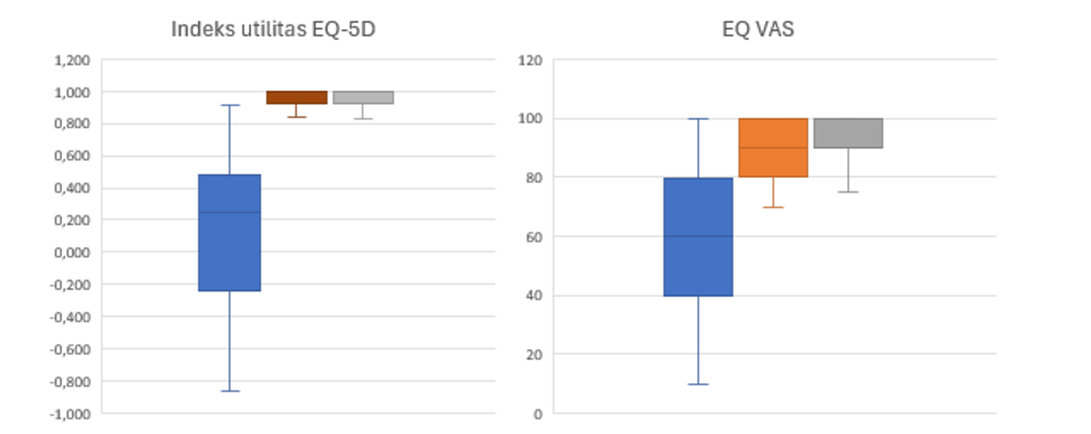
Figure 1. EQ-5D utility index and EQ-VAS before catheter ablation, 1 year after procedure and long term showed statistically significant improvement after catheter ablation. (Blue= before catheter ablation; red= 1 year after procedure; grey= long term

TARGETING ACE2 TO REDUCE CARDIOVASCULAR DISEASES RISK IN OBESITY: A STUDY ON THE EFFECTS OF LOSARTAN, ACE2 MRNA, AND HUMAN RECOMBINANT ACE2 ON IL-6 AND PAI-1

H. O. Hermawan¹, P. M. H. Putri¹, I. M. Sufiyah¹, M. Ardiana¹, Y. H. Oktaviono¹

¹Department of Cardiology and Vascular Medicine, Faculty of Medicine, Universitas Airlangga, Surabaya, Indonesia

Background:
Obesity is a major risk factor for cardiovascular diseases. Excess adipocytes overproduce adipokines that can overactivate the renin-angiotensin system (RAS), leading to increased secretion of pro-inflammatory mediators. Among these, interleukin-6 (IL-6) and plasminogen activator inhibitor-1 (PAI-1) play significant roles in the development of atherosclerosis, coronary artery disease, and heart failure. Targeting angiotensin-converting enzyme 2 (ACE2), a potent negative regulator of RAS, offers a promising approach to inhibit cardiovascular disease progression. Our study investigated the ability of losartan, ACE2 messenger ribonucleic acid (mRNA), and human recombinant ACE2 (hrACE2) to enhance ACE2 activity and reduce the production of IL-6 and PAI-1.

Methods:
ACE2 mRNA was synthesized using in vitro transcription and chemically modified with the addition of N1-Methylpseudouridine-5’-Triphosphate and anti-reverse cap analog. High-fat diet-induced obese male Wistar rats were treated for 4 weeks with placebo, losartan (20 mg/kg/day, orally), hrACE2 (2 mg/kg/day, intraperitoneally), and ACE2 mRNA (30 µg every 3 days, intraperitoneally). After treatment, ACE2 activity as well as levels of IL-6 and PAI-1 were measured in subcutaneous abdominal adipose tissue using enzyme-linked immunosorbent assay (ELISA).

Results:
Obese rats exhibited higher levels of IL-6 (37.09 vs. 10.45 ng/ml, p=0.02) and PAI-1 (5.41 vs. 1.65 ng/ml, p<0.01) compared to non-obese rats. Treatment with losartan in obese rats increased ACE2 activity (1218.87 vs. 622.97 ng/ml, p=0.013) and decreased IL-6 (16.37 vs. 37.10 ng/ml, p=0.046) and PAI-1 levels (3.08 vs. 5.40 ng/ml, p=0.031) compared to untreated obese rats. Similarly, hrACE2 treatment enhanced ACE2 activity (1798.47 vs. 622.97 ng/ml, p<0.01) and reduced IL-6 (10.19 vs. 37.10 ng/ml, p=0.02) and PAI-1 levels (2.26 vs. 5.40 ng/ml, p=0.002). hrACE2 was more effective than losartan in increasing ACE2 activity and lowering IL-6 and PAI-1 levels. ACE2 mRNA did not significantly affect ACE2 activity, IL-6, or PAI-1 levels. Furthermore, ACE2 activity correlated with IL-6 levels but not with PAI-1, while IL-6 levels were correlated with PAI-1.

Conclusion:
hrACE2 significantly enhances ACE2 activity and reduces IL-6 and PAI-1 levels more effectively than losartan in obese rats, highlighting its potential as a therapeutic approach for cardiovascular disease associated with obesity.

Keywords: Losartan, Obesity, hrACE2, PAI-1, IL-6

RV, NOT LV AS PREDICTOR OF MORTALITY IN STEMI PATIENTS

S. Wicaksono¹, B. Y. Setianto¹, H. P. Bagaswoto¹, F. Saputra¹

¹FK KMK UGM

Background:
For a long time, the right ventricle (RV) was recognized as the forgotten chamber. RV function is considered to not significantly contribute to hemodynamic stability. On the other hand, many studies found LV function as predictor of mortality in STEMI patients. By the time, studies found the important role of the RV in filling the LV preload. If there is a RV systolic dysfunction, it will cause a decrease in LV cardiac output and then cardiogenic shock occurs. The purpose if this research is to evaluate the RV systolic dysfunction as a predictor of mortality in STEMI patients.

Methods:
This study is a retrospective cohort based on SCIENCE registry. Seven hundred and thirty-two STEMI patients were found from June 2023 through June 2024. RV systolic dysfunction is defined as TAPSE values ​​<17. Bivariate analysis was performed using chi-square analysis to see the correlation of RV systolic dysfunction with the incidence of mortality. Then, multivariate analysis was performed to determine the relationship of confounding factors in this study.

Results:
Anterior STEMI constitute 50.2% of the analyzed patients. RV systolic dysfunction was shown to be significantly correlated with the incidence of shock and mortality. The results of multivariate analysis with confounding factors (sex, hypertension, and diabetes mellitus) showed that RV systolic dysfunction had an effect on the incidence of shock (OR 2.043; 95% CI = 1.429-2.920, p = 0.000) and mortality (OR 2.476; 95% CI = 1.670-3.672, p = 0.000).

Conclusion:
This study shows the RV is no longer a forgotten chamber, but it has changed the minds of us as clinicians to start thinking about it. RV systolic dysfunction assessed by TAPSE can be used to as predictor of mortality in STEMI patients to guide further managements.

Keywords: TAPSE, Mortality, STEMI, Cardiogenic shock, RV systolic dysfunction

Table 1. Result of chi-square analysis
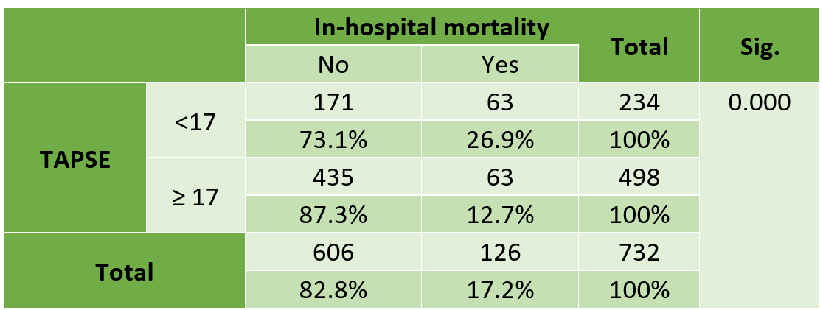

PROGNOSTIC VALUE OF SERUM ENDOTHELIN-1 AND ENDOTHELIN-3 CONCENTRATION IN PATIENTS WITH ACUTE MYOCARDIAL INFARCTION: ONE-YEAR FOLLOW-UP

A. K. Putri¹, A. B. Hartopo¹, B. Y. Setianto¹, I. Puspitawati²

¹Department of Cardiology and Vascular Medicine, Gadjah Mada University / Sardjito General Hospital1
²Department of Clinical Pathology and Laboratory Medicine, Gadjah Mada University / Sardjito General Hospital2

Background:
Increased Endothelin in circulation blood during acute myocardial infarction (AMI) contributes to more significant vasoconstriction and increases the severity of the myocardial infarction and ventricular remodeling. This study elaborates on the role of ET-1 and ET-3 on admission regarding major adverse cardiac events (MACEs) one year after AMI hospitalization.

Methods:
This retrospective cohort study involved 81 patients with AMI; ET-1 and ET-3 were detected and quantified on admission using an ELISA assay kit (IBL, Japan). The outcomes were one year of major adverse cardiac events (MACE), i.e., a composite of death, heart failure, cardiogenic shock, reinfarction, and resuscitated ventricular arrhythmia. The variables were analyzed using non-parametric logistic variables.

Results:
Eighty-one patients were analyzed one year after myocardial infarction. The patient was divided into two groups based on their cumulative ET-1 and ET-3, with a rounded cut-off point of >17 and <17. The ROC curve indicated that the AUC for the cumulative concentration of ET-1 and ET-3 was 0.638. The multivariate analysis of MACEs showed that the cumulative concentration of ET-1 and ET-3 >17 was independently associated with MACEs one year after the admission (OR=5.34, 95% CI 1.36–21.07, p=0.017). Kaplan-Meier survival analysis revealed earlier MACE incidents in patients with a higher cumulative concentration of ET-1 and ET-3 than those with lower cumulative concentrations of ET-1 and ET-3 (264±22 vs 284±23 days; p=0.378; cut-offs=17).

Conclusion:
A higher cumulative concentration of ET-1 and ET-3 on admission predicts MACE in one year of follow-up and provides prognostic value after AMI.

Keywords: acute myocardial infarction, STEMI, Endothelin

ASSESSMENT OF THE TIME IN THERAPEUTIC RANGE (TTR) IN PATIENTS RECEIVING WARFARIN FOR MITRAL STENOSIS AND ATRIAL FIBRILLATION

H. Fauziyah¹, A. C. Lubis¹

¹Universitas Sumatera Utara

Background:
Warfarin is an oral anticoagulant that is commonly used to prevent thromboembolism in atrial fibrillation (AF) that is associated with mitral stenosis (MS). Warfarin has limitations, including a narrow therapeutic range, intra- and inter-patient variability in dose response, and susceptibility to drug–drug and drug–food interactions.The time therapeutic range (TTR) is the percentage of time that the International Normalized Ratio (INR) stays in the 2.0 to 3.0 target range over time.

Methods:
We conducted a prospective study of the International Normalized Ratio (INR) values for all patients throughout a 12-week follow-up period. We estimated the Time in Therapeutic Range (TTR) from January 2022 to March 2024 at Adam Malik Hospital in Medan. TTR was calculated using the Rosendaal technique specifically for patients with atrial fibrillation (AF) and concomitant mitral stenosis (MS) who were receiving warfarin

Results:
There were a total of 80 participants that met the criteria for inclusion in this study. The average age of these patients was 42.4±1.2 and 68.8% (n=55) were female. The average Type-Token Ratio (TTR) in this investigation was 21.9%±2.6%. Out of the total number of instances, 8.8% (n=7) fell into the category of good TTR (≥60%), while 91.3% (n=73) into the category of bad TTR (<60%). The average percentage of days within the target INR range of 2.0 to 3.0 was 26.9±2.94 days.

Conclusion:
Based on this study, we can conclude that the TTR among patients with atrial fibrillation accompanied by mitral stenosis is still suboptimal. It remains our responsibility to maintain the INR within the desired range of 2.0 to 3.0. We recommend a more comprehensive study that examines the relationship between TTR and the clinical manifestations presented in patients.

Keywords: Time in Therapeutic Range, Atrial Fibrillation, International Normalized Ratio, Mitral Stenosis

PREVALENCE OF OBESITY, HYPERTENSION AND HYPERCHOLESTEROLEMIA IN HEALTH SCREENING EXAMINATIONS FOR CANDIDATE OF VOTING ORGANIZING GROUPS (KPPS) IN DKI JAKARTA (STUDY AT UTAN KAYU SELATAN COMMUNITY HEALTH CENTER 1)

N. Chaerully¹

¹Matraman Community Health Center

Background:
The Ministry of Health recorded that 11,239 Voting Organizing Group (KPPS) officers were sick during the 2019 election and 527 people died. Audit results show that 51% of the highest causes of death are caused by cardiovascular problems, such as heart disease and stroke. Indonesia Electoral Commission (KPU) Regulation Number 8 Year 2022 stated that a health certificate is a mandatory requirement for KPPS candidates before registering. The aim of this research is to analyse cardiovascular risk factors in prospective KPPS members.

Methods:
This research used descriptive analytics with a cross-sectional design on prospective KPPS participants at the Utan Kayu Selatan Community Health Center 1, DKI Jakarta, in December 2023. Total data was 306 officers, 231 men (75.5%) and 75 women (24, 5%).

Results:
There were 158 officers (51.6%) that had a body mass index (BMI) which is more than normal (> 24.9%) with an overweight category with an obesity amount (21.5%). And 258 people (74.3%) experienced pre-hypertension to the hypertension stage II (pre-HT: 114 people; HT stage I: 100 officers; HT stage II: 44 people), while only 15.7% have blood pressure normal. Based on the total cholesterol examination shows 218 people (71.2)% suffer from hypercholesterolemia (total cholesterol> 200 mg/dl).

Conclusion:
This study shows that many prospective KPPS members have risk factors for cardiovascular disease as high BMI, hypertension and hypercholesterolemia. This certainly needs to be a concern for policy holders in efforts to prevent a repeat of the 2019 election.

Keywords: Hypercholesterolemia, KPPS, Cardiovascular, BMI, Hypertension

ASSOCIATION BETWEEN SUMMED STRESS SCORE AND SEVERITY OF CORONARY ARTERY DISEASE IN PATIENTS WITH CHRONIC CORONARY SYNDROME

B. A. Hasibuan¹, R. M. Tamba¹, H. A. P. Lubis¹, T. B. Haykal¹, A. C. Lubis¹, C. A. Andra¹

¹Department of Cardiology and Vascular Medicine, Faculty of Medicine, Universitas Sumatera Utara

Background:
The summed stress score (SSS) is one of the independent predictors of the severity of coronary artery disease (CAD). SSS is the sum of the stress scores of the 17 segments of the left ventricle obtained during the stress test. Studies have shown there is a correlation between SSS and the severity of CAD.The aim of this study was to identify the association between SSS and the severity of CAD based on the SYNTAX score in patients with chronic coronary syndrome (CCS).

Methods:
This study was an analytic observational study with a retrospective cohort design in CCS patients who underwent Myocardial Perfusion SPECT at Haji Adam Malik General Hospital from January 2022 to April 2023. All participants underwent MPS with Tc99m sestamibi with pharmacology Adenosine stress test and coronary angiography. The MPS could be performed before coronary angiography. The value of SSS was obtained from an automated program. The Severity of CAD was classified by using the Syntax score.

Results:
The study subjects totaled 93 people with an average age of 55.87±7.44. It was found that the SSS value was significantly different between the two groups of mild and severe CAD based on Syntax score, 23 (15-34) vs 18± (8-24)in the mild vs severe CAD group (p<0.005).

Conclusion:
In this study, we found an association between Summed Stress Score and the severity of coronary artery disease. Whereas more Summed Stress Score gets higher, the more severe the coronary artery disease becomes.

Keywords: Chronic coronary syndrome, Syntax score, summed stress score, coronary artery disease

COMPARISON OF RV FUNCTION IN VOLUME AND PRESSURE OVERLOAD RIGHT VENTRICLE

R. A. Rizki¹, M. S. M. Indah¹, M. Yanni², Nani³

¹Faculty of Medicine, Universitas Andalas, Padang, Indonesia
²Department of Cardiology and Vascular Medicine, Faculty of Medicine, Universitas Andalas/DR.M. Djamil Hospital
³Department of Cardiology and Vascular Medicine, Faculty of Medicine, Universitas Andalas/DR.M. Djamil Hospita

Background:
Pulmonary hypertension (PH) presented a diagnostic challenge, especially in distinguishing between right ventricular (RV) volume overload and pressure overload. This study aimed to differentiate between these two types of RV overload in patients with PH using echocardiographic parameters.

Methods:
The study included patients diagnosed with PH based on echocardiography, who underwent a comprehensive echocardiographic evaluation. Both conventional echocardiographic parameters and RV strain analysis using speckle tracking echocardiography (STE) were assessed. Statistical significance was determined using Student's t-test and Mann-Whitney test, with a significance level set at a P value of <0.05.

Results:
A total of 30 patients were included, with average ages of 43.5 ± 16.8 and 41.8 ± 14.4 years for the volume overload and pressure overload groups. Female was dominated in both groups (60.0% in volume overload group vs 86.7% in pressure overload group). We found Systolic Pulmonal Arterial Pressure (SPAP) was higher significantly in pressure overload group (73.67 ± 38.15 mmHg vs 46.46 ± 22.17 mmHg, p = 0.025) while estimated RA pressure (eRAP) was higher in volume overload group (7.47 ± 2.92 vs 11.73 ± 3.61, p = 0.003). Conventional RV function parameters showed decreased value in pressure overload group than volume overload group (TAPSE 17.67 ± 5.99 vs 22.41 ± 5.63 mm, p = 0.03, S’ velocity 11.87 ± 3.66 vs 13.53 ± 4.12 cm/s, p = 0.25, RVFAC 34.29±10.12 % vs 42.51±9.04 % , p = 0.026, respectively). Speckle Tracking Echocardiography (STE) also showed decreased value on pressure overload group than volume overload group and it were significant statistically (RV GLS -12.07 ± 5.92% vs -17.29 ± 5.95% , p = 0.023, RV FWS 13.41 ± 7.42 % vs -19.16 ± 6.77 %, p = 0.035).

Conclusion:
Conventional echocardiographic parameters and RV strain analysis provided a reliable method for differentiating between RV pressure and volume overload in patients with PH. This approach improved diagnostic accuracy and supported personalized management of PH, highlighting the importance of echocardiographic techniques in clinical practice.

Keywords: Speckle Tracking Echocardiography, Right Ventricular Function, Pulmonary Hypertension

EVALUATION OF CARDIOVASCULAR, METABOLIC, AND RENAL FUNCTION PARAMETERS IN HYPERTENSIVE PATIENTS ENROLLED IN THE INDONESIAN CHRONIC DISEASE MANAGEMENT PROGRAM (PROLANIS) AT THE EASTERN BORDER REGION

W. Widiarti¹, S. Salamah², M. A. S. Fa’iq³, A. A. Rusli⁴, J. B. Swannjo¹, A. A. Shafira⁵, Andrianto⁶, F. F. Alkaff²

¹Faculty of Medicine, Universitas Airlangga, Surabaya, Indonesia
²Division of Nephrology, Department of Internal Medicine, University of Groningen, University Medical Center Groningen, Groningen, The Netherlands
³Level IV Atambua hospital, Atambua, East Nusa Tenggara, Indonesia - Level III Kupang hospital, Kupang, East Nusa Tenggara, Indonesia
⁴Level III Kupang hospital, Kupang, East Nusa Tenggara, Indonesia
⁵Faculty of Medicine Universitas Airlangga, Surabaya, Indonesia
⁶Department of Cardiology and Vascular Medicine, Faculty of Medicine, Universitas Airlangga - Dr. Soetomo General Academic Hospital; Cardiovascular Research and Innovation Center, Universitas Airlangga

Background:
In 2014, the Indonesian government launched PROgram PengeloLAan penyakit kroNIS (PROLANIS) to control the clinical and laboratory outcomes of patients with chronic non-communicable diseases, including hypertension. However, studies evaluating the outcomes of PROLANIS are still limited, and no evaluation study has ever been done in the border region. Therefore, this study aims to evaluate cardiovascular, metabolic, and renal function parameters in hypertensive patients enrolled in PROLANIS in the Eastern border region of Indonesia.

Methods:
This observational study used secondary data from the PROLANIS report of all primary health care in Atambua City, East Nusa Tenggara. All hypertensive patients who attended the routine 6-month evaluation between June 2022 and December 2023 were included. Evaluated parameters included body mass index (BMI), systolic blood pressure (SBP), diastolic blood pressure (DBP), total cholesterol (TC), high-density lipoprotein (HDL), low-density lipoprotein (LDL), triglycerides (TG), serum creatinine, Atherogenic Index of Plasma (AIP), and estimated glomerular filtration rate (eGFR). The targeted thresholds for optimal metabolic control were based on the 2022 Indonesian Heart Association (PERKI) Cardiovascular Disease and Atherosclerosis Prevention guideline, defined as follows: BMI < 25 kg/m2; SBP < 140 mmHg; DBP < 90 mmHg; TC < 200 mg/dl; LDL < 100 mg/dl; TG < 150 mg/dl; HDL > 40 mg/dL.

Results:
This study included 63 participants, 52.40% of whom were male and had a median age of 63 years old. Monthly attendance was high, with 79.36% participants attending three sessions per month. Baseline and follow-up data showed no significant changes in BMI, blood pressure, cholesterol levels, or renal function parameters, indicating stable trends (Figure). The prevalence of patients achieving optimal metabolic control was similar between baseline and follow-up evaluations (BMI 25.40% vs 22.22%; SBP 82.54% vs 79.37%; DBP 90.48% vs 96.83%; LDL 54.00% vs 39.68%; TG 50.80% vs 41.27%; HDL 54.00% vs 63.49%) with the exception of TC (47.62% vs 30.16%).

Conclusion:
This study showed that PROLANIS does not improve the clinical parameters of hypertension patients in the eastern border region of Indonesia, indicating a need for alternative strategies to enhance outcomes. Future research should validate these findings and support the development of other targeted interventions.

Keywords: Hypertension, Government programs, Heart disease risk factors, Primary Health Care

ASSOCIATION OF MIR-1, MIR-21, AND MIR-29 LEVELS WITH LEFT VENTRICULAR HYPERTROPHY AND DIASTOLIC DYSFUNCTION IN PATIENTS WITH HEART FAILURE WITH PRESERVE EJECTION FRACTION

O. W. Firmansyah¹, Andrianto¹, M. J. Al-Farabi¹, M. G. Arifitrianto¹, R. R. Juwita¹, R. E. Intan¹, ,. I. G. R. Suryawan¹, M. Ardiana¹, N. D. Rahmianti¹, B. S. Pikir¹, R. A. Nugraha¹, M. R. Farabi¹

¹Universitas Airlangga

Background:
heart failure is one of leading disease that causes high morbidity and mortality with the prevalence of 5.5% global population nowadays. One pathophysiology that led to the condition of heart failure is diastolic dysfunction and the left ventricular hypertrophy. MicroRNA give the contribution of this pathophysiology. It is a non-coding RNA that involved in post translational regulation of mRNA. There are 3 leading microRNA that can contributes in the pathophysiology of heart failure with preserve ejection fraction such as miR1, miR-21, and miR-29. The aim of this research is to find the association of miR-1, miR-21, and miR-29 with left ventricular hypertrophy and diastolic dysfunction for better understanding of their interaction in molecular to structural and functional pathophysiology of heart failure with preserve ejection fraction.

Methods:
This research is using the observational comparation with cross sectional method. The subject is the heart failure with normal ejection fraction patient in policlinic RSUD Dr. Soetomo Surabaya. We collect blood sample from the patient and analyze the miR-1, miR-21, and miR-29 plasma by RT-qPCR. We collect the echocardiography data from the patient such as RWT for left ventricle hypertrophy and diastolic dysfunction with given parameter by American Society of Echocardiography guideline of LV Diastolic Dysfunction 2016. data were analyzed by SPSS 25.0

Results:
among the 50 subjects of this research, miR-1 is positively associated with diastolic dysfunction (P 0.036, R 0.380) but negatively related with left ventricle hypertrophy (P 0.033, R -0.328). miR-21 is positively associated with diastolic dysfunction (P 0.018, R 0.332) but had no significant association with left ventricular hypertrophy (P 0.092). miR-29, although had a negatively associated with diastolic dysfunction (P 0.013, R -0.314), had a positively associated with left ventricular hypertrophy (P 0.016, R 0.340)

Conclusion:
there is a unique interaction between miR-1, miR-21, and miR-29 on their pathophysiology of diastolic dysfunction in patient with heart failure preserve ejection fraction

Keywords: Heart Failure, microRNA, Biomarker, Left Ventricular Hypertrophy, Diastolic Dysfunction

SURVIVAL ANALYSIS AND PREDICTORS OF YOUNG ADULTS PATIENTS AFTER CORONARY ARTERY BYPASS GRAFTING SURGERY WHO PARTICIPATING IN EARLY PHASE II CARDIAC REHABILITATION PROGRAM: INSIGHT FROM COHORT STUDY IN INDONESIAN NATIONAL HEART CENTER

R. E. Intan¹, Andrianto¹, M. Ardiana¹, B. Radi², A. M. Ambari², B. Dwiputra², A. Santoso²

¹Department of Cardiology and Vascular Medicine - Faculty of Medicine Universitas Airlangga
²National Cardiovascular Center Harapan Kita - Faculty of Medicine Universitas Indonesia

Background:
Different with other countries where most institutes do not perform outpatient supervised cardiac rehabilitation(CR) program exercise (CR phase II) until 6 weeks after CABG, in some center in Indonesia, phase II CR program for CABG have been implemented earlier, within 1-2 weeks after hospitalization discharge and shorter duration. Our study is the first which aimed to analyze the long-term benefit and to investigate the determinants of survival analysis in patients after CABG in young and middle age population who attend early phase II cardiac rehabilitation program

Methods:
This was a single-center, longitudinal study with survival analysis method in all CABG patients under 55 years old who participate in early phase II cardiac rehabilitation program between January 2017 and December 2018. The rates of cardiovascular death and or major adverse cardiac event(MACE) hospitalization were determined over a median follow-up of 25 months. Cox regression and Kaplan-Meier analysis was used to determine the predictors of the events based on data registry.

Results:
There were total 279 patients in this study, with MACE happened to 23(8.45%) patients (3 patients died and 20 patients hospitalized). Patients who drop out(12%) from CR program have higher risk to develop event(HR 3.86, 95% CI 1.36-10.99). Univariate analysis of 245 consecutive patients who completed CR program showed disease comorbid, absence of statin and beta blocker usage, surgery complication, higher resting heart rate, lower chronotropic index, and lower functional capacity were associated with higher event rate. Multivariate cox regression showed that beta blocker usage, chronotropic index, resting heart rate, and functional capacity from 6MWT after CR program were independently corelated with MACE. 6MWT < 376 meters was concluded as significant predictor(p=0.001), with mean survival time shorter by 6 months.

Conclusion:
We confirmed that optimum functional capacity and patient’s medical condition are important predictors for survival prognosis after CABG in non-older patients. Our result also showed that early phase II CR program is not only beneficial for long term survival, but also practical to integrate into our healthcare system in Indonesia. Therefore, early phase II CR program and optimum medication were recommended to achieve longer event-free duration.

Keywords: CABG, survival analysis, CR program
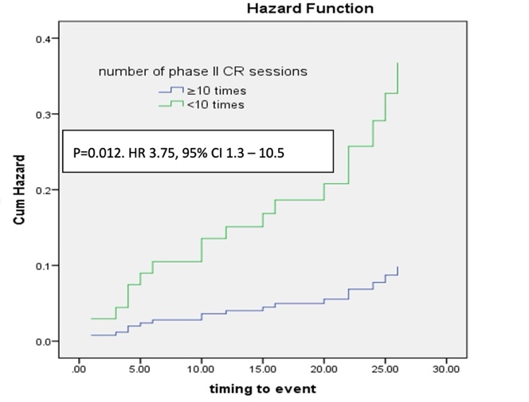
Figure 1. Hazard function plot of CR program status (drop out vs complete) on survival analysis. mean survival time for complete CR group was 4 months longer compared to drop out group
ARTIFICIAL INTELLIGENCE BASED ALGORITHM IN DETECTING OBSTRUCTIVE CORONARY ARTERY DISEASE AMONG CHRONIC CORONARY SYNDROME PATIENTS WITH SUGGESTIVE POSITIVE ISCHEMIC RESPONSE

E. A. Pradipta¹, A. Santoso¹, R. Sukmawan¹, B. D. Putera¹, A. S. Kuncoro¹, A. Y. Husodo², W. Jatmiko³, B. Widyantoro¹

¹Cardiology and Vascular Medicine, Faculty of Medicine Universitas Indonesia, Jakarta, Indonesia
²Department of Informatics Engineering, University of Mataram, Indonesia.
³Faculty of Computer Science, Universitas Indonesia , Depok, Indonesia

Background:
Exercise stress testing (EST) used to be an established modalities in obstructive coronary artery disease (OCAD) detection among chronic coronary syndrome (CCS) patients. However, high false positive rate especially among those with suggestive positive ischemic response (SPIR) EST has hindered its utilization. We aim to develop a machine learning based prediction model to improve detection rate of OCAD among CCS patients.

Methods:
124 out of 513 patients with SPIR who underwent coronary angiography (CAG) within 1-year interval were enrolled. They were randomly split into training (80%) and testing (20%) dataset. Sixteen out of 122 features were used, including clinical information, ECG &amp; non-ECG parameter of the EST. Algorithm used in the model development including support vector machine, logistic regression, random forest, k-nearest neighbor, naive Bayesian, Adaboost, decision tree dan extreme gradient boosting.

Results:
124 out of 513 patients with SPIR were enrolled in this study between January 2019 and December 2023. 86(69,35%) patients had OCAD based on CAG. Random forest algorithm achieved the highest accuracy (0,75±0,05) with Youden index of 0,37 and AUC 0,7±0,14. Pretest probability (PTP) score of OCAD according to guideline and Cuke treadmill score (DTS) <+5 as a predictor of OCAD has AUC of 0.50 ± 0.01 and 0,63 (95% CI 0,522-0,736), respectively.

Conclusion:
EST withML-based algorithm has better OCAD diagnostic accuracy among CCS patients with SPIR compared to DTS and PTP which has been routinely used previously.

Keywords: suggestive positive ischemic response, artificial inteligence, machine learning, obstructive coronary artery disease, treadmill stress testing

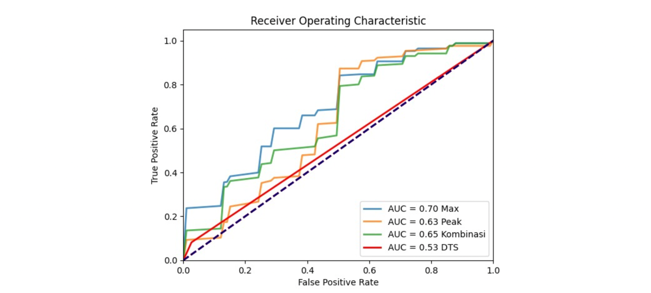
Figure 1. ROC curve analysis of Random Forest algorithm using all type of dataset (right) in comparison to Duke treadmill score (DTS).
POORER RIGHT ECHOCARDIOGRAPHY PARAMETERS IMPLIES POORER EXERCISE TOLERANCE IN PULMONARY ARTERIAL HYPERTENSION

O. N. Saputri¹, A. K. Ratri², A. Y. Putri², B. S. Pikir²

¹Faculty of Medicine, Universitas Airlangga, Surabaya 60286, Indonesia
²Department of Cardiology and Vascular Medicine, Faculty of Medicine, Universitas Airlangga – Dr. Soetomo General Hospital, Surabaya 60286, Indonesia

Background:
Pulmonary arterial hypertension (PAH) is progressive pulmonary vascular disease and life-threatening condition. Patients with pulmonary arterial hypertension due to congenital heart disease (PAH-CHD) exhibit significantly reduced exercise tolerance compared to other PAH groups. Right ventricular (RV) dysfunction is a commonly used independent prognostic parameter in PAH. The objective of this study was to investigate the correlation of RV function to exercise capacity in patients with PAH-CHD.

Methods:
This cross-sectional study was performed on 51 consecutive patients with confirmed diagnosis of PAH due to CHD between October and December 2023. These patients underwent a submaximal exercise testing using the 6-minute walk test (6MWT) and transthoracic echocardiographic (TTE) evaluation, including the measurement of tricuspid annular plane systolic excursion (TAPSE), pulmonary artery systolic pressure (PASP) and TAPSE/PASP ratio as parameters of RV function.

Results:
Fourteen men and 37 women aged 36.0 + 11.2 years participated in this study. The most common CHD was atrial septal defect (88.2%) with left-to-right shunt (51.0%). The mean of 6MWT was 366.8 (± 60.6) m. There was a significant correlation between 6MWT and peripheral capillary oxygen saturation (SpO2) (r = 0.400, P = .004), PASP (r = -0.309, P = .027), TAPSE (r = 0.330, P = .018) and TAPSE/PASP ratio (r = 0.392, P = .018).

Conclusion:
RV dysfunction was closely related to poor exercise tolerance. PASP and TAPSE, indices of RV systolic function parameters by TTE, is a simple and non-invasive tool for assessing the exercise capacity and/or evaluating therapy in patients with PAH-CHD.

Keywords: RV dysfunction, Pulmonary arterial hypertension, Exercise tolerance
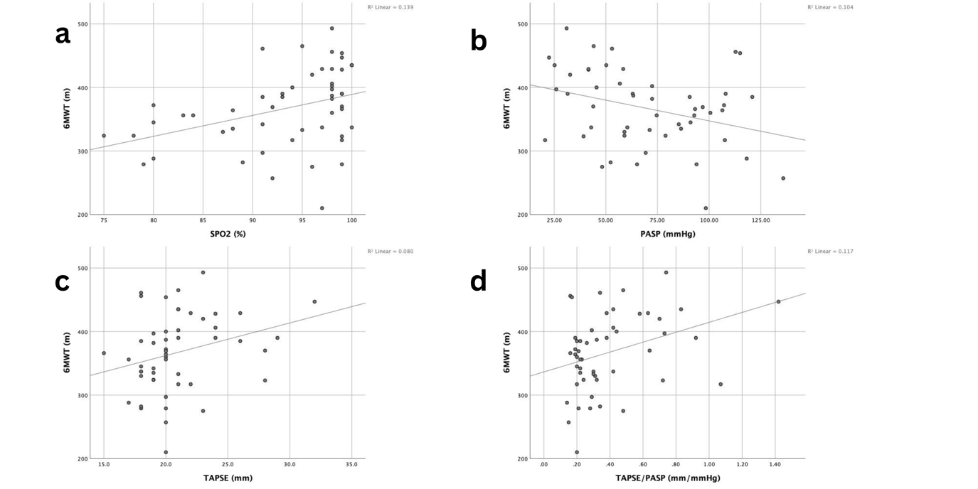
Figure 1. Scatter plot showing the relation between 6MWT with (a) peripheral capillary oxygen saturation (SpO2) (r = 0.400, P= 0.004), (b) pulmonary artery systolic pressure (PASP) (r = -0.309, P = 0.027), (c) tricuspid annular plane systolic excursion (TAPSE) (r = 0.330, P = 0.018) and (d) TAPSE/PASP ratio (r = 0.392, P = 0.018)
ECHOCARDIOGRAPHIC CALCIFICATION SCORE AS PREDICTOR OF SIGNIFICANT LESION OF CORONARY ARTERY DISEASE

Y. B. Ginting¹, A. P. Ketaren², T. W. Ardini², N. Z. Akbar², J. Purba²

¹Cardiology resident at University of Sumatera Utara, Adam Malik General Hospital
²Echocardiography Department of University of Sumatera Utara, Adam Malik General Hospital

Background:
Calciﬁcation of the mitral annulus and of other cardiac structures is associated with calciﬁcation of atherosclerotic lesions with similar risk factors predisposing for coronary artery disease. This study aimed to analyze the diagnostic value of cardiac calciﬁcation score acquired by standard transthoracic echocardiography and its association with severity of coronary artery lesion.

Methods:
50 patients from January to June 2024 were undergone invasive coronary angiography and standard comprehensive transthoracic echocardiography. All patients were retrospectively reviewed for calcifications of the aortic valve, aortic root, mitral annulus, papillary muscles and ventricular septum using echocardiography. A calcification score ranging from 0 to 5 was assigned to every patient. Regarding coronary angiogram results, patients were assigned to groups: “no CAD” means the absence of atherosclerotic lesions in any of the coronary and “signiﬁcant CAD” means ≥ 50% luminal vessel narrowing in at least in one of the three main coronary vessels. ROC analysis was performed to assess sensitivity and specificity of calcification score for significant CAD. Univariate and multivariate logistic regression analysis was performed to assess the association of the calcification score with significant coronary artery disease. Data were analyzed using SPSS software respective to its categorical data.

Results:
Receiver operating characteristic (ROC) analysis revealed Area Under the Curve (AUC) of 0.792 (p<0.001), dichotomizing calciﬁcation score at ≥ 3 enables best clinical application because of the highest positive predictive value (87.2%). Univariate logistic regression analysis revealed a 11,9 times higher risk for having a signiﬁcant CAD in patients with higher calciﬁcation scores (OR = 11.9; CI = 2.536 - 55.848; p< 0.001). The multivariate logistic regression analysis showed that higher calciﬁcation scores proved to be an independent indicator of signiﬁcant CAD (OR = 1.193; CI = 1.485 - 7.316; p=0.003).

Conclusion:
Echocardiography calciﬁcation score shows a strong association with signiﬁcant CAD. This scoring system may serve as a valuable marker for signiﬁcant coronary artery disease.

Keywords: Calcification score, Echocardiography, Coronary artery disease

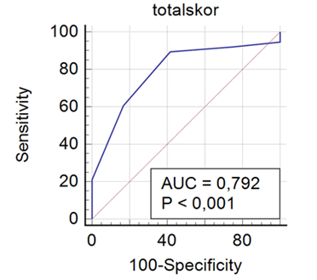
Figure 1. Receiver operating characteristic (ROC) analysis revealed Area Under the Curve (AUC) of 0.792 (p<0.001), dichotomizing calciﬁcation score at ≥ 3 enables best clinical application because of the highest positive predictive value (87.2%).
CLINICAL CHARACTERISTICS AND OUTCOME OF PERCUTANEOUS CORONARY INTERVENTION IN KARAWANG GENERAL HOSPITAL

Z. Firdaus¹

¹Karawang General Hospital

Background:
Percutaneous Coronary Intervention (PCI) is a non-surgical, invasive procedure used to open blocked blood vessels in the coronary arteries. PCI is the primary management strategy for patients with ST Elevation Myocardial Infarction (STEMI) and unstable ACS. Currently, there is no available data regarding the characteristics and outcomes of patients who underwent PCI at Karawang General Hospital. This study aims to determine the characteristics and outcomes of patients who underwent PCI at Karawang General Hospital.

Methods:
All patients underwent PCI, either primary, rescue, early or elective, from June to December 2023 at Karawang General Hostpital. Clinical, demographic, procedural and outcome data were extracted and analyzed using IBM SPSS Statistics for Windows, version 25

Results:
During the study period, out of the 156 patients who underwent coronary angiography, 84 underwent PCI. Among these 84 patients, the average age was 57 ± 8 years, ranging from 36 to 76 years, and 63% were men. Among all patients, 59.5% (50) smoked tobacco, 41.7% (35) had hypertension, 44% (37) had Type 2 diabetes, 22.6% (19) had hyperlipidemia, and 3.6% (3) had a family history of ischemic heart disease. Coronary artery presentations included acute ST-elevation myocardial infarction in 42.9% (36) cases, non-STEMI in 13.1% (11), stable angina in 40.5% (34), and unstable angina in 3.6% (3). Coronary artery interventions consisted of elective PCI in 53.6% (45) cases, primary PCI in 4.8% (4), rescue PCI in 2.4% (2), and early PCI in 34.5% (29), with 82.1% using radial artery access, 9.5% femoral access, and only 8.3% brachial access. PCI primarily targeted the left anterior descending artery in 57.1% (48) cases, the right coronary artery in 29.8% (25), and the left circumflex artery in 13.1% (11). All stents used were drug-eluting during the registry period, and complications occurred in 7.1% (6) of cases.

Conclusion:
Based on this registry data, smoking is the most prevalent risk factor found in patients who underwent PCI. Overall, PCI was performed with success in a large number of patients with a low incidence of complication

Keywords: angina, acute coronary syndrome, registry, Percutaneous coronary intervention

CLINICAL CHARACTERISTIC AND SHORT-TERM OUTCOME OF CONVENTIONAL ABLATION IN PVC WITH LBBB MORPHOLOGY AT THE NATIONAL CARDIOVASCULAR CENTER HARAPAN KITA

D. Putri¹, D. Y. Hermanto¹

¹National Cardiovascular Center Harapan Kita

Background:
Premature ventricular contraction (PVC) is a common arrhythmia that can impact the quality of life. Ablation remains a primary treatment for PVC. This study aims to present the clinical characteristics and short-term outcomes of patients who underwent conventional ablation at the National Cardiovascular Center Harapan Kita (NCCHK).

Methods:
This retrospective observational study includes data from patients who underwent conventional PVC ablation at NCCHK between June 2023 and May 2024. The short-term outcome of success was determined by symptom improvement and evaluation of ECG results 24 hours post-procedure and during a follow-up outpatient visit within one week.

Results:
A total of 184 ablation procedures were performed, with 76 (40.8%) being 3D ablations and 108 (58.7%) being conventional ablations. This study ultimately included 79 patients with left bundle branch block (LBBB) PVC morphology for clinical characteristics analysis due to missing data. Post-procedure evaluation showed a short-term success rate of 79.7% for conventional ablation. The overall mean age of the patients was 41.75 years (range 16-69), with females predominantly represented at 63 (79.7%) and males at 16 (20.3%). Hypertension (30.4%) was the most common comorbidity, and beta-blockers as class II antiarrhythmic drugs (59.5%) were the most prescribed antiarrhythmics. The PVC origin was mostly from the right ventricular outflow tract (RVOT) (86.1%). The PVC transition zone was comparable, with 48.1% in ≤ V3 and 51.9% in > V3, showing no significant difference between the successful and failed ablation groups. There were no statistically significant differences in clinical characteristics between the successful and failed ablation groups.

Conclusion:
This study presents the clinical characteristics and short-term outcomes of patients with PVC who underwent conventional ablation at NCCHK. Females were the predominant gender, hypertension was the most common comorbidity, beta-blockers were the most frequently prescribed medication, and PVCs primarily originated from the RVOT. There were no statistically significant differences in clinical characteristics between successful and failed ablation results. Conventional ablation can be performed on PVCs with LBBB inferior axis with a 79.7% success rate, without depending on the sinus rhythm transition zone in precordial leads.

Keywords: conventional ablatioin, LBBB morphology, premature ventricular complex, clinical characteristics

FOUR-CLASS HYPERTENSION PREDICTION BASED ON MACHINE LEARNING IN PRIMARY CARE

R. I. Estiko¹, R. M. Yusup², I. F. Rakhmat², E. Rijanto³

¹Bandung City Regional General Hospital
²Postgraduate Faculty, Universitas Komputer Indonesia
³National Research and Innovation Agency

Background:
Hypertension contributes to cardiovascular diseases (CVDs), which are the leading cause of death. Machine learning (ML)-based hypertension prediction potentially helps detect and manage the disease. This study aimed at predicting four classes of hypertension, i.e., normal, prehypertension, stage 1 hypertension, and stage 2 hypertension, based on ML using available primary care tools.

Methods:
This cross-sectional registry study used the data collected at Integrated Counselling Posts across Indonesia from 2013 to 2018. We leveraged 15 risk factors, including the family history of hypertension, age, sex, smoking tobacco, drinking alcohol, lack of physical activity, lack of fruit or vegetable intake, body mass index, waist circumference, education level, occupation, resident province, blood glucose, total cholesterol, and triglyceride from 1,396,757 subjects aged above 15 years old. We developed models based on four ML algorithms: Support Vector Machine, Extreme Gradient Boosting (XGBoost), Random Forest, and Logistic Regression.

Results:
In the internal validation using 10-fold cross-validation, the XGBoost model performed best in predicting four classes of hypertension with 86.32% accuracy, 86.14% sensitivity, 87.91% specificity, and 97.25% area under the receiver operating characteristics (ROC) curve (AUC). It also gave the best performance in the external validation with 80.11% accuracy, 79.08% sensitivity, 81.81% specificity, and 94.54% AUC.

Conclusion:
The ML model showed outstanding results in predicting four classes of hypertension with primary care tools. Its use in hypertension screening can alleviate the economic burden, which is often challenging in developing countries.

Keywords: Primary care, Hypertension, Four-class, Machine Learning, Indonesia

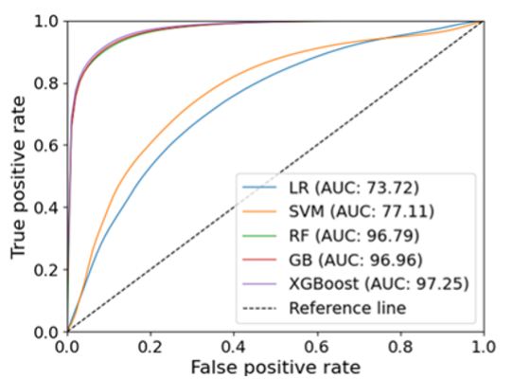
Figure 1. The ROC curves in cross validation
ASSOCIATION BETWEEN STRESS HYPERGLYCEMIA RATIO TO TIMI THROMBUS GRADE AND MAJOR CARDIOVASCULAR EVENTS IN NONDIABETIC PATIENTS WITH ST-SEGMENT ELEVATION MYOCARDIAL INFARCTION TREATED WITH PRIMARY PERCUTANEOUS CORONARY INTERVENTION

A. N. Sulma¹, Safir¹, Bahrudin¹

¹Diponegoro University

Background:
The stress hyperglycemia ratio (SHR) is a measurement index to describe stress-induced hyperglycemia that allows risk stratification in patients with acute coronary syndromes. The purpose of this study was to determine the association between stress hyperglycemia ratio to TIMI thrombus grade and major adverse cardiovascular events (MACEs) in nondiabetic ST-Elevation Myocardial Infarction (STEMI) patients who received primary percutaneous coronary intervention (PPCI).

Methods:
This was retrospective study in nondiabetic STEMI patients with an onset of less than 12 hours who underwent PPCI with stent at Dr. Kariadi Semarang general hospital from January 2020 to March 2023. The outcomes were angiographic characteristics of initial TIMI thrombus grades prior to PPCI and clinical outcomes of in-hospital MACEs which included mortality, cardiogenic shock, acute pulmonary edema and arrhythmias.

Results:
A total of 217 patients met the criteria and were divided into 3 tertiles based on the SHR values. Patients with a large thrombus burden (LTB) and MACEs are found to be more prevalent as tertile SHR values rise. The cut-off for the occurrence of LTB and MACEs at the hospital is SHR value ≥1.0804 (RR 1.341, 95% IK: 1.138 – 1.579, p<0.001) and SHR value ≥1.1946 (RR 3.087, 95% IK: 1.369 – 6.960, p=0.004), respectively. SHR and left ventricular ejection fraction were identified as predictors of MACEs based on multivariate analysis.

Conclusion:
An increase in the SHR value is associated with an increased risk of large thrombus burden and in-hospital MACEs in nondiabetic STEMI patients who underwent PPCI.

Keywords: stress hyperglycemia ratio, TIMI thrombus grade, major cardiovascular events, ST-Elevation Myocardial Infarction, nondiabetic

COGNITIVE FUNCTION AND NON-INVASIVE ATHEROSCLEROTIC MARKERS IN PREDICTING PROGNOSIS FOR OLDER PATIENTS WITH NON-ST ELEVATION ACUTE CORONARY SYNDROME

V. J. Dirjayanto¹, G. Pompei², F. Rubino³, V. Kunadian⁴

¹Faculty of Medicine, Universitas Indonesia, Indonesia
²Cardiovascular Institute, Azienda Ospedaliero-Universitaria di Ferrara & Translational and Clinical Research Institute, Faculty of Medical Sciences, Newcastle University
³Division of Cardiology, Department of Medicine, University of Verona & Translational and Clinical Research Institute, Faculty of Medical Sciences, Newcastle University
⁴Cardiothoracic Centre, Freeman Hospital, Newcastle upon Tyne Hospitals NHS Foundation Trust, Newcastle upon Tyne, United Kingdom

Background:
Despite contributing to substantial morbidity and mortality, there is insufficient evidence for guiding management of older non-ST-elevation acute coronary syndrome (NSTEACS) patients, especially those with cognitive impairment. Non-invasive atherosclerosis-related markers may aid in determining prognosis and guiding more optimal care.Aim: To investigate the long-term prognostic significance of cognitive function and non-invasive markers in older NSTEACS patients.

Methods:
NSTEACS patients aged 75 years and older were followed up for five years based on cognition measured utilising the Montreal Cognitive Assessment [MoCA], endothelial function with the endoPAT reactive hyperaemia index (LnRHI), carotid intima-media thickness (CIMT) utilising ultrasound, and vascular stiffness with the carotid-femoral pulse wave velocity (cfPWV). Statistical analysis was performed independently for all-cause mortality, then for major adverse cardiovascular events (MACE) and its components: deaths, reinfarction, urgent revascularization, stroke/transient ischaemic attack, and significant bleeding, for which time-to-first event was used.

Results:
239 patients with baseline MoCA (median age: 80.9 [interquartile range (IQR): 78.2-83.9] years) were followed for five-year outcomes. Cognitive impairment was independently associated with higher mortality risk (adjusted Hazard Ratio [aHR]: 1.66 (95% Confidence Interval [CI]:1.03-2.69); P=0.038) and worse survival (Log-rank P=0.003, Breslow P=0.002, Tarone-Ware P=0.003). For those with LnRHI (214 patients, 80.9 [IQR:78.2-84.1] years), endothelial dysfunction leaned towards higher mortality risk as a component of MACE. However, for CIMT and vascular stiffness, no prognostic significance was found.

Conclusion:
Cognitive impairment was associated with long-term all-cause mortality. Endothelial dysfunction might predict deaths as a component of MACE, but CIMT and vascular stiffness were less consequential as prognostic predictors. Clinical Trial Registration:NCT01933581

Keywords: non-ST-elevation acute coronary syndrome, carotid intima media thickness, cognition, endothelial function, vascular stiffness

DEVELOPMENT OF A RISK PREDICTION MODEL TO PREDICT ACUTE KIDNEY INJURY IN INTENSIVE CARDIOVASCULAR CARE UNIT

H. Jauhari¹, H. P. Bagaswoto², A. B. Hartopo²

¹Resident of Department of Cardiology and Vascular Medicine, Dr Sardjito General Hospital/Gadjah Mada University, Yogyakarta, Indonesia
²Staff of Department of Cardiology and Vascular Medicine, Dr Sardjito General Hospital/Gadjah Mada University, Yogyakarta, Indonesia

Background:
Acute kidney injury (AKI) is a condition of acutely decreased kidney function characterized by elevated serum creatinine and associated with poor short and long-term prognosis. Early identification of high-risk patients provides an opportunity to develop strategies for prevention, early diagnosis and treatment of AKI.

Methods:
We conducted single-center retrospective analysis from Sardjito Cardiovascular Intensive Care (SCIENCE) registry between January 2022 to December 2023 to develop a risk score for predicting AKI in patients admitted to an intensive cardiovascular care unit (ICCU). Demography, risk factors, comorbidities, laboratory and echocardiography data of patient admitted to ICCU were analyzed. AKI was defined by the Kidney Disease: Improving Global Outcomes criteria (absolute increase of 0.3 mg/dL in 48 h or relative change of 50% from baseline serum creatinine in 7 days). Patients who reached the primary outcome were accepted into the AKI group. We using binary multivariate logistic regression to create risk prediction with cut-off and probability models.

Results:
This study included 883 patients with prevalence of AKI was 32,7%. Significant predictors of AKI in the risk prediction model including diabetes mellitus (OR 1,65, IK95% 1,13-2,42, p=0,012), shock (OR 1,77, IK95% 1,24-2,52, p=0,002), mechanical ventilation (OR 2,90, IK95% 1,93-4,36, p=<0.001), contrast use (OR 1,44, IK95% 1,02-2,02, p=0,037), leukocytosis (OR 1,60, IK95% 1,09-2,37, p=0,017), acidosis (OR 1,98, IK95% 1,22-3,22, p=0,006), and hyperlactatemia (OR 1,58, IK95% 1,09-2,29, p=0,015). The discriminative ability with AUROC was 0.72 (95% CI 0.69–0.75) with optimal cut-off value to distinguish high-risk and low-risk patients is 5 points (sensitivity 51.9%, specificity 80.9%) and from probability model (score 0 to 9) showed that increasing the score will increase the probability of AKI.

Conclusion:
This risk prediction model could help to stratify patients for primary prevention, surveillance and early therapeutic intervention to improve care and outcomes of patient with AKI in ICCU.

Keywords: Risk prediction model, Acute kidney injury (AKI), Intensive cardiovascular care unit (ICCU) 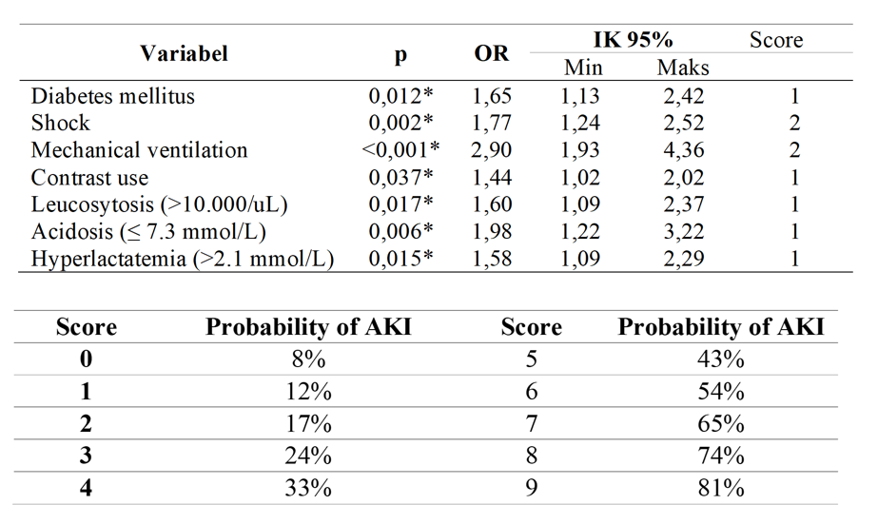
Figure 1. Predictors of AKI obtained by multivariate logistic regression

DIAGNOSTIC PERFORMANCE OF LEARNING INTELLIGENT FOR EFFECTIVE SONOGRAPHY – IN MYOCARDIAL INFARCTION (LIFES-MI) ARTIFICIAL INTELLIGENCE MODEL IN DETECTION OF MYOCARDIAL INFARCTION AMONG PATIENTS WITH NON-ST ELEVATION ACUTE CORONARY SYNDROME (NSTEACS)

K. M. H. J. Tandayu¹, L. D. Liastuti²

¹Department of Cardiology and Vascular Medicine, National Cardiovascular Center Harapan Kita, Universitas Indonesia
²Department of Cardiology and Vascular Medicine, National Cardiovascular Center Harapan Kita, Universitas Indonesia, Jakarta, Indonesia

Background:
Detecting myocardial infarction in the non-ST segment elevation acute coronary syndrome (NSTEACS) population in clinical practice is challenging and leads to failure in appropriate risk stratification. Cardiac enzyme assays are not widely available especially in rural settings, have long waiting times, and incur significant costs

Methods:
This study is a diagnostic study that evaluates the ability of deep learning-based artificial intelligence namely LIFES in detecting myocardial infarction in NSTEACS patients at RSJPDHK from 2019 to 2023 based on echocardiographic videos using three common views PLAX, A4CH, and A2CH. Transfer learning was performed using the research dataset and cross-validation to determine the diagnostic performance of the new model (LIFES-MI) post-transfer learning.

Results:
A total of 721 subjects met the inclusion and exclusion criteria from 2019 to 2023. Among them, 310 were non-ST segment elevation myocardial infarction (NSTEMI) patients. 67.8% of the subjects were male with a median age of 61 years. The median time from admission to echocardiography was three days. There were significant differences in several echocardiographic parameters between the infarct and non-infarct groups, including median EF% 53% vs 63% (p < 0.001), median LVEDD 48.8 mm vs 44.6 mm (p < 0.001), median mean E/E' 12.0 vs 9.8 (p < 0.001), and median LAVI 30 ml/m2 vs 26 ml/m2 (p < 0.001). LIFES diagnostic performance for infarction was best achieved in the PLAX view with sensitivity of 88.7% and specificity of 20.4%, AUC 0.55. Post-transfer learning, the LIFES-MI model produced the best accuracy in the A4C view with sensitivity of 41.3% and specificity of 83.7%, AUC 0.61.

Conclusion:
LIFES-MI deep learning model has good specificity in detecting myocardial infarction based on echocardiographic findings in the NSTEACS population. However the model needs some improvement to augment the sensitivity and the AUC.

Keywords: Deep Learning, Echocardiography, LIFES-MI, NSTEACS, Artificial Intelligence

Table 1. Diagnostic Accuracy of LIFES-MI Deep Learning Model
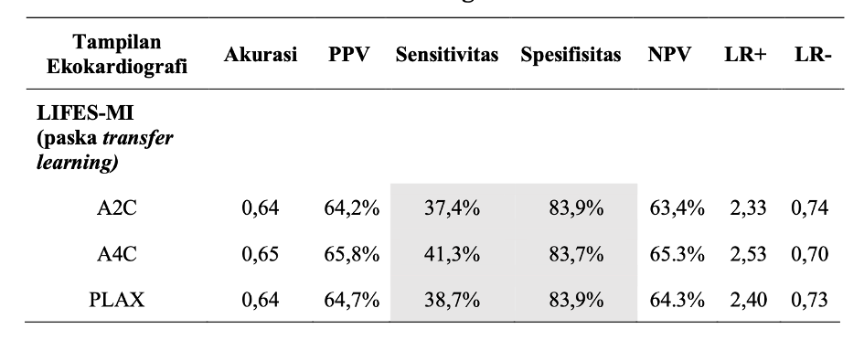

ENHANCING THE ANGIOGENESIS POTENTIAL OF HYPOXIA-PRECONDITIONED ENDOTHELIAL PROGENITOR CELLS IN ISCHEMIC HEART DISEASE BY COMBINING DAPAGLIFLOZIN AND HUMAN UMBILICAL CORD BLOOD SECRETOME: EXPLORING THE UNCHARTED
P. M. Harsoyo¹, H. O. Hermawan¹, R. E. Intan¹, A. N. Fadila¹, Y. H. Oktaviono², B. B. Dharmadjati², I. G. R. Suryawan², M. Y. Alsagaff²

¹Resident, Department of Cardiology and Vascular Medicine, Universitas Airlangga
²Staff, Department of Cardiology and Vascular Medicine, Universitas Airlangga

Background:
Angiogenesis is critical for tissue repair in coronary artery disease (CAD), with endothelial progenitor cells (EPCs) playing a key role. However, EPC function is compromised in CAD patients, affecting the quality and functionality of the newly formed vascular network. This study investigates the effects of dapagliflozin, a sodium-glucose cotransporter 2 inhibitor with cardiovascular benefits, and the secretome of human umbilical cord blood-derived mesenchymal stem cells (HUCB-MSCs) on enhancing angiogenesis in hypoxia-preconditioned EPCs from CAD patient.

Methods:
EPCs isolated from CAD patient were isolated and exposed to HUCB-MSC secretome and its combination with dapagliflozin. Angiogenesis was assessed using in vitro tube formation assays for structural evaluation. Functional assessments included measurements of endothelial nitric oxide synthase (eNOS) and von Willebrand factor (vWF) levels by ELISA.

Results:
Our study was the first to investigate the angiogenesis potential of HUCB-MSC secretome and its combination with dapagliflozin on EPC. Both HUCB-MSC secretome only and dapagliflozin combination groups showed significant increase in tube formation compared to negative control (p = 0.04), although the combination of dapagliflozin and secretome did not significantly enhance tube formation over secretome alone. Statistical analysis indicated significant differences in eNOS levels among groups (p = 0.027). Post hoc analysis confirmed significant increase in eNOS levels of combination group compared to both control and secretome alone (p = 0.046). While ANOVA for vWF did not show significant differences, post hoc Tukey HSD test indicated a near-significant difference between the control and the combination treatment group (p = 0.087).

Conclusion:
HUCB-MSC secretome and its combination with dapagliflozin significantly enhances angiogenesis, as evidenced by increased tube formation as well as eNOS and vWF levels. The increase of eNOS shown by combination group in particular indicates enhanced functionality within formed tubes. This combination therapy shows potential for improving endothelial function and angiogenesis in CAD patients, suggesting promising therapeutic benefits.

Keywords: HUCB-MSC secretome, angiogenesis, coronary artery disease, ischemic heart disease, dapagliflozin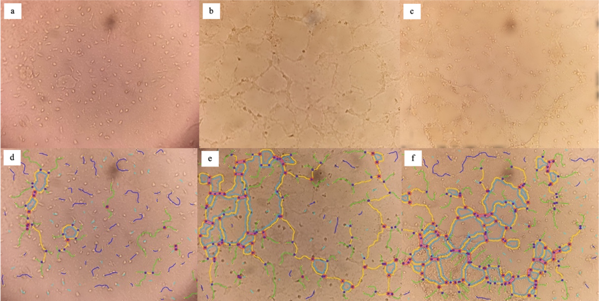
Figure 1: a) Tube assay for the P0 group (control), b) P1 group (secretome treatment), and c) P2 group (secretome + dapagliflozin). Figure 1.d-f show ImageJ Angiogenesis Analyzer results: d) P0, e) P1, and f) P2. Green lines show main branches, blue for small branches, magenta for segments, orange for main segments, light blue for meshes, dark blue for isolated parts, and yellow for tips.
PREVALENCE OF HYPERTENSION AND ITS ASSOCIATED RISK FACTORS IN BENGKULU POPULATION : A CROSS-SECTIONAL STUDY

B. A. Satria¹, E. G. Sari², M. Marzain¹

¹Fakultas Kedokteran Universitas Andalas
²Puskesmas Muara Bangkahulu

Background:
Hypertension is the leading cause of adverse cardiovascular outcomes and causes of death globally each year and remains a worldwide burden in most economically developing and developed countries including Indonesia. This study aimed to determine the prevalence of hypertension and associated risk factors among Muara Bangkahulu sub-district population in Bengkulu city.

Methods:
This study was a cross-sectional study of 1744 respondent (residents of Muara Bangkahulu sub-district) in 2024. The data is obtained based on secondary data that has been owned by Muara Bangkahulu Public Health Centre (Puskesmas). Data was analyzed using binary logistic regression.

Results:
There were significant associations between sex, smoking, body mass index, age and hypertension (p < 0,05, CI = 95%). Male have higher tendency to have hypertension than female ( OR = 2,570, CI = 95% ). Smoker have higher tendency to have hypertension than non-smoker ( OR = 8,040, CI = 95%). Heavier people have higher tendency to have hypertension than normal-weight people ( OR = 2,031, CI = 95% ). Older adults have higher tendency to have hypertension than younger (OR = 1,822, CI = 95 %

Conclusion:
Hypertension prevalence data can be used as a reference for holistic management of hypertension in the present and future in Bengkulu City. A gender-based approach in the health prevention strategy to control hypertension for male and female is needed. Research related to the relationship between hypertension and smoking in this city needs to be done with more specific because it is the most influential risk factor among others.

Keywords: Hypertension, sex, age, smoking, body mass index
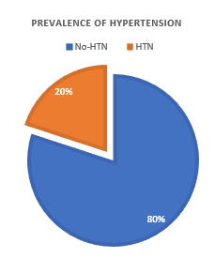

Figure 1. Prevalence of Hypertension in Muara Bangkahulu sub-district population in Bengkulu city
THE IMPACT OF EXPOSURE TO CONVENTIONAL CIGARETTE SMOKE AND E-CIGARETTES ON INTIMA-MEDIA THICKNESS, ATHEROSCLEROSIS EVENTS, TNF-Α AND MCP-1 CONCENTRATIONS IN PERIPHERAL ARTERIES OF RATTUS NORVEGICUS RATS

A. N. Puspitasari¹, J. N. E. Putranto¹, I. G. R. Suryawan¹, A. D. Lamara¹

¹General Academic Hospital Dr. Soetomo

Background:
Smoking continues to be a leading cause of morbidity and mortality worldwide. Many smokers perceive e-cigarettes as a safer alternative to traditional cigarettes. The popularity of e-cigarettes is increasing annually by approximately 10.9%. This research investigates the impact of exposure to electronic and conventional cigarettes on intimal-media wall thickness, TNF-α and MCP-1 concentrations, and the incidence of atherosclerosis in the peripheral arteries of rats (Rattus novergicus).

Methods:
In this study, Rattus norvegicus rats were divided into three groups of ten rats each. The control group was exposed to smoke-free air, the second group to e-cigarette smoke, and the third group to conventional cigarette smoke for a duration of 12 weeks. Blood samples were collected to measure TNF-α and MCP-1 concentrations post-exposure, and iliac artery tissues were subjected to histopathological examination. Statistical analysis was conducted using One-Way ANOVA for normally distributed data, the Mann-Whitney test for non-normally distributed data, and the Fisher test for expected counts less than five.

Results:
This study employed One-Way ANOVA to analyze TNF-α concentrations, revealing no significant difference between conventional cigarettes and e-cigarettes (p=0.217). However, a post-hoc LSD test indicated a significant difference in MCP-1 concentrations between conventional cigarettes and e-cigarettes (p=0.023). In terms of intima-media wall thickening in the iliac arteries, post-hoc LSD tests demonstrated significant differences between the control group and both the conventional cigarette group (p=0.022) and the e-cigarette group (p=0.021), but no significant difference between conventional cigarettes and e-cigarettes (p=0.983). Fisher's exact test showed significant differences in iliac artery atherosclerosis between the control group and the conventional cigarette group (p=0.005), as well as between the control group and the e-cigarette group (p=0.001). However, no significant difference was found between conventional cigarettes and e-cigarettes in terms of the incidence of atherosclerosis (p=1.000).

Conclusion:
Both conventional and e-cigarettes caused a non-significant increase in TNF-α concentrations but led to a significant increase in MCP-1 concentrations, with conventional cigarettes having a greater impact. Intima-media wall thickness and peripheral atherosclerosis were significantly higher in rats exposed to either type of cigarette compared to the control group.

Keywords: Intima-media wall thickening, MCP-1, Peripheral atherosclerosis, cigarette, TNF-α

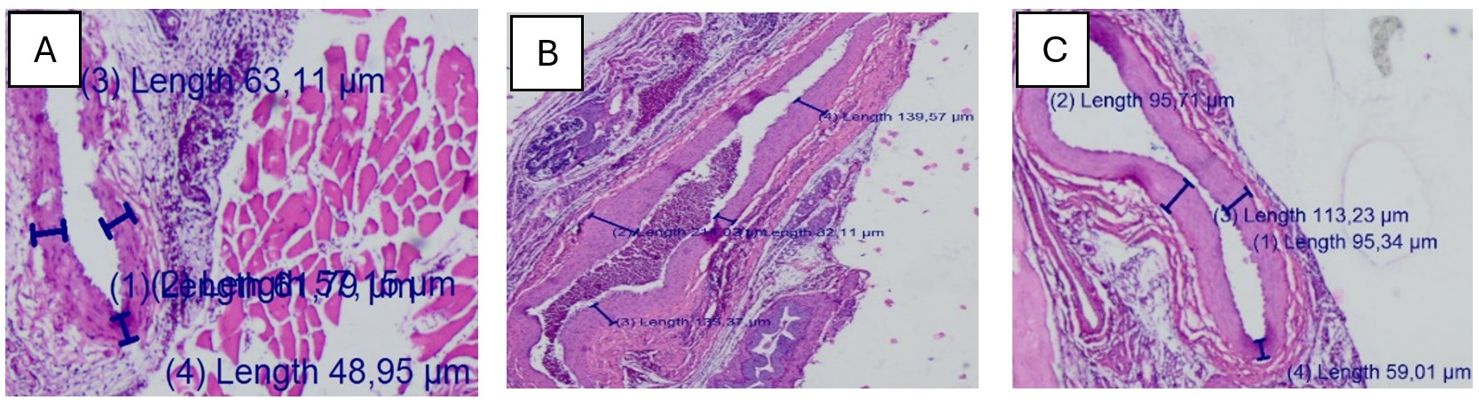
Figure 1. Intima-media wall thickening of peripheral atherosclerosis in Rattus novergicus rats in control group (A), exposed to conventional cigarette smoke (B), and exposed e-cigarette smoke (C).

CHARACTERISTIC OF NON-INVASIVE AND INVASIVE ASSESSMENT OF RIGHT VENTRICLE TO PULMONARY ARTERY COUPLING IN PATIENTS WITH LEFT-SIDED VALVULAR HEART DISEASE

R. Y. S. Situmorang¹, M. Hasan², Irene.Lampita², H. S. Prameswari², M. R. Akbar²

¹RSUP Dr. Hasan Sadikin Bandung
²Cardiologist, Department of Cardiology and Vascular Medicine, Faculty of Medicine, Universitas Padjadjaran/Dr. Hasan Sadikin General Hospital, Bandung, Indonesia

Background:
Valvular heart disease (VHD) is a common cause of right ventricular (RV) dysfunction. The right ventricular (RV) to pulmonary arterial (PA) ratio is indicative of the efficiency with which RV stroke work is transferred into the PA. Invasive assessment remains the gold standard for evaluating RV-PA coupling, as it allows for direct estimation of RV and PA pressures and volumes. However, due to its ease of use at the bedside, non-invasive assessment has become increasingly important for diagnosing RV function..

Methods:
A retrospective cross sectional study was conducted on 28 subjects. All patients undergoing transthoracic echocardiography within 24 hours RHC (Right Heart Catheterization) procedure at Dr. Hasan Sadikin Hospital, Bandung, from October 2021 to April 2024. Invasive data were analyzed using multivariable models, considering non-invasive assessments of RV function..

Results:
The average patient age was 49 years old (49.35 ± 12.12), 16 (57.1%) patients had atrial fibrillation. 12 patients (42.9%) had severe mitral regurgitation and 7 patients (25%) had severe mitral stenosis. 5 patients (17.9%) had severe aortic regurgitation and 3 patients (10.7%) severe aortic stenosis. Most patients had uncoupled RV to PA according to echocardiography parameters (57.1% according to TAPSE/ePASP, 60.7% according to FAC/ePASP and 75% according to RVFWS/ePASP). Meanwhile only 2 patients (7.1%) who had uncoupled RV to PA according to invasive assessment (Right Heart Cathetherization).

Conclusion:
There is a significant discrepancy in the results of non-invasive assessment and invasive assessment for RV to PA coupling in patients with VHD. Further research with larger number of subjects and invasive measurement of the RV/PA ratio using a dedicated catheter are needed to improve the accuracy of non-invasive RV/PA coupling assessment in patients with left-sided VHD

Keywords: Right Heart Catheterization, RV-PA Coupling, right ventricular (RV) dysfunction, left-sided valve heart disease, Echocardiography

ECONOMIC EVALUATION OF HARKIT ICARE APPLICATION IN SECONDARY PREVENTION OF ACUTE CORONARY SYNDROME

S. Oetama¹

¹National Cardiovascular Center Harapan Kita

Background:
mHealth application as addition to standard cardiovascular rehabilitation may improve acute coronary syndrome recurrency compared with conventional program. Cost effectivity analysis is required to determine the economic effectivity of mHealth.

Methods:
a total of 106 hospitalized acute coronary syndrome patients from June 2022 to December 2022 in National Cardiovascular Center Harapan Kita were randomized into standard secondary prevention with HARKIT iCARE monitoring or standard secondary prevention only. Base trial follow-up period was six months. Health utility values were assessed using Indonesian version of EQ-5D-5L questionnaire and converted into quality adjusted life years. Total cost was classified into direct healthcare cost and non-direct cost. Outcomes were cost utility and cost effectivity analysis in incremental cost effectiveness ratio.

Results:
mean age was 59,5 years in HARKIT iCARE and 61,5 years in standard care. Other cost (medical consumables, renal replacement therapy, application development cost specifically for HARKIT iCARE [Δ mean Rp 3.319.179, SE Rp 3.342.412, p = 0,017]) and non-healthcare cost (Δ mean Rp 922.612, SE Rp 1.031.003, p = 0,005) were higher in HARKIT iCARE. A simple three health states Markov model was constructed with time horizon of five years and 30 days cycle. Total cost and health utility values were adjusted with 3% discount. Bootsrap analysis was performed 10,000 times to determine mean and 95% confidence interval. Quality adjusted life years was higher in HARKIT iCARE (3,23 vs 3,06, Δ mean 0,17) with higher cost (Rp 5.495.920.454 vs Rp 5.041.510.027, Δ mean Rp 454.410.427) compared to standard care. Cost utility incremental cost effectiveness ratio was Rp 2.673.002.511, exceeding the willingness to pay based on three times of Indonesia gross domestic product per capita in 2023 Rp 225.000.000. Effectiveness probability in willingness-to-pay curve was constantly at ~40%. There was no difference in all-cause mortality (adjusted RR 0,62, 95% CI 0,12-3,29, p = 0,574) and major adverse cardiovascular event (adjusted RR 0,90, 95% CI 0,33-2,42, p = 0,833), hence no cost effectivity incremental cost effectiveness ratio was calculated.

Conclusion:
HARKIT iCARE as addition to standard secondary prevention was not cost effective compared to standard care in post acute coronary syndrome patients.

Keywords: HARKIT iCARE, mHealth, quality adjusted life years, incremental cost effectiveness ratio, acute coronary syndrome

DISTAL RADIAL ACCESS FOR ANGIOGRAPHY AND INTERVENTION

P. S. Andjari¹

¹RSUD Sumedang

Background:
A new puncture site in distal radial area of the anatomical snuff box has been described and performed as a new approach for angiography and intervention in many countries. In this registry, we would like to demonstrate the feasibility and safety of distal radial access (DRA) based our on center experience

Methods:
All patients between June 2020 to April 2024 planned to do Coronary Angiography (CGA) and Percutaneous Coronary Intervention (PCI) in Sumedang Regional Hospital via DRA were included in this registry. Procedural data, puncture success, crossover rate, and complication were registered

Results:
A total of 835 patients were enrolled (mean age: 59.8 ± 1 years old, 76% male gender). Puncture success, which defined as successful sheath placement, was high (N = 811/835, 97,1%) and crossover rate was low (N = 24/835, 2,87%). The complication was observed clinically as hematoma on punctured area and AV fistula formation, the rate was low (N = 3/835, 0,4%). Major complication was not encountered.

Conclusion:
Distal transradial access can be performed in coronary angiography and intervention as default transradial access with high success rate and safe.

Keywords: Distal Radial Access, Angiography and Intervention

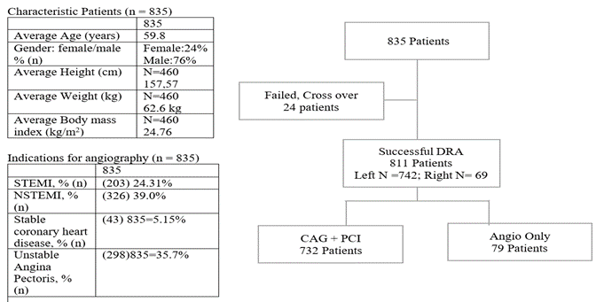
Figure 1. Characteristic patient, indications for angiography, and successful DRA case
CORONARY ARTERY DISEASE AND DIABETES MELLITUS IN THE ELDERLY: A STUDY IN KEBAYORAN BARU PUBLIC HEALTH CENTER, JAKARTA

S. A. Annisa¹

¹Puskesmas Kebayoran Baru

Background:
Coronary artery disease (CAD) is the foremost cause of mortality and morbidity in Indonesia. Additionally, diabetes mellitus (DM) is growing due to the rising prevalence of obesity and changing lifestyles. Diabetic patients are at increased risk of cardiovascular disease and worse prognosis. Furthermore, elderly patients are especially susceptible to CAD and DM, which are silent myocardial infarctions can occur in elderly diabetics. To review the characteristics of CAD in the elderly patients (over the age of 60 years old) and analyze the association of CAD and DM in the elderly, we perform this study in Kebayoran Baru Public Health Center, Jakarta.

Methods:
We retrospectively observed data using a cross-sectional design. Data was taken from the medical records of the Lansia unit in Kebayoran Baru Public Health Center from January 2023 to July 2024 with a total of 3372 elderly patients. There were 325 CAD patients and 559 DM patients, then we analyzed using Chi-square test to study the correlativity of CAD and DM in the elderly. We also analyzed the baseline characteristics of these CAD patients in the elderly, such as comorbidities and laboratory results.

Results:
Descriptively data presented that there were 325 (9.6%) CAD patients and 559 (16.6%) DM patients. There wasn't a significant association between CAD and DM in the elderly (p=0.799). Most of these CAD patients were male (58.1%, n=189). The analysis found that 46.1% (n=150) of patients had obesity with BMI 14.81-43.66, 53.5% (n=174) had hypertension, 40.6% (n=132) had dyslipidemia, 17% (n=56) had diabetes, 3% (n=10) had stroke, 4.9% (n=16) had chronic kidney disease, and 0.9% (n=3) had cardiac arrhythmia. A median of lipid profile level were total cholesterol 207mg/dl (113-351), triglyceride 137mg/dl (59-358), LDL 142mg/dl (55-233), and HDL 39mg/dl (20-65). A median of glucose blood levels was fasting glucose 100mg/dl (80-341) and postprandial glucose 132mg/dl (94-387); ureum 31mg/dl (11-105) and creatinine 1.5mg/dl (0.88-7.39).

Conclusion:
This study showed that the majority of CAD patients were male and had hypertension, but there wasn't a significant association between CAD and DM in the elderly.

Keywords: hypertension, coronary artery disease, diabetes mellitus, elderly

ASSOCIATION OF ANTIBIOTIC-RELATED WORSENING OF RENAL FUNCTION WITH INTRAHOSPITAL MORTALITY IN PATIENTS WITH LEFT-SIDED INFECTIVE ENDOCARDITIS

M. Agustina¹

¹Department of Cardiology and Vascular Medicine, Faculty of Medicine Universitas Indonesia

Background:
Infective endocarditis (IE) is a serious health problem with high incidence, morbidity, and mortality rates. The intrahospital mortality rate for IE patients with worsening kidney function is quite high. Intrahospital antibiotic-related worsening of renal function occurs quite frequently and is associated with worse clinical outcomes.

Methods:
A retrospective cohort study was conducted on 315 patients with active IE on the left side of the heart from January 1, 2013, to May 31, 2023. Bivariate and multivariate analyses were conducted to determine predictors of intrahospital mortality, long-term mortality, length of stay, and the need for renal replacement therapy. A scoring system was also used to predict intrahospital mortality in IE patients.

Results:
There were 315 patients with active IE on the left side of the heart, of whom 169 had antibiotic-related worsening of kidney function, and 146 did not. The intrahospital mortality rate was 20.3%, whereas the intrahospital mortality rate was 34.9% in patients with worsening kidney function due to antibiotics. According to multivariate analysis, factors associated with intra-treatment mortality were antibiotic-related worsening of kidney function (OR 8.6, p=0.001), incidence of sepsis (OR 11.16, p=<0.001), incomplete use of antibiotics (OR 10.49, p=<0.001), length of stay <21 days (OR 5.16, p=0.003), vegetation size >10 mm (OR 5.04, p=0.006), and use of renal replacement therapy (OR 4.74, p=0.008). We obtained the predictor score for intrahospital mortality. The results of the ROC curve analysis for calculating intrahospital mortality predictor scores showed an AUC of 0.927 (95% CI 0.886–0.968; p=< 0.001; H-L 0.610) with a sensitivity of 89.1% and a specificity of 84.5%.

Conclusion:
Worsening kidney function related to antibiotics was associated with intrahospital mortality.

Keywords: worsening renal function, infective endocarditis, antibiotics-related, intrahospital mortality

VALIDATION OF A SELF-TEST FOR EARLY IDENTIFICATION OF HEART FAILURE IN PERIPARTUM CARDIOMYOPATHY (PPCM)

A. Prabhaswara¹, M. A. Putri¹, H. S. Prameswari¹, M. Iqbal¹

¹Department of Cardiology and Vascular Medicine, Faculty of Medicine, Univesitas Padjadjaran, Hasan Sadikin General Hospital

Background:
Peripartum cardiomyopathy (PPCM) is a rare yet potentially life-threatening condition. Timely identification is critical for effective management and improved patient outcomes. This study seeks to validate a self-assessment scoring of the Indonesian translation, adapted from James D. Fett's work, which distinguish common signs and symptoms of heart failure from those related to normal term pregnancy with a score ≥ 4 indicates a need for further evaluation. This study is aiming to offer a practical and accessible diagnostic instrument for healthcare providers, especially in primary settings.

Methods:
Conducted as an observational retrospective analysis with a case-control design, this study evaluated scores based on subjects' presented signs and symptoms, utilizing the PPCM registry at Hasan Sadikin Hospital, Bandung, Indonesia. The diagnostic performance of the self-assessment scoring of the Indonesian translation was assessed through the calculation of sensitivity and specificity. Additionally, the accuracy was measured through ROC analysis, yielding an AUC value.

Results:
A total of 100 women participated, comprising 50 PPCM patients and 50 controls, with a mean age of 28.7±5.3 years. The analysis revealed significant differences in orthopnea, dyspnea, cough, edema, weight gain, and palpitations between cases and controls (P<0.001). ROC analysis demonstrated the self-assessment's efficacy in early heart failure detection in PPCM, achieving a perfect AUC of 100%. A cutoff score of ≥5 exhibited high sensitivity (100%), specificity (100%), PPV (100%), and NPV (100%), distinguishing heart failure from normal physiological conditions during pregnancy, thus warranting further evaluation for PPCM.

Conclusion:
The validated self-assessment scoring of the Indonesian translation for early heart failure diagnosis in PPCM holds promise as a convenient instrument for at-risk individuals (those in the last trimester of pregnancy and postpartum) and healthcare practitioners in the Indonesian population. Its high sensitivity and specificity make it a valuable complement to existing diagnostic approaches, facilitating prompt interventions and potentially mitigating morbidity and mortality associated with heart failure in PPCM-affected women.

Keywords: Heart failure, Early diagnostic, Validity, Self-assessment scoring, Peripartum cardiomyopathy

CROSS-SECTIONAL AND RETROSPECTIVE STUDY : EVALUATION OF ANTIHYPERTENSIVE DRUGS AND BLOOD PRESSURE CONTROL AT KUMPAI BATU ATAS HEALTH COMMUNITY CENTER

M. Ichwanuddin¹, A. Hidayati²

¹CITRA HUSADA HOSPITAL
²Kumpai Batu Atas Community Health Center

Background:
Hypertension, defined as blood pressure above 140/90 mmHg, is prevalent in Indonesia, affecting 589,984 people (29%). Untreated, it can lead to severe cardiovascular diseases. This study aims to assess the effectiveness of antihypertensive drugs in lowering blood pressure at Kumpai Batu Atas Community Health Center.

Methods:
We conducted a cross-sectional, retrospective study from February to May 2024 on newly diagnosed hypertensive patients. Data collected included medication type, dosage, blood pressure readings, BMI, diabetes history, and smoking status. Blood pressure targets were categorized as "essential" or "optimal" based on International Society of Hypertension guidelines.

Results:
The study included participants primarily aged 60-69 (13%), mostly female (56%), with 36% classified as Obese Class 1. Diabetes was present in 23%, and 31% were smokers. Amlodipine 5 mg was used by 12 patients, Amlodipine 10 mg by 14, and Candesartan 8 mg and 16 mg by 1 each. Combination therapy was used by 11 patients. Over 3 months, 2 patients (5%) achieved optimal blood pressure control, 16 (41%) achieved essential control, and 21 (54%) did not meet targets. Chi-square analysis showed a significant association (p = 0.0018) between medication type and blood pressure control.

Conclusion:
Medication selection significantly impacts achieving blood pressure targets in hypertensive patients, highlighting the importance of appropriate drug choices in hypertension management.

Keywords: Antihypertensive Drugs, Hypertension, Blood Pressure Control

EFFECT OF EXERCISE TRAINING PROGRAM ON PULMONARY VASCULAR RESISTANCE BASED ON ECHOCARDIOGRAPHY IN PATIENTS WITH PULMONARY ARTERIAL HYPERTENSION AT DR. M. DJAMIL PADANG HOSPITAL

P. Maulina¹

¹Faculty of Medicine, Universitas Andalas, Padang, Indonesia

Background:
Pulmonary arterial hypertension (PAH) is caused by increased of pulmonary vascular resistance (PVR) and mean pulmonary artery pressure (mPAP). The majority of patients with PAH continue to experience poor exercise tolerance and quality of life despite the used of many pulmonary hypertension targeted therapy drugs in daily practice. Exercise training program is an additional therapeutic modality that can inhibit disease progression in PAH patients, but there is no standardized exercise training program.

Methods:
This study was a non-randomized clinical trial. Adult PAH patients in outpatient clinic in M. Djamil Padang Hospital was included based on right heart catheterization then divided into intervention group that underwent exercise training program and control group. Characteristics, hemodynamic and echocardiography data before and after a four-week (20 sessions, five times a week) physical exercise program were documented. Shapiro-Wilk normality test was performed before analyzing the numerical data, followed by independent t-test or Mann-Whitney test to determine the differences between groups.

Results:
Thirty-two PAH patients were divided into 16 patients in intervention group and 16 patients in control group. Based on the basic characteristic data, there were 22 females (68.75%) and 10 males (31,25%) with an average age of 18-55 years, and the most common cause of PAH was atrial septal defect (ASD). Statistical analysis demonstrated no significant differences in baseline and echocardiographic hemodynamic characteristics between the two groups (p-value >0.05). Furthermore, in the initial echocardiographic PVR measurement, there was no significant difference between the intervention and control groups (3.53 ± 1.43 (95% CI: 1.82-6.92) vs. 3.68 ± 1.48 (95% CI : 1.46-7.46), p-value > 0.05). After 4-weeks of exercise training program, the intervention group showed a lower echocardiographic PVR value when compared with the control group (2.20 ± 0.83 (95% CI : 1.10-4.70) vs 3.67±1.61 (95% CI: 1.35-7.56), p-value < 0.05), and consequently, the ΔPVR in the intervention group was significantly lower compared to control group (-1.36±0.67 (95% CI: -0.33-(-2.85)) vs -0.34±0.30 (95% CI: -0.39 -(0.63)), p-value < 0.05).

Conclusion:
Four weeks exercise training program reduced PVR in patients with PAH.

Keywords: echocardiography, pulmonary arterial hypertension, pulmonary vascular resistance, exercise training

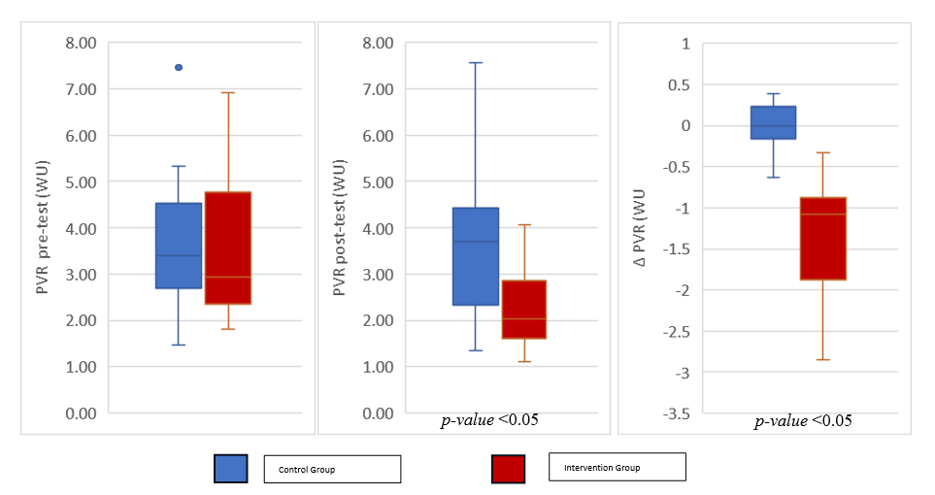
Figure 1. Differences of PVR values between intervention and control group.
OCCURRENCE AND TIMING OF ACUTE KIDNEY INJURY, AND THE RISK OF MAJOR ADVERSE CARDIAC EVENTS IN PATIENTS WITH ACS: AN OBSERVATIONAL STUDY

N. A. Pratiwi¹, T. Wasyanto²

¹Nirmala Suri Hospital
²Department of Cardiology and Vascular Medicine, Faculty of Medicine, University of Sebelas Maret/Dr. Moewardi General Hospital

Background:
Acute kidney injury (AKI), is a condition of sudden and often reversible reduction in the kidney function, as measured by increased serum creatinine by 0.3 mg/dL or more within 48 hours. It is a common complication of acute coronary syndrome (ACS), and is associated with increased risk for adverse outcomes, higher morbidity and mortality, and is a wellknown marker of worse prognosis. We aimed to investigate the risk of Major Adverse Cardiac Events (MACE) in ACS patients in relation to occurence and timing of AKI.

Methods:
This study is a prospective observational study conducted at Nirmala Suri Hospital from October to December 2023. The inclusion criterias are patients with ST elevation myocardial infarction (STEMI), non-ST elevation acute coronary syndrome (NSTE-ACS), or unstable angina (UA), ≥18 years of age and <24 hours of initial symptom. Patients were categorized into 3 groups according to the occurrence and timing of AKI development: early-AKI occurrence (<48h), late-AKI occurrence (>48h), and no-AKI occurrence. We observed in-hospital outcomes that were defined as composite major adverse cardiac events. The primary endpoints were all-cause mortality, myocardial infarction, acute heart failure, and stroke. Risk of MACE was analyzed by using multivariate logistic regression method.

Results:
We enrolled 57 patients, 36 (63%) patients were diagnosed with UA, 12 (21%) NSTE-ACS, and 9 (15%) STEMI. Male patients were 29 (50.8%). We identified 28 patients (49%) developed AKI (16 before 48h, 28%; 12 after 48h, 21%).
The rates of MACE were significantly greater among patients who developed AKI as compared to those who did not develop AKI (early-AKI 12 (21%), late-AKI 7 (12.3%), non-AKI 5 (8.8%); P<0.001).
Risk of MACE in STEMI patients was associated with occurrence and timing of AKI (OR 3.93, 95%CI, 1.86-8.31). The probability of MACE in early-AKI, late-AKI, non-AKI (P=0.78, P=0.48, P=0.19 respectively; CI 95%).

Conclusion:
In this study population of ACS patients, AKI is a frequent complication. The risk of MACE was associated with occurrence and timing of AKI. In-hospital all-cause mortality rate was significantly higher inpatients who developed AKI before 48 hours. Multicenter research with bigger sample is needed to further support this result.

Keywords: acute coronary syndrome, ACS, acute kidney injury, MACE, AKI

TRANSFORMING GROWTH FACTOR-𝛽1 LEVELS CONCERNING THE SEVERITY OF CHRONIC VENOUS INSUFFICIENCY IN THE SUPERFICIAL VEINS OF THE LOWER LIMBS IN PATIENTS UNDERGOING CORONARY ARTERY BYPASS SURGERY

H. Safitri¹

¹RS Penyakit Jantung Nasional Harapan Kita

Background:
Chronic venous insufficiency (CVI) has a fairly high prevalence throughout the world, around 60-70%. Transforming Growth Factor-β1 (TGF-β1) is a complex polypeptide cytokine that is significantly found in all patients with chronic venous insufficiency. The relationship between TGF-β1 levels and the severity of CVI has not yet been determined. Objective: To determine the differences in TGF-β1 levels concerning the severity of chronic venous insufficiency in the superficial veins of the lower limbs.

Methods:
The study used a cross-sectional design for 56 samples patients with healthy veins and patients with chronic venous insufficiency who undergoing coronary artery bypass surgery. The severity of chronic venous insufficiency was assessed by reflux time from duplex ultrasonography examination. TGF-β1 was obtained from ELISA examination of superficial venous tissue. The primary outcome was the difference in TGF-β1 levels based on the severity of chronic venous insufficiency.

Results:
A total of 56 subjects underwent final analysis. The majority of subjects with CVI in this study (67.7%) were classified into severe CVI (reflux time >1000 ms). There were no significant differences in median values between the severity of CVI and TGF-β1 levels (p>0.05). However, it was observed that the median TGF-β1 levels increased in veins with mild-moderate and severe CVI (14.27 pg/mg and 14.04 pg/mg) compared to normal veins (10.97 pg/mg).

Conclusion:
There is no significant differences in TGF-β1 levels concerning the severity of chronic venous insufficiency in the superficial veins of the lower limbs in patients undergoing coronary artery bypass graft surgery.

Keywords: Reflux time, Chronic venous insufficiency, Transforming Growth Factor-β1

CORRELATION OF NET ATRIOVENTRICULAR COMPLIANCE (CN) WITH DURATION OF MITRAL VALVE REPLACEMENT SURGERY IN SEVERE MITRAL STENOSIS PATIENTS

A. P. B. Siagian¹

¹RSUP HAM

Background:
Rheumatic Mitral Stenosis is a valvular heart disease that is commonly found in developing countries, and often leads to mitral valve surgery. The longer the surgery procedure usually indicates a severe predilecting and a bad prognosis. In this research, we aimed to evaluate the correlation of Net Atrioventricular Compliance (Cn) with the duration of mitral valve surgery.

Methods:
This study was a retrospective study that included severe mitral stenosis patients who underwent mitral valve replacement in 2023 – 2024. Basic characteristic data and echocardiographic parameters of the patients were collected before the surgery. The patient immediately went for echocardiographic evaluation at the same hospitalization time as the surgery, such as when the patient was deemed stable. The Net Atrioventricular Compliance (Cn) was calculated using the formula 1270 x (MVA Planimetry/E Slope Time). The correlation between procedure time and Cn was determined using SPSS software. Patients with incomplete echocardiographic data were excluded from the study.

Results:
There were 13 samples collected. The mean values of MV mean PG, MV Area Planimetry, and Cn were 11.76 mmHg, 0.79 cm2, and 1.45 mL/mmHg. The mean Procedure duration time and intensive care length of stay were 246 minutes and 2.31 days. The MV Area had a unidirectional correlation with Cn (P = 0.04; r = 0,576). The Cn had an inverse correlation with procedure time (P = 0.32; r = -0,594) and intensive care length of stay ((P = 0.02; r = -0,767).

Conclusion:
The Net Atrioventricular Compliance (Cn) is one of the parameters available to predict the longer duration of the procedure and intensive care stay in mitral valve replacement due to severe mitral stenosis. However, we also realized the sample size of this study was very small, thus a larger sample size is needed to further determine the correlation.

Keywords: Net Atrioventricular Compliance, Mitral Stenosis

DIAPHRAGMATIC ULTRASOUND COMPARED WITH FLUOROSCOPY AS A DIAGNOSTIC METHOD IN A POPULATION WITH SUSPECTED DIAPHRAGMATIC PARALYSIS POSTOPERATIVE CONGENITAL HEART DISEASE

S. M. A. Sabara¹, S. N. Siagian²

¹Department of Cardiology and Vascular Medicine, Faculty of Medicine Universitas Indonesia
²Pediatric and Congenital Heart Disease Division, Departement of Cardiology and Vascular Medicine, Uniiversitas Indonesia

Background:
Diaphragmatic paralysis after congenital heart disease surgery canincrease patient mortality and morbidity. Establishing a diagnosis of this disorder iskey for making follow-up decisions such as diaphragm plication. Fluoroscopy as the gold standard has limitations for performing post-surgical patients with congenital heart disease.

Methods:
This study is a comparative diagnostic study that evaluates the ability ofdiaphragmatic ultrasound to diagnose diaphragmatic paralysis in patients with suspected diaphragmatic paralysis after surgery for congenital heart disease atRSJPDHK from June 2022 to May 2024. Each diaphragmatic ultrasound result was recorded and compared with the findings on fluoroscopy examination.

Results:
Of the 2,287 heart surgery performed at RSJPDHK, there were 41 patientswho met the inclusion and exclusion criteria. The median patient age was 10 (1-119) months and 43.9% were male. There are significant differences in the type of surgery undertaken. From the calculation results, it was found that the sensitivity and specificity of diaphragm ultrasound compared to fluoroscopy in research subjects was 100% (95% CI 82.35% - 100%) for sensitivity, and 95.5% (95% CI 77.16% - 99.88%) for specificity. Furthermore, the positive predictive value was calculated with results of 95% (95% CI 73.68%-99.27%) and negative predictive value of 100% (95% CI 83.89%-100%).

Conclusion:
Ultrasonography has good sensitivity and specificity compared to fluoroscopy as a diagnostic method in the population with suspected diaphragmatic paralysis after surgery for congenital heart disease with a sensitivity of 100% and a specificity of 95.5%.

Keywords: congenital heart disease surgery, fluoroscopy, diaprhagmatic ultrasound, diaphragmatic paralisys

PREVALENCE OF STEMI AND NSTEACS IN PATIENTS WHO DIAGNOSED AS ACUTE CORONARY SYNDROME AT EMERGENCY DEPARTMENT

R. Pertiwi¹, T. Delfian¹

¹Royal Prima Marelan Hospital

Background:
The first leading cause of death in the world is ischemic heart disease, which is 8.99 million death in 2021. We conducted this study to provide reliable and accurate information on the prevalence of STEMI and NSTEACS in patients who diagnosed as ACS at emergency department in a hospital in Medan, North Sumatera.

Methods:
This study used a retrospective descriptive method to analyze prevalance of STEMI and NSTEACS from medical records of patient emergency department who has been hospitalized in RSU. Royal Prima Marelan. And then, data analyzed using univariate analysis by SPSS ver 27.

Results:
From 268 patients, 64,3% of ACS patients are from age group 45-65 years old; 25% >65 years old; and 10,7% <45 years old. 40,5% with symptom chest pain; 31,5% with shortness of breath; 9,5% with upper abdominal pain; 8,3% with other symptoms; and 7,7% with headache. 29 patients (17,7%) classificated as STEMI and 139 patients (82,7%) classificated as NSTEACS. And 66,7% ACS patients are hypertensive patients.

Conclusion:
Based on medical record, we found the prevalence of NSTEACS is higher than that of STEMI in this study, patients in age group 45-65 years old have higest prevalance, hypertensive is the most comorbidities, and the most common symptom is chest pain.

Keywords: ACS, STEMI, Acute Coronary Syndrome, NSTEACS

ASSOCIATION OF SYSTEMIC IMMUNE INFLAMMATION INDEX AND SPONTANEOUS ECHO CONTRAST IN PATIENTS WITH RHEUMATIC MITRAL STENOSIS

A. -. M. '. A. A. Lubis¹

¹Departemen Jantung dan Pembuluh Darah FK USU

Background:
Spontaneous echo contrast (SEC) is smoke-like echoes in the left atrium and considered as an independent predictor of thromboembolic risk. There is an association between the inflammatory state and the prothrombotic state. Thus, we investigated the association between the Systemic Immune Inflammation Index (SII) and SEC in patients with rheumatic mitral stenosis.

Methods:
A total of 48 patients with rheumatic MS were included in this study. The patients were divided into two groups: patients with MS complicated by SEC and patients with MS without SEC in LA. Cross sectional study was conducted. Multivariate analysis was done using logistic regression. Bivariate analysis was done using unpaired T – test in normally distributed data and Mann Whitney in data that is not normally distributed.

Results:
There were 25 patients (mean age 46.1 ± 6.5) in the SEC (+) group, while there were 23 patients (mean age 45.4 ± 8.5) in the SEC (-) group. In multivariate analysis, high levels of SII and neutrophil – to – lymphocyte ratio were risk factors for SEC in patients with MS (p value <0.01). Higher LAVi, MPAP, and smaller MVA were also predictors of SEC existence in patients with rheumatic MS (p value < 0.01).

Conclusion:
Our study showed that the SII levels were strongly associated with SEC in patients with rheumatic MS.

Keywords: MS, SEC, SII

Table 1. Demographic among patients with Rheumatic Mitral Stenosis
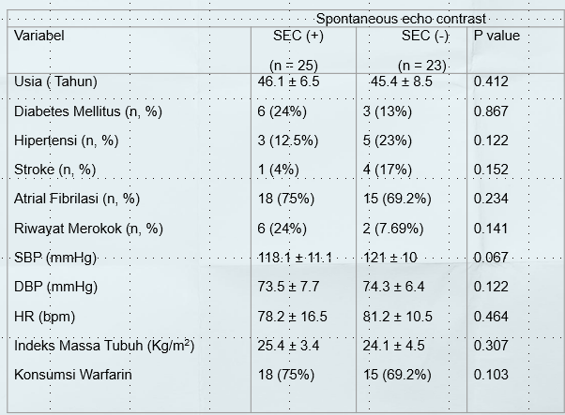
CLINICAL AND CARDIAC MAGNETIC RESONANCE IMAGING PROFILE ON PATIENTS WITH INCREASED LEFT VENTRICULAR WALL THICKNESS

N. S. Azzahra¹

¹Faculty of Medicine, Universitas Padjadjaran

Background:
Increased left ventricular wall thickness is a common thing that is shown on some imaging modalities and is associated with a high risk of morbidity and mortality. It could happen from some conditions, such as genetic, infiltrative heart processes, inflammations, and left ventricular hypertrophy. Therefore, the evaluation of left ventricular wall thickness is necessary to determine the etiology and ensure appropriate patient care and a better prognosis. The gold standard to evaluate wall thickness is Cardiac Magnetic Resonance Imaging (CMR), which has the ability to do tissue characterization and is also known to be more accurate in determining the heart’s mass, volume, and function. Hence, this study is intended to look at the clinical characteristics and CMR examination results of patients with increased left ventricular wall thickness at Hasan Sadikin General Hospital from 2021 until 2023.

Methods:
This study was conducted using a descriptive method by reviewing CMR examination results performed on patients with increased left ventricular wall thickness at Hasan Sadikin General Hospital in 2021─2023. The CMR examination results were obtained in the form of CMR registry data. The study was conducted from September 2023 until July 2024 at Hasan Sadikin General Hospital.

Results:
Of the total 63 patients that were sent for CMR examination, 61% were male, with a median age of 56 (47.3-64.3) years old and hypertrophic cardiomyopathy as a primary diagnosis (36.51%). CMR examination confirmed 47.62% of clinical diagnoses and gave an alternative diagnosis to 52.38% of patients. The median left ventricular wall thickness is 13.63 (11.61-18.6) mm, with the highest increase in left ventricular wall thickness due to primary left ventricular hypertrophy (20.06±4.84 mm). Overall, the structure and function of the heart in patients with increased left ventricular wall thickness tend to be normal, but LVMI tends to increase in each etiology.

Conclusion:
CMR as a gold standard examination tool can be used to confirm and give an alternative diagnosis of increased left ventricular wall thickness. CMR’s ability to assess the structure and function of the heart can help provide an overview of heart conditions related to disease progression.

Keywords: Left Ventricular Hypertrophy, Cardiac MRI, Increased Left Ventricular Wall Thickness, Infiltrative Process, Inflammation

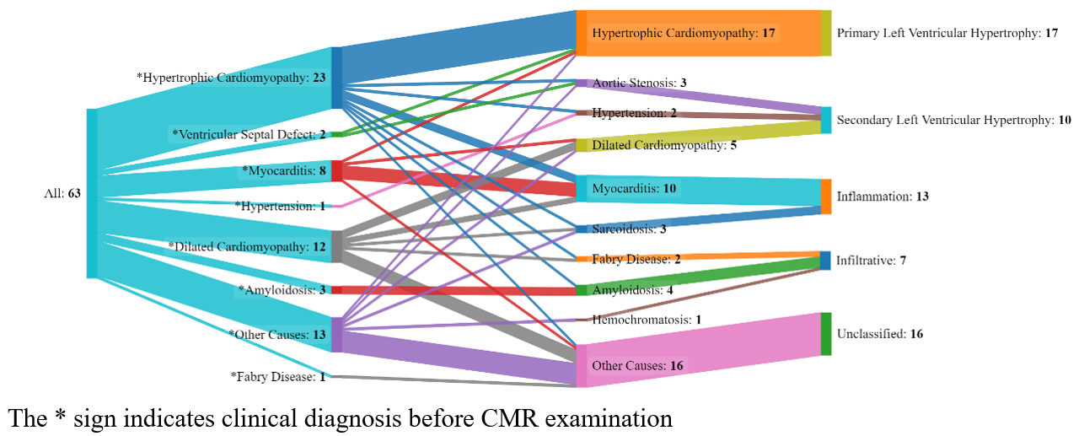
Figure 1. Changes in Clinical Diagnoses Before and After Cardiac MRI Examination
CORRELATION BETWEEN C-TERMINAL PROPEPTIDE OF PROCOLLAGEN TYPE I AND MYOCARDIAL FIBROSIS ASSESSED BY CARDIAC MAGNETIC RESONANCE IN PATIENTS TREATED WITH PRIMARY PERCUTANEOUS CORONARY INTERVENTION

D. E. Wismiyarso¹, Y. Herry¹, P. P. Gharini², M. A. Sobirin¹

¹Department of Cardiology and Vascular Medicine, Faculty of Medicine Universitas Diponegoro - dr. Kariadi General Hospital
²Department of Cardiology and Vascular Medicine, Faculty of Medicine, Public Health and Nursing Universitas Gadjah Mada – Dr. Sardjito Hospital

Background:
Fibrosis is a major contributor to the development of heart failure in patients with ST-elevation myocardial infarction (STEMI), even after undergoing primary percutaneous coronary intervention (PPCI). The process of fibrosis can be evaluated by measuring carboxy-terminal propeptide of procollagen type I (PICP) and the extent of fibrosis can be assessed through late gadolinium enhancement cardiac magnetic resonance (LGE-CMR) imaging. However, no previous studies have examined the relationship between them; therefore, this study aims to determine the correlation between PICP and myocardial fibrosis assessed by LGE-CMR.

Methods:
This study was a prospective cohort study involving post-STEMI patients who underwent successful PPCI. Blood PICP levels were examined on the 4th-day post-STEMI using the ELISA method, and LGE-CMR was performed between days 60 and 75 post-STEMI. The correlation between PICP levels and myocardial fibrosis was analyzed using the Pearson test.

Results:
There were 31 study subjects with a mean age of 52±10 years, and the majority were male (90%). The mean total ischemic time in this study was 489±228 minutes. The non-anterior area was the most common location of the infarction (58.1%), and 54.8% of patients underwent complete revascularization. The PICP levels had a median of 4.37 (0.68-26.68) ng/ml, and the mean fibrosis area from the LGE-CMR imaging was 18.33±7.87%. A moderately positive correlation was found between PICP levels and the extent of fibrosis assessed by LGE-CMR (p=0.015, r=0.433).

Conclusion:
An increase in PICP levels is moderately correlated with the extent of left ventricular fibrosis in patients with STEMI who underwent primary PCI.

Keywords: myocardial fibrosis, primary percutaneous coronary intervention, ST-elevation myocardial infarction, late gadolinium enhancement, carboxy-terminal propeptide of procollagen type I

Table 1. Pearson Correlation Test Between PICP level and Fibrosis Area
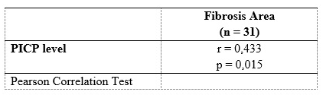
ANALYSIS OF LEFT VENTRICULAR FUNCTION RECOVERY IN LATE PRESENTER STEMI: A COMPARATIVE STUDY BETWEEN EARLY VS. LATE INTERVENTION USING POST SYSTOLIC INDEX ASSESSMENT

S. Y. Pradana¹, M. F. Ahnaf², Suhartono¹, S. Herminingsih²

¹Diponegoro University
²Dr Kariadi General Hospital Semarang

Background:
Recent issue surrounding the need of urgent PCI for stable, late-presenting patients with ST-elevation myocardial infarction is debatable. Research indicates limited mortality benefits with reduced total ischemic time. Exploring post-systolic index (PSI) through strain echocardiography reveals its potential in assessing left ventricular recovery. We compare PSI values in late presenter STEMI patients undergoing PCI.

Methods:
From June to September 2023, a prospective study focused on stable late presenter STEMI patients undergoing PCI. Total ischemic time was classified as ≤ 24 hours (early intervention) and > 24 hours (late intervention). Echocardiography performed thrice: before PCI, 24 hours after PCI, and 30 days after PCI, followed by comparative analysis of PSI values.

Results:
A total of 43 patients with mean age of 58 ± 7.9 years, predominantly male (74.4%). There were no significant difference in PSI values 24 hours after PCI between groups [23,2 ± 7,4 % vs 24,9 ± 8,1 %, p = 0.644]. At the 30-day follow-up, the result showed no difference between the two groups [13,2 ± 4,9 % vs 15,9 ± 7,4 %, p = 0.356]. PSI values before and after PCI showed a significant decrease [31,0 ± 7,6 % vs 23,2 ± 7,4 % and 33,2 ± 7,2 % vs 24,9 ± 8,1 %, p < 0,001], as well as at the 30-day follow-up [31,0 ± 7,6 % vs 13,2 ± 4,9 % and 33,2 ± 7,2 % vs 15,9 ± 7,4 %, p < 0,001].

Conclusion:
Our findings suggest that both early and late interventions in stable late presenter STEMI patients result in better improvements in left ventricular function recovery.

Keywords: left ventricular function recovery, post systolic index, late presenter STEMI, revascularization timing

COMPARISON OF 2-DIMENSIONAL WITH 3-DIMENSIONAL ECHOCARDIOGRAPHIC PARAMETERS FOR EVALUATING RIGHT VENTRICULAR FUNCTION IN HEART FAILURE PATIENTS

H. W. Rawung¹, C. Kurniawan¹, G. Soemara¹, S. Polii¹, B. Poetra¹, J. Chitrahadinata¹, A. L. Panda¹, G. E. H. Reppi¹

¹Department of Cardiology and Vascular Medicine, Faculty of Medicine, Sam Ratulangi University

Background:
Right ventricular (RV) systolic dysfunction is strongly associated with significant morbidity and mortality in heart failure (HF) patients. The evaluation of RV function through echocardiographic measurement demonstrated its superior prognostic stratification of cardiovascular disease patients. Echocardiographic parameters commonly used are tricuspid annular plane systolic excursion (TAPSE), fractional area change (FAC), and RV free-wall longitudinal strain (RVFWLS). However, 3-dimensional RV ejection fraction (3DRVEF) has been recently proposed as a more accurate and sensitive tool to evaluate RV function. The 2015 Guidelines on cardiac chamber quantification recommend the use of 3D method with good image quality and expertise as the preferred modality. It is hypothesized that all echocardiographic parameters of RV function to have concordant result.

Methods:
This was an analytic study with a cross-sectional approach, conducted in June – August, 2023. The number of samples were 51 patients with HF reduced and mildly reduced ejection fraction. Subject who met the inclusion criteria underwent anamnesis and physical, laboratory, electrocardiography dan echocardiography examination. Abnormal echocardiographic parameters for RV function include TAPSE < 17 mm, FAC < 35%, RVFWLS > -19%, and 3DRVEF < 45%.

Results:
Out of 51 eligible subjects, 24 samples (47%) had normal RV function and 27 (53%) had RV systolic dysfunction. Among patients with reduced 3DRVEF had normal TAPSE (59%), FAC (50%), or RVFWLS (36%). Patient with normal 3DRVEF had abnormal TAPSE (14%), FAC (17%), or RVFWLS (14%). Approximate significance value (P-value) in all parameters less than 0.05 with contingency coefficient (CC) of TAPSE, FAC, RVFWLS, and FAC+RVFWLS in correlation with 3DRVEF were 0.294, 0.433, 0.489 and 0.531 respectively. Combining FAC and RVFWLS parameter showed the closest correlation with reduced 3DRVEF value.

Conclusion:
The degree of RV impairment result assessed using conventional echocardiographic methods (TAPSE, FAC, and RVFWLS) varies depending on the parameter and the result shows that only modestly associated with 3DRVEF based assessment. The use of several parameters of 2-dimensional as well as speckle tracking provides better quantitative assessment of RV systolic performance, especially if 3D echocardiography is not available.

Keywords: Right ventricular systolic dysfunction, heart failure, 3-dimensional RV ejection fraction

LEFT ATRIAL STRAIN TO PREDICT LEFT ATRIAL FUNCTION IN PATIENTS WITH SEVERE RHEUMATIC MITRAL STENOSIS AND HOW ITS CORRELATED: A SINGLE CENTER DESCRIPTIVE STUDY

D. Surya¹, D. Azhari¹, M. Yanni², Nani², I. Mukhlisah¹, P. Bahri¹

¹Cardiology Resident, Department of Cardiology and Vascular Medicine, Andalas University, DR. M. Djamil General Hospital, Indonesia
²Academic Staff, Department of Cardiology and Vascular Medicine, Andalas University, DR. M. Djamil General Hospital, Indonesia

Background:
Rheumatic heart disease (RHD) is an endemic disease, which is often found in developing countries. The mitral valve is the most frequently affected in RHD patients, and mitral stenosis (MS) is the most common valve lesion in chronic RHD. Morphological and functional changes in the left atrium (LA) caused by obstruction in MS. Recent advances in the characterization of left atrial (LA) function with stretch echocardiography techniques, have resulted in new insights into the origins of symptoms in MS.

Methods:
We retrospectively performed comprehensive 2D transthoracic echocardiography (TTE) in patients with severe rheumatic MS. Mitral valve area (MVA) by planimetry <1,5 cm2 was considered to define severe MS. Echocardiography parameters in severe rheumatic MS was assessed comprehensively. LA strain [reservoir strain (LASr), conduit strain (LAScd) and contractile strain (LASct)] value were then obtained on a four-chamber and two-chamber views.

Results:
A total of 31 patients with severe rheumatic MS with mean age was 43.7±11.6 years was included in this study. The mean MVA was 0.93 ± 0.33 cm2 with mean gradient 11.16 ± 4.15 mmHg, median LAVI was 87.54 ± 119.51, mean LA size was 5.17 ± 1.12, with LVEF 59.29 ± 8.06. The median values of LASr was (5 ± 3.77), LAScd was (- 4 ± 2.76) and median LASct was (- 1 ± 2.25). The value of LA strain has positive / negative correlation with size of LA diameter.

Conclusion:
LA strain showed a decrease in LA function in patients with severe rheumatic mitral stenosis, particularly in LASr. This may caused by chronic LA pressure overload leads to atrial muscle bundle disorganization and fibrosis resulting in both atrial stiffness and atrial reservoir dysfunction.

Keywords: Rheumatic heart disease, mitral stenosis, LA Strain

Table 1. Comparison between left atrial strain parameters with variouos groups based on left atrium size and left atrial volume index
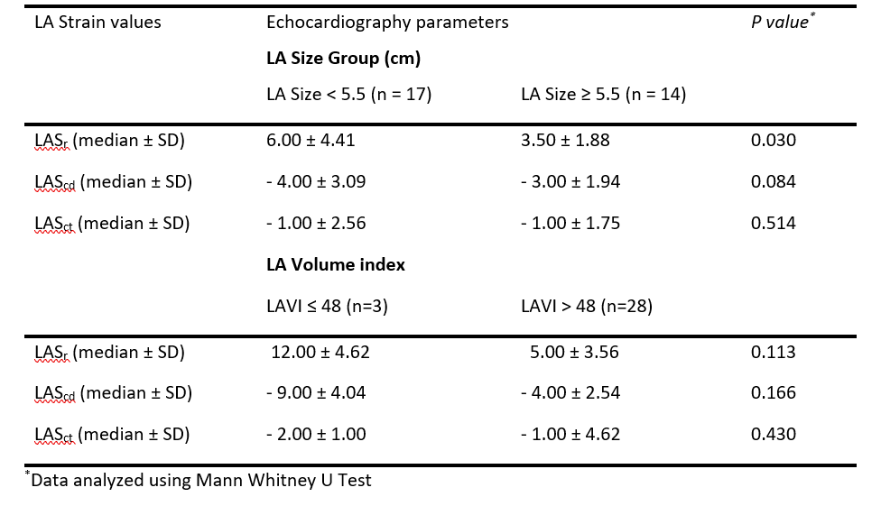
GENDER DISPARITIES IN DYSLIPIDEMIA PREVALENCE AMONG THE INDONESIAN POPULATION: A CROSS-SECTIONAL STUDY

M. D. Darmawan¹, J. Hartanto¹, S. S. Danny,², B. A. S. Kuncoro,³

¹Faculty of Medicine Universitas Indonesia
²Indonesian Heart Foundation (Yayasan Jantung Indonesia/YJI), FMUI-National Cardiovascular Center Harapan Kita
³FMUI-National Cardiovascular Center Harapan Kita, Indonesian Heart Foundation (Yayasan Jantung Indonesia/YJI)

Background:
Elevated blood lipid levels pose a substantial risk for cardiovascular diseases (CVD). Hypercholesterolemia, a prevalent form of dyslipidemia, is notably common in the Asia Pacific region, with a prevalence of 30.3% in Southeast Asia. In Indonesia, CVD stands as the primary cause of morbidity and mortality, accounting for approximately one-third of all deaths. Despite this, there is a scarcity of demographic data concerning dyslipidemia and its determinants in Indonesia.

Methods:
A cross-sectional study was conducted using data from a mobile health screening service program from Indonesian Heart Foundation (Yayasan Jantung Indonesia / YJI) conducted in Indonesia, from February 2019 to December 2023. Participants were directly sampled from diverse locations, and we collected anthropometric data, including age, gender, height, and weight, through a structured web-based questionnaire. Nonfasting total cholesterol (TC) levels were determined from capillary whole blood samples, and dyslipidemia was defined according to the NCEP-ATP-III guidelines.

Results:
Among 10,562 individuals, 4,641 met the inclusion criteria. A total of 3,418 were females and 1,493 were males, with an age range from 18–87 years. We found a dyslipidemia prevalence of 23.5%, with TC levels of 187.00 [160–221] for males and 216.00 [184–246] for females (median [IQR], mg/dl). Notably, significant variations were observed across different demographic groups, with age, gender, and BMI exerting notable influences. Females, especially those post-menopause, exhibited a higher prevalence and risk of dyslipidemia.

Conclusion:
Our finding emphasizes the complexity of dyslipidemia and the importance of comprehensive risk factor evaluation and targeted management strategies. Our study highlights that Indonesians have higher cholesterol levels compared to various Southeast Asian populations. Factors such as gender, age, and BMI contribute significantly to dyslipidemia prevalence.

Keywords: Risk Factors, Dyslipidemia, Indonesia, Gender Disparities, Prevalence

ASSOCIATION BETWEEN NEUTROPHIL TO LYMPHOCYTE RATIO AND POST OPERATIVE ATRIAL FIBRILLATION AFTER CORONARY ARTERY BYPASS GRAFT OPERATION.

A. Sidiek¹, Y. Herry¹, P. Ardhianto¹, U. Bahrudin¹

¹Department of Cardiology and Vascular Medicine, Faculty of Medicine Diponegoro University

Background:
Post operative atrial fibrillation (POAF) is associated with cardiovascular outcomes such as stroke, heart failure, and mortality. Neutrophil to lymphocyte ratio (NLR) is one of biomarker of inflammation. The use of cor pulmonary bypass and ischemic reperfusion injury during cardiac surgery causes inflammation. NLR is suspected to be a biomarker that represents the inflammatory response as a modulator of POAF, but data are still lacking. This study analyzed the association between NLR and POAF after coronary artery bypass graft (CABG) operation.

Methods:
This was an Observational analytic study, involving patients after the CABG procedure in Kariadi Hospital between June 2022 to September 2023. NLR was assessed in the first three hours after operation. ECG Holter was attained for 96 hours post-CABG procedure.

Results:
The total subject was 62 patients, consisting of 57 men and 5 women with a mean age of 58,7 ± 6.39 years. Mean postoperative NLR 4.95 ± 2.17 with a median of 4.56 (1.52-11.00). There was a positive correlation between post-operative RNL and POAF after CABG (p=0.01, r= 0.32). There was a significant association between post-operative NLR with POAF after CABG (p=0.006, OR 4.64, 95%KI 1.50-14.35). High inotropic dose and β blocker initiation time less than 45 hours correlate significantly with POAF after CABG (p<0.001, OR 6.94 dan p=0.001, OR 0.17).

Conclusion:
Postoperative NLR is associated significantly with POAF after CABG.

Keywords: Neutrophil to Lymphocyte Ratio, ECG Holter, Post Operative Atrial Fibrillation, coronary artery bypass graft

CORRELATION BETWEEN NEUTROPHIL-TO-LYMPHOCYTE RATIO (NLR) AND TROPONIN T IN ACUTE MYOCARDIAL INFARCTION: A SINGLE-CENTRE STUDY FROM TERTIARY HOSPITAL IN EAST KALIMANTAN

P. M. Manalu¹, A. R. Magdaleni², R. Amir³

¹Faculty of Medicine Mulawarman University
²Departement of Physiology, Faculty of Medicine Mulawarman University
³Departement of Internal Medicine, Faculty of Medicine Mulawarman University

Background:
Acute myocardial infarction (AMI) indicates irreversible myocardial necrosis confirmed by increased troponin level. However the availability of troponin examination is limited particularly in rural area. Other parameters such as neutrophil-to-lymphocytes ratio (NLR) can be used to indicate troponin level elevation. Increased troponin level in acute myocardial infarction (AMI) occurs due to necrosis of the myocardium causing the release of troponin into the circulation. At the same time, an increase in neutrophils and a decrease in lymphocytes can occur due to the rapid inflammatory response in acute myocardial infarction (AMI). The objective of this study is to examine the correlation between the neutrophil-to-lymphocyte ratio (NLR) and troponin T levels in patients diagnosed with acute myocardial infarction (AMI).

Methods:
This study involved patients diagnosed with acute myocardial infarction (AMI) from January 2022 to December 2022 at Abdoel Wahab Sjahranie General Hospital Samarinda. The participants were selected by non-probability purposive sampling. The value of neutrophil-to-lymphocyte ratio (NLR) and troponin T level at the time of admission were collected and the correlation between those two parameters were analyzed using Pearson Correlation test. The results was considered significant if the p-value is ≤ 0,05.

Results:
The sample consisted of 30 patients with STEMI and 53 patients with NSTEMI. The value of neutrophil-to-lymphocyte ratio (NLR) in STEMI patients was significantly higher than in the NSTEMI patients (p ≤ 0.001). The results of the analysis showed that there was a positive correlation between neutrophil-to-lymphocyte ratio (NLR) and troponin T values (r = 0,602 p-value ≤ 0,05).

Conclusion:
There was a positive correlation between neutrophil-to-lymphocyte ratio (NLR) and troponin T in Acute Myocardial Infarction (AMI).

Keywords: Neutrophil-to-Lymphocyte Ratio (NLR), Troponin T, Acute Myocardial Infarction (AMI)
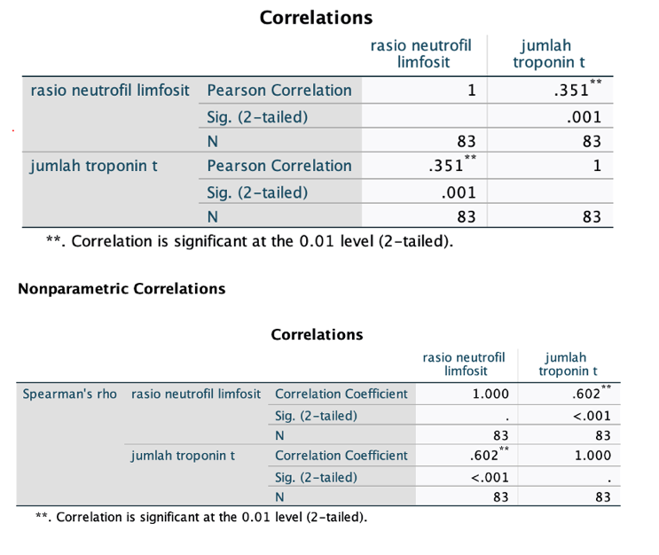

Figure 1. Parametric and non-parametric correlation test result output
PERIPARTUM CARDIOMYOPATHY SCREENING UTILIZING THE ADAPTED SELF-SCREENING TOOL FOR PREGNANT WOMEN IN WEST SIDOARJO PUBLIC HOSPITAL

A. T. L. Avianto¹, I. M. Sufiyah¹, H. A. Sariningrum¹, M. G. Perdana¹

¹Universitas Airlangga

Background:
Peripartum cardiomyopathy (PPCM) is a type of systolic heart failure with decreased left ventricular ejection fraction (LVEF) that occurs late in pregnancy or early in the postpartum period. Early detection is crucial for improving patient outcomes. A tool for PPCM screening needs to be easy to use, fast, accurate, and cost-effective. Fett PPCM Self-Test is a verified method that can be implemented in Indonesia, particularly at West Sidoarjo Hospital, East Java.

Methods:
In June 2024, 66 pregnant women at West Sidoarjo Hospital in East Java were examined over a period of 5 days. Each participant was asked to complete PPCM screening using the Fett PPCM self-test, which had been adapted to the Indonesian language and culture. Additionally, further evaluation was carried out through echocardiography.

Results:
In our study, we found that the largest age group of pregnant women was between 25 and 30 years old, making up 21% of the participants. Among the pregnant women, the highest gestational age was in the 3rd-trimester group, with 34.8% of them being in the 28-40 weeks gestational age range. 30.3% of pregnant women had given birth more than once, while 1.5% were grande-multiparous. Furthermore, 9.1% had a history of experiencing abortion more than two times. 10.6% of pregnant women had a systolic blood pressure (SBP) of 130-139 mmHg, 7.6% had an SBP of 140-159 mmHg, and 4.5% had an SBP of 160-179 mmHg. Regarding diastolic blood pressure (DBP), 7.6% had a DBP of 90-99 mmHg, 9.1% had a DBP of 100-109 mmHg, and 6.1% had a DBP of 110 mmHg or higher. Additionally, in the Fett Score test, 3% of participants scored above 4. All of them have normal LVEF. The mean LVEF value was 65.61%.

Conclusion:
The Fett PPCM self-test is an affordable and straightforward method for PPCM screening, but a larger population is required to validate its effectiveness in screening for PPCM.

Keywords: Screening Instruments, Maternal Health, Fett PPCM Self-Test, Peripartum Cardiomyopathy

ELECTROCARDIOGRAPHY IN HEART FAILURE PATIENTS: WHAT CAN WE LEARN FROM THE INDONESIAN RURAL HOSPITAL?

C. L. Putra¹, M. G. Octapian¹, N. N. G. Setiani¹, J. Vincent², D. N. Tiolung¹, J. Hukom¹, I. G. B. N. Rai¹, T. G. Wiratama¹, M. F. Abdila¹, M. Karokaro¹

¹RSUD Datoe Binangkang
²RSAL ilias tarakan

Background:
An electrocardiogram (ECG) is a standard technique used to record cardiac activity that serves as a diagnostic tool for the evaluation of atrial fibrillation (AF), left ventricular hypertrophy (LVH), right bundle branch block (RBBB), left bundle branch block (LBBB), sinus tachycardia (ST), and old myocardial infarction (OMI). ECG abnormalities were found in almost all heart failure patients (98.2%), and the majority (65.5%) of patients had at least three of these abnormalities. The aim of this study was to assess the relationship between heart failure and ECG abnormalities (LVH, OMI, RBBB, LBBB, AF, and ST), especially in rural areas of Indonesia where it is difficult for patients to get optimal health services.

Methods:
50 patients with acute and chronic heart failure who had ECGs performed at Datoe Binangkang Hospital between January and July of 2024 were included in this cross-sectional study. Heart failure patients were divided into two groups: acute and chronic. Version 26 of the SPSS program was used to examine the data. To determine the significance of the observed relationships between categorical variables, the Chi-squared test was used. P-values <0.05 were regarded as significant.

Results:
A total of 50 patients were analyzed. Patients were predominantly female (72%), with an average age of 67.8 years, with uncontrolled hypertension was the leading risk factor (88%). We found that LVH, OMI, RBBB, AF, and ST were statistically significantly associated (P<0.05) with acute and chronic heart failure. In this study, LVH was the main abnormality in patients with heart failure in a total of 35 patients (70%). However, the incidence of LBBB was not statistically significantly associated with acute or chronic heart failure (P>0.05).

Conclusion:
This study strengthens previous studies where abnormalities in the ECG (LVH, OMI, RBBB, ST, and AF) are significantly associated with the incidence of acute and chronic heart failure, which were studied in rural Indonesian hospitals.

Keywords: acute heart failure, chronic heart failure, electrocardiography

Table 1. Electrocardiography abnormalities in patients with acute heart failure and chronic heart failure

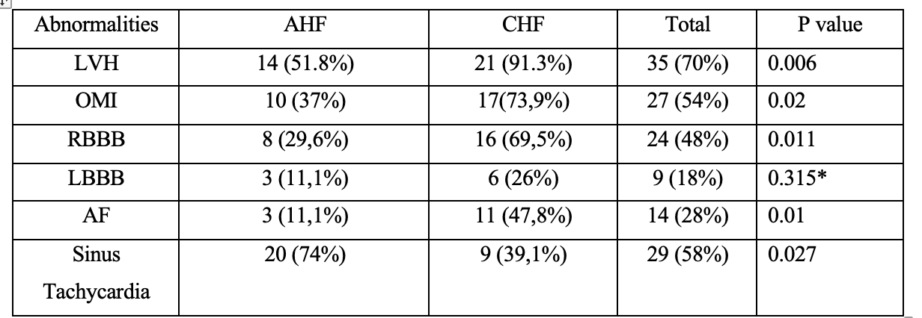
AGE-RELATED PERIPHERAL OXIDATIVE CAPACITY REDUCTION MEASURED WITH NEAR-INFRARED SPECTROSCOPY: AN INSIGHT FOR CARDIOVASCULAR PREVENTION AND REHABILITATION

F. J. Tandirerung¹, A. Jamieson², A. B. Hartopo¹, S. Jones²

¹Gadjah Mada University
²University College London

Background:
Physical fitness is crucial for maintaining cardiovascular health and vice versa. However, even in healthy individuals, physical fitness deteriorates progressively. Unfortunately, inexpensive and reliable tools are limited to continuously monitor cardiovascular and physical fitness in daily clinical practice. Here we demonstrate age-related oxidative capacity decline with near-infrared spectroscopy (NIRS) in healthy, young and older adults.

Methods:
We recruited 14 young adults (9 males; mean age 26 years old, range 21-30) and 14 older adults (8 males; mean age 75 years old, range 58-86). Measured at gastrocnemius muscle, NIRS device combined with intermittent arterial occlusions were used to measure oxidative capacity following a short, rapid exercise protocol. Mitochondrial oxidative capacity was used as a marker for skeletal muscle fitness that was represented by muscle recovery time constant (in seconds). The shorter the time constant, the better the oxidative capacity. The results from both groups were processed with MATLAB R2021a to derive time constant values which further statistically analysed with Stata MP17.

Results:
We found that there was significant difference in skeletal muscle oxidative capacity in young and older groups (29.04 ± 14.05-s vs. 51.78 ± 15.49-s; difference: 22.74 ± 12.67-s, p <0.001). This suggests that in around 5 decades, oxidative capacity declines more than 50%. Further analysis implies that oxidative capacity between males and females were similar in both groups. However, it seems that older adult females took longer to recover compared to their male counterparts (60.12 ± 15.62-s vs. 45.53 ± 12.95-s, difference 14.59-s). Despite not statistically significant, our data is arguably underpowered to reveal significant differences if any. In younger adults, less difference is seen between both genders (4.06-s; p=0.62). Arguably because younger participants` age range is quite narrow.

Conclusion:
Our study found that there is >50% decline in peripheral oxidative capacity between young and older adults. Hence, there is roughly 10% oxidative capacity decline in each decade in healthy, non-athletic adults. Therefore, close monitoring and intervention are extremely important to slow physical deterioration and maintain cardiovascular fitness. NIRS could be a reliable, cheaper and non-invasive method for such purpose.

Keywords: cardiovascular fitness, near-infrared spectroscopy, oxidative capacity

ONE YEAR OUTCOME AFTER PCI PROCEDURE IN ISCHEMIC DILATED CARDIOMYOPATHY PATIENTS AT DR. HASAN SADIKIN GENERAL HOSPITAL: A SINGLE-CENTER STUDY

M. Akbar¹, A. Saboe¹, H. S. Prameswari¹

¹Department of Cardiology and Vascular Medicine, Faculty of Medicine, Padjadjaran University, Indonesia; RSUP dr. Hasan Sadikin Bandung, Indonesia

Background:
Ischemic dilated cardiomyopathy (IDCM) is a major cause of Heart failure (HF) worldwide. About 42% of myocardial infarction patients will develop left ventricular systolic dysfunction (LVSD) with heart failure symptoms. Percutaneous coronary intervention (PCI) is recommended in clinical practice of managing IDCM and has a better outcome to increase survival. This research aimed to study the clinical outcome after PCI in IDCM patients.

Methods:
This cross-sectional study includes subjects from both the Heart Failure and PCI registry in Dr. Hasan Sadikin Hospital from January 2020- May 2023 using the purposive sampling method. We study IDCM patients at Heart Failure clinic who had undergone PCI procedure and ≥12 months of treatment at the HF Clinic. The patients' clinical outcome were analyzed using chi square- Fisher’s exact test.

Results:
A total of thirty seven patients (mean age 59,8 ± 7,83) were included. Most patients are male (81,1%) smoker being the most common risk factors (70,1%). The mean EF at baseline was 28,9 ± 6,64 with 94,6% patients have EF <40%. Based on procedural characteristics most of the patients are in high category SYNTAX Score (48,6%) with 75,7% are those with non Left-Main PCI. The most left main PCI strategy that’s being used are provisional stenting (44,4%) with IVUS (51,3%) is the most using intracoronary imaging during PCI. At the first, most of the patients (73,1%) were in New York Heart Association (NYHA) functional class II After PCI procedure 100% patients have an improvement of NYHA Class. With 21,7% of patients having cardiac reverse remodeling (RR). Heart failure rehospitalization after PCI is 13,5% and the survival rate in 1-year is 86,5%. There’s significant relation between SYNTAX score category with all-cause mortality (p= 0,028; LR= 7.188).

Conclusion:
The PCI procedure in IDCM patients has been shown to improving clinical outcome, reducing the rehospitalization and enhance the one-year survival rate. The dyslipidaemia risk factor and high SYNTAX score may be associated with clinical outcome of IDCM patients undergone PCI.

Keywords: Percutaneous Coronary Intervention, One Year Outcome, Ischemic Dilated Cardiomyopathy, Heart Failure

ASSOCIATION OF NON-ALCOHOLIC FATTY LIVER DISEASE AND CAROTID PLAQUE: IS IT A POTENTIAL NEW RISK FACTOR?

A. R. Ayukusuma¹, I. Uddin¹, P. Ardhianto¹, S. Herminingsih¹, C. O. Permatadewi², S. B. Utami¹, S. N. Sofia¹, D. Indiarso², A. Prasetyo², S. Suhartono³, H. D. Purnomo²

¹Department of Cardiology and Vascular Medicine, Dr Kariadi General Hospital/ Faculty of Medicine Diponegoro University, Semarang-Indonesia
²Division of Gastroenterohepatology Department of Internal Medicine, Dr Kariadi General Hospital/ Faculty of Medicine Diponegoro University, Semarang, Indonesia
³Department of Environmental Health, Faculty of Public Health, Diponegoro University, Semarang, Indonesia

Background:
The Non-Alcoholic Fatty Liver Disease (NAFLD) is one of the most prevalent chronic liver diseases, with an estimated prevalence of 25.24% worldwide. Interestingly, Atherosclerotic Cardiovascular Disease (ASCVD), rather than liver complications, was the leading cause of death for patients with Non-Alcoholic Fatty Liver Disease (NAFLD). Atherosclerotic cardiovascular disease itself was known for its long subclinical phase characteristics. This study investigated association between degree of liver steatosis and carotid plaque in asymptomatic young adult.

Methods:
This is a cross-sectional analytic study. Participants were 71 Fibroscan®-diagnosed NAFLD patients between the ages of 18 and 45 who had no prior history of cardiovascular disease. Carotid ultrasound was done to evaluate carotid plaque. Association and correlation between these two were observed.

Results:
From Fibroscan® examination in 71 NAFLD patients, grade S1, S2 and S3 of liver steatosis were found in 7 (9.9%), 14 (19.7%), 50 (70.4%) patients, respectively. From all these patients, the prevalence of carotid plaque was 81,7%. From carotid ultrasound, the grade 0, I, II, III carotid plaques were found in 13 patients (18,3%), 11 patients (15,5%), 31 patients (43,7%), and 16 patients (22,5%), respectively. There was significant association between degree of liver steatosis and carotid plaque incident (p < 0.001). There was strong positive correlation between degree of liver steatosis and degree of carotid plaque (r = 0,608, p < 0,001).

Conclusion:
Liver steatosis is associated with increased prevalence of atherosclerotic plaques in the carotid arteries. There was also strong positive correlation between degree of liver steatosis and carotid plaque. From this study, we found that NAFLD has occurred since a very young age, and its relationship to the incidence and degree of carotid plaques has been seen even when it was still asymptomatic.

Keywords: NAFLD, carotid plaque, subclinical atherosclerosis, liver steatosis, fibroscan

CORRELATION BETWEEN J-CTO SCORE WITH SYNTAX SCORE AND PROGRESS CTO-MACE SCORE ASSESSED IN PATIENTS WITH ANGIOGRAPHICALLY CONFIRMED CORONARY CHRONIC TOTAL OCCLUSION (CTO)

R. E. Lumentut¹, Subiyanto¹, V. B. F. P. Untu¹, Y. Tandaju¹, J. Samsudin¹, A. Japanto¹, R. Husa¹, S. Rampengan¹, E. Jim¹

¹Department of Cardiology and Vascular Medicine Sam Ratulangi University Prof. Dr. R. D. Kandou General Hospital, Manado, Indonesia

Background:
The correlation between J-CTO, Syntax, and PROGRESS CTO MACE Score provides insights into the interplay between lesion complexity, procedural outcomes, and long-term clinical events in patients undergoing PCI for Chronic Total Occlusions (CTO). The J-CTO Score, initially developed to assess the technical difficulty of CTO PCI based on angiographic features like lesion length, morphology, and collateral circulation, serves as a predictor of procedural success and complication rates. Higher J-CTO Scores typically correlate with greater procedural complexity and increased risk of complications during PCI. In contrast, Syntax Score evaluates anatomical severity and complexity of coronary artery disease, encompassing the extent, location, and severity of lesions. A higher Syntax Score indicates a more complex coronary anatomy and is associated with increased procedural challenges and poorer outcomes post-PCI. The PROGRESS CTO MACE Score focuses on long-term clinical outcomes following CTO PCI, specifically major adverse cardiac events such as myocardial infarction, unstable angina, or cardiovascular death.

Methods:
A retrospective cross-sectional study was performed in Prof. Kandou General Hospital, Manado, from January 2021 to December 2022. Study subjects were enlisted from patients undergoing angiography and found to have CTO during the study period. The primary outcome was the correlation between J-CTO score, Syntax Score, and Progress CTO Score. Scores were expressed in numeric variable, and statistical analysis would be performed with IBM SPSS Version 24

Results:
A total of 43 study subjects were included in this study, which consists of 32 male and 11 female. Demographic analysis shows significant difference in age between male and female subgroups (mean age 63.25 vs 56.46, respectively, p < 0.05). Significant correlation was found between J-CTO score and PROGRESS CTO MACE Score (p = 0.046) , this inversely proportional to Syntax Score (p=0.176)

Conclusion:
This study shows positive correlation between the J-CTO score and the PROGRESS CTO MACE score. This was in line with previous study on similar subjects. Limited sample size and confounding variables might affect final result

Keywords: J-CTO

RELATIONSHIP BETWEEN HIGH GLYCATED HEMOGLOBIN TO CLINICAL PROFILE AND VESSEL CHARACTERISTIC IN DIABETIC STEMI PATIENTS

Y. A. Santoso¹, H. P. Bagaswoto¹, F. Saputra¹, B. Y. Setianto¹

¹Universitas Gadjah Mada

Background:
Over the past decade, acute myocardial infarction (AMI) has been the leading cause of death worldwide, with ST-elevation myocardial infarction (STEMI) being the most severe form, necessitating urgent medical intervention. Diabetes mellitus (DM) is a significant risk factor for AMI. In diabetic patients, plasma glucose levels are closely associated with the occurrence and severity of both micro-vascular and macro-vascular complications, indicating extensive coronary atherosclerosis. This study examines the relationship between HbA1c levels and the clinical profiles and vessel characteristics of STEMI, considering factors like cardiogenic shock, Killip class, and the number of stenosed vessels in the presence of comorbidities.

Methods:
This cross-sectional study included 844 patients with STEMI admitted to the intensive care unit of Sardjito Hospital from January 2023 to June 2024. Patients were categorized based on their HbA1c levels into two groups: Group 1 (HbA1c ≤ 6.5%) and Group 2 (HbA1c > 6.5%). The clinical profiles of the patients were evaluated using Killip classification and incidence of cardiogenic shock. The angiographic results were classified as normal coronary arteries (NCAs), single vessel disease (SVD), double vessel disease (DVD), and triple vessel disease (TVD).

Results:
Of the 844 patients, 685 (81.2%) were male, and the mean age was 59.7 ± 11.3 years. Group 1 included 541 patients (64%), while Group 2 had 303 patients (36%). Patients with HbA1c > 6.5% were significantly associated with acute heart failure (Killip class > 1) (p=0.042) and a higher number of diseased vessels (SVD: p < 0.001, DVD: p=0.011, TVD: p=0.041).

Conclusion:
Our study found a correlation between elevated HbA1c levels and both the number of diseased vessels and the incidence of acute heart failure among STEMI patients.

Keywords: Acute Heart Failure, Cardiogenic Shock, HbA1c, CAD, STEMI

Table 1. Comparison of coronary angiographic findings between HbA1c groups
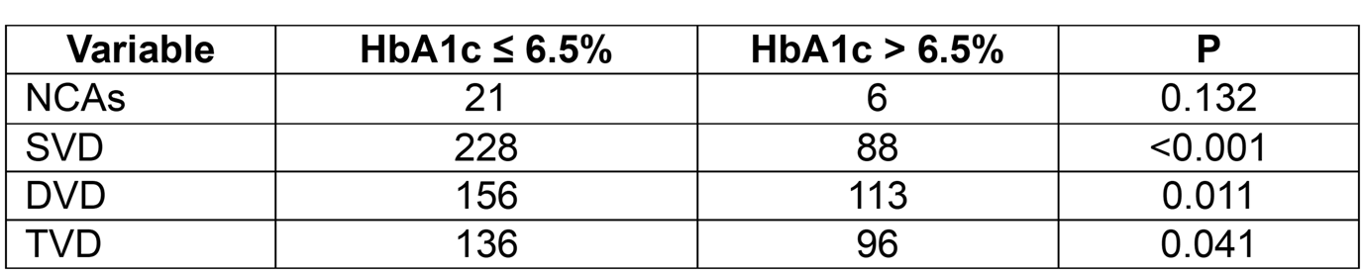
CORRELATION BETWEEN CORRECTED TIMI FRAME COUNT WITH THE EXTENT OF MYOCARDIAL FIBROSIS ON ST-ELEVATION MYOCARDIAL INFARCTION PATIENTS UNDERGOING PRIMARY PERCUTANEOUS CORONARY INTERVENTION

R. M. Munandar¹, P. Ardhianto¹, S. Herminingsih¹, P. P. R. Gharini², M. A. Sobirin¹

¹Department of Cardiology and Vascular Medicine, Faculty of Medicine, Universitas Diponegoro, Dr. Kariadi General Hospital, Semarang, Indonesia
²Department of Cardiology and Vascular Medicine, Faculty of Medicine, Public Health, and Nursing, Universitas Gadjah Mada, Dr. Sardjito General Hospital, Yogyakarta, Indonesia

Background:
Microvascular injury after primary percutaneous coronary intervention (PPCI) reperfusion contributes to necrosis propagation. Corrected TIMI Frame Count (CTFC) is a surrogate marker of microvascular dysfunction and can stratify in-hospital mortality risk in patients with final TIMI flow 3. The extent of myocardial fibrosis after STEMI is associated with a higher incidence of major cardiovascular events. This study was aimed to determine the relationship between CTFC in the infarct-related artery and myocardial fibrosis area based on cardiac magnetic resonance (CMR) in STEMI patients undergoing PPCI.

Methods:
This retrospective cohort study included 31 STEMI patients who had undergone PPCI and CMR examination between days 60 and 75 after STEMI as the sample. CTFC was measured in the infarct-related artery from post-PPCI angiogram recordings. The myocardial fibrosis area was measured from late gadolinium enhancement CMR (LGE-CMR) imaging results.

Results:
In this study, the mean age was 51.61±10.49 years, 90.3% were male, non-anterior infarction location was 58.1%, mean total ischemic time was 489.48±228.33 minutes, mean CTFC was 27.4±9.3 frames, and mean myocardial fibrosis was 18.33±7.87%. There was no significant correlation found between CTFC and myocardial fibrosis (p=0.530), however total ischemic time had a positive and significant correlation with myocardial fibrosis (p=0.025, r=0.403).

Conclusion:
CTFC in the infarct-related artery is not correlated with myocardial fibrosis area in STEMI patients undergoing PCI.

Keywords: ST Elevation Myocardial Infarction, LGE-CMR, Myocardial Fibrosis, Corrected TIMI Frame Count, Primary Percutaneous Coronary Intervention

SYSTOLIC BLOOD PRESSURE, INSULIN LEVELS, OBESITY AND THEIR CORRELATION WITH CAROTID INTIMA-MEDIA THICKNESS AMONG ADOLESCENTS

S. Rahma¹, M. Ardiana², N. A. Widjaja³, W. Diarsvitri⁴

¹Dr. Iskak General Hospital, Tulungagung, Indonesia
²Department of Cardiology and Vascular Medicine, Faculty of Medicine Universitas Airlangga /- Dr. Soetomo General Academic Hospital, Surabaya, Indonesia
³Division of Nutrition and Metabolic Diseases, Child Health Department, Faculty of Medicine Universitas Airlangga /- Dr. Soetomo General Academic Hospital, Surabaya, Indonesia
⁴Department of Community Medicine, Faculty of Medicine, Hang Tuah University, Surabaya, Indonesia

Background:
Obesity is increasing in children and adolescents, and insulin resistance (IR) is becoming more prevalent. A strong association between adolescent obesity, IR, and metabolic syndrome is important in enabling cardiovascular risk. This study aimed to analyze the correlation between obesity, fasting insulin, cardiometabolic indicators, and carotid intima-media thickness (cIMT) in adolescents in Surabaya and Sidoarjo, Indonesia.

Methods:
This cross-sectional study was conducted on 72 adolescents from five high schools in Surabaya and Sidoarjo, which was completed with informed parental consent. Anthropometry based on Z-score, blood pressure, and laboratory examinations were measured. cIMT was assessed by ultrasound of the right and left common arteries. The results were analyzed by correlation test, bivariate analysis with SPSS Ver 22.

Results:
Of the 72 adolescents aged 14-18, 62.5% were males, 73.6% were obese, 75.0% were hypertensive, fasting insulin levels were 14.23-36.8 mIU/L, and 44.4% had cIMT >0.6mm with range 0.52-0.69mm. cIMT had a significant correlation with obesity, fasting insulin levels, and systolic blood pressure (SBP) (p=0.001; p=0.005; p=0.032, respectively)

Conclusion:
Carotid thickening in 44.4% of adolescents in our study was higher compared to adolescents abroad. The correlation between cIMT with obesity, SBP, and fasting insulin levels indicating the importance of screening for cardiometabolic components among adolescents. Further studies with multicenter and larger sample size are needed to predict the increased risk factors of cIMT to prevent the onset of cardiovascular disease in adulthood

Keywords: Insulin, adolescents, Cardiovascular diseases, Carotid Intima-Media Thickness, Obesity

ASYMTOMATIC PROLONGATION OF QTC DURATION FINDINGS IN PRIMARY SCHOOL AGED IN PASAMAN BARAT REGION, WEST SUMATERA.

Y. Muya¹, H. E. Rasyid¹, F. Junaidy¹

¹Departement of Cardiology and Vascular, Universitas Andalas/RSUP dr M Djamil Padang, West Sumatera

Background:
Many causes of sudden death in the pediatric population are due to genetic heart disorders, which can lead to structural abnormalities (eg, hypertrophic cardiomyopathy) and arrhythmogenic abnormalities (eg, familial long QT syndrome). Indeed, sudden cardiac death in the pediatric population can be the first presentation of an underlying heart problem. Long QT syndrome is a genetically transmitted cardiac arrhythmia caused by ion channel protein abnormalities. It is characterized by electrocardiographic abnormalities and a high incidence of syncope and sudden cardiac death.

Methods:
We conducted an observational, cross-sectional study of electrocardiography findings in primary school aged (7 to 13 y.o) in west Pasaman region, West Sumatera province in 2023. Classification using Bazzet formula adjusted by pediatric age and gender.

Results:
A total of 201 ECGs were obtained from screening of primary school student with age 7 to 13 y.o. In all 157 (78,1%) student got normal QTc, 8 (3,9%) student got borderline value of QTc, and 8 (3,9%) student with prolonged QTc, the other 28 (11,4%) student got short QTc. In all patient with prolonged QTc showed no symptom and disturbances in daily activity.

Conclusion:
The majority of the students QTc finding are suggestive of normal value of QTc duration. Small portion of the sample show prolonged and shortening of QTc duration according to bazzet formula cut off according to age and gender. From this findings, more comprehensive research and examination were needed to rule out possibilities in malignant complication in future, include population-based samples and incorporating other childhood age groups and sex regarding asymptomatic prolonged QTc duration to prevent serious cardiac problem in pediatric.

Keywords: pediatric, Long QT syndrome

A DECADE BIBLIOMETRIC ANALYSIS OF HYPERTENSION RESEARCH TRENDS IN INDONESIA : A COMPREHENSIVE OVERVIEW

R. Mulawarman¹, Tommy¹, H. Ardining¹, A. B. Aryaputra¹, R. A. Halim¹, R. Satrio¹, M. Trifitriana¹

¹Cardiovascular Medicine Resident, University of Indonesia, Jakarta, Indonesia

Background:
Hypertension poses a considerable global public health issue, significantly affecting cardiovascular health. In the context of Indonesia, it is essential to comprehend the evolution of hypertension research in the last ten years for informed decision-making and the development of effective healthcare strategies. This study aims to conduct a comprehensive bibliometric analysis of trends and collaborative networks within hypertension research in Indonesia from 2014 to 2024.

Methods:
A systematic search was conducted using the Web of Science Core Collection database to identify pertinent publications on the topic of hypertension in Indonesia from January 2014 until July 2024. Quantitative analysis was performed using the VOSviewer software, employing statistical, data mining, and data visualization techniques to analyze various bibliometric indicators.

Results:
A total of 2126 publications related hypertension trend in Indonesia were identified over the past ten years, with H-index of 47 and an average of 8.79 citations per paper. The annual publication output peaking in 2021. Among the relevant affiliations, most prominent publications, including University of Indonesia (n=458/21.54%), Airlangga University (n=204/9.59%), and Padjajaran University (n=192/9.03%).The research topics were divided into six distinct clusters: hypertension, mortality, obesity, prevalence, management, and blood pressure. These clusters represent the most common areas of focus in the publications, reflecting the primary research interests and directions in the field. The most conference titles was 15th scientific meeting by INASH (n=77/3.62%).

Conclusion:
This bibliometric analysis highlights the dynamic nature of hypertension research in Indonesia over the past decade. The identified trends and collaborative networks provide valuable insights for researchers, policymakers, and healthcare professionals. Understanding these patterns is pivotal for shaping future research, implementing evidence-based interventions, and ultimately improving the management of hypertension in Indonesia.

Keywords: bibliometrics, hypertension, trends

UTILITY OF PEAK SYSTOLIC VSD VELOCITY TO ESTIMATE MEAN PULMONARY ARTERIAL PRESSURE IN PATIENTS WITH VENTRICULAR SEPTAL DEFECT

M. F. A. Hamid¹, M. Yanni², Kino², M. S. M. Indah¹

¹Cardiology Resident, Department of Cardiology & Vascular Medicine, Andalas University / DR. M. Djamil General Hospital, Padang, Indonesia
²Medical Staff, Department of Cardiology & Vascular Medicine, Andalas University / DR. M. Djamil General Hospital, Padang, Indonesia

Background:
The measurement of mean pulmonary arterial pressure by right heart catheterization is the gold standard for the diagnosis of pulmonary hypertension. However, there are currently no echocardiographic parameters that can establish the diagnosis of pulmonary hypertension using mean pulmonary arterial pressure in patients with ventricular septal defect (VSD). The trans VSD gradient, formed by the peak systolic VSD velocity as a basic component, can only measure the pulmonary arterial systolic pressure (PASP) in VSD patients. We aimed to evaluate the correlation between the peak systolic VSD velocity values and the mean pulmonary arterial pressure values in patients with ventricular septal defect for the diagnosis of pulmonary hypertension and estimate the mean pulmonary arterial pressure based on the peak systolic VSD velocity.

Methods:
This study was an analytical cross-sectional study in patients with ventricular septal defects at Cardiac Center DR. M. Djamil Hospital Padang from October 2021 – February 2024. A total of 32 patients underwent right heart catheterization to measure mean pulmonary arterial pressure and transesophageal echocardiography simultaneously during the catheterization procedure to measure peak systolic VSD velocity. Statistical analysis was performed using the Spearman correlation test. Simple regression techniques were used to determine the relationship between peak systolic VSD velocity and MPAP.

Results:
Based on the Spearman correlation test, peak systolic VSD velocity had a strong negative correlation (r = - 0.749) with mean pulmonary arterial pressure and it was statistically significant (p=0.000). The linear regression results showed an R² value of 0.765. By regression equation, using the following equation mPAP = 85 – 15(Vvsd), peak systolic VSD velocity can be used to estimate mPAP in VSD patients.

Conclusion:
There was a strong and significant negative correlation between peak systolic VSD velocity measured by echocardiography with mPAP measured by right heart catheterization. In patients with VSD, peak systolic VSD velocity can be used to assess mPAP. Further studies are needed to verify the accuracy of this equation.

Keywords: mean pulmonary arterial pressure, ventricular septal defect, peak systolic VSD velocity

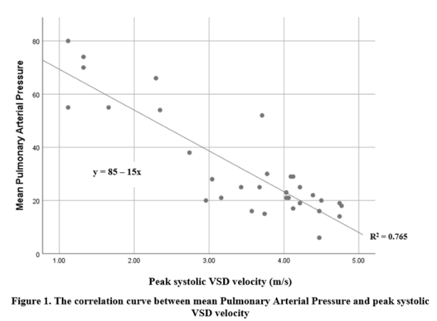
Figure 1. The correlation curve between mean Pulmonary Arterial Pressure and peak systolic VSD velocity
THE INFLUENCE OF BODY MASS INDEX ON THE SIX-MINUTE WALKING TEST FINDINGS IN PATIENTS POST CARDIAC SURGERY

S. P. Sidhi¹, A. H. Raynaldo², S. S. Ramadhani¹, M. Furqan¹

¹Faculty of Medicine, Universitas Sumatera Utara, Medan, Indonesia
²Department of Cardiology and Vascular Medicine, Faculty of Medicine, Universitas Sumatera Utara, Medan, Indonesia

Background:
The six-minute walking test (6MWT) used to assess functional capacity in post-heart surgery patients and predict post-operative complications and mortality. Body mass index (BMI), an indicator of body fat based on height and weight, is known to influence physical performance and endurance. Higher BMI is often associated with reduced exercise capacity and poorer outcomes in various clinical settings. This study aims to investigate the influence of body mass index (BMI) on the performance of the six-minute walk test (6MWT) in patients who have undergone cardiac surgery.

Methods:
This analytical, cross-sectional study sampled post-cardiac surgery patients at RSUP HAM using consecutive sampling. Patients underwent a 6MWT examination to measure distance and METs. Patients body mass index was divided into two groups: normoweight less than 22.9 kg/m² and overweight higher than 23 kg/m² were analyzed using Mann-Whitney test.

Results:
A total of 212 patients, consisting of 106 overweight/obese patients and 106 normoweight patients, were involved in this study, including 128 male patients (60.4%) and 84 female patients (39.6%) with an average age of 45.77 ± 15.43 years. Overweight patients had a median distance and METs value of (140 M, and 2.7 mm/hour), while normoweight patients had a median distance and METs value of (200 M, and 3.9 mm/hour). Statistically, there was a significant difference in distance and METs values between normoweight and overweight/obese patients with a p-value < 0.001.

Conclusion:
The body mass index of the patient can be one of the factors used for establishing the distance and METs value following heart surgery.

Keywords: BMI, 6MWT, Heart surgery

Table 1. Non-parametric statistical analysis comparing two groups across six variables. Height, weight, BMI, distance, and age using The Mann Whitney Test
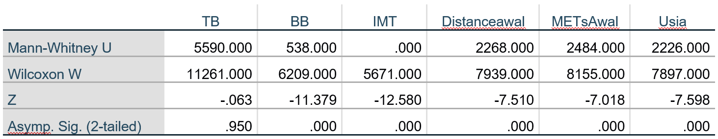
COMPARISON OF PULMONARY ARTERY GROWTH RATE BETWEEN RIGHT VENTRICULAR OUTFLOW TRACT STENTING AND MODIFIED-BLALOCK-THOMAS-TAUSSIG SHUNT IN TETRALOGY OF FALLOT PHYSIOLOGY

I. Pratiwi¹, R. Ariani², D. Fakhri³, I. S. Atmosudigdo⁴, S. Indriani⁵, S. N.Siagian⁴, O. Lelya⁴, O. Lilyasari⁴, R. Prakoso⁴

¹Department of Cardiology and Vascular Medicine, National Cardiovascular Center Harapan Kita, Jakarta, Indonesia.
²Division of Echocardiography and Cardiovascular Imaging, Department of Cardiology and Vascular Medicine, National Cardiovascular Center Harapan Kita, Jakarta, Indonesia
³Department of Thoracic and Cardiovascular Surgery, Division of Pediatric and Congenital Cardiac Surgery, National Cardiovascular Center Harapan Kita, Jakarta, Indonesia.
⁴Division of Pediatric Cardiology and Congenital Heart Disease, Department of Cardiology and Vascular Medicine, National Cardiovascular Center Harapan Kita, Jakarta, Indonesia
⁵Division of Vascular, Department of Cardiology and Vascular Medicine, National Cardiovascular Center Harapan Kita, Jakarta, Indonesia.

Background:
TOF with high surgical risk criteria requires palliative therapy before undergoing corrective surgery, TOF repair. Recently, Right Ventricular Outflow Tract Stenting (RVOT stenting) has emerged as an invasive transcatheter palliative therapy alternative to modified-Blalock-Thomas-Taussig Shunt (mBTTS). However, studies regarding pulmonary artery growth rate after RVOT stenting and mBTTS in Indonesia had not ever been performed. To compare pulmonary artery growth rate after RVOT stenting and mBTTS on TOF physiology.

Methods:
The study was a clinical consecutive retrospective cohort with congenital heart disease with TOF physiology who underwent palliative therapy at the Cardiovascular Center Harapan Kita between December 2019 and December 2023. RPA and LPA growth post palliative therapy assessed by serial echocardiogram. Primary outcome was daily pulmonary artery growth represented by z-score per day and analysed using mixed-model.

Results:
Total 139 patients [RVOT stenting (n=35); mBTTS (n=104) were obtained.Results of analysis of a total 492 echocardiograms, median RPA z-score/day after RVOT stenting (2.5 x 10⁻³ ) were higher significantly than mBTTS (0.9 x 10⁻³ ), p<0.001). Median LPA z- score/day after RVOT stenting (1.7 x 10⁻³ ) were higher significantly than mBTTS (0.7 x 10⁻³ ), p<0.001). RVOT stenting had better LPA to RPA growth distribution ratio (0.93 (IQR 0.87-1.01) than mBTTS (0.91(IQR 0.83-0.98), significantly (p<0,01). The median time from palliative treatment to TOF repair in RVOT stenting was shorter (204 days (95% CI [133-362] vs 759 days (95%CI [740-996], p-value = 0.000). Median length of stay after RVOT stenting shorter (7 days (95%CI [6.49-10.31] vs 8 days (95%CI [9.07-11.96], p value=0.000). The partial pressure of arterial blood oxygen (PaO2) and Arterial oxygen saturation (SaO2) had a statistically significant increase after RVOT stenting (p<0.05).

Conclusion:
RVOT stenting significantly accelerates faster growth of right and left pulmonary artery branches and produces a more symmetric distribution of pulmonary artery branch growth than mBTTS in patients with TOF Physiology. RVOT stenting significantly reduces the length of stay and the time required from post-palliation to TOF repair surgery. In addition, RVOT stenting resulted in a better increase in oxygen levels compared to mBTTS.

Keywords: mBTTS, Tetralogy of Fallot, RVOT stenting

SUDDEN CARDIAC DEATH IN HFREF: THE INDONESIAN HF CLINIC EXPERIENCE AND THE CRITICAL ROLE OF ICDS IN PRIMARY PREVENTION BEYOND OPTIMIZED MEDICAL THERAPY

M. Devani¹, A. W. Fitriyani¹, H. S. Prameswari¹, M. Iqbal¹

¹Universitas Padjadjaran / Dr. Hasan Sadikin Hospital

Background:
Sudden cardiac death is a catastrophic complication of heart failure. Current guidelines recommend ICD for sudden death prevention in patient with reduced ejection fraction (LVEF) and at least 3 months after optimized heart failure (HF) treatment. However, there was underuse of ICD for primary prevention included in Indonesia was only 1.5%. We need to reconsider which group of HFrEF patient that need of ICD by investigating the associated factor for sudden cardiac death in heart failure clinic of Dr Hasan Sadikin General Hospital.

Methods:
All baseline and clinical parameters were prospectively collected from a cohort study at Dr. Hasan Sadikin General Hospital heart failure outpatients clinic between October 2018 – June 2024. Patients followed a protocol of monthly visits to optimize heart failure therapy. Survival status and cause of death are documented by reviewing records and contacting family members. We compared sudden death according to variable type using Chi square test. Logistic regression analyses were performed to conduct multivariate analyses.

Results:
This study recorded 45 deaths from total 309 outpatients at Dr Hasan Sadikin General Hospital heart failure clinic from October 2018 – June 2024. Sudden cardiac death was leading cause of death, accounting for 30 deaths (66.8%). A significant association with sudden death was found in ischemic etiology (P=0.02), last updated LVEF before died (P= 0.04) and recent NYHA (P= 0.01). Multivariate analysis describes ischemic etiology (OR 4.957) and milder symptoms (NYHA class II or III) increase the risk of sudden cardiac death (OR 0.320) in HFrEF patients.

Conclusion:
Sudden cardiac death represented 66.8% cause of death in heart failure outpatient clinic and was significantly associated with ischemic heart disease and NYHA class II despite optimized medical treatment. Therefore, we might need to reconsider the necessity and timing for using ICDs as primary prevention for SCD in HFrEF patient in the outpatient setting in Indonesia.

Keywords: ischemic heart diseases, sudden cardiac death, ICD, heart failure

Table 1: Patient Characteristics as a Function of Cause of Death (Sudden vs Non Sudden)

MYOCARDIAL WORK IN HYPERTENSIVE HEART DISEASE PATIENTS: THE INFLUENCE OF LEFT VENTRICULAR GEOMETRY

A. Firmansyah¹, M. Yanni², P. M. Bahri¹, Nani²

¹Resident of Cardiology Training Program, Department of Cardiology and Vascular Medicine, Universitas Andalas
²Staff at Department of Cardiology and Vascular Medicine, Universitas Andalas / DR. M. Djamil Hospital, Padang, Indonesia

Background:
Myocardial work (MW) is a novel set of dynamic non-invasive parameters that involve afterload and overcome the load of dependency of left ventricular ejection fraction (LVEF) and left ventricular (LV) strain as standard parameter of echocardiography field. This method particularly useful to detect myocardial deformation by increased filling pressure and diastolic dysfunction of LV when changes are subtle and not easily determined by standard parameter. We aimed to evaluate MW using pressure-strain loops in hypertensive heart disease (HHD) patients with different LV geometric as an early detector of myocardial deformation.

Methods:
A cross-sectional study was conducted on 60 HHD patients with normal ejection fraction and diastolic function divided equally into two groups, 30 patients concentric remodeling (CR) group and 30 patients concentric hypertrophy (CH) group. MW was evaluated by speckle tracking 2D echocardiography using global work index (GWI), global constructive work (GCW), global waste work (GWW), and global work efficiency (GWE). Mean MW both groups were compared and analyzed statistically.

Results:
Of 60 patients, 52% were male and 48% were female with mean age group CR was 54±16 y.o and group CH was 57±14 y.o. CR group had significant difference in GWW than CH group (203±83 vs 254±103 mmHg%, p=0.04). CR group had lower GWI and GCW than CH group respectively (1302±398 vs 1461±470 mmHg%, p=0.164; and 1704±374 vs 1825±515mmHg%, p=0.301). GWE CR group was higher than CH group (87.9±5.3% vs 86.7±5.3%, p=0.371).

Conclusion:
This study showed LVH concentric hypertrophy had significant amount of wasted work, which translated into reduced work efficiency than LVH concentric remodelling. MW should be considered as early detector of myocardial deformation in HHD patients.

Keywords: Myocardial Work, Hypertensive Heart Disease, LV Geometry

MYOCARDIAL WORK ON HYPERTENSIVE PATIENTS WITH STROKE

F. Ladediska¹, M. Yanni², Nani², M. S. M. Indah¹, P. Risani¹

¹Andalas University
²Andalas University / dr. M. Djamil Hospital

Background:
Myocardial work is a novel echocardiographic measurement that offers detailed insights into cardiac mechanics. Myocardial work has been evaluated in a variety of clinical conditions to assess the added value of myocardial work (MW) compared to left ventricular ejection fraction (LVEF) and global longitudinal strain (GLS). This study was aimed to evaluate the characteristics of cardiac function by myocardial work in hypertensive patients with stroke.

Methods:
This study was a descriptive study conducted on hypertensive patients with stroke at Dr. M.Djamil Hospital Padang from September 2023 to May 2024. The participants underwent echocardiographic examination to evaluate GLS and MW value (global work index (GWI), global constructive work (GCW), global wasted work (GWW), global work efficiency (GWE)).

Results:
Of thirty three hypertensive patients with stroke, 61% patients were male with mean age of 58 ± 16.09 years, average BSA of 1.70 ± 0.23, 94% had stroke infarction. Based on antihypertensive therapy, 75.8% patients was given ACEI/ARB, followed by CCB dihidropiridin (54.5%), Beta Blockers (24.2%), spironolactone (12.1%) and furosemide (3%). 75.8% was LV concentric hypertrophy patients. Mean Systolic BP and diastolic BP was 136.27 ±16.03 mmHg and 79.73 ± 9.05 mmHg, respectively. Mean ejection Fraction was 51.97 ± 8.18 % while mean GLS value were -13.95 ± 3.87 %. Myocardial work values showed mean GWI was 1430.49 ± 510.23 mmHg%, mean GCW was 1798.09 ± 516.93 mmHg %, with minimum and maximum GWW values were 39 mmHg% and 775 mmHg%, while minimum and maximum GWE values were 68 mmHg and 98 mmHg.

Conclusion:
Myocardial work as a novel echocardiographic parameter can be used to evaluate cardiac performance in hypertensive patients with stroke.This study found anabnormal value in GWW on hypertensive patients with stroke.

Keywords: Myocardial Work, hypertension, Global Longitudinal Strain, stroke
Table 1. Basic Characteristics, Demography, and Paramether Echocardiography of Research Subjects

EFFECTS OF RENAL FUNCTIONS ON PROLONGED HOSPITALIZATION IN PATIENTS WITH HEART FAILURE REDUCED EJECTION FRACTION: AN OVERVIEW

S. P. Sidhi¹, Y. Sarastri,²

¹Faculty of Medicine, Universitas Sumatera Utara, Medan, Indonesia
²Department of Cardiology and Vascular Medicine, Faculty of Medicine, Universitas Sumatera Utara, Medan, Indonesia

Background:
Heart failure with reduced ejection fraction (HFrEF) is serious condition characterized by the heart's inability to pump blood effectively. The management of HFrEF often involves prolonged hospitalization, which can be due to various complications, including exacerbations of the underlying condition. One crucial aspect in the prognosis and management of HFrEF is renal function, assessed using the estimated glomerular filtration rate (eGFR). This study aims to investigate the relationship between eGFR and the duration of hospitalization in patients with HFrEF.

Methods:
This analytical, cross-sectional study sampled acute decompensated heart failure (ADHF) patients with reduced ejection fractions at RSUP HAM using consecutive sampling. The sample of this study consists of ADHF patients hospitalized at RSUP HAM with EF <40%. Patients are categorized as having prolonged hospitalization if their length of stay is more than 8 days. Blood examination including urea, BUN and creatinine, were analyzed using the Mann-Whitney's test. The analysis was conducted using IBM SPSS Statistics.

Results:
In this study, a total of 90 ADHF patients were involved, divided into 45 patients with prolonged hospitalization and 45 patients with normal hospitalization. The study included 70 male patients (77.7%) and 20 female patients (22.2%), with an average age of 57.28 ± 10.39 years. The median values of kidney function parameters such as urea, creatinine, BUN, and eGFR in the prolonged hospitalization group were 73 (16 - 434), 1.72 (0.72 - 17), 34.76 (7.7 - 203), and 42.65 (2.94 - 116.03), respectively. In the normal hospitalization group, the values were 40 (12 - 128), 0.99 (0.52 - 1.43), 18.5 (5.8 - 72.5), and 76.48 (50.37 - 164.16), respectively. Statistically, there were significant differences in the urea, creatinine, BUN, and eGFR values between patients with prolonged hospitalization and those with normal hospitalization, with a p-value < 0.001.

Conclusion:
HF patients with prolonged hospitalization have worse kidney function parameters compared to patients with normal hospitalization. Therefore, kidney function tests such as urea, creatinine, BUN, and eGFR can be used as supportive examinations to determine the length of hospital stay for HF patients.

Keywords: Heart failure with reduced ejection fraction, eGFR, Prolonged hospitalization

Table 1. Non-parametric statistical analysis comparing two groups across four variables. Ejection fraction, ureum, creatinine, and BUN using The Mann Whitney Test
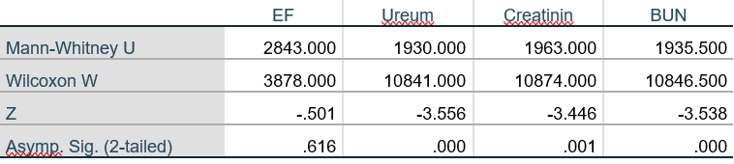
PREDICTING MAJOR BLEEDING IN LIMB-SAVING CATHETER-DIRECTED THROMBOLYSIS WITH ALTEPLASE

Y. Adani¹, D. W. Anggrahini¹, H. Hariawan¹

¹Department of Cardiology and Vascular Medicine, Dr Sardjito General Hospital/ Universitas Gadjah Mada, Yogyakarta, Indonesia

Background:
Catheter-directed thrombolysis (CDT) for acute limb ischemia (ALI) is a well-established alternative to surgical embolectomy. Despite its efficacy, CDT presents a risk of bleeding complications. In a study examining CDT in ALI cases, 7% experienced major bleeding, with a 4.5% in-hospital mortality rate. No reports have studied predictors for major bleeding in the Indonesian population. This study may represent the first investigation aimed at predicting major bleeding in ALI patients undergoing CDT.

Methods:
A retrospective cohort analysis was conducted using data from all consecutive patients with ALI who underwent CDT with alteplase at Sardjito General Hospital between 2020-2023. Baseline characteristics and laboratory parameters during CDT were collected. The area under the curve (AUC) of receiver operating characteristic (ROC) was calculated to determine optimal cut-off values for the dose and duration of CDT. The primary endpoint was major bleeding events during hospitalization, defined according to the Bleeding Academic Research Consortium (BARC) criteria type III/V.

Results:
Of the 117 cases included in the study, the overall incidence of major bleeding was 37.6%. Among these, 56.8% had a hemoglobin decrease of ≥3 g/dl, 75% required blood transfusions, 9.1% developed intracranial bleeding, and 2.3% encountered fatal bleeding. The in-hospital mortality rate was 19.7%. The median total alteplase dose administered was 38 mg, with a median bolus dose of 10 mg, an accumulated drip dose of 27 mg, and a median duration of 34 hours. AUC analysis identified cut-off values for total dose at 34.5 mg, bolus dose at 13.5 mg, drip dose at 25.25 mg, and duration at 50.5 hours. Out of 12 proposed predictors, ischemic heart disease (IHD) (odds ratio [OR] 8.69, 95% confidence interval [CI] 1.58-47.82), dual antiplatelet therapy (DAPT) before CDT (OR 3.19, 95% CI 1.01-10.11), and an initial alteplase bolus dose ≥13.5 mg (OR 3.01, 95% CI 1.27-7.13) were independent predictors of major bleeding during CDT.

Conclusion:
The incidence of major bleeding in this study was higher compared to previous reports. IHD, the use of DAPT, and an alteplase bolus dose of ≥13.5 mg were significantly associated with increased major bleeding during CDT.

Keywords: acute limb ischemia, catheter-directed thrombolysis, alteplase, major bleeding

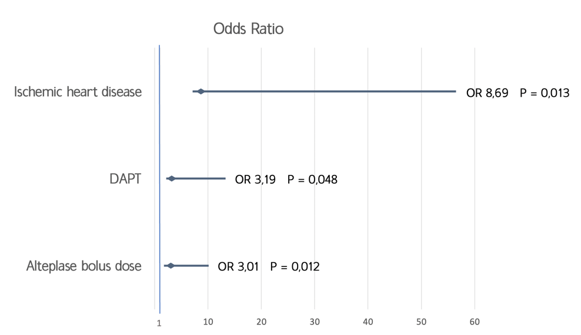
Figure 1. Forest Plot of Multivariate Analysis of Variables Predicting Major Bleeding during CDT in ALI patients
WEB-BASED HEART DISEASE PREDICTION USING RANDOM FOREST METHOD AND STREAMLIT FRAMEWORK

Hariadi¹, A. A. Adam², A. N. Rohmah²

¹RSI AT-TAQWA GUMAWANG
²Informatics Engineering University of Muhammadiyah Surakarta

Background:
Acute coronary syndrome is a significant health issue, making it crucial for individuals to be proactive in recognizing potential heart attacks. Early detection is essential to prevent dangerous complications, including the risk of death. With the rapid advancement of technology, the medical field has greatly benefited, particularly through the development of systems for disease diagnosis. One such advancement is the use of machine learning algorithms like Random Forest, which can be employed for early detection via web-based applications.

Methods:
Data from heart disease patients were collected from Kaggle using the keyword 'Heart Disease', comprising a total of 1,025 patients. The dataset was divided into 70% for training and 30% for testing. The data were preprocessed before being implemented into a Random Forest model. Model evaluation was conducted using a confusion matrix to measure accuracy and recall.

Results:
The Random Forest model demonstrated an accuracy of 100% and a recall of 100%. These outcomes suggest that the model is highly effective for accurately classifying acute coronary syndrome patient data, exhibiting no signs of overfitting. Subsequently, this accurate machine learning model was implemented using the Streamlit framework. Streamlit is an open-source, Python-based platform designed to assist developers in creating interactive web applications. The implementation can be accessed at: https://app-jantung-a8wgebwsyg9.streamlit.app/

Conclusion:
The Random Forest algorithm has proven to be effective in classifying acute coronary syndrome data with high accuracy. This study demonstrates the significant potential of Random Forest in the analysis of complex medical data and its application in heart disease diagnosis. The outcome of this study is a web-based application capable of diagnosing acute coronary syndrome with an accuracy of 100%.

Keywords: Random Forest, Machine Learning, Web-based diagnosis, Heart Disease


Figure 1. User interface
DEMOGRAPHIC CHARACTERISTICS AND CLINICAL OUTCOMES OF ACUTE CORONARY SYNDROME PATIENTS AT RSUD JAGAKARSA EMERGENCY UNIT, MAY 2023-2024

T. D. Cahyaningtyas¹, A. Ervina¹

¹RSUD Jagakarsa

Background:
Acute coronary syndrome (ACS) is various conditions resulting from a sudden decrease of myocardial perfusion. ACS remains the leading cause of death in Indonesia. DKI Jakarta ranked fourth among Indonesian cities with the highest ACS prevalence at 1.9%, surpassing the national average at 1.5% (2019 Riskesdas). Based on data above, physicians should be aware of the demographics characteristics and clinical outcomes of ACS patients in purpose to decrease the mortality of ACS

Methods:
This descriptive cross-sectional study analyzed retrospective secondary data on the demographic profiles, risk factors, onset of symptoms, and clinical outcomes of ACS patients admitted to RSUD Jagakarsa from May 2023 to May 2024. Purposive sampling techniques were employed to enroll 39 patients. Statistical analysis was conducted using frequency distribution.

Results:
During the observational period from May 2023 to May 2024, RSUD Jagakarsa admitted a total of 9,039 patients to its emergency unit. Among these admissions, 39 patients (0.4%) were diagnosed with ACS. Analysis of the demographic profile revealed that a significant demographic segment, the age range of ACS patients were on 50 to 60 years old (30%), with majority 61% males. Notably, the onset of ACS symptoms predominantly occurred during the evening to midnight hours, encompassing 30.7% of cases between 6:00 PM and 12:00 AM. Hypertension (41%) emerged as the predominant risk factor in ACS cases. And majority of patients presented with Acute Decompensated Heart Failure (ADHF) ini clinical conditions (37,5%).

Conclusion:
Understanding the characteristics of age, sex, and risk factor of ACS patients play an important role in the early screening of high-risk individuals. Additionally, knowing that the highest onset of symptoms occurs at night enables clinicians to prepare therapeutic modalities to control risk factors, such as ensuring blood pressure’s patient stability during the night. So with knowing demographic characteristics and clinical outcomes of ACS, clinicians can make preventive measures more targeted in reducing the mortality of ACS.

Keywords: Clinical outcomes, ACS, Demography

CLINICAL OUTCOME IN STABLE ANGINA PECTORIS PATIENT WITH CTO FOLLOWING PERCUTANEOUS INTERVENTION REVASCULARIZATION COMPARE TO NON-REVASCULARIZED

Subiyanto¹, J. Julianus¹, B. Poetra¹, A. Eliata¹, E. L. Jim¹, S. H. Rampengan¹

¹Department of Cardiology and Vascular Medicine, Sam Ratulangi University, Manado

Background:
Percutaneous Coronary Intervention (PCI) Revascularization of CTO is considered for patients with refractory angina symptoms despite optimal medical therapy. However, there is still ongoing debate regarding the benefits of its outcomes. Thus; we aim to evaluate the outcomes of those who underwent PCI revascularization in comparison to those who were not revascularized.

Methods:
We conducted retrospective cross-sectional study based on the angiography analysis of stable angina patients at Prof. Dr. R. D. Kandou General Hospital; from January 2021 to December 2022. Comparison of major cardiovascular events and outcomes such as angina symptoms, quality of life, and physical capacity during one-year follow-up was conducted using Fisher's Exact Test. Changes in left ventricular ejection fraction (LVEF) was compared using paired t-test. P value < 0.05 is considered significant. All data was processed using IBM SPSS statistical software.

Results:
The study consisted of two groups, PCI revascularization group (40 patients) and non-revascularization group (43 patients) of total 83 subjects. Male subjects predominated in both groups, although the PCI revascularization group had a younger mean age (56.68 vs. 61.51 years). After a one-year observation period, major cardiovascular events occurred more frequently in the non-revascularization group (Mortality 2.3% vs 0%; P = 0.518; Congestive Heart Failure 7,0% vs 5,0%; P = 0.535; Recurrent Infarction 4,7% vs 0%; P = 0.265). Significant differences were found in outcomes such as angina symptoms, quality of life, and physical limitation in the PCI revascularization group (P < 0.001). Baseline LVEF values were not significantly different between the two groups (55.68 ± 9.03 vs 55.44 ± 10.18; P = 0.456), but an increase in LVEF following PCI revascularization was observed (57,4 ± 7,51 vs 51,9 ± 10,32; P = 0.021).

Conclusion:
The occurrence of major cardiovascular events between the two groups showed no significant differences. However, significant improvement was observed in terms of angina symptoms, quality of life, physical limitation; and LVEF after one year of observation in the PCI revascularization group.

Keywords: Revascularization, PCI, Chronic Total Occlusion

THE MAGNITUDE OF RAMADAN FASTING ON LIPID PROFILE IN PATIENTS WITH STABLE CORONARY ARTERY DISEASE

A. P. Monika¹, A. B. Hartopo¹, I. A. Arso¹

¹ Department of Cardiology and Vascular Medicine, Dr. Sardjito General Hospital/Gadjah Mada University

Background:
Controlling risk factors in stable coronary artery disease (CAD), including dyslipidemia, is a crucial form of secondary prevention to prevent major cardiovascular events in the future. Ramadan fasting can alter lifestyle and dietary patterns, affecting lipid profiles in CAD patients. Previous studies on the impact of Ramadan fasting on lipid profiles have reported varied results, which may be influenced by geographic differences affecting climate and differing socio-economic conditions. As the largest Muslim country, Indonesia has conducted limited research on the effects of Ramadan fasting on improving lipid profiles, especially in patients with stable CAD.This study aims to investigate the effects of Ramadan fasting on lipid profile levels (total cholesterol (TC), low-density lipoprotein-cholesterol (LDL-c), high-density lipoprotein-cholesterol (HDL-c), and triglycerides (TG)) in patients with stable CAD at Dr. Sardjito General Hospital.

Methods:
We conducted a quasi-experimental study using a one-group pretest-posttest design on stable CAD patients at the outpatient clinic of Dr. Sardjito General Hospital. The level of TC, LDL-c, HDL-c, and TG were measured by an enzymatic colorimetric method with an automated chemical analyzer with Cobas® c 503 that conducted at Integrated Laboratory Installation of Dr. Sardjito General Hospital, before and after Ramadan fasting in 2024.

Results:
This study included 64 patients with stable CAD who intended to fast during Ramadan, including 56 males and 8 females with a mean age of 57.03 ± 8.01 years. Among these four parameters, a significant decrease was found in LDL-c and HDL-c levels. LDL-c significantly improved (92,5 mg/dL (76-110,5) before Ramadan and 84,5 mg/dL (75-100,5) after Ramadan, p=0,009; Wilcoxon test) and HDL-c decreased significantly (42 mg/dL (36-48) before Ramadan and 38 mg/dL (33-44) after Ramadan, p<0,001; Wilcoxon test). No statistically significant changes were observed in TC and TG.

Conclusion:
Ramadan fasting in stable CAD patients significantly decreased LDL-c and HDL-c level.

Keywords: stable coronary artery disease, Ramadan fasting, lipid profile

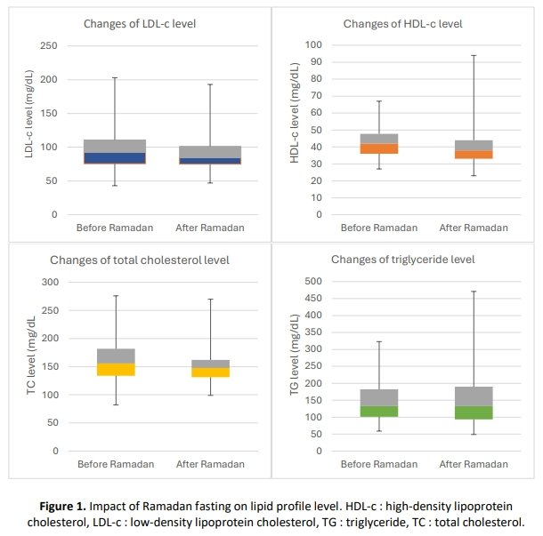
Figure 1. Impact of Ramadan fasting on lipid profile level.
HDL-c: high-density lipoprotein cholesterol, LDL-c: low-density lipoprotein cholesterol, TG: triglyceride, TC: total cholesterol
COMPARATIVE EVALUATION OF RV FUNCTION USING TAPSE MEASUREMENT: INSIGHTS FROM CARDIAC CT AND ECHOCARDIOGRAPHY

K. Alifah¹, H. Arifianto², Irnizarifka², R. Myrtha², A. A. Asrial²

¹Sebelas Maret Heart Failure Clinic, Universitas Sebelas Maret Hospital, Sukoharjo, Indonesia
²Sebelas Maret Heart Failure Clinic, Universitas Sebelas Maret Hospital, Sukoharjo, Indonesia; Department of Cardiology and Vascular Medicine, Faculty of Medicine, Universitas Sebelas Maret, Surakarta, Indonesia

Background:
Right ventricular (RV) function is one of the key parameters for management of patients with severe heart failure. In clinical practice, RV function is estimated from measurement of transthoracic echocardiography (TTE), including tricuspid annular plane systolic excursion (TAPSE). It reflects the magnitude movement of the tricuspid annulus between end-diastole and end-systole. TAPSE correlates strongly with RV ejection fraction (RVEF). Cardiac CT is mainly used for the evaluation of coronary artery diseases, however it can also be used to evaluate LV and RV function and morphology. This study aims to evaluate the correlation the TAPSE value as a parameter of RV function between cardiac CT and TTE.

Methods:
Forty-one patients who had undergo TTE and cardiac CT with in January-April 2024 at Universitas Sebelas Maret Hospital were evaluated retrospectively. Patients with arrhythmia were excluded in this study. RV function was evaluated based on TAPSE value. CT-TAPSE was measured by calculating the distance from tricuspid annulus to RV apex in end-systolic phase subtracted from end-diastolic phase in four-chamber reformatted view.

Results:
Pearson correlation was conducted in this study. CT-TAPSE did not significantly correlated with TTE-TAPSE. There was a weak, positive correlation between CT-TAPSE and TTE-TAPSE based on the analysis (r = 0.259; p = 0.102)

Conclusion:
:There was a weak, positive correlation in TAPSE measurement between cardiac CT and TTE. TTE is still a first modality to evaluate RV function based on TAPSE measurement.

Keywords: Cardiac CT, RV Function, Echocardiography, TAPSE

Table 1. Correlation analysis between CT-TAPSE and TTE-TAPSE
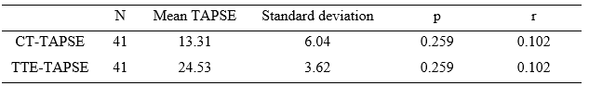
SAFE SCORE AND AVERAGE TISSUE DOPPLER IMAGING AS SHORT-TERM REHOSPITALIZATION PREDICTORS OF ACUTE HEART FAILURE

T. S. R. Sembiring¹, B. Widyantoro¹, D. A. Juzar¹, A. M. Soesanto¹, R. Ariani¹, N. Iryuza¹, V. Rossimarina¹

¹National Cardiovascular Center Harapan Kita

Background:
Short-term-rehospitalization due to acute heart failure (AHF) worsens prognosis and frequently occurs due to persistently elevated left ventricular end-diastolic pressure (LVEDP) despite optimal medical therapy and improvement of heart failure (HF) signs and symptoms, known as hemodynamic congestion. Therefore, it is necessary to ascertain complete decongestion prior to hospital discharge. Sonographic Assessment of intravascular Fluid Estimate (SAFE) score is a potential tool to do so because it measures 3 main components of hemodynamic congestion: pump (ejection fraction/EF), pipe (internal jugular vein collapsibility index/IJVCI and inferior vena cava collapsibility index/IVCCI) and interstitial tissue (B-lines). In addition to SAFE score, average E/e' is also a useful indicator of hemodynamic congestion considering its diagnostic and prognostic value. Combining average E/e' with SAFE score might potentially lead to a better predictor of AHF-related-rehospitalization.

Methods:
A prospective cohort study was conducted by involving 100 patients admitted with AHF in National Cardiovascular Center Harapan Kita. Prior to hospital discharge, all patients underwent echocardiography, lung ultrasonography and duplex ultrasound to evaluate EF, B-lines, IVCCI, and IJVCI. Rehospitalization rate due to AHF within 30-day-follow up was recorded to investigate and compare the predictive power of SAFE score and SAFE score+average E/e'.

Results:
The incidence of 30-day-AHF-related-rehospitalization in this study was 20%. By using Kaplan-Meier curve, significantly higher rehospitalization rate was recorded in patients discharged with hypervolemia than those with normovolemia (1,9% vs 40,4%, p < 0,001). SAFE score+average E/e' had better predictive power than SAFE score in predicting 30-day-AHF-related-rehospitalization (AUC 0,84 [95% CI: 0,75 - 0,93] vs AUC 0,8 [95% CI: 0,71 - 0,89]).

Conclusion:
No patient was discharged with hypovolemia in this study. Hypervolemia as indicated by SAFE score was associated with higher rehospitalization rate. SAFE score+average E/e' had better predictive power than SAFE score regarding 30-day-AHF-related-rehospitalization.

Keywords: average E/e', SAFE score, rehospitalization, acute heart failure

CROSS-SECTIONAL AND RETROSPECTIVE STUDY : FROM RISK TO REALITY, THE CLOSE RELATIONSHIP BETWEEN RISK FACTOR AND CARDIOVASCULAR DISEASE AT KUMPAI BATU ATAS COMMUNITY HEALTH CENTER, WEST KOTAWARINGIN REGENCY

M. Ichwanuddin¹, A. Hidayati²

¹CITRA HUSADA HOSPITAL
²Kumpai Batu Atas Community Health Center

Background:
Cardiovascular diseases (CVD) are the leading cause of death worldwide, with annual deaths in Indonesia reaching 651,481. The prevalence of CVD is increasing with hypertension, obesity, and dyslipidemia as major risk factor. This study aims to assess the relationship between cardiovascular risk factor and the likelihood of fatal and non-fatal cardiovascular events over the next 10 years at Kumpai Batu Atas Community Health Center.

Methods:
This study is a descriptive analytical study conducted cross-sectionally and retrospectively, aiming to determine the relationship between risk factors and the occurrence of cardiovascular disease. The inclusion criteria for this study are respondents who have a history of cardiovascular disease and have been receiving regular treatment without interruption during the period from March to May 2024. The exclusion criteria are incomplete medical records. Data collected include age, gender, type of cardiovascular disease, body mass index (BMI) (weight and height), history of diabetes mellitus, smoking history, systolic and diastolic blood pressure, and cholesterol levels .

Results:
This retrospective cross-sectional study analyzed 108 respondents with a history of CVD. Most respondents were aged 50-59 (37%) and female (67%). The most common CVD type was hypertension 86%, with 32% having Class 1 obesity and 68% high dyslipidemia levels. Significant risk factors included current CVD type (P-value 0,045), BMI (P-value 0,036), systolic blood pressure (P-value 0,001), and dyslipidemia (P-value 0,0001).

Conclusion:
Current CVD type, BMI, systolic blood pressure, and dyslipidemia levels significantly affect 10-year risk of fatal or non-fatal CVD events. Prevention and management of these factors and current CVD are crucial to reducing the burden of future CVD event or worsening conditions in the community.

Keywords: Cardiovascular diseases (CVD), Risk factor

THE CORRELATION BETWEEN TRIGLYCERIDE-GLUCOSE INDEX AND HYPERTENSION: A CROSS-SECTIONAL STUDY IN BINJAI HULU DISTRICT, WEST OF KALIMANTAN

J. M. Samallo¹, A. P. N. Anisya²

¹UPTD PKM Mensiku
²RSUD Kembangan

Background:
Abnormalities in lipid and glucose levels have been known to be associated with hypertension. The triglyceride-glucose index (TyG) is an indicator of insulin resistance that has been studied in cardiovascular disease. However, studies on the relationship between TyG and hypertension are still limited, particularly in the Indonesian population. Here we hypothesized that the TyG index may also be related to hypertension.

Methods:
A cross-sectional study was conducted using primary data collected from patients who participated in Pos Binaan Terpadu on non-communicable disease (Posbindu-PTM) screening in Mensiku Community Health Centre, Kalimantan Barat, between May and June 2024. The correlation between TyG index and hypertension was evaluated by Spearman’s correlation analysis. In addition, we also assessed TyG-BMI and TyG-WC for hypertension.

Results:
A total of 41 participants were eligible for this study. The average TyG index in the hypertension group was 5,23 and 4,78 for the normotensive group. Significant positive correlations were observed between TyG-index with systolic (r = 0,494, p = 0,001) and diastolic blood pressure (r = 0,505, p = 0,001). In addition, TyG-WC also correlates with diastolic blood pressure (r = 0,370, p = 0,017).

Conclusion:
The TyG index was found to be correlated with moderate strength for systolic and diastolic blood pressure. However, further investigation is required to determine whether this is a causal relationship.

Keywords: anthropometry parameters, hypertension, TyG index

CORRELATION BETWEEN LEFT VENTRICLE SYSTOLIC FUNCTION BASED ON FOUR-DIMENSIONAL ECHOCARDIOGRAPHIC EVALUATION WITH MADIT-ICD BENEFIT SCORE IN ISCHEMIC CARDIOMYOPATHY

W. Kwandou¹, S. Adiwinata¹, F. M. Halim¹, J. Julianus¹, F. M. Yofrido¹, B. M. Setiadi¹, A. L. Panda¹

¹Department of Cardiology and Vascular Medicine Sam Ratulangi University Prof. Dr. R. D. Kandou General Hospital

Background:
Left ventricle (LV) systolic function especially left ventricle ejection fraction (LVEF) have been reported as a parameter that can predict sudden cardiac death (SCD) in ischemic cardiomyopathy, however LVEF is a potent predictor of overall mortality and non-SCD, which limits its specificity as a predictor for SCD. The MADIT-ICD benefit score was developed based on landmark MADIT trials to predicts implantable cardiac defibrillator (ICD) benefit by assessing the competing risk of life threatening ventricular tachyarrhythmia vs. non-arrhythmic mortality using simple clinical variables. However, correlation between these variables are not widely studied. The aim of this study is to assess correlation between LV systolic function with ICD benefit probability measured with MADIT-ICD benefit score in ischemic cardiomyopathy

Methods:
This is a cross-sectional study including 84 ischemic cardiomyopathy patients in Prof. Dr. R. D. Kandou general hospital with left ventricular ejection fraction (LVEF) ≤ 40%. LV systolic function was calculated using auto left ventricle quantification (LVQ) based on GE Vivid E95 Machine with four-dimensional probe 4-VC. MADIT-ICD Benefit score was calculated based on ventricular tachycardia/ventricular fibrillation (VT/VF) score and non-arrhythmic mortality score of the patients.

Results:
Among 84 subjects, 60 patients (71%) are male and 24 patients (29%) are female with a mean age of 61 ± 9.7 years. Among all of LV systolic function parameters based on four-dimensional echocardiography, there are significant correlations between LV systolic function including LVEF, end diastolic volume (EDV), end systolic volume (ESV) with VT/VF mortality score (r = -0.25, 0.28, 0.3, all p = < 0.05). All of LV systolic function parameters including LVEF, sphericity index and strain parameters (global longitudinal strain, area strain, circumferential strain and radial strain) have a strong significant correlation with non-arrhythmic mortality score but none of them have a correlation with ICD benefit score.

Conclusion:
LV systolic function parameters only have a significant correlation with VT/VF and non-arrhythmic mortality score, but none of them have a correlation with ICD benefit probability based on MADIT-ICD benefit score. Further research for another SCD risk stratification beside LV systolic function is needed to optimize ICD benefit therapy.

Keywords: Left Ventricular Systolic Function, ICD Benefit, Ischemic Cardiomyopathy, 4D Echocardiography

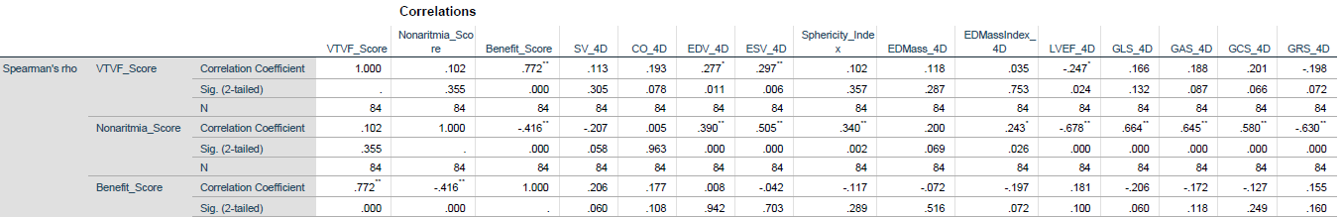
Figure 1. Spearman Correlation Between 4D LV Systolic Quantification with MADIT-ICD Benefit Score in Ischemic Cardiomiopathy
COMPARISON OF PHYSIOLOGICAL RESPONSE AND SYMPTOM PERCEPTION IN PATIENTS WITH CHRONIC HEART FAILURE UNDERGOING 1 MINUTE SIT-TO-STAND TEST AND 6-MINUTES WALKING TEST

Gestano¹, G. Soemara², V. Joseph², N. Lampus², S. Rampengan²

¹Department of Cardiology and Vascular Medicine Sam Ratulangi University Prof. Dr. R. D. Kandou General Hospital
²Department of Cardiology and Vascular Medicine Sam Ratulangi University Prof. Dr. R. D. Kandou General Hospital, Manado, Indonesia

Background:
A key strategy in managing heart failure is to improve the patient's functional capacity, making it essential to assess this capacity in heart failure patients. The 6-Minute Walking Test (6MWT) is a reliable, valid, and responsive measure of functional exercise capacity for patients with congestive heart failure. However, the 6MWT requires a considerable amount of space (a 20-30 meter corridor) and time, posing challenges in clinical settings. To address space and time limitations, alternative tests have been developed. One such test is the 1-minute sit-to-stand test (1mSTS). Like the 6MWT, it involves tasks commonly performed in daily life and depends on the individual's self-paced speed. This study aims to compare the physiological responses and symptom perceptions of patients with chronic heart failure undergoing the 1mSTS and the 6MWT.

Methods:
This research is an observational study employing a hospital-based cross-sectional design. Data collection was conducted prospectively on patients visiting the cardiology clinic at Prof. Dr. R. D. Kandou General Hospital (RSUP) in Manado. The comparison of Physiological Response and Symptom Perception between 1-minute sit-to-stand test (1mSTS) and the 6-Minute Walking Test (6MWT) will be analyzed using Paired-sample t-test, statistical significance was set at p<0.05.

Results:
Out of a total of 87 research subjects, the average age was 60 years, with the majority being male, comprising 69% of the entire sample. The physiological responses and symptom perception of the 1mSTS and 6MWT were similar (p>0.05)

Conclusion:
Sit to Stand Test can be an alternatives to 6-Minute Walking test in Chronic Heart Failure Patients in terms of physiological response and symptom perception.

Keywords: 6 minute walking test, 1 minute sit to stand test, functional capacity

ECHOCARDIOGRAPHIC LEFT VENTRICULAR MECHANICAL DISPERSION CORRELATED WITH THE EXTENT OF MYOCARDIAL FIBROSIS BY CARDIAC MAGNETIC RESONANCE IN STEMI PATIENTS UNDERGOING PRIMARY PERCUTANEOUS CORONARY INTERVENTION
A. R. Andini¹, S. Herminingsih², M. A. Sobirin¹, P. P. Gharini³
¹Department of Cardiology and Vascular Medicine, Faculty of Medicine Diponegoro University, Semarang, Indonesia
²Department of Cardiology and Vascular Medicine, RSUP dr. Kariadi, Semarang, Indonesia
³Department of Cardiology and Vascular Medicine, Public Health, and Nursing Gadjah Mada University, Yogyakarta, Indonesia

Background:
Dispersion of left ventricular contraction occurs in patients experiencing ST-elevation myocardial infarction (STEMI) and may result from heterogeneous electrical conduction due to myocardial fibrosis. Dispersion of left ventricular contraction and myocardial fibrosis are associated with poor outcomes after STEMI, however, no previous study has examined their correlation in the acute and chronic phase of ST-elevation myocardial infarction (STEMI) patients who underwent primary percutaneous coronary intervention (PPCI). This study aimed to analyze the correlation between left ventricular mechanical dispersion (LVMD) and the extent of myocardial fibrosis in STEMI patients who underwent PPCI.

Methods:
This retrospective study involved post-STEMI patients who underwent successful PPCI. Echocardiographic LVMD was measured on days 4 and 60-75, and myocardial fibrosis was assessed with Late Gadolinium Enhancement (LGE) by Cardiac Magnetic Resonance (CMR) on days 60-75 after STEMI.

Results:
The number of subjects was 30 patients, mostly male with an average age of 52.9 ± 10.5 years. The mean LVMD values assessed on days 4 and 60-75 after SKA-EST were 59.3 ± 25.7 and 76 ± 38.3. The extent of myocardial fibrosis had a mean of 18.48 ± 7.97%. There was a positive moderate correlation between LVMD values on day 4 (p=0.017; r=0.433) and 60-75 (p=0.001; r=0.590) with the extent of myocardial fibrosis assessed by LGE-CMR.

Conclusion:
A positive correlation was found between the LVMD value and the extent of myocardial fibrosis in the acute and chronic phases of STEMI patients who underwent PPCI

Keywords: myocardial fibrosis, ST-segment elevation myocardial infarction, primary percutaneous coronary intervention, Left ventricle mechanical dispersion, late gadolinium enhancement
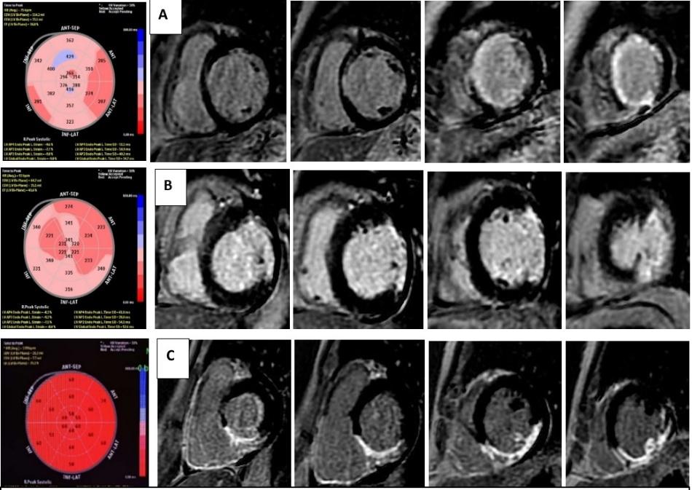
Figure 1. Representation of the correlation between LVMD and the extent of fibrosis assessed by LGE-CMR obtained from this study. Representation of the correlation between LVMD and fibrosis area assessed by LGE-CMR. (A) LGE-CMR of a patient with a fibrosis area of 3.71%; LVMD60-75 34.7ms; and a total ischemic time of 190 minutes. (B) LGE-CMR of patients with fibrosis area of 20.96%; LVMD60-75 52.6 ms; and total ischemic time of 315 minutes. (C) LGE-CMR of patients with a fibrosis area of 34.05%; LVMD60-75 160.6ms; and a total ischemic time of 740 minutes.

ATRIAL SECONDARY MR (ASMR) : CLINICAL CHARACTERISTICS, ECHOCARDIOGRAPHY FEATURES AND LONG-TERM OUTCOMES

V. Rosady¹, M. Yanni², Nani², M. S. Indah¹

¹Andalas University
²Andalas University/ dr. M. Djamil Hospital

Background:
The prevalence, clinical characteristics, and long-term outcomes of patients with ASMR are not well described. For analysis, the etiology of MR was classified as primary (due to degenerative mitral valve disease), VSMR (due to LV dilatation/dysfunction), or ASMR (due to atrial dilatation). ASMR criteria included grade III/IV MR, normal mitral valve, LA dilatation, normal LV volume, LVEF ≥ 50%, and no wall motion abnormalities.

Methods:
We conducted a retrospective study of consecutive grade III/IV MR patients using echocardiography at RSUP M. Djamil Padang (January 2022- April 2024). Data from medical records and echocardiography of the patients with ASMR compared with VSMR and primary MR. The data were analyzed using ANOVA and Chi-Square tests with SPSS.

Results:
A total of 30 mitral regurgitation (MR) patients were included in this study. The mean age of the ASMR group (57 years old) showed no significant statistical difference compared to other groups. Patients in the ASMR group were more likely to have atrial fibrillation (AF) than those in the VSMR and Primary MR groups. However, this was not statistically significant (66.7% vs 16.7% vs 16.7%, p= 0.153, respectively). A statistically significant difference in hypertension was observed between the ASMR and the VSMR and Primary MR groups (60% vs 20% vs 20%,p = 0.008). Echocardiographic parameters revealed significant differences in LVEDD, LVESD, LVEF, and LAVi (p = 0.005, p =0.001, p = 0.001, p = 0.044, respectively), with ASMR groups demonstrating lower LVEDD and LVESD, higher LVEF, and a larger LAVi compared to other groups. No significant differences were found in mitral annulus diameter or PASP. Regarding long-term outcomes, there were no significant differences in the occurrence of heart failure, rehospitalization, or mortality across all groups.

Conclusion:
This study ASMR patients had higher rates of atrial fibrillation and hypertension. Echocardiographic showed lower LV dimensions with the higher EF, and larger LAVi. However, there is no statistically significant impact on long term outcomes of ASMR patients compared to other groups.

Keywords: Ventricular secondary mitral regurgitation, Heart Failure, Atrial secondary mitral regurgitation

COMPARING LEFT ATRIAL STRAIN AND LEFT ATRIAL VOLUME INDEX TO PREDICT DIASTOLIC DYSFUNCTION IN PATIENTS WITH HEART FAILURE

G. Soemara¹, I. Posangi¹, H. Rawung¹, J. C. Kurniawan¹, Gestano¹, F. M. Yofrido¹, B. Poetra¹, A. L. Panda¹, G. E. H. Reppi¹

¹Department of Cardiology and Vascular Medicine, Faculty of Medicine, Sam Ratulangi University, Manado, Indonesia

Background:
The volumetric analysis of the left atrium (LA) using the maximal LA volume index (LAVI) is a reliable method to estimate the cumulative impact of elevated left ventricular (LV) filling pressures over time. However, LAVI has limitations in detecting early left ventricular diastolic alterations because this volumetric parameter primarily reflects the chronic effects of elevated LV filling pressures. Recent findings indicate that a new LA functional parameter, LA strain, shows a strong correlation with invasive gold standard diastolic measurements and left ventricular filling pressures, surpassing the accuracy of LAVI. This study will compare LA strain with LAVI, which of these two variables is better in predicting diastolic dysfunction.

Methods:
This was an analytic observational study with a cross-sectional approach, conducted in November 2021-January 2022. The number of samples were 60 heart failure patients with hypertension, type 2 diabetes mellitus, stable coronary heart disease, and obesity. Subjects who met the inclusion criteria underwent anamnesis and physical, laboratory, electrocardiography and echocardiography examinations.

Results:
Out of 60 eligible subjects, 62% were male with a mean age of 58.3±10.5. Average Ejection Fraction (EF) with mean of 62.27±9.3. 34 subjects (57%) had abnormal diastolic function. Average LA strain with mean of 17.7±5.4. 13 subjects (21%) had LAVI more than 34 ml/m² . In ROC analysis showed that LA strain had AUC 0.827 while LAVI had AUC 0.771. There was no significant difference between LA strain and LAVI to predict diastolic dysfunction using De Long method (p=0.47).

Conclusion:
LA strain tends to be better at predicting diastolic dysfunction compared with LAVI. However, additional studies are needed to strengthen the hypothesis by adding an ejection fraction less than 50.

Keywords: heart failure, diastolic dysfunction, left atrial volume index, left atrium strain

LEFT ATRIAL STRAIN VALUE AS A PREDICTOR OF ATRIAL FIBRILLATION IN ST-SEGMENT ELEVATION MYOCARDIAL INFARCTION PATIENTS UNDERGOING PRIMARY PERCUTANEOUS CORONARY INTERVENTION: THE TALASC2-AF RISK SCORE

R. Muliawan¹, R. K. Marsam², H. P. Bagaswoto²

¹Resident of Department of Cardiology and Vascular Medicine, Dr Sardjito General Hospital/Gadjah Mada University, Yogyakarta, Indonesia
²Staff of Department of Cardiology and Vascular Medicine, Dr Sardjito General Hospital/Gadjah Mada University, Yogyakarta, Indonesia

Background:
Atrial fibrillation (AF) in ST-segment elevation myocardial infarction (STEMI) patients after primary percutaneous coronary intervention (PCI) has been a significant factor that worsens outcome and increases mortality. Early assessment of left atrial (LA) dysfunction by measurement of LA strain values is an effective method for detecting left atrial mechanical and structural disorders associated with AF. It is crucial to develop techniques to identify people at risk of AF in the hospital.

Methods:
Retrospective cohort study of STEMI patients after primary PCI from the Sardjito Cardiovascular Intensive Care (SCIENCE) registry between June 2022 to July 2023. Baseline data and LA strain assessment by echocardiography after primary PCI were collected to develop the risk prediction model. The area under the curve (AUC) of receiver operating characteristic (ROC) was calculated to measure the accuracy. This study aims to determine the value of LA strain and other clinical factors in predicting the occurrence of AF during hospitalization in STEMI patients undergoing primary PCI.

Results:
A total of 225 eligible patients with STEMI were enrolled. Of these, 29 (12.88%) developed AF after PCI during hospitalization. The independent predictors of AF in patients with STEMI includes conduit strain values <13.5%, contractile strain <11.5%, hs-troponin T >1765.5 ng/L and age ≥60 years were enclosed into the TALASC2 (hs-Troponin T, Age, LA Strain Conduit and Contractile)-AF score for AF prediction. A risk score of ≥ 3 points was associated with a heightened risk to develop AF (sensitivity 89.7%, specificity 62.2%). The AUC of the model for predicting AF in this population was 0.813 (95% CI; 0.742-0.884) and the calibration curve demonstrates satisfactory calibration of this prediction model. The TALASC2-AF risk score outperformed the CHADS2, HARMS2AF and C2HEST scores in predicting AF in the STEMI population.

Conclusion:
The TALASC2-AF score is a novel tool to assess the probability of AF development in STEMI patients after PCI. It is reliable and had clinical application value.

Keywords: atrial fibrillation, left atrial strain, hospitalization, TALASC-AF Score, STEMI
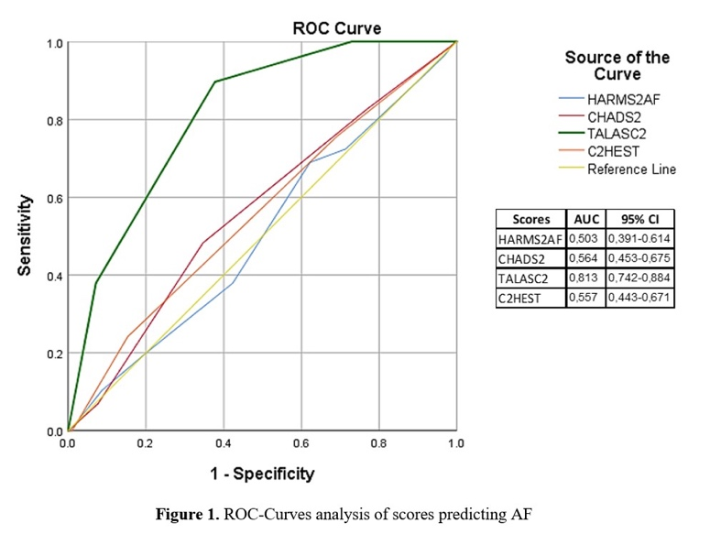
Figure 1. ROC-Curves analysis of scores predicting AF

COMBINATION OF ADMISSION BLOOD GLUCOSE AND HBA1C TO PREDICT IN-HOSPITAL MORTALITY IN PATIENTS WITH ST ELEVATION MYOCARDIAL INFARCTION

R. B. Prasetyo¹, H. P. B. F. S. B. Y. Setianto¹

¹FK KMK Universitas Gadjah Mada

Background:
ST Elevation Myocardial Infarction (STEMI) has emerged most important cause of death worldwide. Hyperglycemia in patients with diabetes mellitus or non diabetes mellitus can be strong predictor for the poor prognosis of these patients. However, the relationship between admission blood glucose and glycated hemoglobin (HbA1C) with the poor outcomes of ST Elevation Myocardial Infarction (STEMI) patients has not been elucidated yet. Here, we aim to combination admission blood glucose and HbA1C serum levels to in-hospital mortality in patients with STEMI.

Methods:
This retrospective cohort study includes 667 patients who were admitted in intensive care unit with STEMI between May 2023 and May 2024. Patient were stratified according to their blood glucose and HbA1c into four groups: Group 1 blood glucose < 200 mg/dL and HbA1c ≤ 6.5%, Group 2 blood glucose < 200 mg/dL and HbA1C > 6.5%, Group 3 blood glucose ≥ 200 and HbA1c ≤ 6.5%, and Group 4 blood glucose ≥ 200 and HbA1c > 6.5%. The clinical end points were comparison in-hospital mortality for each group.

Results:
Out of 667 patients, 80% were males and 20% females, There are 503 patients with blood glucose < 200 mg/dL (75.4%) and 164 patients with blood glucose ≥ 200 mg/dL (24.6%), and there are 427 patients with HbA1c ≤ 6.5% (64%), and 240 patients with HbA1c >6.5% (36%). There are 403 patients (60.4%) were classified into group 1, 100 patients (15%) into group 2, 24 patients (3.6%) classified into group 3, and 140 patients were classified (21%) into group 4. There are 54 (48.2%) patients were passed away in group 1,14 (12.5%) patients in group 2, 12 (10.8%) patients in group 3, and 32 (28.5%) patients in group 4. In analyses showed that hyperglycemia and HbA1c serum was associated with in-hospital mortality (p=0.001).

Conclusion:
Our study shows that high blood glucose at admission combined with normal HbA1c levels is associated with in-hospital mortality in STEMI patients.

Keywords: STEMI, HbA1c, Mortality, Blood glucose

Table 1. Percentage mortality rate of STEMI patients in each group
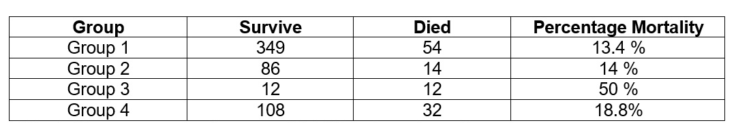
SYSTEMIC IMMUNE-INFLAMMATION INDEX AS A PREDICTOR OF MORTALITY AND REHOSPITALIZATION IN HEART FAILURE

H. Mumpuni¹, A. B. Hartopo¹

¹RSUP DR.SARDJITO

Background:
Heart failure (HF) is a disease closely associated with inflammation and a newly defined index – systemic immune-inflammation index (SII) has recently been reported to have prognostic value in patients with cardiovascular disease. SII is a combined inflammatory marker that includes three significant immune cells neutrophils, lymphocytes and platelets. As an advantage, SII is an inexpensive and easily accessible laboratory test in peripheral health facilities.

Methods:
This study was a retrospective cohort study using data of chronic heart failure patients who underwent hospitalization. Data were collected from Heart Failure (HF) registry Dr. Sardjito Hospital in period January 2022 to February 2023. SII was calculated as platelet count × absolute neutrophil count / absolute lymphocyte count. Laboratory examination was taken during patient admission and clinical outcome was assessed in one-year follow-up.

Results:
This study included 188 patients who met inclusion criteria from 282 chronic heart failure patients underwent hospitalization. Subjects had a mean age of 58.80 ± 11.48 years. A total of 67.6% (n=127) of subjects were male. SII value for mortality based on receiver operating characteristic (ROC) cut-off was 1459.59 (area under curve (AUC) 0.600, sensitivity 55.6%, specificity 68.8%) and the ROC cut-off for rehospitalization was 0.474. Kaplan-Meier analysis of SII to mortality, subjects with high SII values (>1459.59) had a 50.5% survival rate with a mean survival of 8.5 months and low SII (<1459.59) had a 74% survival rate with a mean survival of 9.9 months (figure 1). Multivariate regression analysis found SII as an independent predictor of mortality (OR 3.08, 95% confidence interval (CI) 1.59 – 5.95, p=<0.001) but not significant for rehospitalization.

Conclusion:
Systemic Immune-inflammation Index (SII) is an independent predictor of mortality, but not a predictor of rehospitalization in chronic heart failure patients underwent hospitalization.

Keywords: heart failure (HF), rehospitalization, Systemic Immune-inflammation Index (SII), mortality

ATRIAL FIBRILLATION IN RHEUMATIC HEART DISEASE: AN IDENTIFICATION OF POTENTIAL MECHANISM BASED ON PROTEIN-PROTEIN INTERACTION NETWORK ANALYSIS

N. E. Erwan¹, A. M. Ambari²

¹Research Assistant of Department of Cardiovascular Prevention and Rehabilitation, National Cardiovascular Center Harapan Kita, Jakarta, Indonesia
²Department of Cardiovascular Prevention and Rehabilitation, National Cardiovascular Center Harapan Kita, Jakarta, Indonesia & Department of Cardiology and Vascular Medicine, Faculty of Medicine, University of Indonesia, Jakarta, Indonesia

Background:
Atrial fibrillation (AF) is the most common arrhythmia finding in rheumatic heart disease (RHD) patients, leading to higher morbidity and mortality in the endemic area. Understanding the underlying molecular mechanisms by identifying essential proteins and pathways involved in disease development is crucial to predicting and building the emerging target for diagnostic or therapeutic interventions. This study used a bioinformatic approach to explore gene interaction in AF within the RHD population.

Methods:
Bioinformatic analysis used in this study comprised three stages, including data mining and gene selection of intersecting AF and RHD genes, which both gene sets were cross-referencing from multiple databases, Disgenet (disgenet.org), GeneCards (genecards.org), and NCBI gene databases. The protein-protein network was constructed using the STRING webserver and Cytoscape software, and then the DAVID webserver was used for gene ontology and KEGG enrichment analysis. R system was used for statistical analysis with a p-value<0.05.

Results:
Analysis from the three databases found ten potential genes from 293 gene elements involved in AF-RHD, which show the top-5 genes such as IL6, TNF, IL1B, TGFB1, and ACE proteins have the highest betweenness and closeness centrality scores. The Gene Ontology test on biological process, cellular component, and molecular function parameters (FDR<0.05) essential for a fibroinflammatory response, and the KEGG pathway enrichment showed the highest FDR value (p<0.05) belonging to the TNF signaling pathway (FDR<0.05).

Conclusion:
The IL6, TNF, IL1B, TGFB1, and ACE genes indicate the functional pathways of AF in RHD. These pathways may be investigated as future biomarkers or therapy targets to advance RHD prevention and intervention strategies. Nevertheless, further research is needed to elucidate these encouraging discoveries.

Keywords: Atrial fibrillation, Protein-protein interactions, Rheumatic heart disease, Network analysis

COMPARING LEFT ATRIAL STRAIN AND E/E’ TO PREDICT DIASTOLIC DYSFUNCTION IN PATIENTS WITH HEART FAILURE

G. Soemara¹, I. Posangi¹, H. Rawung¹, J. C. Kurniawan¹, F. M. Yofrido¹, B. Poetra¹, A. L. Panda¹, G. E. H. Reppi¹

¹Department of Cardiology and Vascular Medicine, Faculty of Medicine, Sam Ratulangi University, Manado, Indonesia

Background:
The most clinically reliable index of diastolic function is the combined assessment of transmitral flow and mitral annulus velocity. The E/e’ ratio is the most accurate indicator for distinguishing normal filling pressures (<8) from elevated filling pressures (>12). Recent findings indicate that a new LA functional parameter, LA strain, shows a strong correlation with invasive gold standard diastolic measurements and left ventricular filling pressures. This study will compare LA strain with E/e’, which of these two variables is better in predicting diastolic dysfunction.

Methods:
This was an analytic observational study with a cross-sectional approach, conducted in November 2021-January 2022. The number of samples were 60 heart failure patients with hypertension, type 2 diabetes mellitus, stable coronary heart disease, and obesity. Subjects who met the inclusion criteria underwent anamnesis and physical, laboratory, electrocardiography and echocardiography examinations.

Results:
Out of 60 eligible subjects, 62% were male with a mean age of 58.3±10.5. Average Ejection Fraction (EF) with mean of 62.27±9.3. 34 subjects (57%) had abnormal diastolic function. Average LA strain with mean of 17.7±5.4. Average E/e’ with mean of 9.12±2.41. In ROC analysis showed that LA strain had better prediction than E/e’ parameter (LA Strain AUC 0.827; E/e’ AUC 0.58; p=0.001).

Conclusion:
LA strain was better at predicting diastolic dysfunction compared with E/e’. However, additional studies are needed to strengthen the hypothesis by adding an ejection fraction less than 50.

Keywords: heart failure, diastolic dysfunction, left atrium strain, E/e’

POOR RIGHT VENTRICULAR SYSTOLIC FUNCTION (LOWER TAPSE) AS A PREDICTOR FOR REHOSPITALIZATION WITHIN 3 MONTHS IN MITRAL STENOSIS PATIENTS

S. S. Ramadhani¹, T. W. Ardini²

¹Faculty of Medicine, University of North Sumatera
²Departement of Cardiology and Vascular Medicine, Faculty of Medicine, University of North Sumatera

Background:
Mitral stenosis is one of the most common heart valve diseases and is associated with significant cardiovascular morbidity and mortality. Mitral stenosis defined as narrowing of the mitral valve orifice area that causes disruption of the left ventricle filling and can lead to complications of right ventricular dysfunction. Right ventricular systolic function as measured by echocardiography which is assessed by looking at the tricuspid annular plane systolic excursion (TAPSE). This study aims to determine the correlation between right ventricular dysfunction with rehospitalization in mitral stenosis patients. Understanding these metrics may enhance prognostic evaluations.

Methods:
This retrospective cohort study was conducted from January 2022 to December 2022 in RSUP H Adam Malik. A total of 151 mitral stenosis patients were involved in our study.An echocardiographic examination of the right ventricular systolic function assessed by TAPSE was done at the time of admission.Rates of rehospitalization were observed during 3 months of follow up. Logistic regression models were performed to examine the association between TAPSE and 3-months rehospitalization

Results:
Among 151 patients, 60,3% were female and 39.7% were male with an average age of 42 years old. Eighty-one (53.6%) patients were rehospitalized within 3 months. The mean values TAPSE was 17.48 ± 4.25. Logistic regression analysis reveals significant correlations between TAPSE and incidence of re-hospitalization (p = 0.039).

Conclusion:
This study suggests that TAPSE was a significant predictor of 3-months rehospitalization in mitral stenosis patients, even after adjusting for other clinical factors.

Keywords: TAPSE, rehospitalization, mitral stenosis

CORRELATION BETWEEN REGULATORY T CELLS, T HELPER 17 CELLS, AND IL-17A+FOXP3+ REGULATORY T CELLS WITH LEFT VENTRICULAR HYPERTROPHY IN THE ESSENTIAL HYPERTENSION POPULATION

A. V. A. Ruhukail¹, B. Widyantoro¹, H. S. Muliawan¹

¹Department of Cardiology and Vascular Medicine, Faculty of Medicine, Universitas Indonesia

Background:
Left ventricular hypertrophy (LVH) and myocardial fibrosis as part of cardiac remodelling have been identified as frequent hypertension-related target organ damage, accounting for over 30% of this population, despite antihypertensive therapy. It is associated with global issue due its higher morbidity and mortality. Numerous animal studies have been conducted regarding the role of immune cells, specifically Regulatory T cells, T helper 17 cells, and IL-17A+Foxp3+ Regulatory T cells in LVH and myocardial fibrosis, with limited studies conducted on humans, particularly in Indonesia.

Methods:
This cross-sectional study involving 80 subjects of essential hypertension (EH) aged 30-65 years who met the research inclusion criteria at the National Cardiovascular Center Harapan Kita, Indonesia, in May 2024–June 2024. Demographics, clinical data, home blood pressure monitoring, laboratory results (including flowcitometry data on Regulatory T cells, T helper 17 cells, and IL-17A+Foxp3+ Regulatory T cells and ELISA data on soluble ST2), and transthoracic echocardiography were collected. Comparative tests and multivariate analysis were applied for primary outcome analysis

Results:
For 80 EH participants, IL-17A+Foxp3+ Regulator T cells were significantly higher in the LVH group with median of 38.6 (5.6-69.8) and a p value of 0.049. No correlation exists between Regulatory T cells and T Helper 17 cells with LVH. In a multicoleniarity test, IL-17A+Foxp3+ Regulator T cells and obesity influenced the occurrence of hypertrophy when controlled by the interaction between IL-17A+FOXP3+ Regulatory T cell with Regulatory T cell and statistically significant (p=0.036 and p=0.037 in sequence). After controlling of obesity status, IL-17A+Foxp3+ Regulatory T cells and the abdominal circumference significantly correlated with myocardial fibrosis which described in soluble ST2 values

Conclusion:
The number of IL-17A+Foxp3+ Regulatory T cells on LVH group in subjects with essential hypertension is significantly higher compared to the non-LVH group, while no correlation was found in Regulatory T cells and T Helper 17 cells. In addition, IL-17A+Foxp3+ Regulatory T cell is significantlly corellated with myocardial fibrosis in subject with essential hypertension, whereas Regulatory T cells and T helper 17 cells are not.

Keywords: Regulatory T cells, T helper 17 cells, Essential hypertension, Left ventricular hypertrophy, IL-17A+Foxp3+ Regulatory T cells

THE CHARACTERISTICS OF MYOCARDIAL WORK DURING PRE-ECLAMPSIA PREGNANCY USING TWO DIMENSIONAL ECHOCARDIOGRAPHY: A DESCRIPTIVE STUDY

I. Mukhlisah¹, M. Yanni¹, Nani¹, D. Surya¹, D. Azhari¹

¹RS MJAMIL PADANG

Background:
Pre-eclampsia (PE) is defined as new onset hypertension after 20 weeks gestation with evidence of maternal organ or uteroplacental dysfunction or proteinuria. Pre-eclampsia is a life-threatening disease in pregnancy and a leading cause of maternal and neonatal morbidity and mortality. Pre-eclampsia is associated with cardiac dysfunction with a reduction in global longitudinal strain (GLS) and long-term cardiovascular disease. This study aimed to analyze the changes in myocardial work (MyW) properties during PE pregnancy.

Methods:
This was a descriptive retrospective study conducted at M. Djamil General Hospital Padang, Indonesia in patients diagnosed with PE between July 2023 and March 2024. Standard two-dimensional and speckle-tracking echocardiography were sequentially performed on all subjects. Four components of MyW: global myocardial work index (GWI), constructive work (GCW), wasted work (GWW) and work efficiency (GWE) were measured. All samples were analysed statistically using SPSS software.

Results:
Twenty one PE patients were included in this study. Despite maintaining normal left ventricular ejection fraction (LVEF), PE patients had a reduced mean global longitudinal strain (GLS) (-16.12 ± 4.58%.). Most patients exhibited a left ventricular concentric hypertrophy geometry pattern. The study revealed normal mean values for GWI, GCW, GWW and GWE. However, PE patients in hypertension stage 2 demonstrated higher mean GWI, GCW, and GWW, and lower GWE. Notably, only the mean GWE showed a statistically significant difference between hypertension stage 1 and stage 2 (p= 0.017).

Conclusion:
In PE the LV pumps against higher arterial pressure, reducing the LV stroke volume and increasing the energy required for LV pump function, hence elevating the global MW index. In this study, patients diagnosed PE displayed a reduction in GLS which suggests a subclinical LV dysfunction in PE and showed normal values for MyW. Conversely, individuals with PE in stage 2 hypertension exhibited higher mean GWI, GCW, and GWW along with reduced GWE.with a significant difference observed between hypertension stage 1 and stage 2.

Keywords: myocardial work, echocardiography, preeclampsia

Table 1. Patient Characteristics
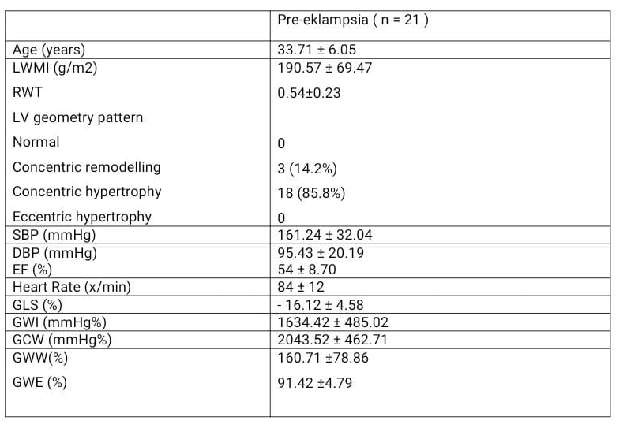

DIFFERENTIATION OF MYOCARDIAL WORK IN HYPERTROPHIC CARDIOMYOPATHY AND HYPERTENSIVE HEART DISEASE PATIENTS

P. Risani¹, M. Yanni¹, Nani¹, M. S. Indah¹, F. Ladediska¹

¹RSUP dr. M. Djamil Padang

Background:
Compared to left ventricular ejection fraction and myocardial strain, left ventricular myocardial work showed incremental value in diagnosis and prognostication. The aim of this study were to describe myocardial work in Hypertrophic Cardiomyopathy (HCM) and Hypertensive Heart Disease (HHD) patients and to compare echocardiography parameters and myocardial work in HCM and HHD patients.

Methods:
A cross-sectional study was conducted on HCM and HHD patients at Dr. M. Djamil Hospital Padang from August 2023 to May 2024. We retrieved data from medical records and traced the echocardiography of the patients with HCM and HHD. The data were then analyzed using T-independent tests and Mann-Whitney tests with SPSS.

Results:
This study population consisted of 10 patients with HCM and 10 patients with HHD. The mean age in HCM patients was 60.3 ± 11.9 years old and 55.7 ± 15.6 years old in HHD patients. Patients with HCM had thicker IVSD (p = 0.00) and higher ratio of IVDS/LVPWD (p = 0,017). There were no statistical differences among the groups in LVEDD, LVESD, LVEDV, LVMI, RWT, LA diameter, LAVI and LVEF. When compared to HHD patients, GWI (global work index), GCW (global constructive work), and GWE (global work efficiency) were significantly lower in HCM patients (1190.4 ± 363.68 mmHg% vs 1796.9 ± 344 mmHg%, p = 0.001; 1414.3 ± 396.63 mmHg% vs 2187.2 ± 437.32 mmHg%, p = 0.001; 86.7 ± 3.2% vs 94 ± 2.49%, p = 0.000, respectively). While GWW (global wasted work) was higher in HCM patients than in HHD patients (206.4 ± 83.07 mmHg% vs 129.2 ± 63.45 mmHg%, p = 0.031).

Conclusion:
Myocardial work in HCM patients is more impaired than in HHD patients. GWI, GCW, and GWE were lower in HCM patients than HHD patients, while GWW was higher in HCM patients than HHD patients indicating that the myocardial work of the global left ventricular was significantly damaged in HCM patients when LVEF was normal. The damage to the myocardial work may be related to the hypertrophy of myocardial cells and the disordered myocardial fiber arrangement and interstitial fibrosis in HCM patients.

Keywords: echocardiography, hypertensive heart disease, myocardial work, hypertrophic cardiomyopathy

THE CHARACTERISTICS OF PATIENTS WITH COR PULMONALE CHRONIC IN RSUP SURAKARTA: RELATIONSHIP WITH LUNG DISEASE AND ECHOCARDIOGRAPHY
A. N. Hafika¹, M. Z. Fananie¹
¹RSUP Surakarta

Background:
Cor pulmonale chronic (CPC) is characterized by structural and functional right heart abnormalities caused by respiratory system disorders and also a complication of pulmonary hypertension, one of which is caused by chronic lung diseases. It is necessary to analyze the characteristics of CPC patients so that they can develop better strategies for handling CPC.

Methods:
This study design is descriptive and analytical. Samples were taken from the medical record data of patients diagnosed with CPC from March 2023 to March 2024. Sampling was done using a cross-sectional research methodology. The variables used are pulmonary disease (asthma, chronic obstructive pulmonary disease (COPD), post-tuberculosis, and bronchiectasis), the severity of tricuspid regurgitation (TR), the probability of PH and echocardiographic variables (TAPSE, TR Vmax, and mPAP)—data analysis using SPSS version 24.

Results:
For research analysis, 206 CPC patients were included. The patient's average age was 63.19 ± 10.73 years, and 65.5% of the patients in this study were male. COPD was the most prevalent lung condition, affecting 146 patients (70.9%). In the mild category, the tricuspid regurgitation severity peaked at 59.7%. Most patients (66.6%) fell into the low-level PH probability category. In the meantime, 11.7% of patients had a high level of PH in the probability group. Further investigation revealed that mild tricuspid regurgitation affected 60.3% of COPD patients, along with bronchiectasis (60%), post-tuberculosis (58.8%), and asthma (55.6%). The probability of low PH with COPD was 65.1%, bronchiectasis was 64%, post-tuberculosis was 70.6%, and asthma was 61.1%, according to the examination of the probability of PH with lung illness. However, both analyses are not significant (p > 0.05). TAPSE, TR Vmax, and mPAP showed a significant connection (p<0.001) with the risk of PH. There is a strong correlation between PH risk and tricuspid regurgitation severity (p<0.001).

Conclusion:
This study shows that COPD is most often associated with CPC. The majority of CPC patients have mild tricuspid regurgitation and a low probability of pulmonary hypertension. This research can be a strategy for handling CPC at RSUP Surakarta.

Keywords: cor pulmonale chronic, COPD, pulmonary hypertension, pulmonary disease

Table 1. Demography and Clinical Data of Cor Pulmonary Chronic Database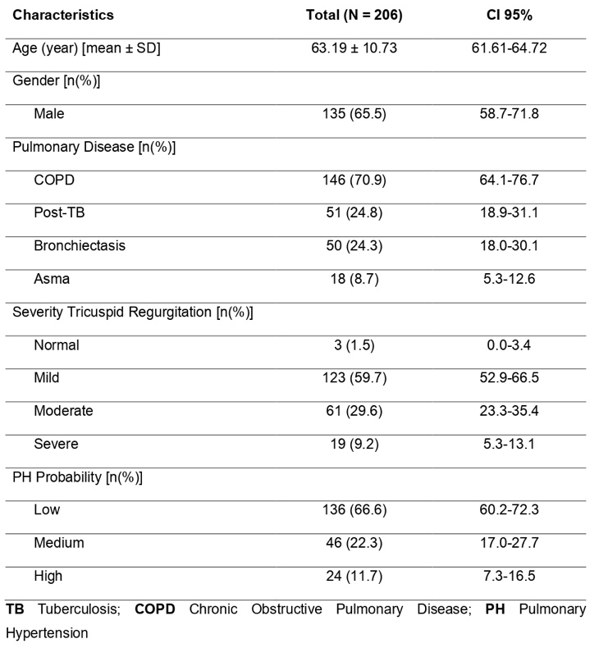

PREDICTORS OF IN-HOSPITAL MORTALITY IN PATIENTS WITH POST-ACUTE MYOCARDIAL INFARCTION VENTRICULAR SEPTAL RUPTURE: A SINGLE-CENTER 10-YEAR RETROSPECTIVE STUDY

J. Phowira¹, H. Prasetyo¹, B. Widyantoro¹

¹National Cardiovascular Center Harapan Kita, Jakarta, Indonesia

Background:
Ventricular septal rupture (VSR) presents as a rare but fatal mechanical complication following acute myocardial infarction (AMI). The mortality rate associated with VSR remains high despite advancements in treatment strategies. This retrospective single-center observational study aimed to investigate the predictors of in-hospital mortality of patients with VSR post-AMI in Indonesia.

Methods:
Retrospective data from electronic medical records of VSR post-AMI patients at the National Cardiovascular Center Harapan Kita, spanning from 2014 to 2024, were collected from 12,003 AMI admissions. Clinical data analyzed included baseline demographics, AMI characteristics, echocardiography, laboratory data, coronary angiography, management plan, and clinical outcomes. The primary endpoint assessed was in-hospital mortality. Differences were expressed as odds ratios (ORs) with 95% confidence intervals (CIs) to evaluate the relationships between potential predictors and in-hospital mortality.

Results:
Out of the 93 patients enrolled, we observed an in-hospital mortality rate of 58%. The mean age of the patients was 59±8 years, with a male predominance of 59%. Cardiogenic shock occurred in 53% of the patients, and 49% developed secondary infection, most commonly pneumonia (43%). Surgical repair and device closure was performed in 46 and 2 patients, respectively. In multivariate analysis, diabetes mellitus (OR 28.993, 95% CI 3.412-246.362), MI onset <14 days (OR 6.326, 95% CI 1.263-31.685), KILLIP III-IV (OR 16.218, 95% CI 2.602-101.074), pneumonia (OR 5.397, 95% CI 1.043-27.923), vasopressor (OR 30.486, 95% CI 4.043-229.854), and mechanical ventilation (OR 10.555, 95% CI 1.634-68.174) were significant predictors of in-hospital mortality, while surgical repair (OR 0.114, 95% CI 0.016-0.803) and CABG (OR 0.094, 95% CI 0.009-0.929) were significant predictors of survival. Receiver operating characteristic curve analysis demonstrated an area under the curve of 0.961 (p<0.05).

Conclusion:
Our study reported a high mortality among VSR patients. Diabetes mellitus, onset of MI <14 days, higher KILLIP classification, pneumonia, patients requiring vasopressor, and mechanical ventilation support were independent risk factors of in-hospital mortality. Surgical repair and CABG were predictors of survival in patients with VSR.

Keywords: Survival, Mortality, Mechanical complication, Acute myocardial infarction, Ventricular septal rupture

Table 1. Multivariate analysis of predictors of in-hospital mortality in patients with post-acute myocardial infarction ventricular septal rupture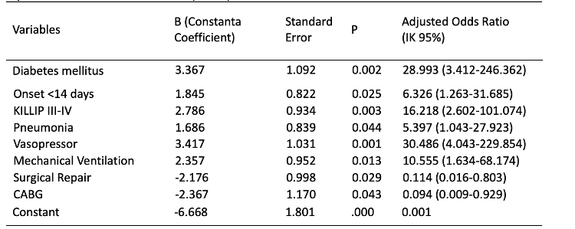
THE POTENTIAL OF INDONESIA HERBAL COMPOUNDS AS KELCH LIKE ECH‑ASSOCIATED PROTEIN 1 (KEAP1) INHIBITOR TO REGULATE FERROPTOSIS IN DOXORUBICIN-INDUCED CARDIOMYOPATHY THROUGH IN SILICO APPROACH

R. F. Muhammad¹, B. Satrijo²

¹Universitas Brawijaya
²Saiful Anwar General Hospital

Background:
Ferroptosis is a type of programmed cell death dependent on iron, characterized by lipid peroxides accumulation. Ferroptosis-inducing factors can affect glutathione peroxidase through different pathways, resulting in decreased antioxidants and lipid reactive oxygen species (ROS) accumulation in cells, leading to oxidative cell death. Recent studies have shown that ferroptosis is closely related to cardiovascular diseases, including doxorubicin-induced cardiomiopathy (DIC). Doxorubicin commonly used antitumor agent with fatal cardiotoxicity, including cardiomyopathy. Doxorubicin induces lipid peroxidation by inhibiting glutathione peroxidase 4 (GPX4) resulting in ferroptosis. GPX4 is glutathione-dependent enzyme that are transcriptionally regulated by nuclear factor erythroid 2-related factor 2 (Nrf2). Nrf2 key regulation is interceded by proteasome degradation mainly mediated by the repressor protein Kelch‐like ECH‐associated protein 1 (KEAP1). Researchers have previously found that KEAP1 blocking increases Nrf2 production. Indonesia had various antioxidant-rich plants that exert anti-inflammatory potency, including Apium graveolens (Luteolin), Allium cepa L. (Quercetin), Ocimum sanctum L. (Orientin), Zea mays (Lumichrome), and Tridax procumbens (7,8-Dihydroxyflavone). This research aims to explore Indonesia herbs as anti-ferroptosis through KEAP-1 inhibitory pathways in DIC, and compared with Carvedilol as common medication.

Methods:
This study used computational methods, which all of the structures were obtained from PubChem and Protein Data Bank databases. Furthermore, pharmacokinetic analysis using Lipinksi Rule of Five and pkCSM was carried out, and performed molecular docking using Vina Wizard. The interactions between ligand-protein target were analyzed to assess compounds inhibitor potency.

Results:
Pharmacokinetic analysis showed that Luteolin, Lumichrome, and 7,8-DHF fullfilled all of the criteria. The molecular docking results showed that Luteolin, Quercetin, Orientin, Lumichrome, and 7,8-DHF bound KEAP-1 with -5.2, -5.2, -5.0, -5.3, and -5.4 kcal/mol energy, respectively. These binding affinity are much lower than Carvedilol (-3.6 kcal/mol), indicating that Indonesia herbal compounds had stronger inhibitor potency, especially for Tridax procumbens (7,8-DHF). All of these natural compounds also had more protein residue interaction, compared to Carvedilol.

Conclusion:
Indonesia herbal compound showed promising inhibitor activity against KEAP-1 based on its strong and stable binding energy, highlighting its potential for regulating ferroptosis-induced inflammation in DIC.

Keywords: Kelch like ECH‑associated protein 1, Doxorubicin-induced Cardiomyopathy, Indonesia herbal compounds, Ferroptosis, In silico

PREVALANCE OF CARDIOTOXICITY CARDIOMYOPATHY AMONG BREAST CANCER PATIENTS UNDERGOING CHEMOTHERAPY AT DR HASAN SADIKIN GENERAL HOSPITAL BANDUNG

A. A. Arderia¹

¹Universitas Padjadjaran

Background:
Chemotherapy is one of the lines of cancer therapy but has significant side effects in the form of cardiotoxicity. One of the most effective drugs for breast cancer chemotherapy is anthracycline, but this drug has progressive and irreversible levels of cardiotoxicity. This study was conducted to determine the prevalence of cardiotoxicity cardiomyopathy among breast cancer patients undergoing chemotherapy with anthracycline regimens in Indonesia, especially West Java.

Methods:
This retrospective descriptive study involved 98 breast cancer patients undergoing chemotherapy with an anthracycline regimen from July 2018 to February 2020. The patients were serially evaluated for a clinical condition and echocardiography, at baseline, 3 weeks, 12 weeks, and 24 weeks after chemotherapy initiation. The results of this study were categorized into symptomatic and asymptomatic cancer therapy-related cardiac dysfunction (CTRCD). Symptomatic CTRCD was defined as the presence of cardiac dysfunction with symptoms of heart failure resulting from cancer treatment and was grouped into very severe, severe, moderate and mild. Asymptomatic CTRCD was defined as the absence of symptoms of heart failure resulting from cancer treatment. Asymptomatic CTRCD was grouped into severe, intermediate and mild.

Results:
Asymptomatic cardiotoxicity was found in 17.82% of patients, which are divided into mild (13.89%), moderate (1.98%) and severe (1.98%). Symptomatic cardiotoxicity was found in 4.95% of patients, which were divided into mild symptoms (3.96%) and moderate symptoms (0.99%). Asymptomatic cardiotoxicity can be detected as early as the first month after chemotherapy (8.91%), while symptomatic cardiotoxicity was first detected in the third month in 2.97% of patients.

Conclusion:
Asymptomatic cardiotoxicity already found since the first month after initation of chemotherapy, while symptomatic CTRCD cases discovered in the third month after chemotherapy. The number of asymptomatic cardiotoxicity cases is higher compared to those showing clinical symptoms. Therefore, it is necessary to assess risk factors at the beginning of treatment, followed by monitoring of cardiac function, to enable early detection and initiation of therapy for cardiotoxicity in patients at risk.

Keywords: Cardiotoxicity, Chemotherapy, Breast Cancer, Anthracycline

INTEGRATING NETWORK PHARMACOLOGY AND EXPERIMENT VALIDATION TO IDENTIFY POTENTIAL ANTIFIBROSIS ACTIVITIES ON VALVULAR INTERSTITIAL CELL CULTURE AGAINST RHEUMATIC HEART DISEASE

R. A. Nugraha¹

¹Department of Cardiology and Vascular Medicine, Faculty of Medicine Universitas Airlangga – Dr. Soetomo General Hospital

Background:
Continuous activation of valvular interstitial cells by chronic exposure of TGF-β1 may stimulate transformation from quiescent fibroblast to activated myofibroblast phenotype. It is considered to be an initiating event in rheumatic heart disease via PI3K/AKT/mTOR pathway. Objectives: This study was designed to evaluate the molecular mechanisms of various pharmacology agents against rheumatic heart disease via network pharmacology analysis combined with experimental verification based on α-SMA expression in valvular interstitial cell model.

Methods:
We performed laboratory experimental study from 2022-2024 with posttest-only controlled group design. Subjects were Valvular Interstitial Cell induced by exogenous 5ng/mL of TGF-β1 for 72 hours. Network pharmacology agents include Dexamethasone (0.1 mM), Curcumin (20nM,50nM), Lisinopril (1mM,10mM,100mM), Olmesartan (100nmol/L), Losartan (10mmol/L), Valsartan (30mmol/L), Simvastatin (10mM), Atorvastatin (10mM), Rosuvastatin (10mM,25mM,50mM), Resveratrol (50mM,100mM,200mM,400mM) and negative control group. After 72 hours, α-SMA expression were detected by immunocytochemistry staining.

Results:
Administration of 5ng/mL of TGF-β1 increase myofibroblast trans-differentiation based on α-SMA expression similar to IL-1β, IL-6, and TNF-α (p = 0.631). Dexamethasone 0.1mM decrease α-SMA by 69.38% to control group (p <0.001). Curcumin 20nM and 50nM decrease α-SMA by 35.68% and 39.80% respectively (p =0.05). Lisinopril 100mMdecrease α-SMA by 42.46%. Olmesartan 100nmol/L decrease α-SMA by 67.12%, Losartan 10mmol/L decrease α-SMA by 73.59%. Valsartan 30mmol/L decrease α-SMA by 78.45%. Rosuvastatin 25mM and 50mM decreased α-SMA expression by 83.15% and 83.38% respectively (p <0.001). Resveratrol 50mM and 400mM decreased α-SMA expression compared to control (12.13{8.35-22.96} vs 11.59{8.50-20.29} vs 14.28{9.03-22.27}, p <0.001).

Conclusion:
These findings indicate that TGF-β1 may promote myofibroblast trans-differentiation activity among valvular interstitial cell via PI3K/AKT/mTOR pathway. Dexamethasone, Lisinopril, Olmesartan, Losartan, Valsartan, Rosuvastatin, and Resveratrol had greater antifibrosis activity based on α-SMA expression at their optimal dose. Further investigation is needed to clarify the role of various pharmacology agents against rheumatic heart disease in animal models.

Keywords: TGF-β1, Resveratrol, Rheumatic Heart Disease, Myofibroblast, Rosuvastatin

THE FIRST EPIDEMIOLOGICAL DATA OF ACUTE CORONARY SYNDROME PATIENTS IN NUNUKAN REGENCY GENERAL HOSPITAL, NORTH KALIMANTAN, INDONESIA

J. E. Afandy¹, Taslim¹

¹Nunukan Regency General Hospital

Background:
Acute coronary syndrome (ACS) encompasses a group of conditions with a wide range of clinical manifestations that cause significant morbidity, mortality, and a high economic burden. North Kalimantan is province with the highest prevalence of cardiac disease in Indonesia. The northernmost region of North Kalimantan, Nunukan, is an archipelagic area that has only one general hospital. This study aimed to provide epidemiological data regarding ACS patients to aid the terrain that will be encountered in ACS management in Nunukan.

Methods:
A retrospective cross-sectional study was conducted among all ACS patients between January and August 2023 at Nunukan Regency General Hospital. Patient demographics, risk factors, complaints, vital signs, diagnoses, workups, treatments, and outcomes were collected from paper-based medical records.

Results:
A total of 241 patients were included (4.56% ST-elevation myocardial infarction (STEMI), 35.68% very high-risk non-ST-elevation (NSTE)-ACS, 59.75% non-very high-risk NSTE-ACS). Most patients were men (51.5%), obese (35.7%), mean age of 55.4 ± 12.26 years, and median risk factor of 2 (1 - 2.5) with hypertension being the most common (72.6%). Most patients are presented in late-onset. The fibrinolytic rate was only 36.4% among STEMI patients. The median length of stay was 6 (5 - 7) days, with a 3.3% mortality rate.

Conclusion:
ACS patients at Nunukan Regency General Hospital had unique profiles which were younger, obese, had multiple risk factors, and presented late-onset. Despite the limitations, our patients had comparable outcomes to those in other studies. Several attempts still need to be made to improve cardiovascular care in Nunukan.

Keywords: STEMI, North Kalimantan, epidemiology, NSTE-ACS, acute coronary syndrome

CORRELATION OF ATHEROGENIC PLASMA INDEX WITH DIVERSE HEALTH METRICS AMONG EAST JAVA LAW ENFORCEMENT: A DESCRIPTIVE CROSS-SECTIONAL ANALYSIS

F. Zahra¹

¹RSUD Dr. Soetomo Surabaya

Background:
The atherogenic plasma index (API) has emerged as a significant biomarker for evaluating cardiovascular risk. This study aims to explore the correlation between API and various health metrics among law enforcement personnel in East Java. Given the demanding nature of law enforcement duties, which often involve high-stress situations and irregular work hours, it is crucial to understand the health profile of these individuals. This research seeks to provide a comprehensive overview of the relationship between API and health parameters such as lipid profiles, blood pressure, body mass index (BMI), and lifestyle factors. Understanding these associations can inform targeted interventions to improve the cardiovascular health and overall well-being of law enforcement officers in this region.

Methods:
A cross-sectional observational research was conducted on police officers at the East Java Regional Police Headquarters from January to April of 2024. All 8767 individuals received thorough medical examinations. The statistical software SPSS version 26 was used for the analyses. The Mann-Whitney and Kruskal-Wallis tests were used for the compare means test, while the Spearman correlation test was used for the correlation test. The sign of statistical significance is p<0.05.

Results:
Of the 8767 participants, the average age was 51.51±11.01, 89.6% were male, 27.8% were obese and 28.3% were overweight, 41.8% had a history of hypertension, abdominal circumference was 88.20±16.3, 42.3% had TG ≥150, 41.6% had blood sugar ≥100, 42.1% had LDL ≥100, average HDL 35.99±22.69, Atherogenic Index 0.31±0.29, as many as 0.7% ischemic response positive, 1.5% abnormal, average Creatinine 1.9±3.16, NLR 1.79±0.65, as many as 2% have proteinuria, average METs 11.9±3.08. Significant results were obtained in the correlation between the atherogenic plasma index and HDL (p<0.001; r:0.360), Creatinine (p<0.001; r=0.476), NLR (p<0.001; r=0.043), gender (p<0.001), and ischemic response (p<0.001).

Conclusion:
The study found a correlation between atherogenic plasma index and HDL, creatinine and NLR. There were significant differences in atherogenic index in sex and ischemic response. These findings highlight the potential of API as a valuable marker for assessing cardiovascular risk and emphasize the need for targeted health interventions in this high-risk population.

Keywords: Cardiovascular Health, Atherosclerosis, Atherogenic Plasma Index

ASSOCIATION BETWEEN TREADMILL TEST RESULTS AND VARIOUS HEALTH PARAMETERS IN EAST JAVA POLICE OFFICERS: AN OBSERVATIONAL CROSS-SECTIONAL STUDY
C. G. Savitri¹
¹General Academic Hospital Dr. Soetomo

Background:
Cardiovascular health assessments, including treadmill tests, are crucial for early detection of ischemic conditions and other abnormalities. This provide critical insights into an individual's cardiovascular fitness and potential risk factors. However, the relationship between treadmill test outcomes and a range of health parameters, including metabolic and physiological indicators, remains underexplored in specific occupational groups. This study seeks to bridge this gap by examining how treadmill test results correlate with various health parameters among police officers in East Java. By understanding these associations, the study aims to enhance the development of targeted preventive strategies and interventions in improving cardiovascular health and operational efficiency within this high-stress profession.

Methods:
An observational cross-sectional study was conducted on police officers at the East Java Regional Police Headquarters from January to April 2024. Participants underwent medical check-up, including treadmill testing and measurement of various health parameters. Statistical analysis was performed using the Chi-square test for categorical data and the independent t-test for numerical data, utilizing SPSS 24.

Results:
The study included 8767 male and female officers, with findings of treadmill stress test result categorized into positive ischemic, abnormal other than positive ischemic, and normal treadmill findings. Key results included no significant difference in treadmill outcomes based on sex, body mass index, hypertension, triglyceride, glycemia, LDL, HDL status. However, we found higher incidence of positive ischemic findings in subjects with proteinuria (p=0.002). Furthermore, age, abdominal circumference, Triglyceride-Glucose (TyG) index, Atherogenic Plasma Index (API), Neutrophil-Lymphocyte Ratio, and serum creatinine levels showed no significant differences between positive ischemic and normal treadmill results.

Conclusion:
This study found no significant associations between treadmill test results and most examined health parameters, except for proteinuria.

Keywords: Atherogenic Plasma Index, Cardiovascular Health, Triglyceride-Glucose Index, Proteinuria, Treadmill Test

Table 1. Results of comparison
